**RASA-Slack**

Step 1: rasa init

Step 2: credentials.yml in the root folder of your Rasa Open Source project

slack:

slack_channel: "CA003L0XZ" # channel ID, not a channel name!

slack_token: "xoxb-XXX" # token obtained in the next step

slack_signing_secret: "YYY" # secret obtained in the next step

Step 3: create slack channel on your workspace in slack account

Step 4: create a Slack App to get the values for slack_token and slack_signing_secret

4.1 To create the app go to Your Apps and click on Create New App.

<https://api.slack.com/apps>

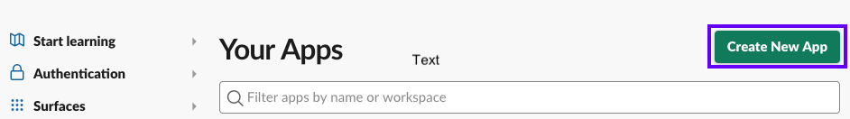

Step 4.2 : OAuth & Permissions and scroll down to Scopes. Scopes give your app permission to do things in your workspace.

To get started, you should at least add the following scopes:

* app_mentions:read,
* channels:history,
* chat:write,
* groups:history,
* im:history,
* mpim:history and
* reactions:write.

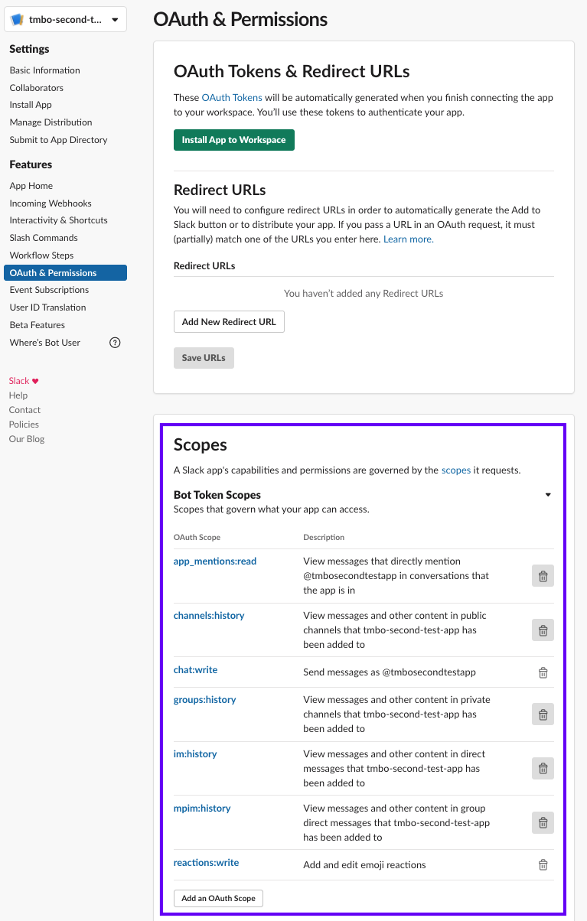

Step 4.3 : On the OAuth & Permissions page, click Install App to Workspace to add the bot to your workspace.

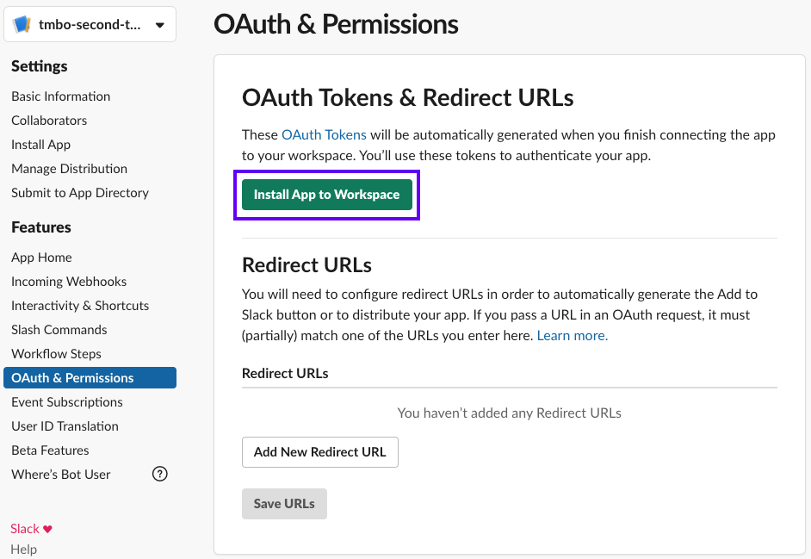

Slack will show you a Bot User OAuth Access Token which you'll need to add to your credentials.yml as the value for slack_token

slack:

slack_channel: "your-channel" # choose a channel for your bot

slack_token: "xoxb-XXX" # token obtained in the next step

slack_signing_secret: "YYY" # secret obtained in the next step

The token should start with xoxb.

Step 4.4: Head over to Basic Information to gather the Signing Secret

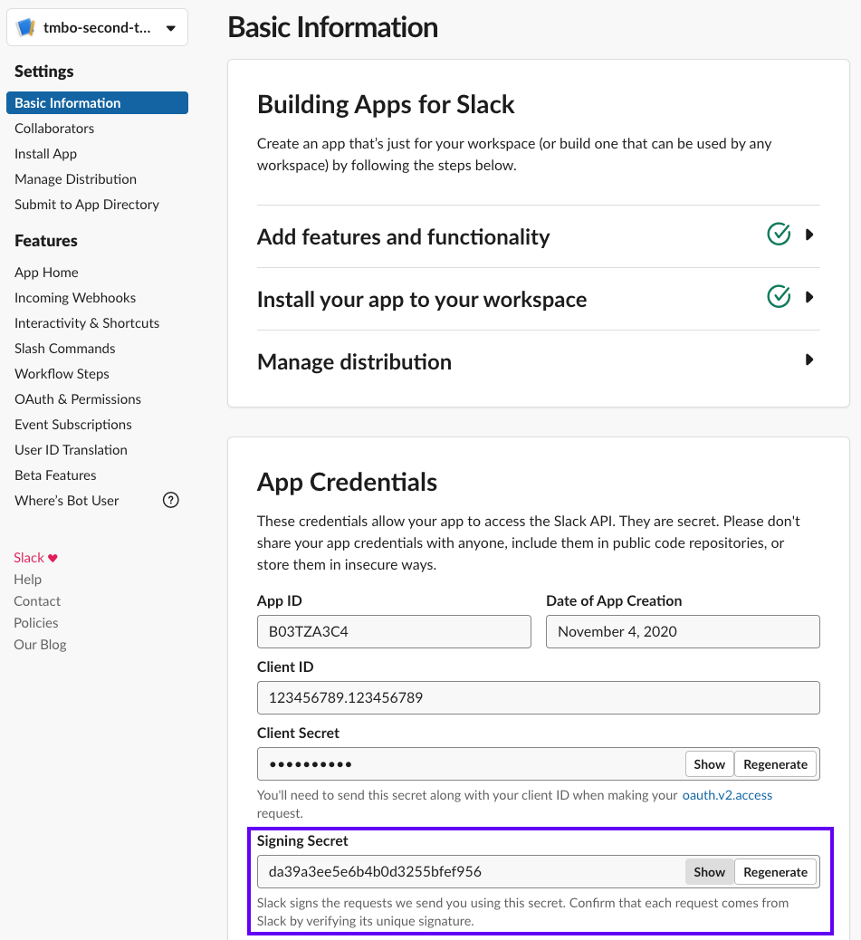

Copy the signing secret into your credentials.yml as the value for slack_signing_secret

slack:

slack_channel: "your-channel" # choose a channel for your bot

slack_token: "xoxb-XXX" # token obtained in the next step

slack_signing_secret: "YYY" # secret obtained in the next step

Step 5 : To receive messages, you will need a publicly available URL for Slack to reach your bot and tell you about new messages. If you are running locally, you can test channels using ngrok

Step 5.1 To install ngrock

<https://ngrok.com/>

Create a account

Step 5.2 : Download ngrok for your OS

Step 5.3 : On Linux or Mac OS X you can unzip ngrok from a terminal with the following command.

unzip /path/to/ngrok.zip

On Windows, just double click ngrok.zip to extract it.

Step 5.4 : Connect your account

./ngrok authtoken 1jhkjeqiQbo8YL7wabkjkjYBxW2pWf_5YewKrnjkngCZ4ZYt21HGMw

Step 5.5 : start a HTTP tunnel forwarding to your local port 5005, run this next:

./ngrok http 5005

Step 6: To configure your bot to receive messages, your bot needs to be running. Start your bot

rasa run

Step 7: Configure the webhook by heading to Event Subscriptions and turning Enable Events on

Step 7.1: As a request URL enter the public url of your bot and append /webhooks/slack/webhook

Step 7.2: using ngrok, your url should look like <https://92832de0.ngrok.io/webhooks/slack/webhook>

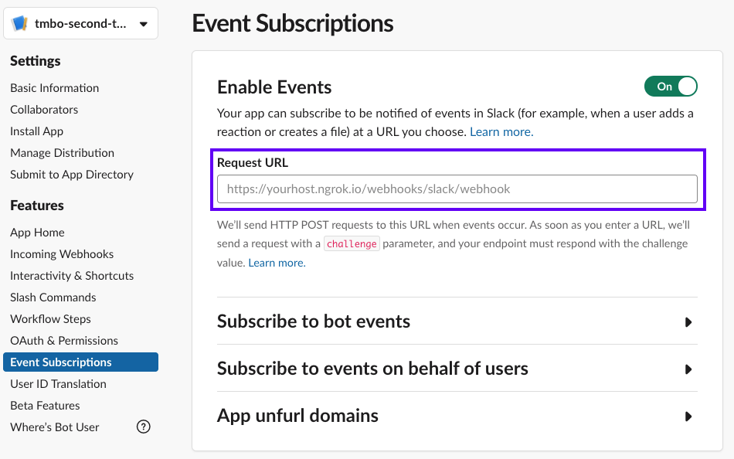

Step 7.4: you'll need to Subscribe to bot events on the same page. You'll need to add the following events:

* message.channels,
* message.groups,
* message.im and
* message.mpim.

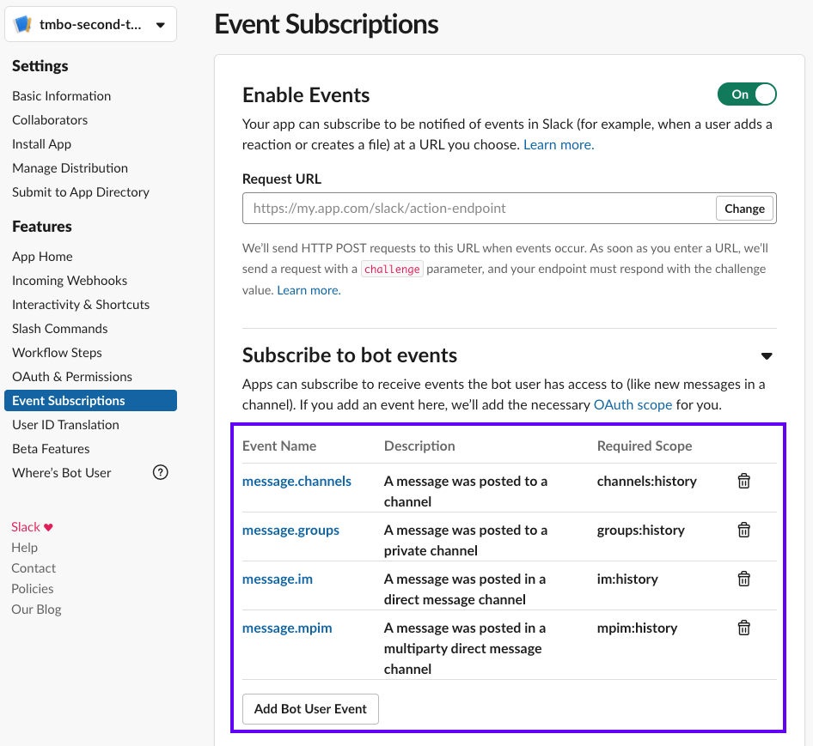

Make sure to hit Save Changes at the bottom of the page after you've added these events.

Step 8: run the action server

rasa run actions

Step 9: add your bot app in slack to you channel by @botapp_name

THANK YOU