To start docker in mac:

brew services start docker

To start docker in windows:

1.Restart windows after installation

2. Open docker desktop

Create docker repository:

1. signup for docker hub

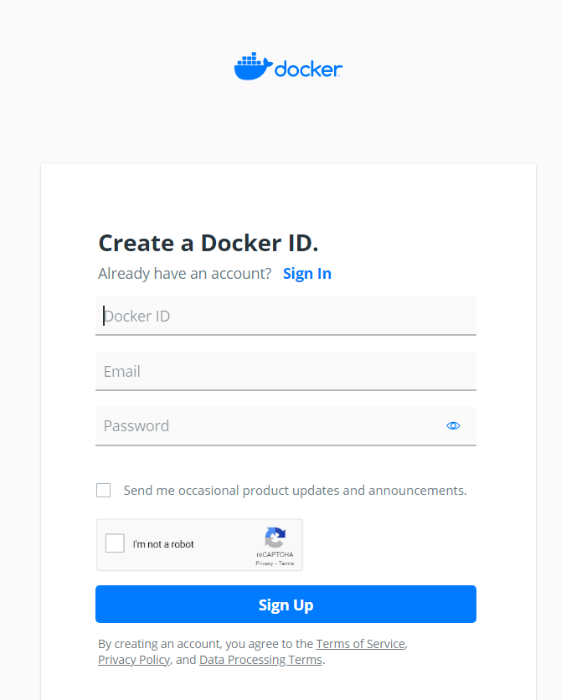

2. sign into Docker Hub, click on Repositories then Create Repository

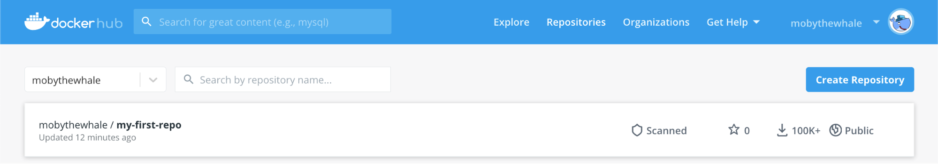

3. choose docker repo name

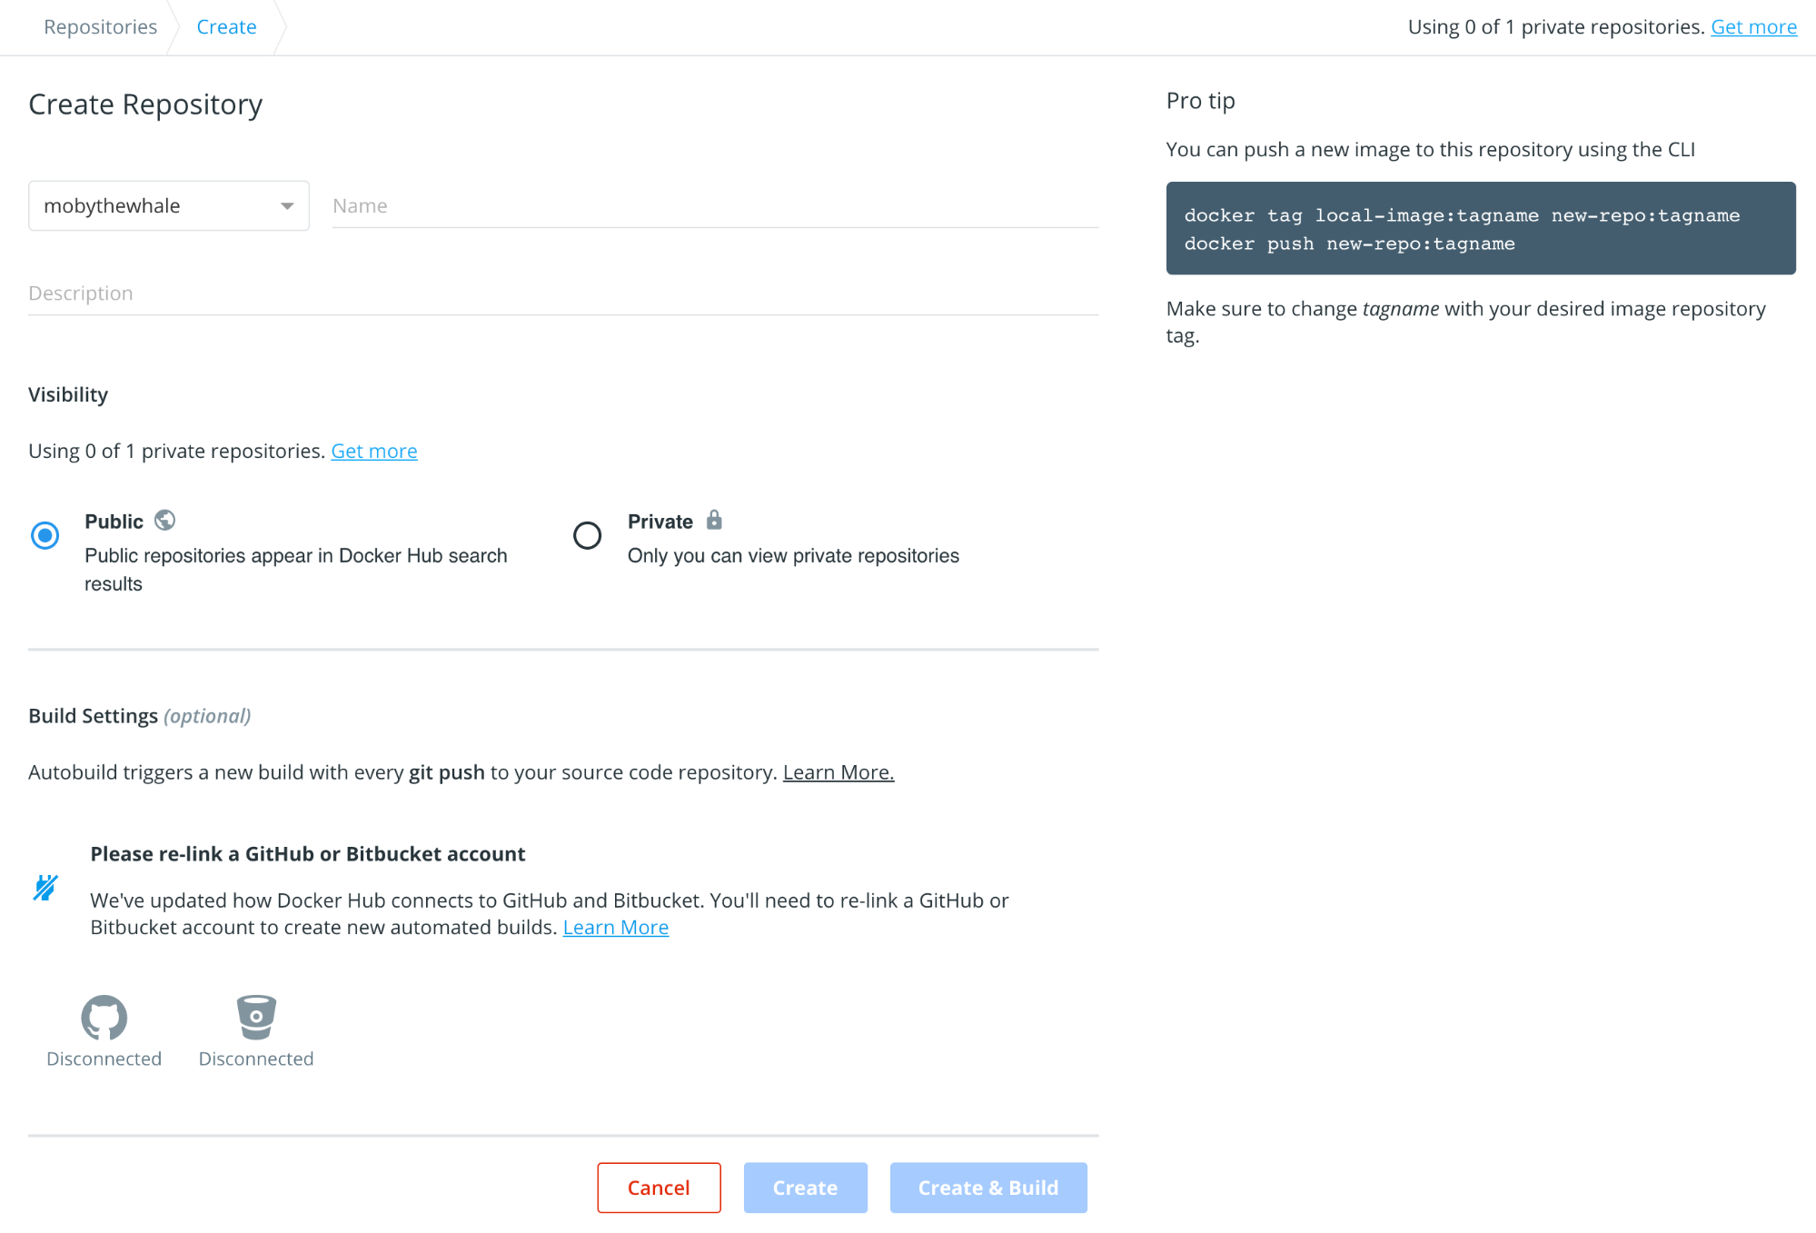

4.hit the Create button