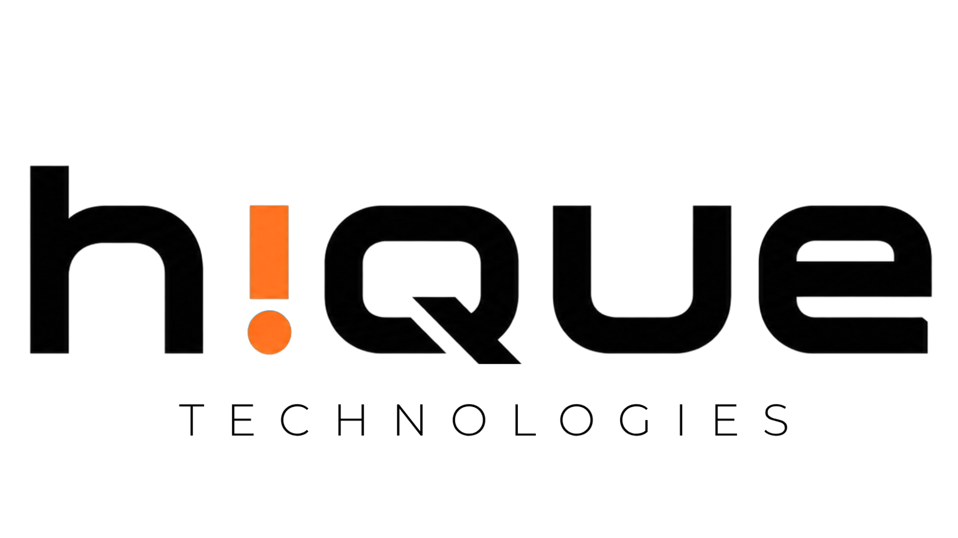

Easy Job Platform
Architecture Recommendation & Cost Analysis
Prepared by Hique Technologies

1. Executive Summary

The Easy Job platform is expected to scale across Tamil Nadu with high concurrent mobile traffic, OTP authentication, and frequent job listing updates. This proposal compares the client-requested Firebase architecture with Hique Technologies’ recommended scalable backend infrastructure optimized for long-term cost efficiency, performance, and operational control.

2. Client Stack vs Recommended Infrastructure

Layer | Client Requested Stack | Recommended Infrastructure
Frontend | Android Java/XML | Android Java/XML
Backend | Firebase Functions | Go Fiber API
Database | Firestore | PostgreSQL
OTP | Firebase OTP | MSG91
Storage | Firebase Storage | Cloudflare R2
Hosting | Firebase Managed Services | DigitalOcean / Hetzner VPS

3. Why Hique Recommended This Architecture
- Predictable monthly infrastructure pricing
- Better scalability for high read/write workloads
- Lower storage and bandwidth costs
- Efficient relational data handling using PostgreSQL
- Reduced vendor lock-in compared to Firebase
- High-performance backend APIs using Go Fiber
4. Infrastructure Cost Comparison

Scale | Firebase Stack | Recommended Infrastructure | Savings
MVP (0 – 5k Users) | ₹5k – ₹20k/month | ₹8k – ₹15k/month | Minimal
Growth (10k – 50k Users) | ₹50k – ₹2L/month | ₹30k – ₹1L/month | 30% – 50%
Large Scale (1L+ Users) | ₹2L – ₹8L+/month | ₹1L – ₹4L/month | 40% – 60%

Disclaimer: Estimated costs are based on projected active users, API requests, OTP usage, storage, and bandwidth consumption. Actual infrastructure costs may vary depending on platform usage and scaling requirements.
5. Reliability & Security
- Daily automated database backups
- API-level authentication and validation
- Secure HTTPS communication
- Scalable VPS deployment architecture
- Cloudflare R2 object storage integration
- Basic server monitoring and error logging
4. Final Recommendation

Final Recommendation
Firebase provides rapid MVP development advantages, but the recommended Go Fiber + PostgreSQL architecture offers better long-term scalability, predictable infrastructure pricing, and operational flexibility for Tamil Nadu-wide platform growth.

