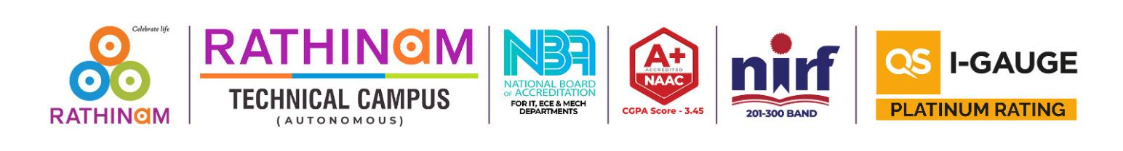
AN INTELLIGENT AI CHATBOT - DECIMIND AI

23MC411-PROJECT WORK
Submitted by
SASIKUMAR S (24205093)

in partial fulfillment for the award of the degree
of
MASTER OF COMPUTER APPLICATIONS
in
COMPUTER APPLICATIONS


RATHINAM TECHNICAL CAMPUS
Eachanari – 641021
(Autonomous)
Affiliated to Anna University, Chennai - 600025

MAY - 2026
ANNA UNIVERSITY, CHENNAI
BONAFIDE CERTIFICATE

Certified that this report titled AN INTELLIGENT AI CHATBOT - DECIMIND AI is the bonafide work of SASIKUMAR S (24205093) who carried out the project work under my supervision during the Academic Year 2025 – 2026.

Dr. K. Anuradha
Professor and Director
Master of Computer Applications
Rathinam Technical Campus
Coimbatore.
Dr. K. Anuradha
Supervisor
Master of Computer pplications
Rathinam Technical Campus
Coimbatore.

Submitted for End Semester Project viva-voce Examination held on...................

Internal Examiner External Examiner
DECLARATION

I SASIKUMAR S hereby declare that the project report titled “AN INTELLIGENT AI CHATBOT - DECIMIND AI” is done by me under the guidance of Dr. K. Anuradha, Professor, Department of of MCA., at Rathinam Technical Campus, is submitted in partial fulfillment of the requirements for the award of Master of Computer Applications. Certified further that to the best of my knowledge the work reported herein does not form part of any other project report or dissertation on the basis of which a degree or award was conferred on an earlier occasion on this or any other candidate.

DATE: SIGNATURE OF THE CANDIDATE
PLACE:

ACKNOWLEDGEMENT
Apart from the efforts, the success of this project depends largely on the encouragement and guidelines of many others. I take this opportunity to praise the almighty and express my gratitude to the people who have been instrumental in the successful completion of my project.
I wish to acknowledge with sincere gratitude to Dr. Madan A. Sendhil, B.E., M.S., Ph.D., Chairman, RGI for providing the excellent infrastructure and facilities on the campus for the successful completion of my project.
I also wish to express my heartfelt thanks to Dr. R. Manickam, MCA., Ph.D., CEO, RGI for providing the necessary facilities and academic environment to carry out the project successfully.
I extend my sincere thanks to Dr. B. Nagaraj, M.E., Ph.D., PDF (Italy), CBO, RGI for providing the required resources and facilities for the successful execution of my project work.
I wish to express my hearty thanks to Dr. K. Geetha, M.E., Ph.D., Principal (Administration), RTC for providing me with the opportunity and encouragement to complete the project successfully.
I extend my heartfelt gratitude to Dr. K. Anuradha, Professor & Director, Department of MCA, RTC for her tremendous guidance, continuous support, motivation, valuable suggestions, and encouragement throughout the completion of my project.
It is my primary duty to thank my Project Supervisor, Dr. K. Anuradha, Professor & Director, Department of MCA, RTC who served as the backbone of all my project activities. Her guidance, motivation, patience, continuous support, and encouragement helped me complete the project successfully.
Finally, I extend my heartfelt thanks to my parents, friends, and faculty members for their constant support, encouragement, and motivation throughout this project. The assistance and guidance received from everyone greatly contributed to the successful completion of this project.

SASIKUMAR S

