PLURALSIGHT INSTALLATION

1.Prepare the Ubuntu VM(Common Prerequisites)
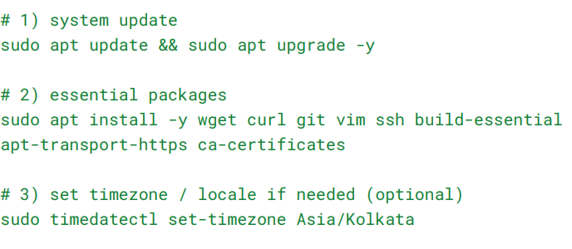
2. Install Java (OpenJDK 17)
# java 17(OpenJDk)
sudo apt install -y openjdk-17-jdk-headless (if it is shows error you can use this command)
sudo apt install openjdk-17-jdk
java --version #verify
3.Install Python 3.11 and pip
#Python 3.11
sudo apt install -y software-properties-common
sudo apt install -y python3.11 python3.11-venv python3.11-dev python3-pip
python –version
pip –version
4. Set JAVA_HOME in your shell (add to ~/.bashrc):
echo 'export JAVA_HOME=/usr/lib/jvm/java-17-openjdk-amd64' >> ~/.bashrc
echo 'export PATH=$JAVA_HOME/bin:$PATH' >> ~/.bashrc
source .bashrc

5.Install SDKMAN
sudo apt-get install zip unzip
curl -s "https://get.sdkman.io" | bash
source "$HOME/.sdkman/bin/sdkman-init.sh"
sdk version
6.Install Scala
sdk install scala 2.13.16
scala -version
7. Download & configure Hadoop (single-node pseudo-distributed)
Update system packages to avoid dependency issues:
sudo apt update && sudo apt upgrade -y
Install java(if you already installed java just ignored)
sudo apt install openjdk-17-jdk -y
verify
java –version

Download Hadoop 3.3.5:
wget https://downloads.apache.org/hadoop/common/hadoop-3.3.5/hadoop-3.3.5.tar.gz
Extract Hadoop:
tar -xvzf hadoop-3.3.5.tar.gz
Move it to /usr/local/:
sudo mv hadoop-3.3.5 /usr/local/hadoop
Set permissions:
sudo chown -R $USER:$USER /usr/local/hadoop
Edit the ~/.bashrc file:
nano ~/.bashrc
Add these lines at the end:
# Hadoop Environment Variables
export HADOOP_HOME=/usr/local/hadoop
export HADOOP_INSTALL=$HADOOP_HOME
export HADOOP_MAPRED_HOME=$HADOOP_HOME
export HADOOP_COMMON_HOME=$HADOOP_HOME
export HADOOP_HDFS_HOME=$HADOOP_HOME
export HADOOP_YARN_HOME=$HADOOP_HOME
export HADOOP_CONF_DIR=$HADOOP_HOME/etc/hadoop
export PATH=$PATH:$HADOOP_HOME/bin:$HADOOP_HOME/sbin

Apply changes:
source ~/.bashrc
Verify:
echo $HADOOP_HOME
Expected output:
/usr/local/Hadoop
Configure Hadoop Core Files
Edit Hadoop environment configuration:
nano $HADOOP_HOME/etc/hadoop/hadoop-env.sh
Find the line:
export JAVA_HOME=
Replace it with:
export JAVA_HOME=/usr/lib/jvm/java-17-openjdk-amd64
Configure core-site.xml
nano $HADOOP_HOME/etc/hadoop/core-site.xml
Add:
<configuration>
<property>
<name>fs.defaultFS</name>
<value>hdfs://localhost:9000</value>
</property>
</configuration>

Configure hdfs-site.xml
nano $HADOOP_HOME/etc/hadoop/hdfs-site.xml
Add:
<configuration>
<property>
<name>dfs.replication</name>
<value>1</value>
</property>
<property>
<name>dfs.name.dir</name>
<value>file:///usr/local/hadoop/hdfs/namenode</value>
</property>
<property>
<name>dfs.data.dir</name>
<value>file:///usr/local/hadoop/hdfs/datanode</value>
</property>
</configuration>
Create necessary directories:
mkdir -p /usr/local/hadoop/hdfs/namenode
mkdir -p /usr/local/hadoop/hdfs/datanode
Set permissions:
sudo chown -R $USER:$USER /usr/local/hadoop/hdfs
Configure mapred-site.xml
nano $HADOOP_HOME/etc/hadoop/mapred-site.xml
Add:
<configuration>
<property>
<name>mapreduce.framework.name</name>
<value>yarn</value>
</property>
<property>
<name>yarn.app.mapreduce.am.env</name>
<value>HADOOP_MAPRED_HOME=/usr/local/hadoop</value>
</property>
<property>
<name>mapreduce.map.env</name>
<value>HADOOP_MAPRED_HOME=/usr/local/hadoop</value>
</property>
<property>
<name>mapreduce.reduce.env</name>
<value>HADOOP_MAPRED_HOME=/usr/local/hadoop</value>
</property>
</configuration>

Configure yarn-site.xml
nano $HADOOP_HOME/etc/hadoop/yarn-site.xml
Add:
<configuration>
<property>
<name>yarn.nodemanager.aux-services</name>
<value>mapreduce_shuffle</value>
</property>
</configuration>
Configure Passwordless SSH
sudo apt install ssh -y
ssh-keygen -t rsa -P ""
cat ~/.ssh/id_rsa.pub >> ~/.ssh/authorized_keys
chmod 600 ~/.ssh/authorized_keys
Test SSH:
ssh localhost
Format the Namenode:
hdfs namenode -format
Start HDFS:
start-dfs.sh
Start YARN:
start-yarn.sh
Start All:
start-all.sh
Verify:
jps
Expected output:
NameNode
DataNode
ResourceManager
NodeManager
Create directory:
hdfs dfs -mkdir /demo
list the directory:
hdfs dfs -ls /

