EX.NO: 1 COMPUTE THE GCD OF TWO NUMBERS

DATE:

AIM:
To write a python program to compute the GCD of two numbers.

ALGORITHM:
.
Step 1: Enter two numbers.
Step 2. The two numbers are passed as arguments to a recursive function.
Step 3. When the second number becomes 0, the first number is returned.
Step 4. Else the function is recursively called with the arguments as the second number and the remainder when the first number is divided by the second number.
Step 5. The first number is then returned which is the GCD of the two numbers.
Step 6. The GCD is then printed.

PROGRAM

def gcd(a,b):
if(b==0):
return a
else:
return gcd(b,a%b)
a=int(input("Enter first number:"))
b=int(input("Enter second number:"))
GCD=gcd(a,b)
print("GCD is: ")
print(GCD)

Execution Steps:

- Open Python IDLE
- Click File -> New file
- Type the program
- Save the program with .py extension
- To execute the program click Run or press F5
- Exit

OUTPUT:

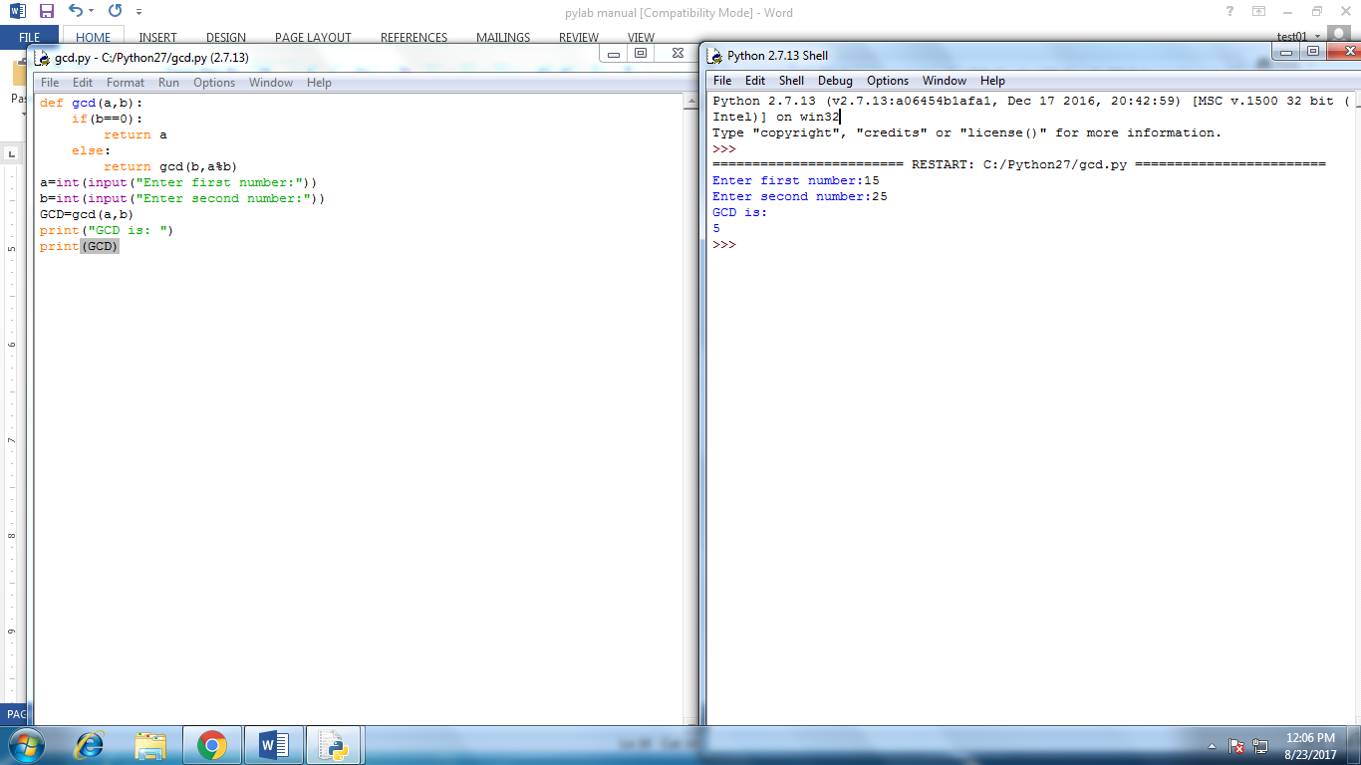

RESULT:

Thus the program to compute GCD of two numbers is executed successfully.

EX.NO:2 FIND THE SQUAREROOT OF A NUMBER (NEWTON’S METHOD)

DATE:

AIM:

To write a python program to find the squareroot of a number using Newton’s method.

ALGORITHM:

Step 1: Enter the number.
Step 2: Enter the number of times the answer to be estimated
Step 3: Calculate square root of num,Sqrt(num)
Step 4: Display the Computed result
Step 5:Stop

PROGRAM:

n=float(input("what number would you like to square root?"))
x=float(input("estimate your answer"))
final=(0.5*(x+(n/x)))
print(final)
for i in range (0,10):
final=(0.5*(final+(n/final)))
print(str(final))

OUTPUT:

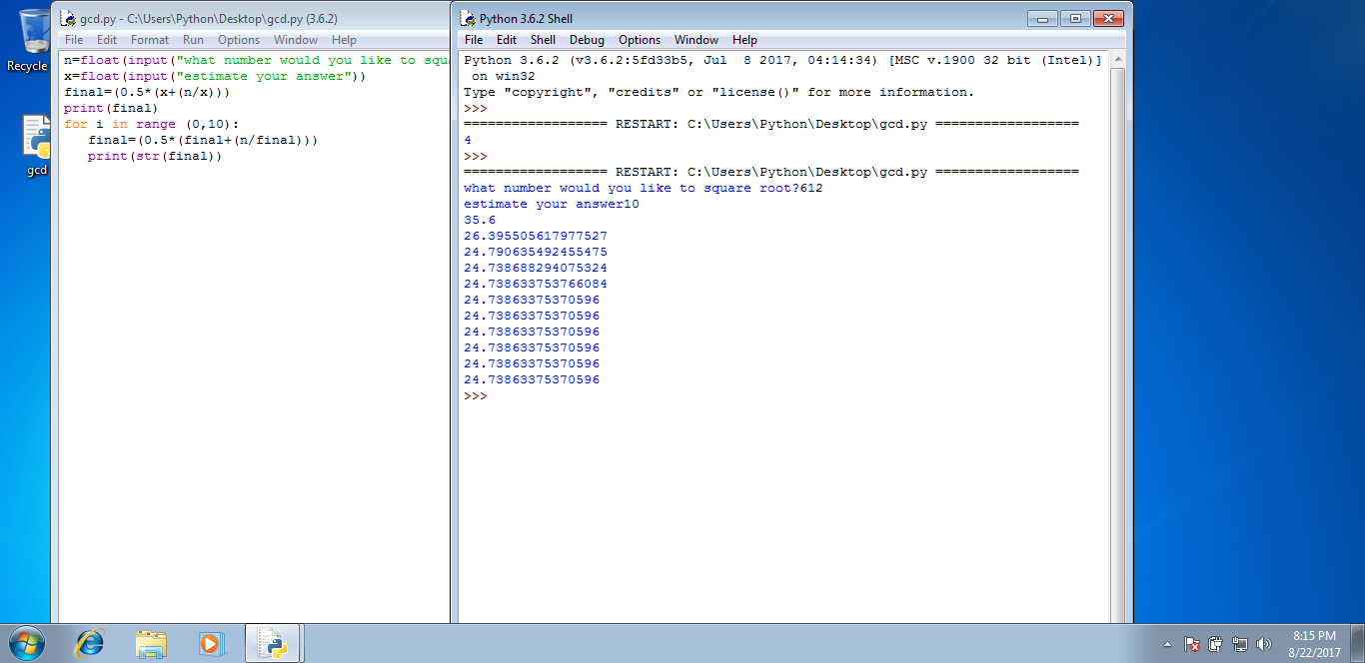

RESULT:

Thus the program to find the square root of a number using Newton’s method is executed successfully.

EX.NO:3 EXPONIENTIATION (POWER OF NUMBER)

DATE:

AIM:

To write a python program to find the power of a number.

ALGORITHM:

Step 1: Enter the base and exponential value.
Step 2. The numbers are passed as arguments to a recursive function to find the power of the number.
Step 3. Calculate n raise to the power of p,POWER(n,p)
Step 4: The final result is printed.

PROGRAM:

n = int(input("Enter a Number : "))
p = int(input("Enter a Number : "))
sum = 1
for i in range(1,p+1):
sum = sum * n;
print sum

OUTPUT:

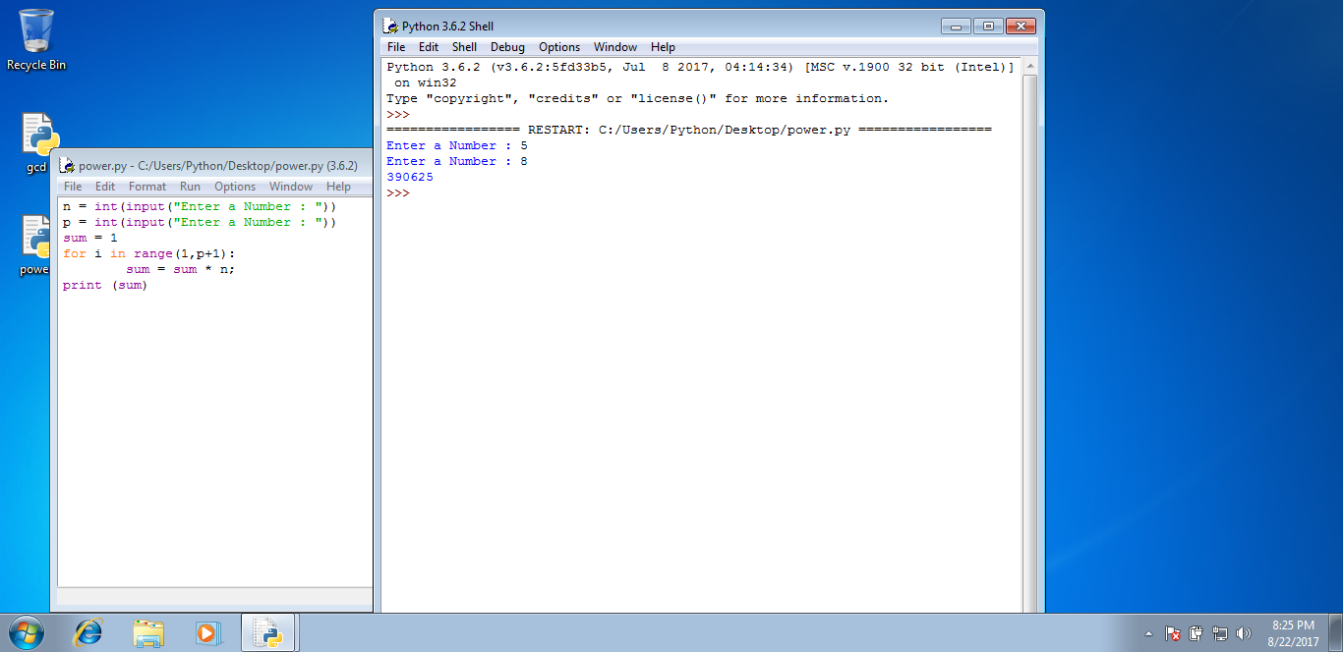

RESULT:

Thus the program to find the power of a number is executed successfully.

EX.NO:4 FIND THE MAXIMUM OF A LIST OF NUMBERS

DATE:

AIM:

To write a python program to find the maximum of a list of numbers.

ALGORITHM:

Step 1:Read input number asking for length of the list using input() or raw_input().
Step 2:Initialise an empty list lst = [].
Step 3:Read each number using a for loop.
Step 4: In the for loop append each number to the list.
Step 5: Now we use predefined function max() to find the largest element in a list.

PROGRAM:
lst = []
num = int(input('How many numbers: '))
for n in range(num):
numbers = int(input('Enter number '))
lst.append(numbers)
print("Maximum element in the list is :", max(lst))

OUTPUT:

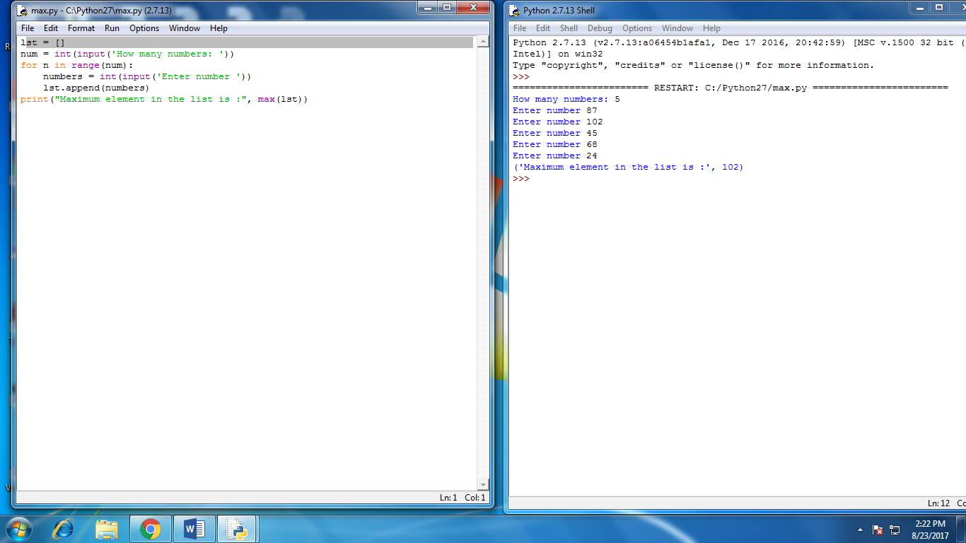

RESULT:

Thus the program to find the maximum of a list of numbers is executed successfully.

EX.NO:5 (A) LINEAR SEARCH AND BINARY SEARCH

DATE:

AIM:

To write a python program for finding the number using Linear Search algorithm.

ALGORITHM:
Step 1:Input the numbers in a List
Step 2:Intialize the target number as key
Step 3:Read each number using a for loop.
Step 4:In the for loop compare the current item to the target item.
Step 5:If the current value matches the target then we declare flag as 1 and print “Key found”.
Step 6:If the current value mismatches the target then set the flag as 0 and print “key not found”.

PROGRAM:

list1 = [1, 2, 3, 4, 5 ];
key = 7
flag = 0
for i in range(len(list1)):
if key == list1[i]:
flag=1
if flag==0:
print("Key not Found")
else:
print("Key Found")

OUTPUT:

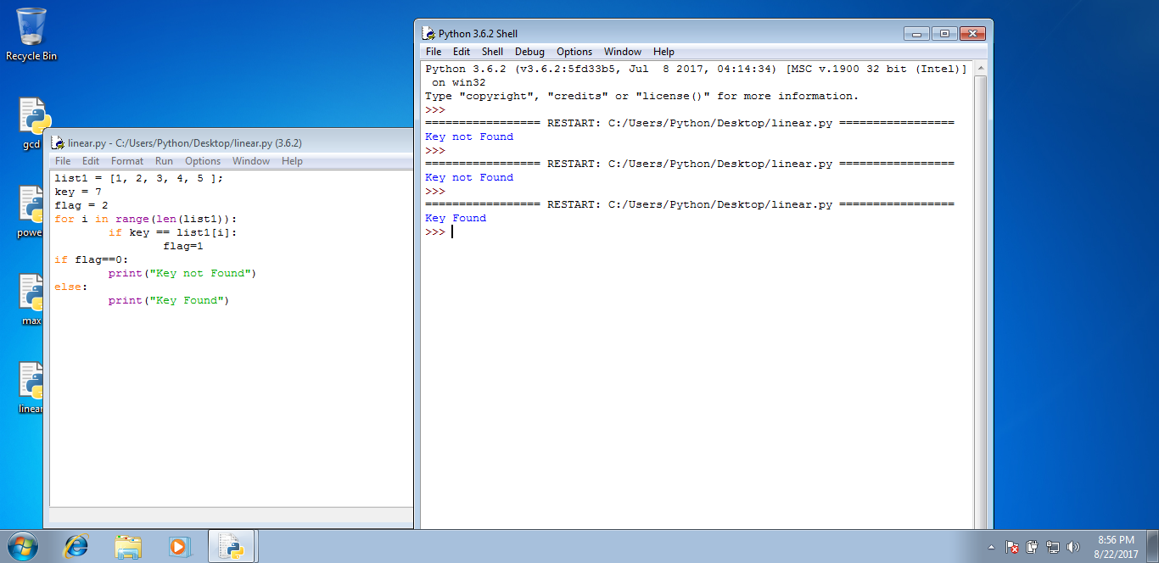

RESULT:

Thus the program to find the number using linear search is executed successfully.

EX.NO: 5(B) BINARY SEARCH

DATE:

AIM:

To write a python program for finding the number using Binary Search algorithm.

ALGORITHM:
Step 1:Input the numbers in a List
Step 2:Intialize the target number as key
Step 3:Read each number using a for loop.
Step 4:In the for loop compare the current item to the target item.
Step 5:If the current value matches the target then we declare flag as 1 and print “Key found”.
Step 6:If the current value mismatches the target then set the flag as 0 and print “key not found”.

PROGRAM:

list1 = [1, 2, 3, 4, 5,6,7,8,9,10 ];
key = 11
flag = 0
low=0
high=len(list1);
if key<=list1[5]:
high=5
else:
low=5

for i in range(low,high):
if key == list1[i]:
flag=1
if flag==0:
print("Key not Found")
else:
print("Key Found")

OUTPUT:

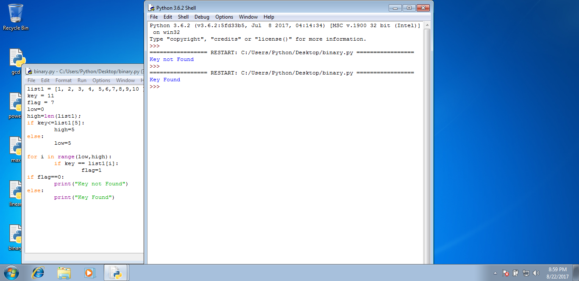

RESULT:

Thus the program to find the number using Binary search is executed successfully.

EX.NO:6 (a) SELECTION SORT
DATE:

AIM:

To write a python program that uses Selection sort technique to sort an array of elements

ALGORITHM:

Step 1: Start
Step 2: Accept array which need to be sorted (num[])
Step 3: Call function i_sort (num)
Step 4: Display the sorted array num[]
Step 5: Stop

PROGRAM:

n=int(input("Enter no of terms : "))
m = 0
list1=[]
print("Enter the numbers\n")
for i in range(n):
list1.append(raw_input())
for i in range(n):
for j in range(i,n):
if(list1[i]>list1[j]):
temp=list1[i]
list1[i]=list1[j]
list1[j]=temp
print("The sorted numbers\n")
for i in range(n):
print list1[i]

OUTPUT:

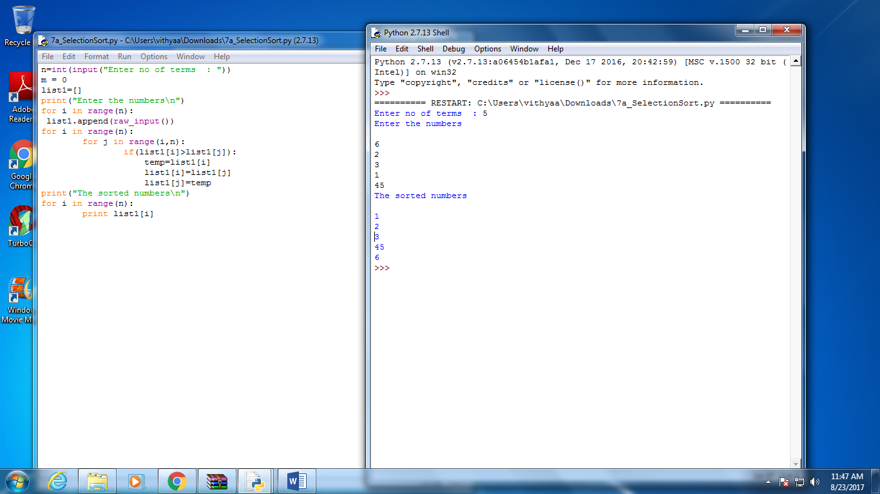

RESULT:

Thus the program using Selection sort to sort an array is executed successfully.

EX.NO:6 (b) INSERTION SORT

DATE:

AIM:

To write a python program that uses insertion sort technique to sort an array of elements

ALGORITHM:

Step 1: Start
Step 2: Accept array which need to be sorted (num[])
Step 3: Call function i_sort (num)
Step 4: Display the sorted array num[]
Step 5: Stop

PROGRAM:

n=int(input("Enter no of terms : "))
m = 0
list1=[]
print("Enter the numbers\n")
for i in range(n):
list1.append(raw_input())

for i in range (1,n):
temp = list1[i]
j = i-1
while ((temp < list1[j]) and (j >= 0)):
list1[j + 1] = list1[j]
j = j - 1
list1[j + 1] = temp;

print("The sorted numbers\n")
for i in range(n):
print list1[i]

OUTPUT:

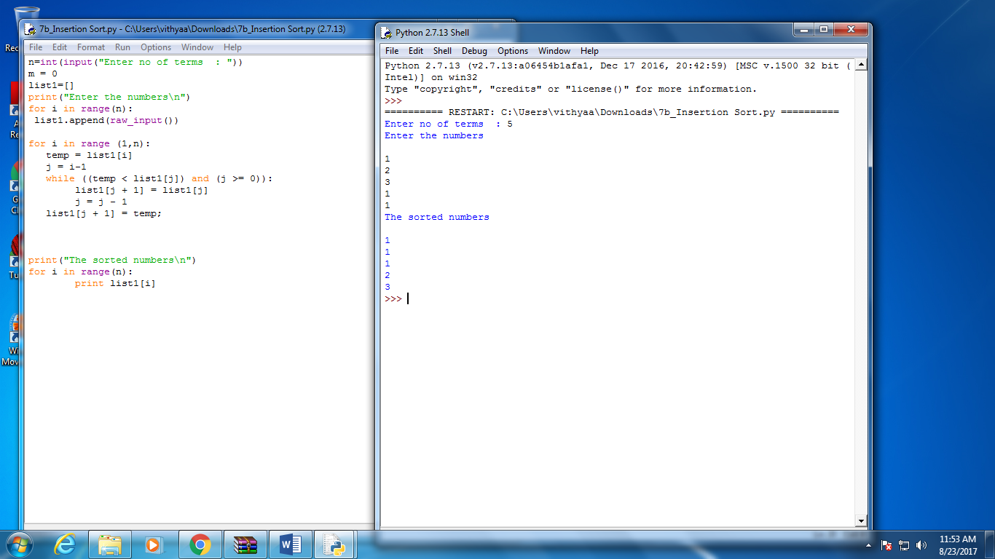

Result:

Thus the program using insertion sort to sort an array is executed successfully.

EX.NO:7 MERGE SORT

DATE:

AIM:

To write a python program that uses merge sort technique to sort an array of elements

ALGORITHM:

Step 1: Start
Step 2: Accept array which need to be sorted (num[])
Step 3: Call function i_sort (num)
Step 4: Display the sorted array num[]
Step 5: Stop

PROGRAM:

def merge(arr, l, m, r):
n1 = m - l + 1
n2 = r- m

# create temp arrays
L = [0] * (n1)
R = [0] * (n2)

# Copy data to temp arrays L[] and R[]
for i in range(0 , n1):
L[i] = arr[l + i]

for j in range(0 , n2):
R[j] = arr[m + 1 + j]

# Merge the temp arrays back into arr[l..r]
i = 0 # Initial index of first subarray
j = 0 # Initial index of second subarray
k = l # Initial index of merged subarray

while i < n1 and j < n2 :
if L[i] <= R[j]:
arr[k] = L[i]
i += 1
else:
arr[k] = R[j]
j += 1
k += 1

# Copy the remaining elements of L[], if there
# are any
while i < n1:
arr[k] = L[i]
i += 1
k += 1

# Copy the remaining elements of R[], if there
# are any
while j < n2:
arr[k] = R[j]
j += 1
k += 1

# l is for left index and r is right index of the
# sub-array of arr to be sorted
def mergeSort(arr,l,r):
if l < r:

# Same as (l+r)/2, but avoids overflow for
# large l and h
m = (l+(r-1))/2

# Sort first and second halves
mergeSort(arr, l, m)
mergeSort(arr, m+1, r)
merge(arr, l, m, r)

# Driver code to test above

n=int(input("Enter the size of an array : "))
list1=[]
print("Enter the numbers\n")
for i in range(n):
list1.append(raw_input())

print ("Given array is")
for i in range(n):
print (list1[i])

mergeSort(list1,0,n-1)
print ("\n\nSorted array is")
for i in range(n):
print (list1[i])

OUTPUT:

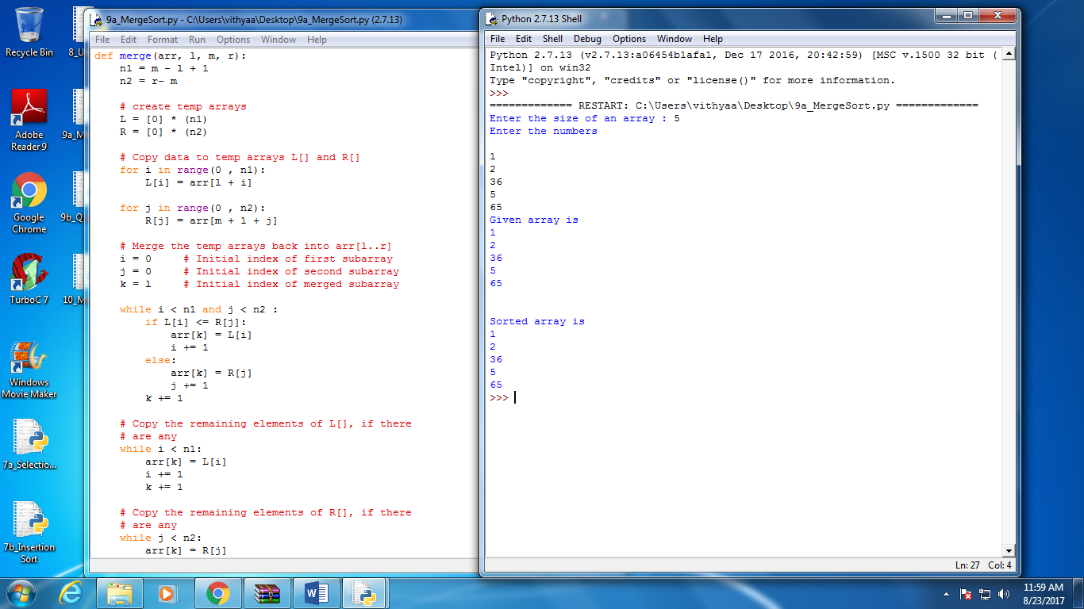

Result:

Thus the program using Merge sort to sort an array is executed successfully

EX.NO:8 FIRST N PRIME NUMBERS

DATE:

AIM:

To write a python program to find out n number of prime numbers.

ALGORITHM:

Step 1: Start
Step 2: Define the function primes(n)
Step 3: Declare a list for prime number
Step 4: For Loop Iterates from 1 upto n+1
Step 5: Number is prime ,add it to list
Step 6: Repeat the step 3&4
Step 7: stop

PROGRAM:

def primes(n):
out=list()
for num in range(1,n+1):
prime=true
for i in range(2,num):
if (num%i==0):
prime=false
if prime:
out.append(num)
return out
n=int(input("enter a number"))
print primes(n)

OUTPUT:

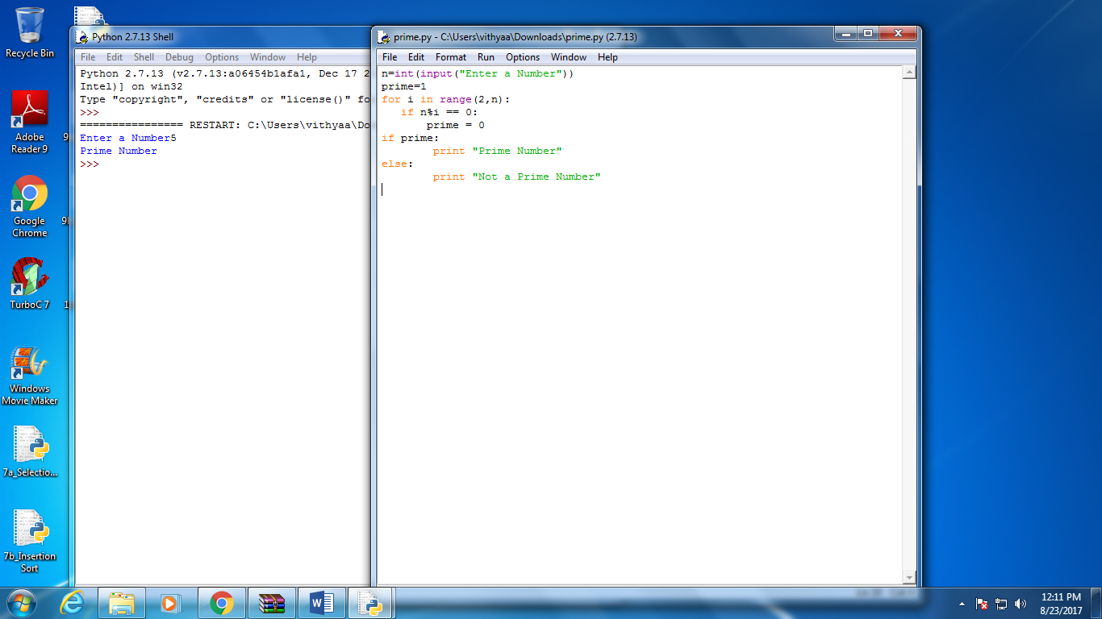

RESULT:

Thus the program to find first n number of prime is executed successfully

EX.NO:9 MATRIX MULTIPLICATION

DATE:

Aim:

To Perform Matrix Multiplication in Python Programming

Algorithm:

Step 1: Start
Step 2: Read matrix A and B
Step 3: To multiply two matrices sufficient and necessary condition is “number of columns in A = number of rows in B”
Step 4: Loop for each row in matrix A
Step 5: Loop for each columns in B and initialize output matrix C to 0. This loop will run for each rows of A
Step 6: Multiply A[i,k] to B[k,j] and add this value to C[i,j]
Step 7: Print matrix C
Step 8: Stop

Program:

X = [[1,1,1], [1,1,1], [1,1,1]]

Y = [[1,1,1,1], [1,1,1,1], [1,1,1,1]]

result = [[0,0,0,0],[0,0,0,0], [0,0,0,0]]

# result is 3x4 result = [[0,0,0,0],[0,0,0,0], [0,0,0,0]]

# iterate through rows of X

for i in range(len(X)):

# iterate through columns of Y

for j in range(len(Y[0])):

# iterate through rows of Y

for k in range(len(Y)):

result[i][j] += X[i][k] * Y[k][j]

for r in result:

print(r)

Output:

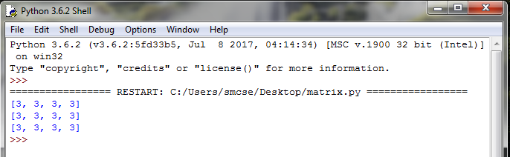

Result:

Thus the program to perform matrix multiplication was executed and the output was verified.

Ex No: 10 COMMAND LINE ARGUMENTS (word count)

Date:

Aim:

To write a program to pass command line arguments (word count).

Algorithm:

Step 1: Start

Step 2: Add arguments to find the words and lines.

Step 3: Add file name as argument

Step 4: Parse the arguments to get the values

Step 5: Format and print the words and lines

Step 6: Stop

Program:

#!/usr/bin/python import sys, getopt def main(argv):
inputfile = ''
outputfile = '' try:
opts, args = getopt.getopt(argv,"hi:o:",["ifile=","ofile="])
except getopt.GetoptError:
print 'test.py -i <inputfile> -o <outputfile>' sys.exit(2)
for opt, arg in opts:
if opt == '-h':
print 'test.py -i <inputfile> -o <outputfile>' sys.exit()
elif opt in ("-i", "--ifile"):
inputfile = arg
elif opt in ("-o", "--ofile"):
outputfile = arg
print 'Input file is "', inputfile print 'Output file is "', outputfile

if name == " main ":
main(sys.argv[1:])

Output:

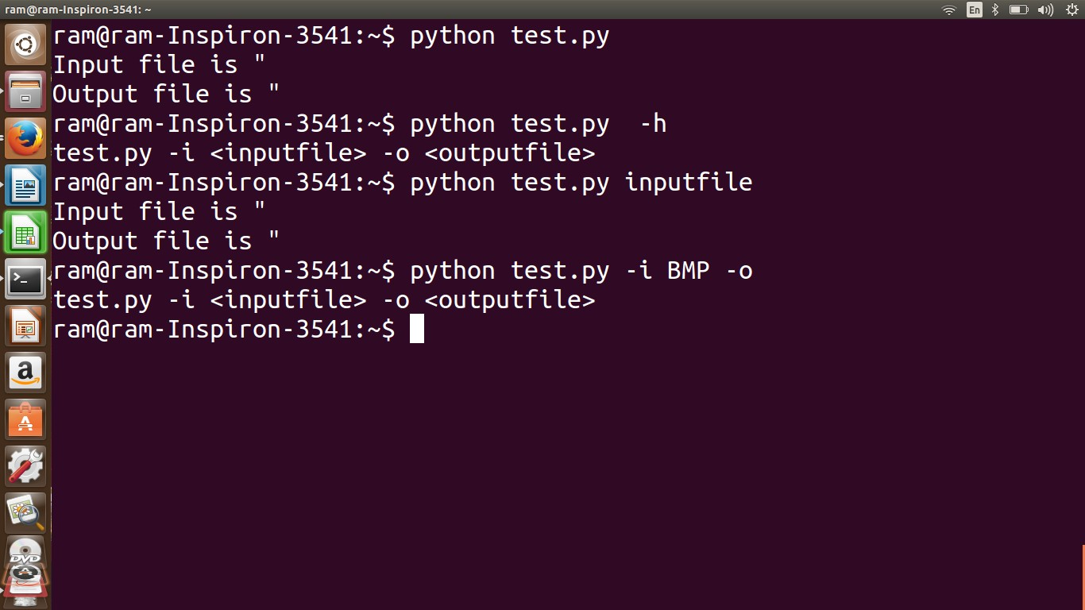

Result:

Thus the program to perform command line arguments (word count) is executed and the output is verified.

Ex No: 11 FREQUENT WORDS IN A TEXT READ FROM A FILE

Date :

Aim:

To write a program to count the occurrences of words in a text read from a file.

Algorithm:

Step 1: Start

Step 2: Read a file name

Step 3: Open the file

Step 4: Read each line from the file to count the lowers and words.

Step 5: Read each line from the file to replace the punctuations

Step 6: Split each line in to words and count them

Step 7: Print the words and counts

Step 8: Stop

Program:

import re
import string
frequency = {}
document_text = open('test.txt', 'r')
text_string = document_text.read().lower()
match_pattern = re.findall(r'\b[a-z]{3,15}\b', text_string)

for word in match_pattern:
count = frequency.get(word,0)
frequency[word] = count + 1

frequency_list = frequency.keys()

for words in frequency_list:
print words, frequency[words]

OUTPUT:

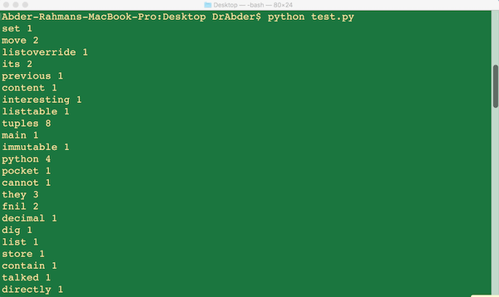

Result:

Thus the program to display the frequency of words in a text from a file is executed and the output is verified.

Ex No: 12 ELLIPTICAL ORBITS IN PYGAME

Date:

Aim:

To Simulate Elliptical orbits is Python using Vpython(Visual Python)

Program:

from visual import *
from visual.graph import *
scene = display(width = 600, height = 600, center = (0,5,0)) Sun = sphere(pos = (0,0,0), radius = 100, color = color.orange)
earth = sphere(pos=(-200,0,0), radius=10, material=materials.earth, makae_trail
= true)
earthv = vector(0,0,6)
gd = gdisplay(x =800,y=0,width =600, height=600,foreground = color.black, background = color.white, xmax = 3000, xmin = 0, ymax =500, ymin =0)
f1 = gcurve(color = color.red)
t = 0

for i in range(1000):
rate(100)
earth.pos = earth.pos + earthv
dist = (earth.x**2 + earth.y**2 + earth.z**2)**0.5 radialVector = (earth.pos - Sun.pos) /dist
Fgrav = -10000*radialVector/dist**2 earthv = earthv + Fgrav
earth.pos += earthv f1.plot(pos = (t,mag(earthv))) t += 1
if dist <- Sun.radius: break

OUTPUT:

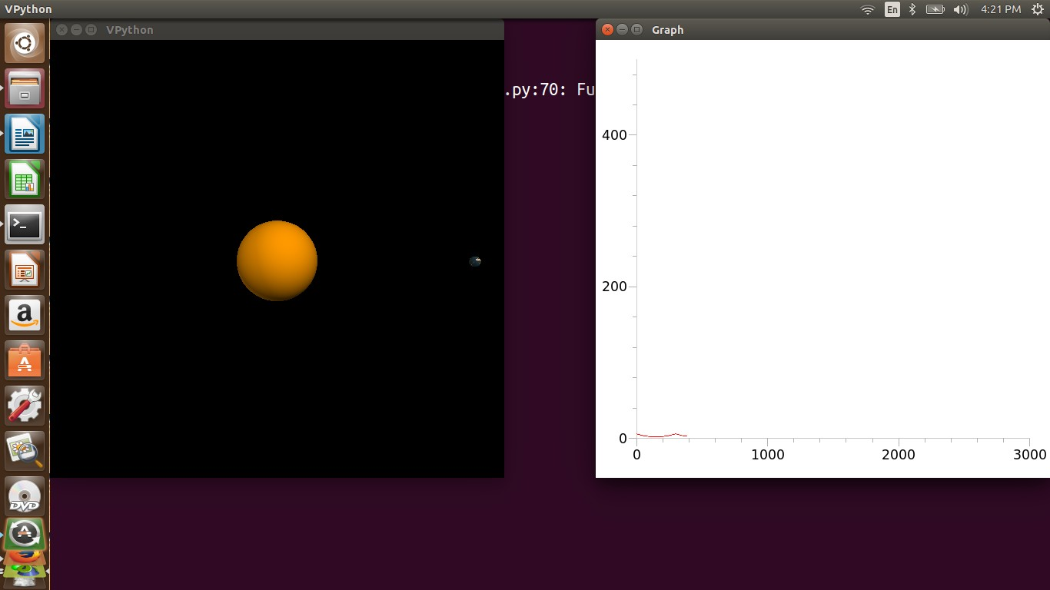

Result:

Thus the program to simulate elliptical orbits in Pygame was executed and the output was verified.

Ex No: 13 SIMULATION OF BOUNCING BALL

Date:

Aim:

To Simulate Bouncing balls in python using Vpython

Program:

from visual import *

floor = box (pos=(0,0,0), length=4, height=0.5, width=4, color=color.blue)
ball = sphere (pos=(0,4,0), radius=1, color=color.red)
ball.velocity = vector(0,-1,0)
dt = 0.01

while 1:
rate (100)
ball.pos = ball.pos + ball.velocity*dt if ball.y < ball.radius:
ball.velocity.y = abs(ball.velocity.y)
else:
ball.velocity.y = ball.velocity.y - 9.8*dt

OUTPUT:

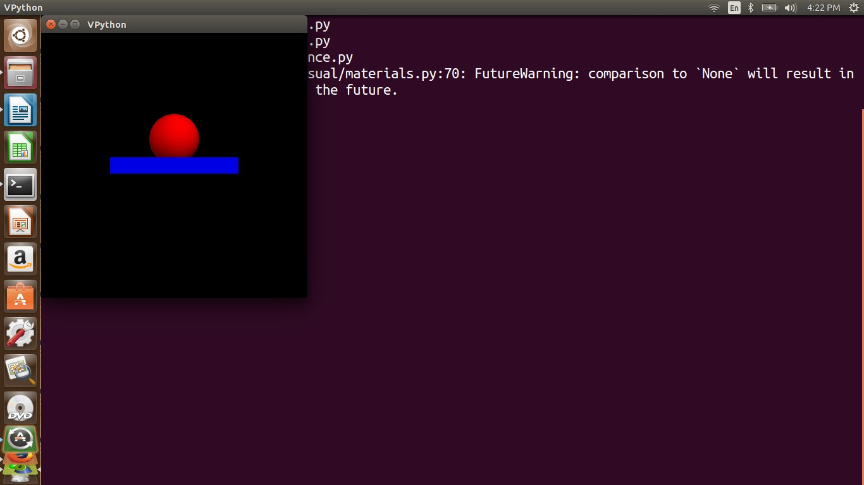

Result:

Thus the program to simulate bouncing ball in Pygame was executed and the output was verified.

