# 1010 ORDER

**MODULE: MM**

**PROCESS: Sales Reversal Order**

**OWNED BY: R. Arun Prasath DATE: 10.07.2024.**

**DOCUMENT: Creation of Sale Reversal Order**

|  |  |  |
| --- | --- | --- |
| **S.no** | **Key Codes** | **Description** |
| 1. | VA01(T-Code) | Create Sales Document |
| 2. | ZRTN | More than 20 days Sale order type |
| 3. | ZBND | Sale order type for only invoiced Stock |
|  |  |  |
|  |  |  |
|  |  |  |
|  |  |  |
|  |  |  |
|  |  |  |
|  |  |  |
|  |  |  |
|  |  |  |
|  |  |  |
|  |  |  |
|  |  |  |
|  |  |  |

1. VA01(T-Code) is used to open sale order and ZRTN sale order type.

Fill the Document and give order reason to complete the return.

2. ZRETAPP(T-Code) for business return order approval.

3. VL01N(T-Code) is used for outbound delivery and Post Goods Receipt.

4. check in VA03(T-Code) and Document Display flow.

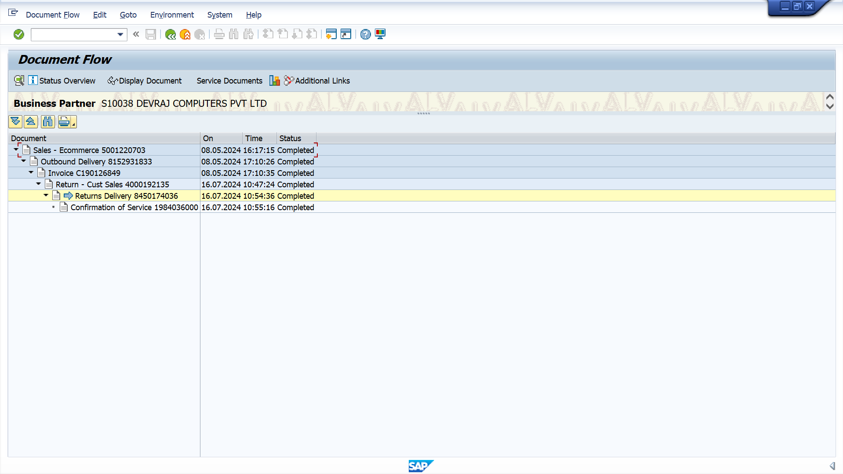

5. VA01(T-Code) and ZBND return order type

6. ZRETAPP for business team approval for return order type

7. VL01(T-code) creates outbound delivery and done Post Goods Receipt.

8. VA03(T-Code) is used to display Document flow Return order.

