**PSG COLLEGE OF TECHNOLOGY, COIMBATORE – 641 004**

**DEPARTMENT OF APPLIED MATHEMATICS AND COMPUTATIONAL SCIENCES**

**I M.Sc (SS/TCS) - C Programming Lab – Work Sheet 3**

**Control Structure:**

1. Write a program which reports how many days are in a month.

**Sample Input :** 3 as input (standing for March)

**Sample Output :** message saying there are 31 days in March

2. The *wind chill index* (WCI) is calculated from the wind speed v in miles per hour and the temperature t in Fahrenheit. Three formulas are used, depending on the wind speed:

if (0 <= v <= 4) then WCI = t

if (v >=45) then WCI = 1.6t - 55

otherwise, WCI = 91.4 + (91.4 - t)(0.0203v - 0.304(v)1/2 - 0.474).

Write a program that can calculate the wind chill index.

3. Write a program that asks the user to enter an integer and determines whether it is divisible by 5 and 6, whether it is divisible by 5 or 6, and whether it is divisible by 5 or 6 but not both.

For example, if your input is 10, the output should be:

Is 10 divisible by 5 and 6? false

Is 10 divisible by 5 or 6? true

Is 10 divisible by 5 or 6, but not both? True

4. Caféday wants you to write a program to take orders from the Internet. Your program asks for the item, its price, and if overnight shipping is wanted. Regular shipping for items under $10 is $2.00; for items $10 or more shipping is $3.00. For overnight delivery add $5.00.  For example, the output might be:

  Enter the item: Tuna Salad

Enter the price: 450

Overnight delivery (0==no, 1==yes):

1

**Invoice:**

Tuna Salad   4.50

shipping     7.00

total        11.50

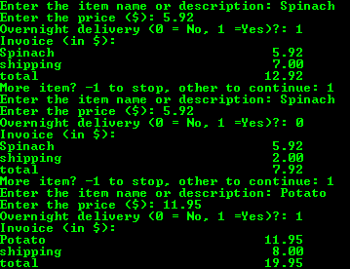

5. Write a program that reads an integer between 0 – 999 and adds all the digits in the integer. For example, if an integer is 932, the sum of all its digit is 14. Hint: Use the % operator to extract digits and use the / operator to remove the extracted digit. For instance, 932 % 10 = 2 and 932 / 10  = 93.

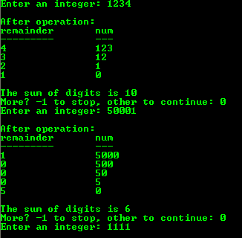

6. Write a program that asks the user to input an integer and then outputs the individual digits of the number.

**Answer:** Using the division (/) and modulus (%).

Sample Output:



7. Write a program that converts numbers to words. For example, 895 results in "eight nine five."

The number 85 is pronounced "eighty-five," not "eight five." Modify the previous program to handle the numbers through 100 so that all numbers come out as we really say them. For example, 13 would be "thirteen" and 100 would be "one hundred."

8. Write a program that can read n integers from the user and then determines the smallest value among the all integers.

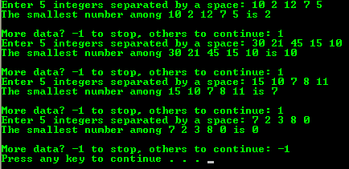

9. Write a complete working program that will ask for a person’s name and his/her game score. Then it will ask for a second person’s name and score. The program will print the winner’s name and also print by how many points that person won.

10. Write a program to read a list of integers as input from the user until you enter any negative value. Enter a sample input: 16, 22, 13, 19, 11, -1. Your task is to determine the smallest number entered except last negative value.

Sample Output:

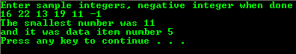

Modify the code to use the sample input: 16, 22, 13, 19, 11 and -1 to determine the smallest and the largest numbers entered.

Sample Output:

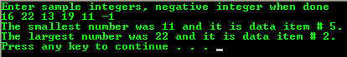

11. Men and women are running races. We need to know what was the lowest men’s score and the highest women’s score. Data are given so that men’s scores alternate with those of women: first men’s, then women’s. The program stops when a time of zero is read for a man’s score. A sample input and output are given below.

**-----------------Output----------------**

7.80

5.70

5.80

8.95

0.0

Lowest men’s : 5.80

Highest women’s : 8.95

12. Write a program that will read a amount to deposited or withdrawn to/from the bank account as float value and a character value for indicating deposit or withdraw. The character could be d for deposit or w for withdrawal. Starting with a balance of zero, add the deposits and subtract the withdrawals until the balance becomes negative. Then print by how much the balance went negative. The sample input and output are given below.

  -----------------Output---------------

XYZ Bank of India

***** ****** ** ******

Amount Transaction Type

100.0    d

20.0     d

60.0     w

200.0    w

Sorry your account is in lesser the minimum balance.

Your Current balance amount is Rs. -140.00.

13. Write a program that reads in three integers, a, b, and c, representing

The lengths of the sides of a triangle and say whether the resulting triangle is isosceles or equilateral or neither. An isosceles triangle is a triangle with (at least) two equal sides. An equilateral triangle is a triangle with three equal sides.

Test your program with the following values of a, b and c. (Using Iteration to take any number of inputs)

Input 1: 3, 4, 5 Output: Given Triangle is not an isosceles or an equilateral

Input 2: 5, 5, 2 Output: Given Triangle is an isosceles

Input 3: 10, 6, 6 Output: Given Triangle is an isosceles

Input 4: 7, 7, 7 Output: Given Triangle is an equilateral

14. **Reverse an integer :**

Problem statement: Given an integer n such as 1367. Write a (C) program that computes the inverse inv of this integer as 7631 and also the double of the inverse 15262. Also, when the input changes to a different number like 2467, it should compute the inverse 7642 and twice that as 15284; and when the input changes to 5 digits number 12345, it computes 54321 and 108642.

15. Write a C++ program which gets a three digit number as input and checks whether the middle digit is numerically equal to the sum of the other two digits.

16. Write a program that prints the insurance fee to be paid for a pet according to the following rules:

* A dog that has been neutered costs Rs 350
* A dog that has not been neutered costs Rs 280
* A cat that has been neutered costs Rs 240
* A cat that has not been neutered costs Rs 260
* A bird or reptile costs nothing
* Any other animal generates an error message

The program should prompt the user for appropriate information using a code to determine the kind of animal(i.e D or d represents a Dog, C or c represents a cat, B or b represents a bird, R or r represents a reptile, and anything else represents some other kind of animal). After printing the insurance fee, the program should ask the user if he/she wants to insure another animal.