AI-Based Emergency Medical Drone System
Project Report

Abstract
This project proposes an autonomous emergency medical drone that carries a first-aid kit to an accident location before the ambulance arrives. A Pixhawk flight controller performs autonomous flight, while a Raspberry Pi handles AI processing, live video streaming, voice communication, and medical guidance.

Objectives
- Reduce emergency response time.
- Deliver first-aid supplies quickly.
- Enable live doctor-patient communication.
- Provide GPS-based autonomous navigation.

System Overview
The emergency control center receives an accident alert and GPS coordinates. The drone launches automatically, flies to the destination using Pixhawk autopilot, streams live video through the Raspberry Pi, and delivers the medical kit.

Hardware Components
• Pixhawk Flight Controller
• Raspberry Pi 5
• GPS + Compass
• Telemetry Radio
• Raspberry Pi Camera
• BLDC Motors (4)
• ESCs (4)
• Li-Po Battery
• Power Distribution Board
• Servo Motor
• Speaker
• Microphone
• LCD Display (Optional)
• Medical Kit

Software
Mission Planner, Raspberry Pi OS, Python, OpenCV, MAVLink/MAVSDK, DroneKit or MAVSDK-Python, Arduino IDE (if required).

Working Principle
1. Accident detected.
2. GPS location sent to control center.
3. Drone receives mission.
4. Pixhawk navigates autonomously.
5. Raspberry Pi streams live video and audio.
6. Doctor provides first-aid instructions.
7. Medical kit is delivered.
8. Ambulance reaches the scene.

Advantages
Fast response, autonomous navigation, reduced mortality risk, remote medical assistance, scalable for disaster relief.

Applications
Road accidents, rural healthcare, disaster management, military rescue, flood and earthquake response.

Future Scope
AI victim detection, thermal camera, 5G communication, automated AED delivery, swarm drone coordination.

Conclusion
The proposed system combines autonomous flight and AI-assisted communication to improve emergency medical response by delivering life-saving equipment before an ambulance arrives.

System Block Diagram
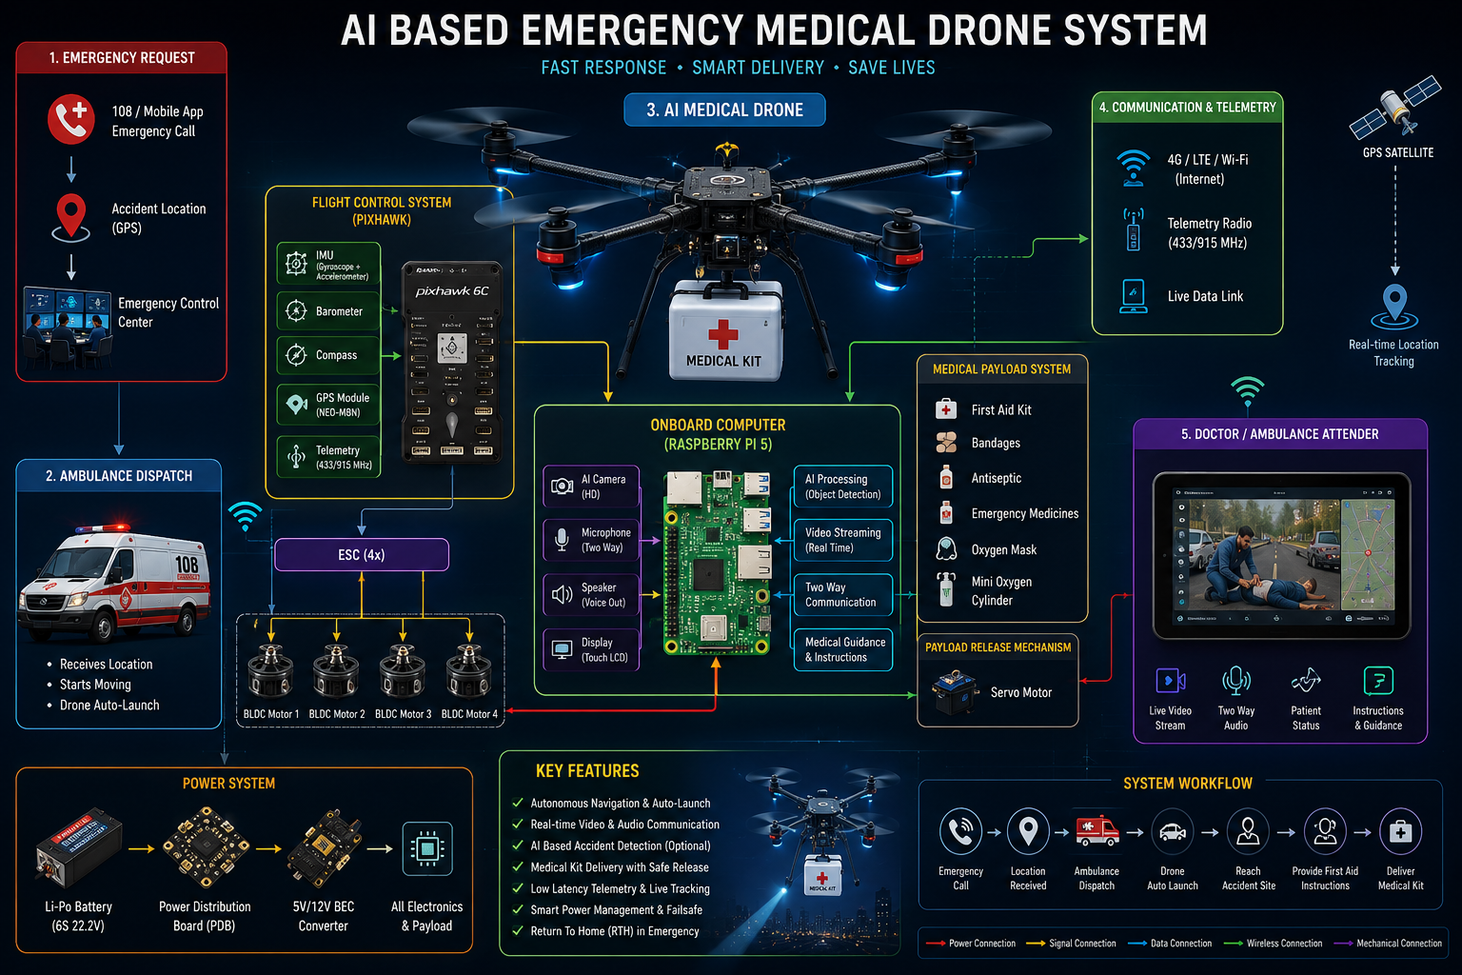
Figure: Proposed AI-Based Emergency Medical Drone System Architecture.

