SMART SOLAR POWERED AGRICULTURAL WORKER SAFETY MONITORING SYSTEM USING ESP32 AND IoT
Project Report
Department of Electronics and Communication Engineering

Abstract
This project develops a smart solar powered agricultural worker safety monitoring system using ESP32. The system ensures worker safety by detecting mask usage, monitoring hazardous gas concentration using an MQ135 sensor, measuring battery and solar voltage, controlling a sprayer motor through a relay, and displaying live information on a local web dashboard. When hazardous gas exceeds the threshold, the motor stops automatically and a buzzer alert is activated.

Objectives
• Protect agricultural workers during spraying.
• Allow motor operation only when a mask is detected.
• Monitor hazardous gas levels.
• Automatically stop the motor during unsafe conditions.
• Display battery voltage, battery percentage, solar voltage, runtime and alerts on a local dashboard.

Hardware Components
ESP32 Development Board
MQ135 Gas Sensor
IR Proximity Sensor
Relay Module
2N2222 Transistor
Buzzer
Battery Voltage Sensor
Solar Voltage Sensor
Solar Panel
Rechargeable Battery
Buck Converter
Sprayer Mixer Motor

Software Used
Arduino IDE
Embedded C/C++
HTML
CSS
JavaScript
WebSocket
Google Chrome

Working Principle
Solar energy charges the battery through a charging circuit. The ESP32 continuously monitors the IR proximity sensor for mask detection and the MQ135 gas sensor for hazardous gas. If the mask is worn and gas is within the safe limit, the relay switches ON the sprayer motor. If the gas level exceeds the threshold, the ESP32 turns OFF the relay, activates the buzzer, and updates the web dashboard with an emergency alert. Battery voltage, battery percentage, solar voltage and runtime are displayed in real time.

Block Diagram
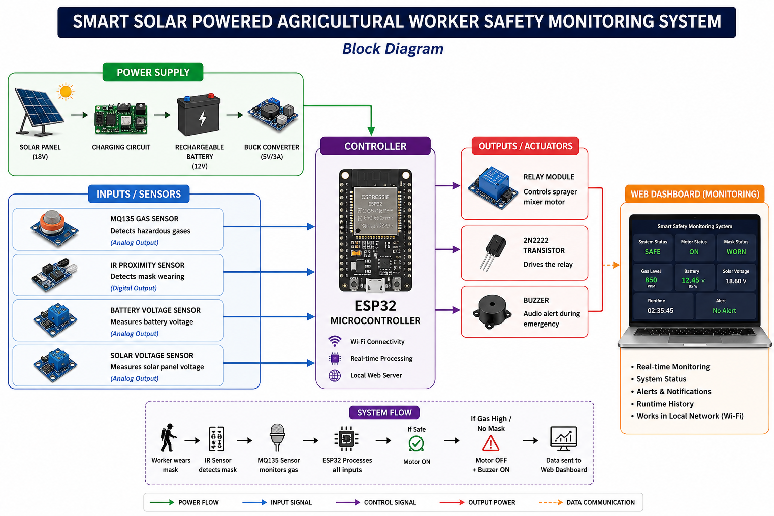
Figure 1: Smart Solar Powered Agricultural Worker Safety Monitoring System Block Diagram

Advantages
• Solar powered
• Low cost
• Renewable energy
• Automatic safety shutdown
• Real-time local monitoring
• User-friendly dashboard

Applications
Agriculture, pesticide spraying, greenhouse monitoring, worker safety systems, smart farming.

Future Scope
Cloud monitoring, mobile app, GPS tracking, AI-based PPE detection, GSM alerts, data logging.

Conclusion
The proposed system improves agricultural worker safety by combining renewable energy, embedded systems, and IoT technologies. It provides reliable real-time monitoring and automatic protection during hazardous conditions.

