Smart Emergency Vehicle Alert System Using ESP32

Abstract
The Smart Emergency Vehicle Alert System is designed to detect ambulance, police, and fire engine sirens using two MAX9814 microphone modules connected to an ESP32. The controller compares the sound received by the left and right microphones to identify the direction of the approaching emergency vehicle. The system displays the direction on an OLED display and uses LED indicators to alert the driver. This prototype demonstrates a low-cost embedded solution for improving road safety and helping drivers respond quickly to emergency vehicles.

Objectives
- Detect emergency vehicle sirens.
- Determine the direction of the emergency vehicle.
- Display direction on an OLED display.
- Provide visual alerts using LEDs.
- Improve road safety using an embedded system.

Hardware Components
Component | Purpose
ESP32 Development Board | Main controller
MAX9814 Microphone Module (2) | Detect siren sound
0.96-inch OLED Display (I2C) | Display alerts and direction
Red LED | Emergency indicator
Green LED | Normal status indicator
220 Ω Resistors | LED current limiting
Breadboard | Prototype assembly
Jumper Wires | Connections
USB Cable / 5V Supply | Power supply

Software Used
- Arduino IDE
- ESP32 Board Package
- Adafruit SSD1306 Library
- Adafruit GFX Library

Working Principle
Two microphones continuously monitor surrounding sounds. The ESP32 reads both microphone signals and compares their sound levels. When the sound exceeds the preset threshold, the controller recognizes a possible emergency siren. By comparing the left and right microphone values, the ESP32 determines whether the emergency vehicle is approaching from the left, right, or front. The OLED display shows the detected direction while the LEDs indicate system status.

Block Diagram
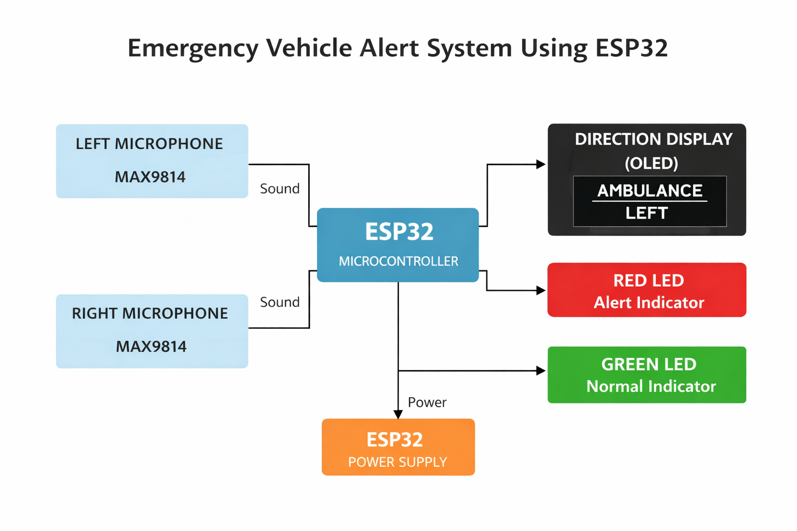

Advantages
- Low-cost prototype
- Simple hardware design
- Real-time siren detection
- Easy to install and maintain
- Improves driver awareness
- Low power consumption

Applications
- Cars and taxis
- Buses
- Public transport
- Smart transportation systems
- Traffic safety research
- Educational embedded projects

Future Scope
- AI/FFT-based siren recognition
- Automatic music volume control
- GPS integration
- Distance estimation
- Vehicle-to-Vehicle (V2V) communication
- Mobile application integration

Conclusion
The Smart Emergency Vehicle Alert System is a simple and effective embedded solution for detecting emergency vehicle sirens and informing drivers about the direction of approaching emergency vehicles. By combining dual microphones, an ESP32, OLED display, and LED indicators, the system enhances road safety and can be expanded into a full automotive assistance system.

