How to detect and remove outliers for a machine learning model – Boston Data Set
https://medium.com/analytics-vidhya/how-to-detect-and-remove-outliers-for-a-machine-learning-model-ebfcc4d3d1f
To access the full code please checkout my git hub repository here.
https://github.com/SharmaNatasha/Machine-Learning-using-Python/blob/master/Simple%20projects/Detecting_Removing_Outliers.ipynb
Read this example:
https://towardsdatascience.com/ways-to-detect-and-remove-the-outliers-404d16608dba

What is an outlier?
An outlier is an observation in a data set that is unusually different from all other observations.
Eg:- age → [21, 20, 45, 60, 35, 150, 77]
In the above example, we have age data, and the outlier over here is 150 because a person having the age of 150 is impossible.
Outliers can either be a mistake or just a variance in the dataset.
Example of with and without outliers:
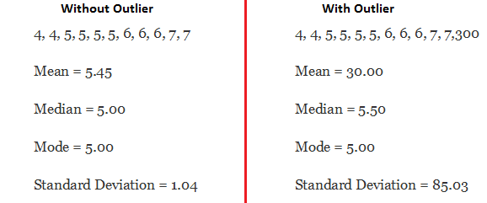

How to detect outliers?
The most common way to identify outliers is the observation that is far from the rest of the observation or far from the mean.
Different ways to find outliers are:
- Box-plot
- Scatterplot
- Z-score
- Interquartile range (IRQ)

Effect of outliers
Data outliers can spoil and mislead the training process resulting in longer training times, less accurate models, and, ultimately, more average results.
The presence of outliers in data can lead to a poor machine learning model with very low performance.

What is the reason for an outlier to exists in a dataset?
An outlier could exist in a dataset due to
- Variability in the data
- An experimental measurement error

What are the types of Outliers?
An outlier can be of two types: Univariate and Multivariate.
Univariate outliers can be found when we look at the distribution of a single variable.
Multi-variate outliers are outliers in an n-dimensional space. In order to find them, you have to look at distributions in multi-dimensions.

Dataset
We will use the Boston house regression dataset from scikit-learn API. It includes 14 columns and 506 rows.
# load dataset
from sklearn.datasets import load_boston# read data
data = datasets.load_boston()# add the load data into a dataframe
df = pd.Dataframe(data.data, columns=data.feature_names)# add target to the dataframe
df['target'] = data.target# check the first five row of the dataset
df.head()

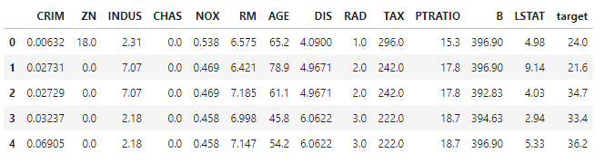

Detect outliers with visualization

Scatter plot
The scatter plot is the collection of points that shows values for two variables. A Scatter plot will show us if a data point lies outside the overall distribution of the dataset.
# plot the scatter plot
sns.scatterplot(df['INDUS'], df['TAX'])
plt.show()

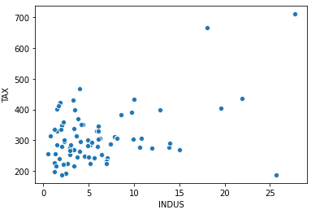
As we can observe in the above plot there are points bottom right and top right which is far from the population data, which are considered to be an outlier.

Box-plot

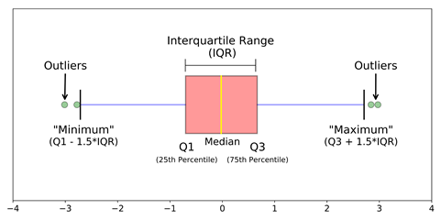
Box plots are a very simple but effective way to visualize outliers. Think about the lower and upper whiskers as the boundaries of the data distribution. Any data points that show below minimum and above the maximum can be considered outliers.
# plot the box plot
sns.boxplot(df['RM'])
plt.show()

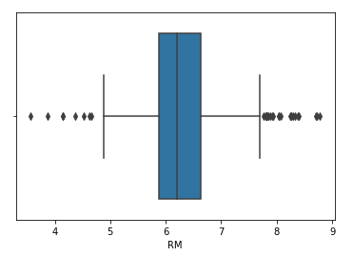

Detect outliers with Statistical method

z-score
Z-score is measured in terms of standard deviations from the mean. If a Z-score is 0, it indicates that the data point’s score is identical to the mean score. A Z-score of 1.0 would indicate a value that is one standard deviation from the mean. Z-scores with a positive value indicating the score is above the mean and a negative score indicating it is below the mean.
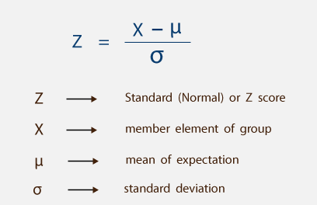

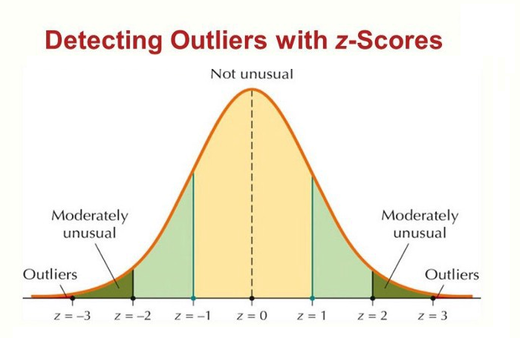
# find z score
from scipy import stat
z = np.abs(stats.zscore(df)
print(z)

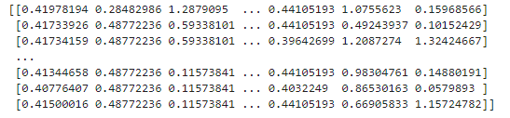
We find the z score for each of the data points in the dataset and if the z score is greater than 3 than we can classify that point as an outlier. Any point outside of 3 standard deviations would be an outlier.
# value greater then 3 is mark as outlier
threshold = 3
print(np.where(z>3))

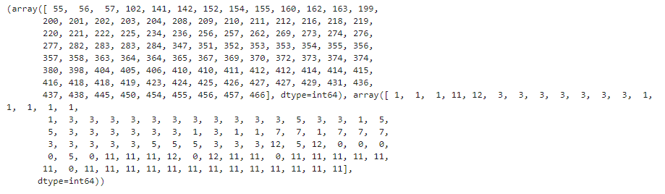
Don’t be confused by the results. The first array contains the list of row numbers and second array respective column numbers, which mean z[55][1] have a Z-score higher than 3.
# z-score higher the 3
print(z[55][1]#output
3.3750
Hence the 55th row contains an outlier.

IQR Score
Interquartile Range (IQR) is used to define the outliers. It is the difference between the third quartile (75%) and the first quartile (25%) (IQR = Q3 -Q1). A value below (Q1 − 1.5x IQR) and higher the (Q3 + 1.5x IQR) is considered to be an outlier.
# find the IQR
q1 = new_df.quantile(.25)
q3 = new_df.quantile(.75)IQR = q3 -q1print(IQR)

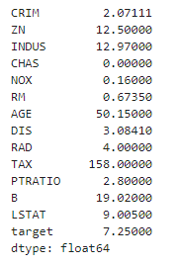
Above is the IQR for each column.
Find the outliers in using IQR value below (Q1 − 1.5x IQR) and higher the (Q3 + 1.5x IQR) is considered to be an outlier.
print(df < (q1 - 1.5 * IQR)) |(df > (q3 + 1.5 * IQR))
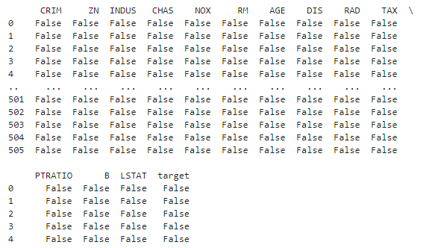
Those data point where we have Flase is considered valid and True is considered as outliers.

How to handle outliers
Outliers can be handled in the following ways:
- Trimming
- Mean/Median or random Imputation

1. Trimming
In this method, we remove the outlier completely. It is one the fast way to handle the outliers but we are losing lot of valuable information.
In this article, we have detected the outlier using the z-score and IQR Score. We can remove all those outliers.

z-score
Continuing the code after we find the outlier using a z-score. We will remove the outlier.
new_df = df[z < 3].any(axis=1)

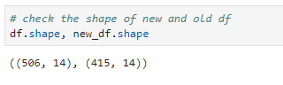
The above code will remove all the z-score values less than 3. After the removal of an outlier, we are left with 415 rows.

IQR-score
new_df_2 = df[~((df < (q1 - 1.5 * IQR)) |(df > (q3 + 1.5 * IQR))).any(axis=1)]

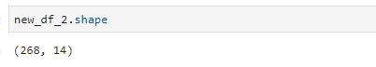
After removing the outlier we are left with 268 rows.

2. Mean / Median / Random Sampling:
If we have reasons to believe that outliers are due to mechanical error or problems during measurement. That means, the outliers nature is similar to missing data, then any method used for missing data imputation the same method we can use to replace outliers. We can use mean/median/random imputation to replace them.

