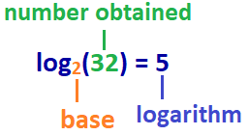
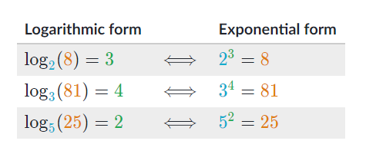
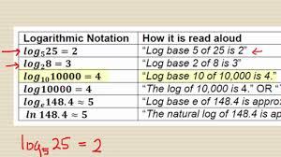

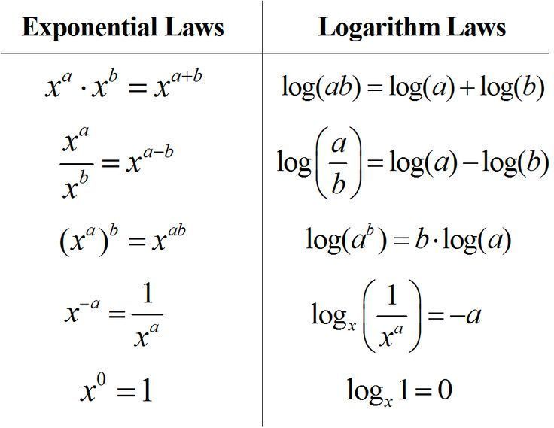

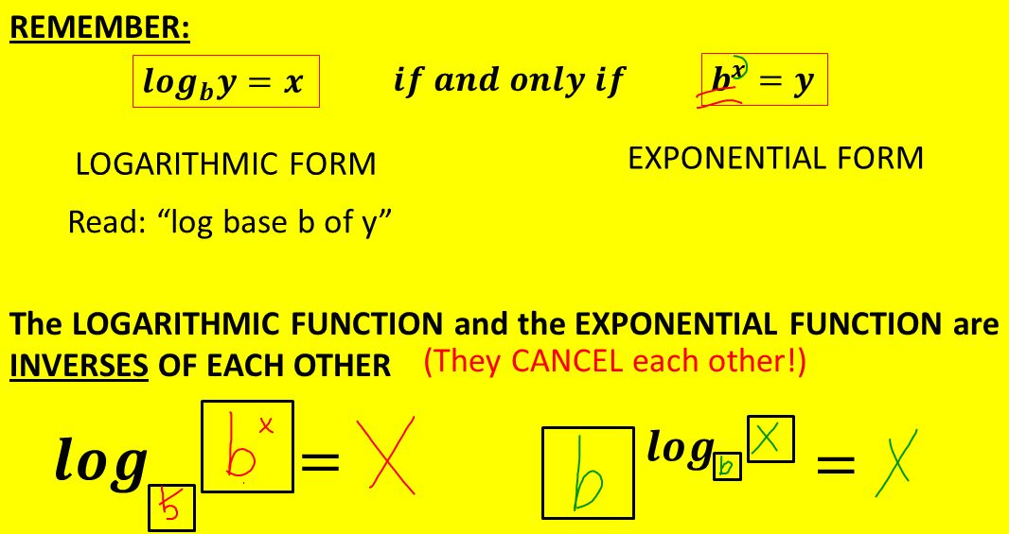

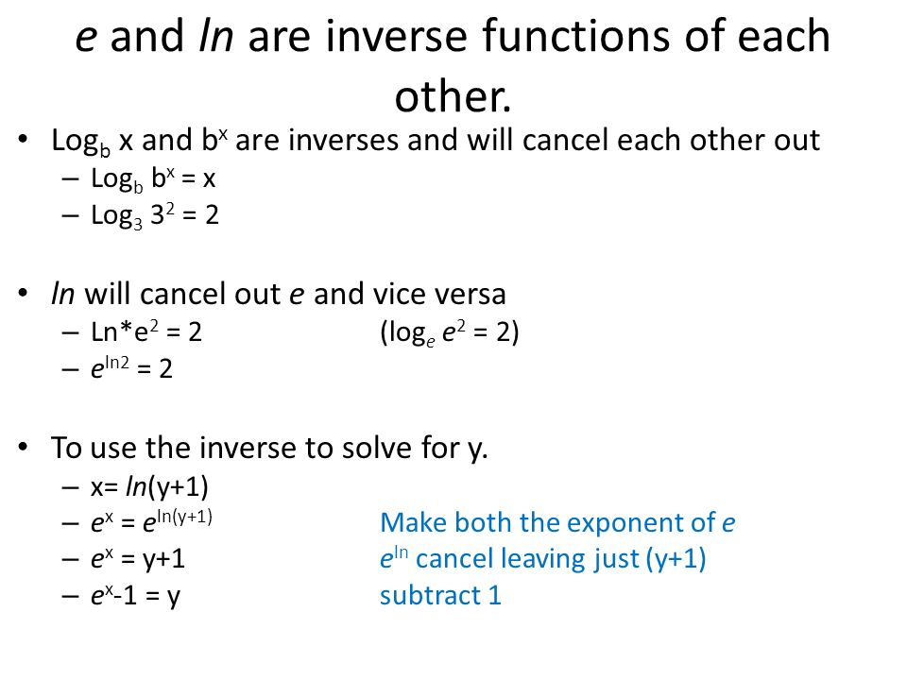

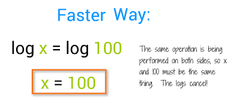

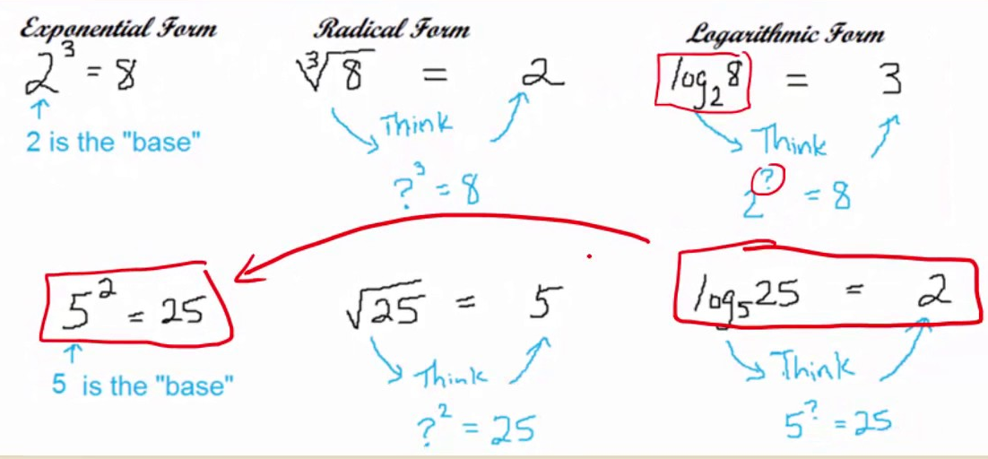

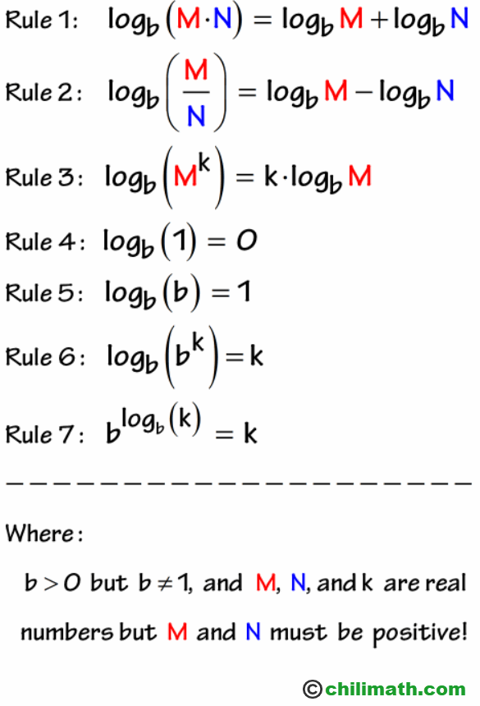

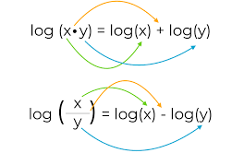

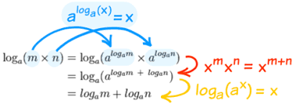

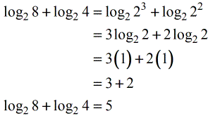

Antilog

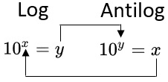

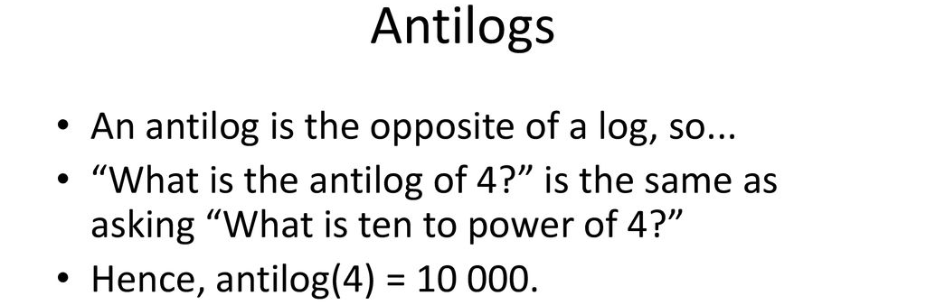

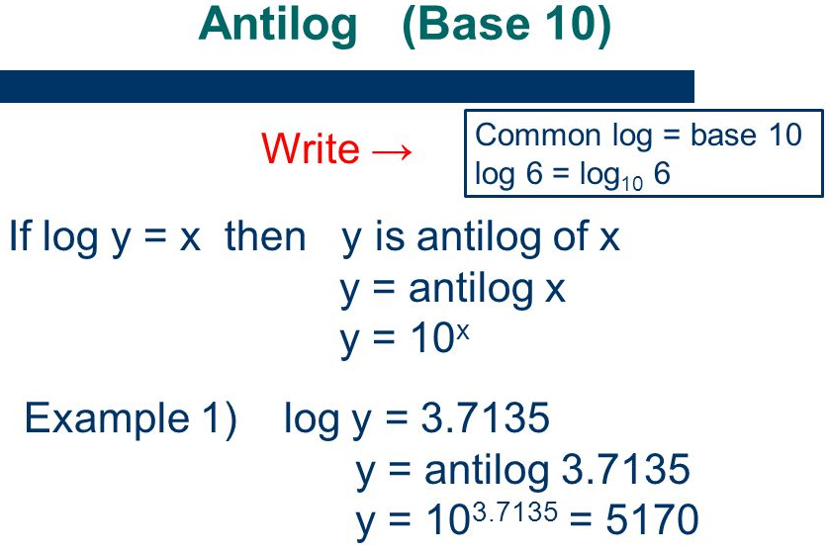

Finding log from the log table:

Quick Instructions: Finding a Logarithm
  - Example: log₁₀(31.62) requires a base-10 table.

1
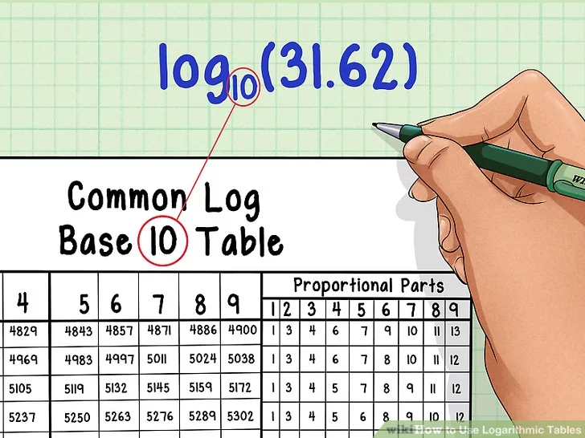

Choose the correct table. To find log_{a}(n), you'll need a log_{a} table. Most log tables are for base-10 logarithms, called "common logs."[2]
  - Example: log₁₀(31.62) requires a base-10 table.

2
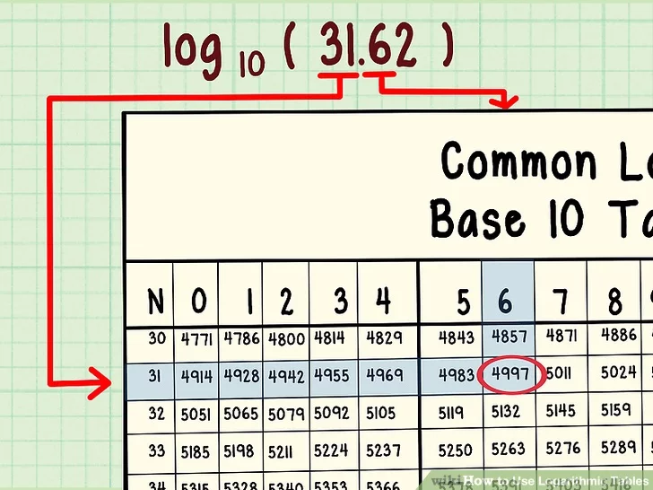
Find the correct cell. Look for the cell value at the following intersections, ignoring all decimal places:[3]
  - Row labeled with first two digits of n
  - Column header with third digit of n
  - Example: log₁₀(31.62) → row 31, column 6 → cell value 0.4997.

3

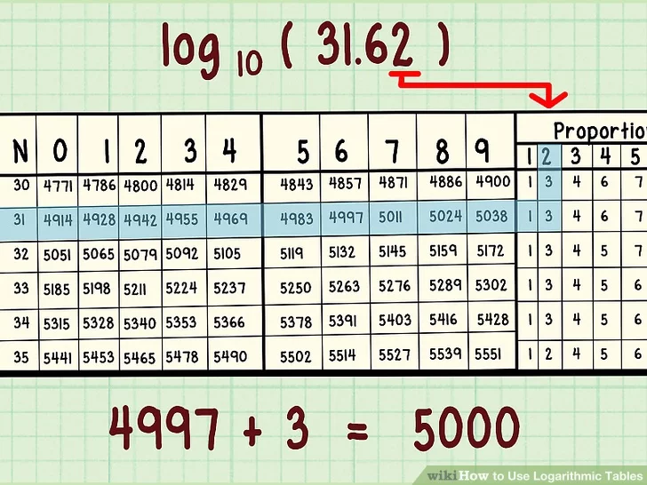
Use smaller chart for precise numbers. Some tables have a smaller set of columns on the right side of the chart. Use these to adjust answer if n has four or more significant digits:
  - Stay in same row
  - Find small column header with fourth digit of n
  - Add this to previous value
  - Example: log₁₀(31.62) → row 31, small column 2 → cell value 2 → 4997 + 2 = 4999.

4

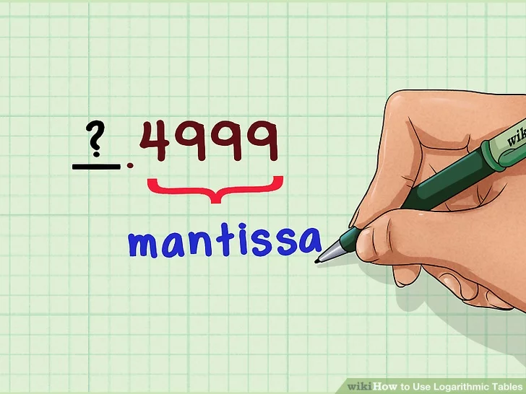
Prefix a decimal point. The log table only tells you the portion of your answer after the decimal point. This is called the "mantissa."[4]
  - Example: Solution so far is ?.4999

5

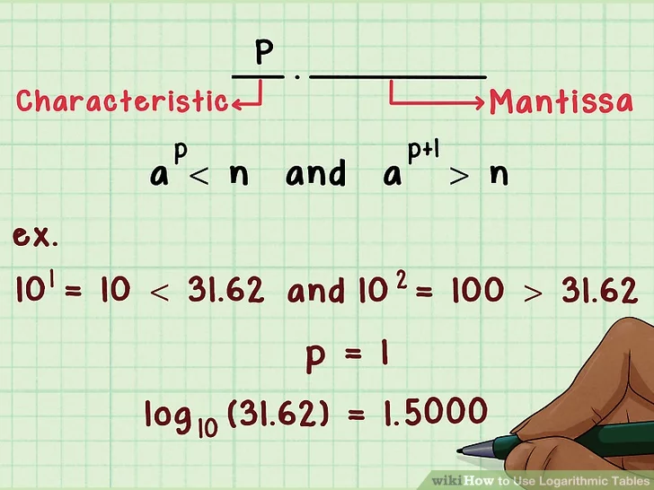
Find the integer portion. Also called the "characteristic". By trial and error, find integer value of p such that and .
  - Example: and . The "characteristic" is 1. The final answer is 1.4999
  - Note how easy this is for base-10 logs. Just count the digits left of the decimal and subtract one.

