Description

Intended User

Features

User Interface Mocks

Screen 1

Screen 2

Key Considerations

How will your app handle data persistence?

Describe any corner cases in the UX.

Describe any libraries you’ll be using and share your reasoning for including them.

Describe how you will implement Google Play Services.

Next Steps: Required Tasks

Task 1: Project Setup

Task 2: Implement library for authentication via phone number

Task 3: Implement UI for Each Activity and Fragment

Task 4: Implement chats

Task 5: Notifications

Task 6: Animations/Transitions

Task 7: Create a widget

**GitHub Username**: arunrajora

Chit-Chat

# Description

Chit-Chat is a chat application which has support for bots. You can chat with any one you like and also chat with chat bots. There is an assistant bot which can assist with tasks while you chat with someone else. You can add or remove a chat bot.

There will be another app -Chit-Chat Bot where developers can register their chat bot for people to use and manage their bots. They can also visualize the statistics of their bots.

# Intended User

Chit-Chat app: Everyone who loves chatting online.

Chit-Chat Bot app: Anyone who can create chat bots.

# Features

Chit-Chat app:

* Login with mobile number.
* Add and edit name and picture as profile information.
* Chat with people in your phone contacts (if they don’t use app, send invite).
* Send files/photos/videos.
* Get assistance from the assistance bot.
* Add or remove chat bots.

Chit-Chat Bot:

* Login with mobile number.
* Add/remove/modify a web API url and name for the chat bot.
* See statistics usages of:
* Number of people using the bot currently.
* Number of people who used in the last seven days (per-day stats).
* Number of messages sent and received.

# User Interface Mocks

## Screen 1

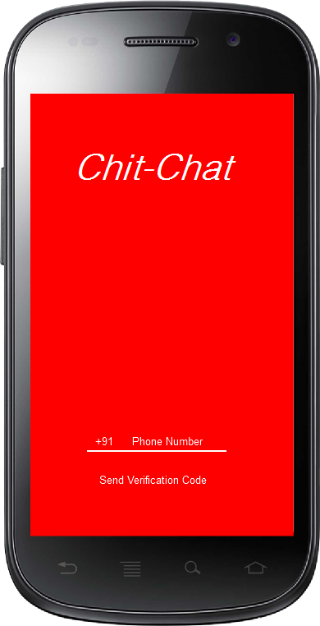

Login via Phone Number

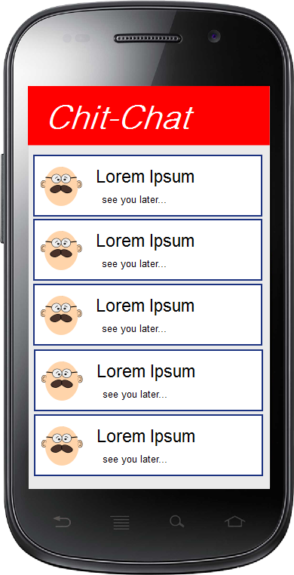

Chat Screen

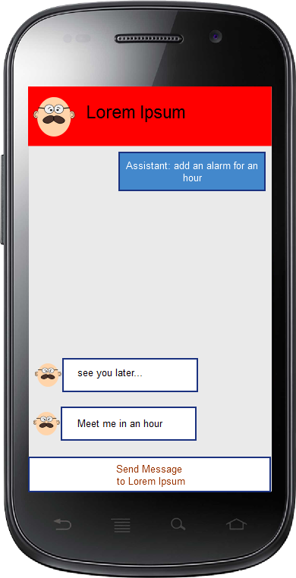

Chat detail with assistant bot on top right.

# Key Considerations

### How will your app handle data persistence?

For getting contacts list, Contacts provider will be used.

For storing chat messages and subscribed chat bots details, a new content provider will be used. Chat messages will be stored in firebase.

### Describe any corner cases in the UX.

User will have to do a compulsory login and profile completion. If the user terminates app in between he will be presented to resume later on.

### Describe any libraries you’ll be using and share your reasoning for including them.

* Picasso to handle the loading and caching of images.
* MPAndroidChart to display charts.
* Firebase to connect to firebase and store and retrieve data.
* Schematic by SimonVT for creating content provider backed by database.
* Retrofit to make HTTP calls.
* Digits sdk to verify phone numbers.
* Backendless sdk to upload user files/photos/videos.

### Describe how you will implement Google Play Services.

Google Places API will be used by the assistant bot to assist with location suggestions.

# Next Steps: Required Tasks

## Task 1: Project Setup

* Create two apps in a single project.
* Include appropriate libraries in both projects.
* Create a library to be used by these two apps.

## Task 2: Implement library for authentication via phone number

* Create User Interface
* Verify phone number
* If phone number verification failed, handle the error.

## Task 3: Implement UI for Each Activity and Fragment

* Build UI for (after login) profile creation -Name and profile pic.
* Build UI for chats contacts list.
* Build UI for chat details list.
* Build UI for editing profile.
* Build UI for adding/removing chat bots.
* Build UI for Assistant bot to show up on top of chats.
* Build UI for adding/removing a chat bot (for developers)
* Build UI for visualizing the statistics of chat bot (for developers)

## Task 4: Implement chats

* Implement profile updating/creation.
* Implement contact list.
* Implement chat sending/receiving messages
* Implement bots sending/receiving messages.
* Implement assistant bot sending/receiving messages.
* Implement adding/removing bots
* Implement adding/removing bots (for developers).
* Implement visualizing bot statistics (for developers).

## Task 5: Notifications

* Implement notifications if someone sends you a message.
* Implement daily stats notification of chat bot (for developers).

## Task 6: Animations/Transitions

Implement animations and transitions for each layout.

## Task 7: Create a widget

Create widgets for chat app.

.