ALM to qTest Migration Utility
A practical tool for moving test cases between platforms

Prepared for: Central QA / Test Management Team
Purpose: Proposal for standardising ALM-to-qTest test case migration
Status: For review and discussion

Summary
As teams adopt qTest for test management, there is a recurring need to bring existing test cases over from HP ALM. This utility provides a consistent, repeatable way to do that.
The tool reads test cases exported from ALM as an Excel file and loads them into qTest through qTest's API, including their steps and key fields. It also handles placing test cases into the correct folders in qTest.
This document explains what the tool does, how it works at a high level, and why it is worth adopting as a shared approach across teams.

Background
Migrating a test suite from ALM to qTest involves transferring each test case along with its steps and field values, and organising the test cases into the right folder structure in qTest. A typical suite can contain hundreds of test cases, each with many steps.
Without a standard tool, each team approaches this differently, which leads to inconsistent results, extra effort, and a higher chance of small errors such as a missing step, an incorrect status, or a test case placed in the wrong folder. A shared utility makes the process consistent and predictable for everyone.

The proposed solution
The utility takes an Excel file exported from ALM, a standard ALM feature, and creates the matching test cases in qTest through qTest's official API. The user points the tool at the file, and it handles the rest.
It is a lightweight tool that runs from the command line. There is nothing to install on a server and no ongoing maintenance. A user runs it on their own machine when they need it.

What it handles for you
- Reads test cases and all their steps from the exported Excel file.
- Matches ALM columns to the correct qTest fields, with the mapping defined once in a simple settings file.
- Translates field values (such as priority or status) to the values qTest expects.
- Creates folders in qTest and places test cases into the right one.
- Can process many files in a single run, sending each to its own folder.
- Checks everything first in a “dry run” so issues are caught before anything is written to qTest.

How it works
The migration follows five straightforward steps. The first two are a one-time setup; after that, running a migration is quick.
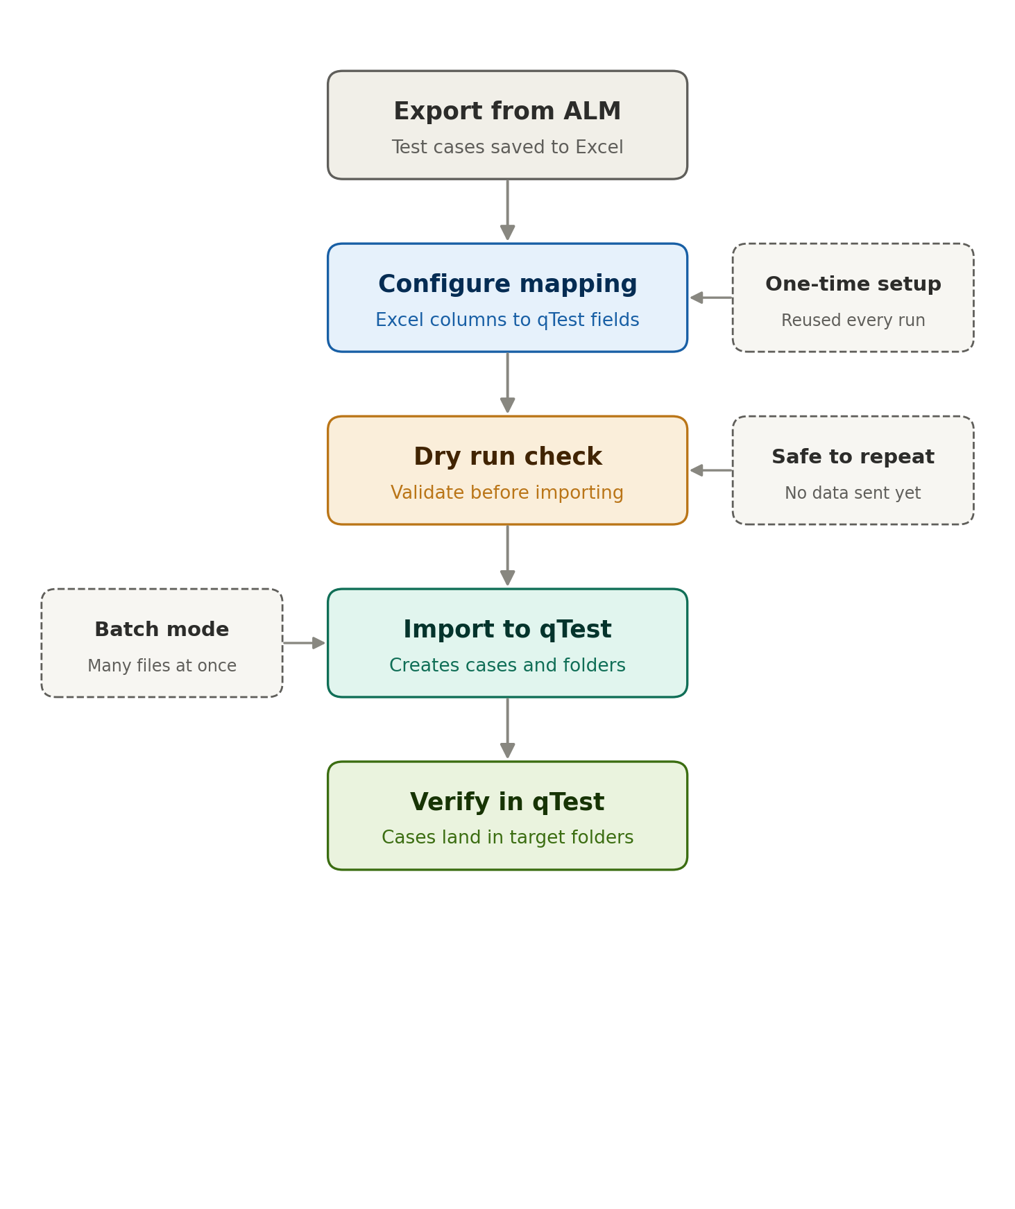
Step by step
- Export from ALM. The user exports their test cases from ALM into an Excel file using ALM's built-in export.
- Configure mapping. A simple settings file tells the tool which Excel column corresponds to which qTest field. This is set up once and reused for every later run.
- Dry run check. The tool reads the file and reports how many test cases and steps it found, and flags any problems before anything is created in qTest.
- Import to qTest. Once the dry run looks correct, the tool creates the test cases in qTest, along with any folders requested.
- Verify in qTest. The user confirms the test cases have landed in the expected folders with their steps and fields intact.

Why adopt it
Benefit | What it means
Efficient | A full suite can be loaded into qTest in a single run that finishes in minutes.
Accurate | Steps and fields are carried across exactly as exported, keeping the data intact.
Consistent | Every team uses the same mapping and process, so migrations look the same across projects.
Safe by design | The dry run lets users confirm everything before any data is created in qTest.
Low overhead | No servers and no maintenance. It runs on demand from a user's machine.

Security and access
The tool connects to qTest using the same login each user already has, so it respects existing permissions, a user can only do what their account allows. It communicates with qTest's official API over a secure connection.

Suggested next steps
- Use an upcoming migration as an initial trial.
- Agree on a standard column mapping that fits how teams export from ALM.
- Run the migration in dry-run mode, review the results, then import.
- Gather feedback and make the approach available to other teams.
A live demonstration on a sample project can be arranged on request.

