Project Tracker — Technical Documentation
**Application:** Project Management Dashboard with GenAI Chatbot
**Stack:** Python · FastAPI · SQLite · Streamlit · Google Gemini
**Repository:** https://github.com/arunsabharwal1/arun-practise
**Local URL:** http://localhost:8501

System Architecture
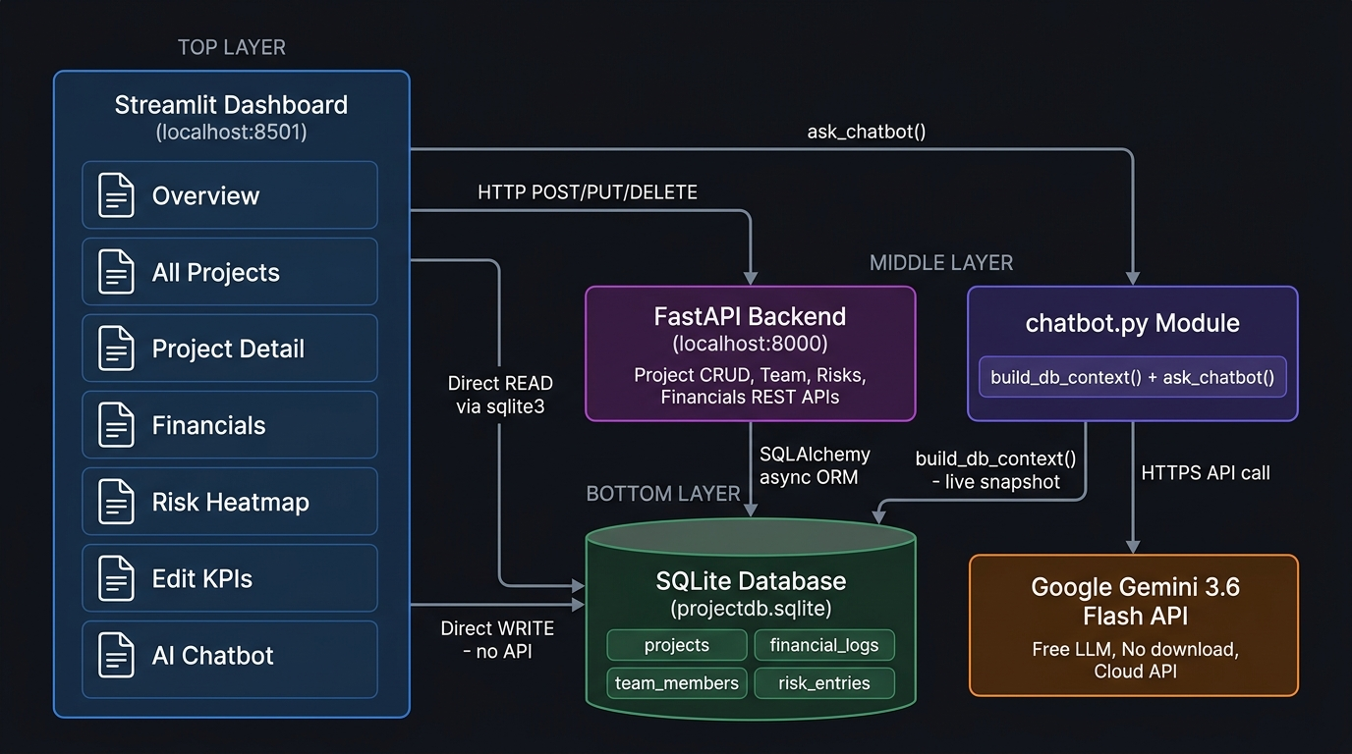
Figure: Full system architecture diagram

Part 1 — How the Application Was Built (Step by Step)
Phase 1: Backend API (FastAPI + SQLite)
The foundation of the application is a REST API built with FastAPI. It manages all project data and exposes endpoints for create, read, update, and delete operations.
Step 1 — Project scaffolding
The project was initialized with a clean Python virtual environment:
python3 -m venv .venv
source .venv/bin/activate
pip install fastapi uvicorn sqlalchemy aiosqlite pydantic python-dotenv

Step 2 — Database models (`app/models.py`)
Four SQLAlchemy ORM models were created to represent the core entities:
Table | Columns
`projects` | id, name, description, client, status, start_date, end_date
`financial_logs` | id, project_id, budget, actual_cost, revenue, notes
`team_members` | id, project_id, name, role, email, allocation_percentage, is_lead
`risk_entries` | id, project_id, title, probability, impact, status, mitigation_plan, owner

Relationships used CASCADE DELETE — deleting a project removes all related financials, team, and risks automatically.
Step 3 — Pydantic schemas (`app/schemas.py`)
Request and response schemas were defined using Pydantic v2 for automatic data validation. Computed fields like profit_margin and budget_utilization are returned in responses but not stored raw in the DB — they are calculated at query time.
Step 4 — CRUD functions (`app/crud.py`)
Pure async functions were written for every database operation. These functions are cleanly separated from the HTTP layer, making them callable by AI agents directly without going through HTTP.
Step 5 — API routers (`app/routers/`)
Four routers handle the REST endpoints:
- `projects.py` → `/projects` (CRUD)
- `financials.py` → `/projects/{id}/financials`
- `teams.py` → `/projects/{id}/team`
- `risks.py` → `/projects/{id}/risks`
Step 6 — Risk Matrix logic
A probability × impact matrix was implemented to auto-compute risk levels:
Probability ↓ / Impact → | Low | Medium | High | Critical
**Low** | low | low | medium | medium
**Medium** | low | medium | high | critical
**High** | medium | high | critical | critical
**Critical** | medium | high | critical | critical

Step 7 — Database seeding (`seed_data.py`)
10 sample projects were seeded with realistic financial data, team members, and risk entries so the dashboard had meaningful data from day one:
python seed_data.py

Phase 2: Streamlit Dashboard (`dashboard.py`)
The dashboard is a single-file Streamlit application that reads directly from SQLite for display and calls FastAPI for writes.
Step 8 — Custom dark-mode CSS
A comprehensive dark theme was applied using inline st.markdown() CSS:
- Background: `#0f1117`
- Sidebar gradient: `#1a1f2e → #16213e`
- Status badges with colour-coded borders (green=active, blue=planning, amber=on_hold, etc.)
- Risk badges mapped to severity colours
Step 9 — Cached DB helpers
Four cached loader functions were written with a 5-second TTL:
@st.cache_data(ttl=5)
def load_projects(): ...
def load_financials(): ...
def load_team(): ...
def load_risks(): ...

This ensures the dashboard is fast but always shows data that is at most 5 seconds stale.
Step 10 — Dashboard pages built
Page | What it shows
🏠 Overview | 6 KPI metric cards + 5 Plotly charts
📁 All Projects | Searchable, filterable project list with financials
🔍 Project Detail | Per-project tabs: Financials, Team, Risks, Edit
💰 Financials | Summary table + portfolio waterfall chart
⚠️ Risk Heatmap | Interactive heatmap + stacked risk-by-project chart
➕ Add Project | Form to create new projects with optional financials and lead

Step 11 — Plotly charts integrated
All charts use Plotly with transparent backgrounds (paper_bgcolor="rgba(0,0,0,0)") to blend into the dark Streamlit theme:
- Donut chart (project status distribution)
- Grouped bar chart (budget vs cost vs revenue)
- Horizontal bar chart (profit margin per project)
- Gauge chart (budget utilization)
- Heatmap (risk matrix)

Part 2 — How the Chatbot Was Created (Step by Step)
Step 1 — LLM API selection
Three options were evaluated:
Option | Download? | Free? | Context Window | Chosen?
Google Gemini | ❌ No | ✅ Yes | 1M tokens | ✅ **Yes**
OpenAI GPT | ❌ No | Paid | 128K | ❌
Hugging Face | ❌ No | ✅ Yes | Varies | ❌

Gemini 3.6 Flash was chosen: free tier, no download, large context window to fit the full DB snapshot.
Step 2 — Install the SDK
pip install google-genai>=1.0.0

Note: Google deprecated `google-generativeai` — the new package is `google-genai`.
Step 3 — Get a free API key
- Go to https://aistudio.google.com/app/apikey
- Sign in with Google
- Click "Create API key"
- Copy the key → paste into `.env`:
GEMINI_API_KEY=AIzaSy...your-key

Step 4 — Build `chatbot.py`
The chatbot was built as a standalone module (separate from dashboard.py) with two core functions:
`build_db_context(db_path)` — The Data Bridge
This function queries all 4 tables and serializes the data into structured text the LLM can reason over:
def build_db_context(db_path="projectdb.sqlite") -> str:
# Queries: projects, financial_logs, team_members, risk_entries
# Formats numbers to match dashboard exactly ($1.2M, 56.8%, etc.)
# Returns ~8,500 character structured text block

Sample output snippet:
=== PROJECT TRACKER - LIVE DATABASE SNAPSHOT ===
Total Projects : 10
Total Budget : $6.28M
Total Revenue : $7.14M
Portfolio Margin: 61.4%
[Project #1] ERP System Migration
Client : Apex Manufacturing Ltd
Status : ACTIVE
Budget : $850.0K
Profit Mrgn : 56.8%
...

`ask_chatbot(user_question, db_path, chat_history)` — The LLM Caller
def ask_chatbot(user_question, db_path, chat_history=None) -> str:
# 1. Validate API key
# 2. Call build_db_context() for fresh data
# 3. Build system prompt with context injected
# 4. Reconstruct conversation history in Gemini format
# 5. Call Gemini API (temperature=0.2 for factual answers)
# 6. Return response.text

Key design decisions:
- temperature=0.2 — keeps answers factual, reduces hallucination
- max_output_tokens=1024 — concise answers
- System prompt instructs the model to only use provided data, never invent numbers
- Conversation history passed on every call → multi-turn dialogue works
Step 5 — Chatbot data flow
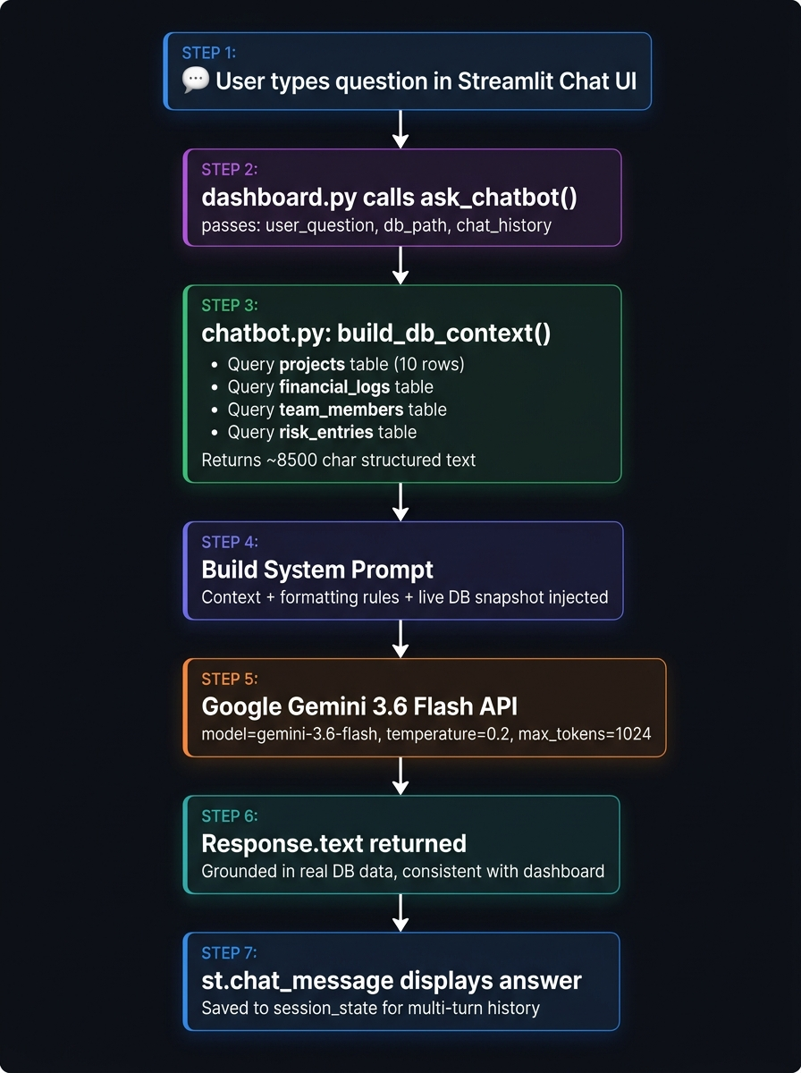
Figure: Chatbot data flow diagram
Step 6 — Model version troubleshooting
During setup, two deprecated models were encountered:
Model tried | Error | Resolution
`gemini-2.0-flash` | 404 — no longer available | Updated to `gemini-2.5-flash`
`gemini-2.5-flash` | 404 — unavailable to new users | Listed all available models via API, chose `gemini-3.6-flash`

How models were listed:
client = genai.Client(api_key=key)
for m in client.models.list():
print(m.name) # confirmed gemini-3.6-flash is available

Part 3 — Integration Between App and Chatbot
Integration Architecture
┌─────────────────────────────────────────────────┐
│ Streamlit Dashboard │
│ dashboard.py │
│ │
│ ┌──────────────┐ ┌────────────────────────┐ │
│ │ Edit KPIs │ │ AI Chatbot Page │ │
│ │ page │ │ │ │
│ │ │ │ st.chat_input() │ │
│ │ st.data_ │ │ st.chat_message() │ │
│ │ editor() │ │ ask_chatbot() ───────┼─┼──► chatbot.py
│ │ │ │ │ │ │
│ └──────┬───────┘ └────────────────────────┘ │ │
│ │ Direct WRITE │ │ build_db_context()
│ │ (no FastAPI) │ │ │
└─────────┼───────────────────────────────────────┘ │ │
│ │ │
▼ ▼ ▼
┌─────────────────────────────────────────────────────────────────┐
│ SQLite Database │
│ projectdb.sqlite │
│ │
│ projects │ financial_logs │ team_members │ risk_entries │
└─────────────────────────────────────────────────────────────────┘
│
▼
Google Gemini 3.6 Flash
(free API, cloud)

How data consistency is guaranteed
The key design principle is that the chatbot always reads the same source of truth as the dashboard:
- Dashboard displays data from SQLite (via `@st.cache_data` loaders)
- Chatbot reads data from SQLite (via `build_db_context()` — no cache)
- Edit KPIs page writes data directly to SQLite
This means:
- If you change a budget in Edit KPIs → SQLite is updated
- Next chatbot question → `build_db_context()` queries SQLite fresh → Gemini sees the new number
- Dashboard refreshes (cache cleared on save) → shows the same new number
No data ever diverges.
Edit KPIs → Chatbot update cycle
User edits Budget in ✏️ Edit KPIs
│
▼
db_update_financials(project_id, budget, cost, revenue)
│ (direct sqlite3 UPDATE — no FastAPI required)
▼
SQLite financial_logs table updated
│
├──► st.cache_data.clear() + st.rerun()
│ Dashboard charts refresh immediately
│
└──► Next chatbot question:
build_db_context() → fresh SQLite query
→ Gemini sees updated numbers
→ Answer reflects the change ✅

Files and their roles
File | Role | Reads DB? | Writes DB?
`app/main.py` | FastAPI entry point | Via ORM | Via ORM
`app/crud.py` | Async DB operations | ✅ | ✅
`app/models.py` | SQLAlchemy table models | — | —
`app/schemas.py` | Pydantic request/response models | — | —
`dashboard.py` | Streamlit UI + page logic | ✅ Direct sqlite3 | ✅ Via FastAPI OR direct sqlite3
`chatbot.py` | Gemini chatbot module | ✅ Direct sqlite3 (fresh, no cache) | ❌
`seed_data.py` | One-time data seeder | ❌ | ✅
`projectdb.sqlite` | The database | — | —

API key security
File | Committed to Git? | Contains API key?
`.env` | ❌ No (in `.gitignore`) | ✅ Real key
`.env.example` | ✅ Yes | ❌ Placeholder only

Running the Full Application
# 1. Clone
git clone https://github.com/arunsabharwal1/arun-practise.git
cd arun-practise
# 2. Virtual environment
python3 -m venv .venv
source .venv/bin/activate
# 3. Install dependencies
pip install -r requirements.txt
# 4. Configure environment
cp .env.example .env
# Add your GEMINI_API_KEY to .env
# 5. Seed database (first time only)
python seed_data.py
# 6. Start FastAPI backend (optional — needed for project writes)
uvicorn app.main:app --reload
# Runs at http://localhost:8000
# 7. Start Streamlit dashboard
streamlit run dashboard.py
# Runs at http://localhost:8501

Tech Stack Summary
Component | Technology | Version
Dashboard UI | Streamlit | 1.63.0
Charts | Plotly | 7.0.0
Data processing | Pandas | 3.0.5
REST API | FastAPI | 0.115.0
API server | Uvicorn | 0.30.6
ORM | SQLAlchemy | 2.0.35
Async DB driver | aiosqlite | 0.20.0
Data validation | Pydantic v2 | 2.9.2
AI SDK | google-genai | 2.22.0
LLM | Gemini 3.6 Flash | Free tier
Database | SQLite | Built-in
Environment | python-dotenv | 1.0.1

