ABSTRACT
SilentHelp is an app that helps people in emergencies. It is designed to be very quiet and secret, so people can use it when they need help but cannot talk loudly or make a normal emergency call. The people who made SilentHelp want to help individuals who are in danger from someone they know, like someone who is being hurt at home or followed by someone. SilentHelp does not look like an emergency app; it looks like a normal calculator on the phone. It has special ways to send emergency messages, like typing secret codes into the calculator, shaking the phone or using voice commands. When someone uses one of these ways to send a message, the app sends a help message to the chosen people, along with the user's location (Anon., n.d.). The people who made SilentHelp want to make sure the SilentHelp app is safe, something you can count on and easy to use. They want the SilentHelp app to be simple so you can use the SilentHelp app when you need it. SilentHelp is being made with tools called Flutter and Firebase, so it will work on Android phones. The goal of SilentHelp is to help people stay safe without putting them in danger. SilentHelp is a tool that can really help people in bad situations. SilentHelp will make a difference in people's lives by providing them with a safe way to get help when they need it.

ACKNOWLEDGEMENT
They gave me the encouragement. Help, I needed to keep going. My supervisor also gave me feedback that made my work better. Thanks to them, I could. Make my work better. I am grateful to my supervisor for their help. My supervisor supported me. I got the help I needed. They checked my work. Told me how to improve. I am very grateful. I couldn't have done this project without the instructors from the BSc (Hons) Software Engineering program. They showed me what I had to learn. My family and friends helped me too. They inspired me. They gave me ideas. Feedback. Support. My supervisor, the lecturers of the BSc (Hons) Software Engineering course and my family and friends all helped me. I am thankful to the Software Engineering course lecturers, my supervisor, my family and friends for their help. Thus, I am pleased to take this opportunity to thank everyone who assisted me with the completion of my final year project, SilentHelp. I want to thank the BSc (Hons) Software Engineering course lecturers for their help. I also want to thank my family and friends for their support. I want to thank my supervisor again for all that they did for me. I am grateful to everyone who helped me with this project, including the people who gave me ideas and feedback and the people who supported me in various ways.
Arun Sagar Rai
16 September 2026

Table of Contents
ABSTRACT 2
ACKNOWLEDGEMENT 3
Chapter 1 – Introduction 5

Chapter 1 – Introduction
People are getting hurt in the world. It is a big problem. Some people are in situations like being hurt at home, or someone is following them, or they are being bothered, and they need help. They can really help us stay safe. Our phones can show us where we are, and we can talk to people away. A lot of the apps that are supposed to help us in an emergency are easy to see, and we have to touch the screen to use them. This is not good if someone is trying to hurt us, and we need to be quiet. That is why we made SilentHelp. It is an app that looks like a regular calculator on our phone. So if someone is looking at our phone, they will just think it is a calculator. It has special things inside, like secret buttons, and we can even shake the phone to get help. We can also talk on the phone to send a message to people we trust. We worked hard to make SilentHelp a good app. SilentHelp is an idea, but it can really help people. SilentHelp is an app that helps people in situations, and it is very important for people who need it. SilentHelp can really make a difference in people's lives. That is why I will make SilentHelp.

1.1 Background
Personal safety has become a significant factor in recent times, especially because of the rise in the number of occurrences of domestic abuse, harassment, and security threats. According to reports from all over the world, many people, especially women, are in a difficult situation where they are unable to seek help in a timely manner because the perpetrators are keen observers of their victims, and sending a message or making a call could put them in a worse situation. Therefore, these people are in dire need of alternative communication tools.
As a result, conventional methods of responding to emergencies, for example, by contacting the police or other emergency services, are useful in many situations, depending on the ability of the person in question to communicate freely. In a similar vein, existing mobile safety apps have features that are immediately noticeable, for example, a panic button or alert button. Although these apps are useful, especially in situations where safety is a priority, they are limited in situations where discretion is a requirement. However, with the development of smartphone technology, a variety of features are now possible in contemporary smartphones, such as location tracking through GPS, motion detection through accelerometers, and voice recognition through the use of a smartphone's microphone. This makes it possible to develop creative and hidden safety solutions. These features can be used for the development of solutions that enable users to seek help in a hidden manner.
The importance of user privacy, security, and ethical issues in the development of mobile applications is another factor that is becoming increasingly important in the development of applications in this field. Applications that deal with sensitive information, for example, contact information and location, should be able to handle these issues well, and therefore, a solution designed in this field should be able to achieve a balance between privacy and security features. The rationale behind the development of the SilentHelp solution lies in the resolution of these problems through the use of modern mobile technologies and hidden user engagement mechanisms. This represents a paradigm shift in software engineering, as context-aware and user-centric safety solutions are considered.

1.2 Problem Statement
Therefore, a person might not be able to seek help in an obvious manner in a number of situations related to domestic abuse, stalking, harassment, or other personal threats. Although a number of safety apps are currently designed for use on different smartphones, most of these apps are affected by the fact that they are based on an obvious SOS feature, mechanisms or direct user interaction, which makes them unsuitable for use in a stealthy and dangerous situation. This calls for the development of a stealthy and reliable support system in a way that a person in need of help can request support without drawing attention, as well as sending alarms and location information promptly to trustworthy contacts.

1.3 Proposed Solution
The project proposal of the SilentHelp is to create a discreet mobile application to enable users to request assistance in unrestrained conditions under high-risk situations, to address the constraints so that they may not alert an aggressor. SilentHelp is an application that exists on a mobile phone in the form of an ordinary calculator, such that it does not make one suspicious when using it every day. The application has various hidden emergency activation systems behind a simple interface, including patterned calculator input, phone shaking recognition, which uses the device accelerometer and optional voice activation (Sarkar et al., n.d.). They are made in such a way that they are easy, quick and easy to remember so that the users can make use of emergency help without attracting any attention to them. After the triggering, the application takes some steps in the background without any notice. Some of these include the real-time location of the user as determined by the GPS services and sending an alert message to the pre-defined trusted individuals. It is made to be efficient even when it is running in the background, so that alerts are delivered in a timely manner. The application is also dedicated to ensuring the user's privacy and the reliability of data because it safely deals with sensitive information like location data and contact details. The development of SilentHelp is based on the latest mobile technologies, such as Flutter to develop a cross-platform application and Firebase to support the back end, such as authentication and real-time communication. The design strategy is user-centred and modular in order to guarantee reliability, scalability and ease of use. The proposed solution, on the whole, is to offer a convenient, non-obtrusive and efficient emergency aid system that would improve personal security but reduce risk and be applicable in sensitive and dangerous environments.

Business Context Diagram

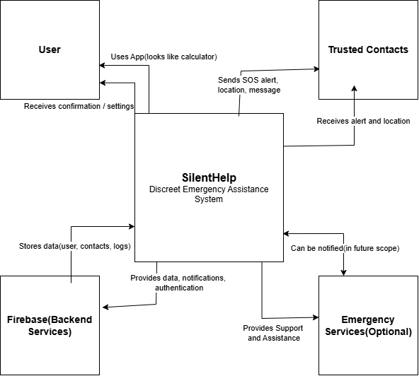

2. Functional Architecture
Presentation Layer (Flutter)
- Provides the main user interface of SilentHelp.
- Contains the disguised calculator interface.
- Includes hidden settings and menu options.
- Allows users to manage trusted contacts and alert preferences.
Application Logic Layer
- Processes the main functions of the application.
- Detects hidden emergency triggers.
- Handles secret calculator input.
- Processes shake detection and voice activation.
- Prepares the SOS alert when a valid trigger is detected.
Sensor and Service Layer
- Uses the GPS to obtain the user's location.
- Uses the accelerometer for shake-based triggers.
- Uses the microphone for voice-based activation.
- Supports background services required for emergency functions.
Backend Layer – Firebase
- Stores required user and contact information.
- Manages application data and alert records.
- Supports cloud-based communication.
- Uses Firebase Cloud Messaging (FCM) for notifications.
Notification Layer
- Prepares and sends the emergency alert.
- Sends the user's location with the SOS message.
- Supports push notifications and other configured alert methods.
- Delivers the alert to trusted contacts.
Trusted Contacts
- Receive the SOS emergency message.
- Receive the user's location information.
- Can respond and provide assistance during an emergency.

3. Use Case
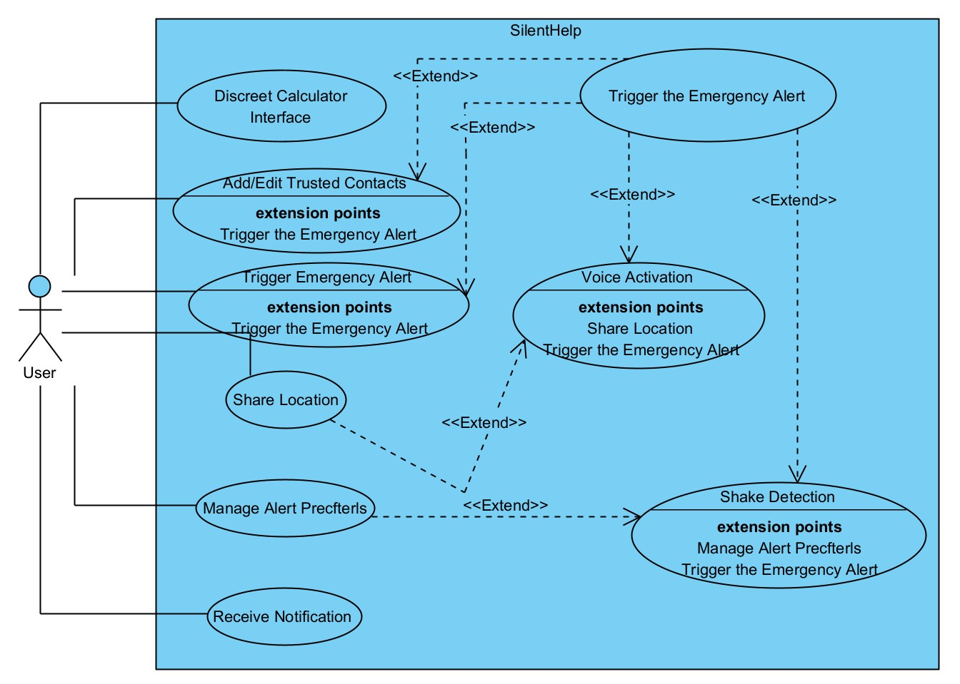

4. Data Flow
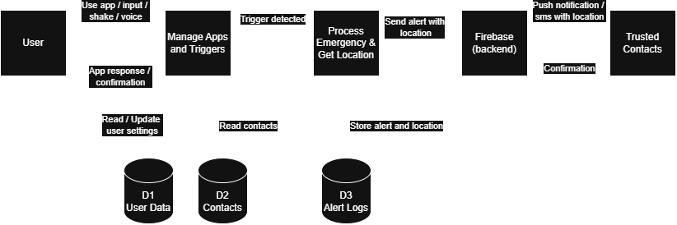

5. System Architecture
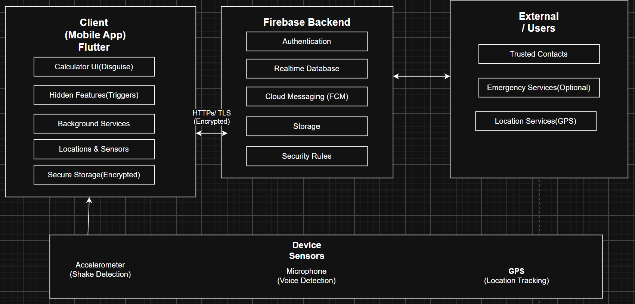

5. Functional Architecture of SilentHelp

