Course URL: <https://www.youtube.com/watch?v=HXV3zeQKqGY&t=1802s>

Queries used in the course: <https://www.mikedane.com/databases/sql/>

**⭐️ Contents ⭐**

⌨️ (0:00) Introduction

⌨️ (2:36) What is a Database?

⌨️ (23:10) Tables & Keys

⌨️ (43:31) SQL Basics

⌨️ (52:26) MySQL Windows Installation

⌨️ (1:01:59) MySQL Mac Installation

⌨️ (1:15:49) Creating Tables

⌨️ (1:31:05) Inserting Data

⌨️ (1:38:17) Constraints

⌨️ (1:48:11) Update & Delete

⌨️ (1:56:11) Basic Queries

⌨️ (2:08:37) Company Database Intro

⌨️ (2:14:05) Creating Company Database

⌨️ (2:30:27 ) More Basic Queries

⌨️ (2:26:24) Functions

⌨️ (2:45:13) Wildcards

⌨️ (2:53:53) Union

⌨️ (3:01:36) Joins

⌨️ (3:11:49) Nested Queries

⌨️ (3:21:52) On Delete

⌨️ (3:30:05) Triggers

⌨️ (3:42:12) ER Diagrams Intro

⌨️ (3:55:53) Designing an ER Diagram

⌨️ (4:08:34) Converting ER Diagrams to Schemas

CRUD: Create, Read, Update ,Delete.

Types:

# Relational: Organizes data into 1 or more tables.

Columns & Rows, Unique key identifiers.

# Non-Relational: Organize any data.

Key-value stores.

Documents (JSON, XML)

Graphs

Flexible tables

# Relations DBs:

SQL: Standardized, performs CRUD,

# Non-Relational:

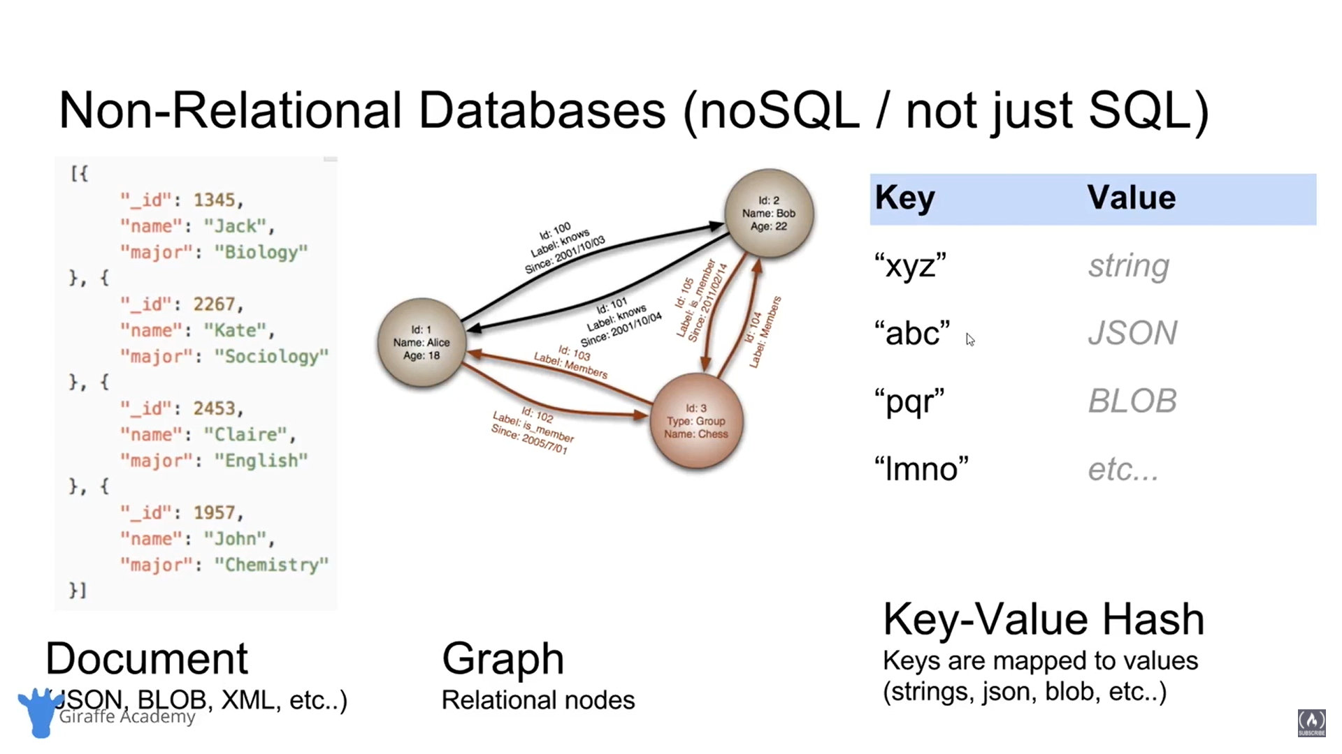

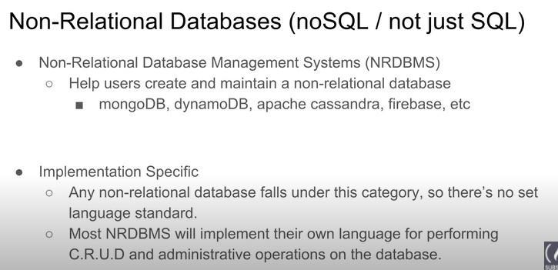

# Tables and Keys:

Surrogate keys – Primary, No mapping for the key .

Natural keys – Primary, using a mapped key.

Foreign key:

Define relationships between 2 tables.

The key is the Primary key of the linked table.

Primary key: Composite key (Combination of multiple Primary keys of diff. tables)

Combination of multiple Foreign keys make a Composite key.

# SQL:

Interacting with RDBMS.

Implementations vary between systems. -> Implementation may vary.

**Types:**

DQL (Data Query language) : Query for info, Get info that is stored.

DDL (Data Definition “): define schemas

DCL (Data Control “): Control access, User Permission mgmt

DML (Data Manipulation “): CRUD.

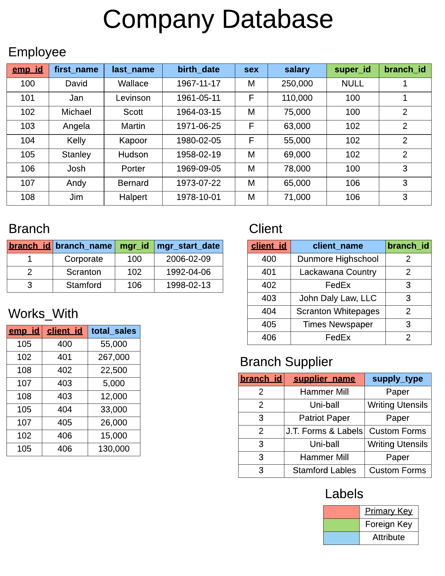

JOIN:

General

LEFT

