Lab: Atomic Widgets

In this lab, you will answer questions about widget properties, and create a new set of widgets for the customer relationship fields you created in the previous Data Model labs.

Exercise 1: Widget Properties

1. Display the PCF Format Reference. Using the Quick Jump box, jump to the reference for "Input" widgets.
2. Using the Input reference, name the property that can be used to implement the following requirements for the following hypothetical widgets:
3. When the user mouses over the Legacy Code widget, the text "This code must come from the legacy claim system." text should appear.
4. When the user attempts to change the Policy Number widget value, a dialog box appears that asks the user to confirm he or she really wants to make the change.
5. The label for the Expiration Date widget should be in bold.

Exercise 2: Create New Widgets

You need to create a new section in the Contact Details UI for a person that looks like this:

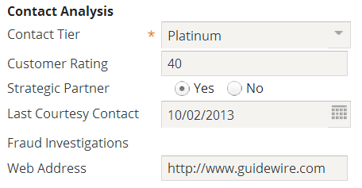

1. The PCF ABContactDetailsCV.ABPerson, which has a set of widgets for "Basic Information" and a set of widgets for "Primary Address". The Primary Address section contains an input set named "BasicAddressInputSet". Underneath the "BasicAddressInputSet", first create a DetailView and InputColumn, and the widgets specified below. (NOTE: Do **NOT** place your widgets within the BasicAddressInputSet.)

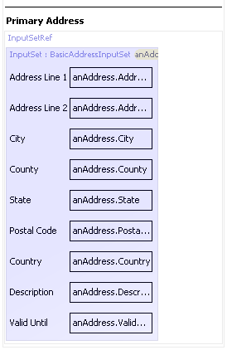

Add the widgets here

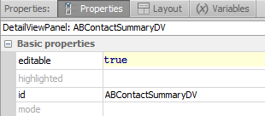

HINT 1: Before adding the widgets, add a DV with these specifications.

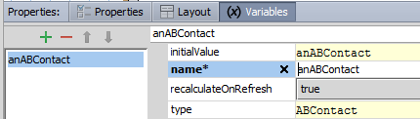

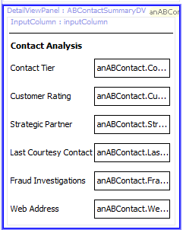

HINT 2: PCF additions – a DV with an InputColumn

HINT 3: Each widget needs a display properties entry in order to have a label. .

Widgets to add:

* An input divider
* A label widget labeled "Contact Analysis"
* An editable input widget labeled "Contact Tier" that displays ABContact's Contact Tier field
* An editable input widget labeled "Customer Rating" that displays ABContact's Customer Rating field
* An editable input widget labeled "Strategic Partner" that displays ABContact's Strategic Partner field
* An editable input widget labeled "Last Courtesy Contact" that displays ABContact's Last Courtesy Contact
* A non-editable input widget labeled "Fraud Investigations" that displays ABContact's Number Of Fraud Investigations field
* An editable input widget labeled "Web Address" that displays ABContact's Web Address field

# 

Verification

You can verify your addition by reloading the UI and adding information to the new section in the UI.

|  |  |
| --- | --- |
|  | Stop and ask your instructor to review your completed lab or compare it with the available solution files. |