Lab: Detail Views

In this lab, you will create a detail view for the customer relationship widgets. This detail view will be used on the Analysis screen and on the Details screen's "Analysis" card.

Requirements

To complete this lab, the only requirement is that your completed the previous lab.

Tasks

1. If you have not already done so, create a folder named "training labs". All new PCF files that you create should go into this folder.
2. In the "training labs" folder, create a detail view named ABContactAnalysisDV. It should have an ABContact object as its root object.
3. Move all the widgets from the previous lab (except the input divider) onto this detail view. By the end of the lab, there should no longer be any contact analysis widgets on ABContactSummaryDV.ABPerson and ABContactSummaryDV.ABCompany (and any other contact type that requires an Analyses section). You may also need to make changes to the detail view or the widgets to ensure they work on the new detail view. This includes adding a Panel Ref. See the Hints that follow.
4. Open ABContactAnalysisPage. This page contains a screen which contains an inline detail view with a single label. Replace the existing inline detail view with a reference to ABContactAnalysisDV.

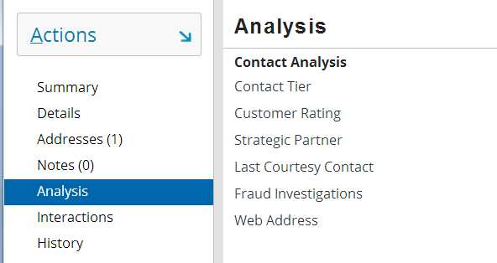

1. Open ABContactDetailsCV. This card view contains an Analysis card which currently contains an inline detail view with a single label. Replace the existing inline detail view with a reference to ABContactAnalysisDV.

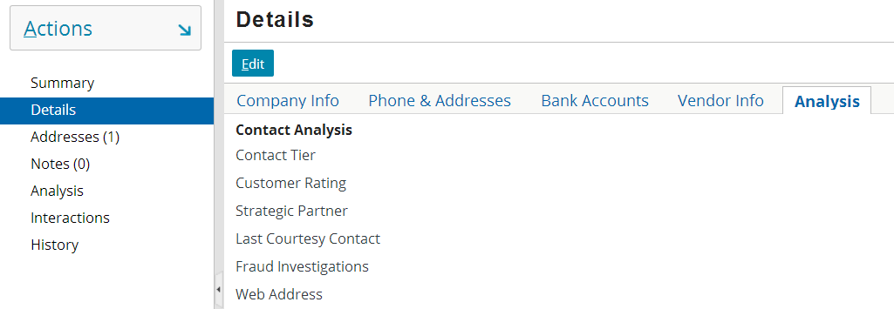

Verification

A correct implementation includes the Analysis page displaying with the correct fields. However, note that you will not be able to edit any of the fields because the DV is not editable yet.

|  |  |
| --- | --- |
|  | Stop and ask your instructor to review your completed lab or compare it with the available solution files. |