Lab: Editable Detail Views

In this lab, you will modify the application so that ABContactAnalysisDV is editable.

Tasks

1. In TrainingApp, modify the Analysis screen to include a toolbar with Edit/Update/Cancel buttons that act on the ABContactAnalysisDV.

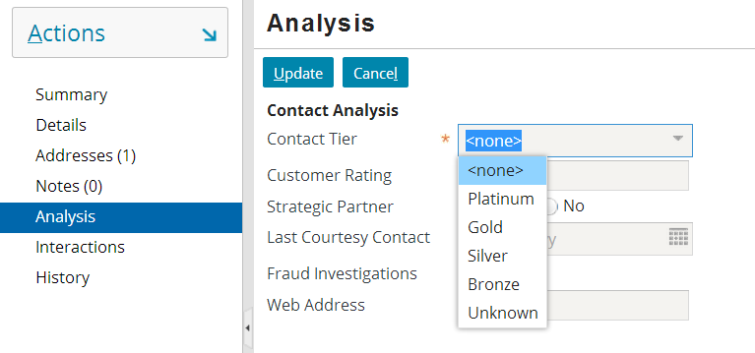

1. Test your changes by modifying each of the editable fields and updating the details. (Fraud Investigations should not be editable.)

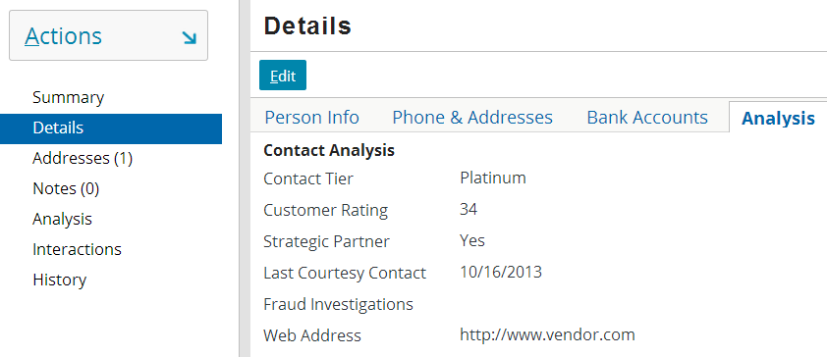

1. The instance of ABContactAnalysisDV on the Detail screen's Analysis card already has a toolbar with Edit/Update/Cancel buttons on it. Why does this detail view already have a toolbar?

|  |  |
| --- | --- |
|  | Stop and ask your instructor to review your completed lab. |