Lab: Input Sets

In this lab, you will add a new section for Email addresses that uses input widgets.

Tasks

1. Create an EmailAddressInputSet which has an ABContact as its root object. It should contain the following widgets:

* A label widget labeled "Email Addresses"
* An editable input widget labeled "Main" that displays ABContact's EmailAddress1 field
* An editable input widget labeled "Alternate" that displays ABContact's EmailAddress2 field

1. Reference the input set from the ABContactSummaryDV. (Add an input divider directly under the Valid Until widget, and reference the input set directly below this input divider.)

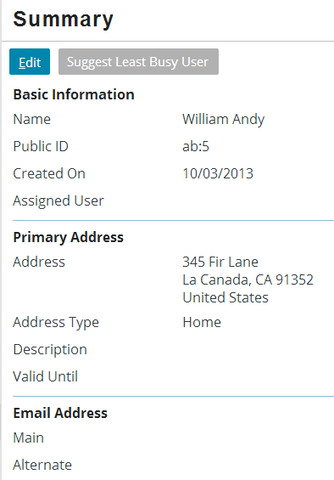 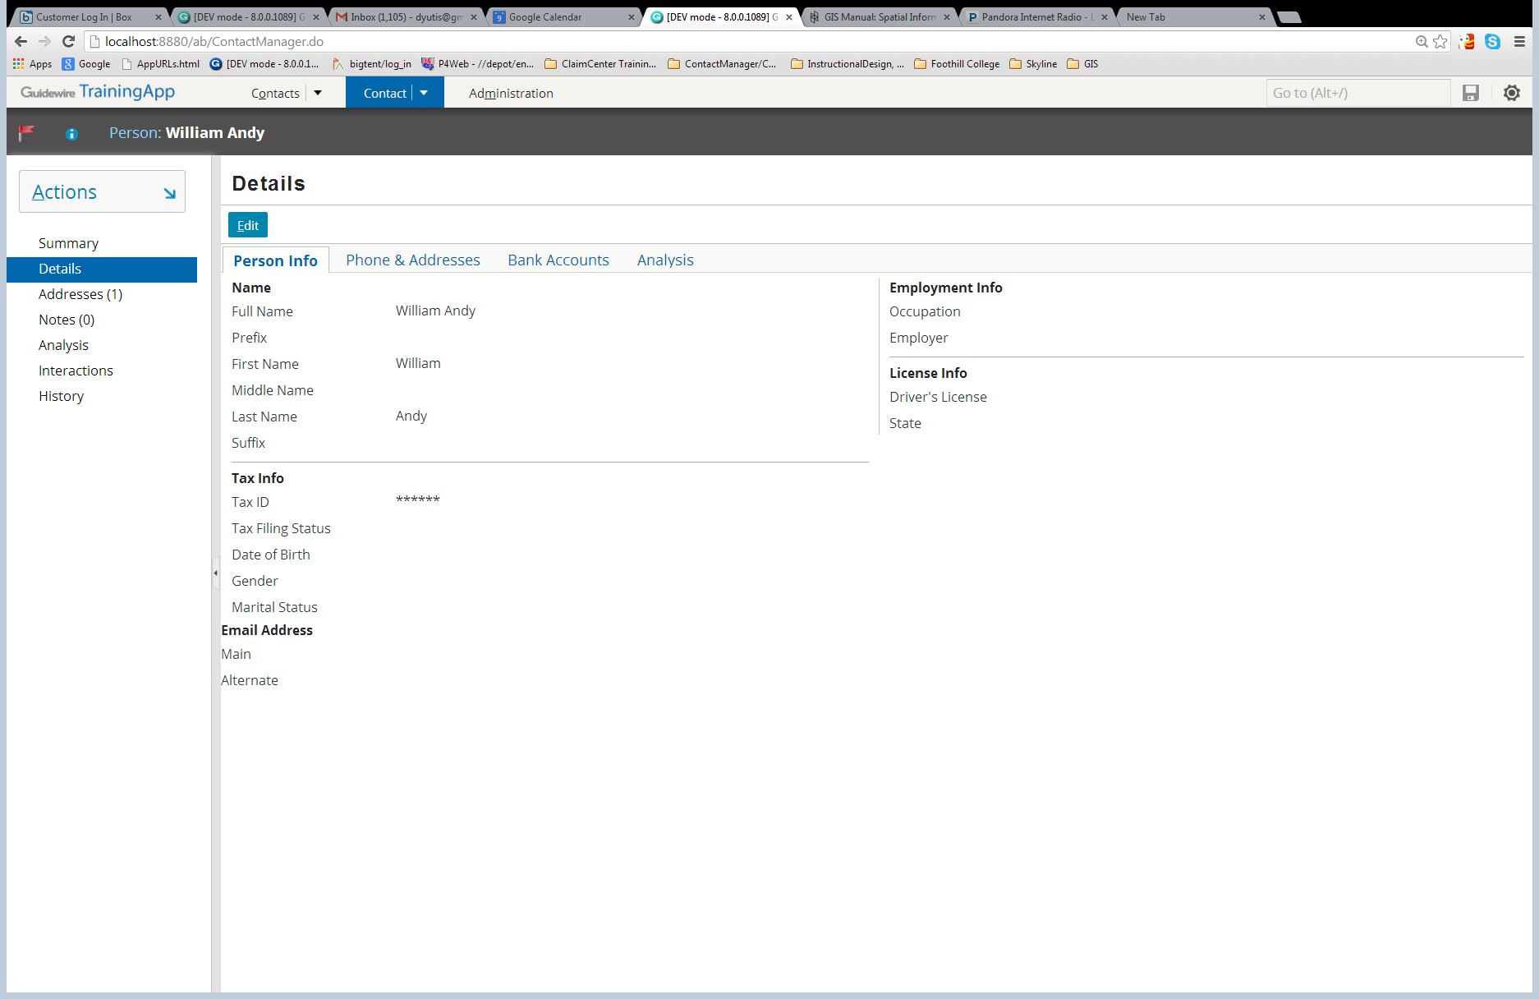

1. Reference the input set from **both** the ABContactDetailsCV.ABPerson.pcf and ABCOntactDetailsCV.ABCompany "Phone & Addresses" cards. (Once again, add an input divider directly under the Valid Until widget, and reference the input set directly below this input divider HINT: use an\ DetailView Panel with an InputSetRef widget to get this to work correctly.)

|  |  |
| --- | --- |
|  | Stop and ask your instructor to review your completed lab or compare your results to the available solution set. |