Lab: List Views

In this lab, you will create a list view for a given contact's interactions. This list view will be displayed on the screen which is displayed when you click the Interactions screen link. (For this lab, the list view will have columns, but no rows of data. The next lab addresses how to add data to the list view.)

Tasks

1. Create a reusable InteractionsLV list view which has an ABContact as its root object. The list should display the ABContact's interactions. Each row of the list view should display the following:

* A cell widget labeled "Date" that displays each interaction's Interaction Date field
* A cell widget labeled "Reason" that displays each interaction's Interaction Reason field
* A cell widget labeled "User" that displays each interaction's User field

1. Open ABContactInteractionsPage. This page contains a screen which currently contains an inline detail view with a single label. Replace the existing inline detail view with a reference to InteractionsLV. Three HINTS follow.

* You are accessing a new entity (Interaction_Ext) you created in an earlier lesson
* You also need a PanelRef, which will reference InteractionsLV
* In the next lab, you need a Toolbar, so you might as well add it with an Edit button

1. Test your work by clicking the Interactions screen link. Verify all columns display.

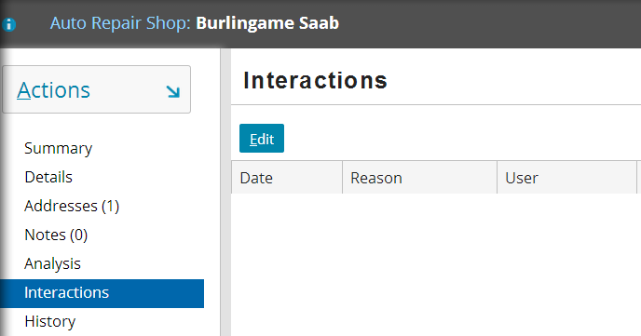

|  |  |
| --- | --- |
|  | Stop and ask your instructor to review your completed lab or compare the available solution files with your own files. |