Lab: Editable List Views

In this lab, you will modify InteractionsLV so that rows may be added or deleted..

Tasks

To complete this lab, the only requirement is that your completed the previous lab.

1. Modify TrainingApp so that, when displayed on the ABContactInteractionsPage, InteractionsLV:

* Has a toolbar with Edit/Update/Cancel buttons and with Add/Remove buttons
* Lets you add and remove rows upon selecting the appropriate buttons
* Shows the checkboxes by each row only when in edit mode
* Lets you modify or enter data in all three columns

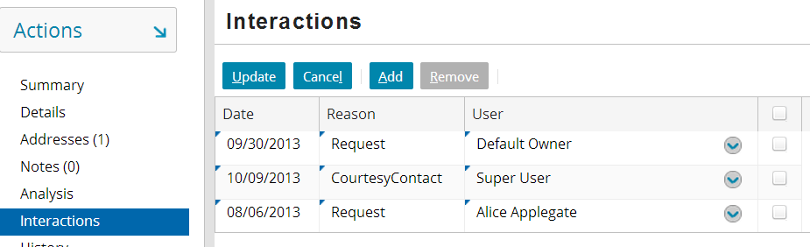

**Note:** TrainingApp has internal functionality such that if you have a foreign key field that points to the User entity, then whenever the field is rendered in the user interface, it automatically comes with additional User search functionality when the widget is editable. This is an aspect of the foreign key to the User entity and not the cell widget itself. In almost all other cases, cell widgets have no special search functionality.

1. Test your work by adding and saving an interaction. Then, edit and save the interaction. Finally, delete the interaction.
2. Later labs will make use of interactions. If time permits, create three interactions for a given contact, such as William Andy.

|  |  |
| --- | --- |
|  | Stop and ask your instructor to review your completed lab. |