Lab: Introduction to Locations

In this lab you will make a contact's employer and employee names link to the corresponding detail pages.

Tasks

1. On ABContactDetailsPersonDV (originates from ABContactDetailsPage), the Person Info card has an Employer widget. Currently, this widget is not clickable. Modify this widget so that it is clickable, and when clicked it navigates to the contact's employer. (It should navigate to the Details screen and it should pass that contact's employer to the destination location.)

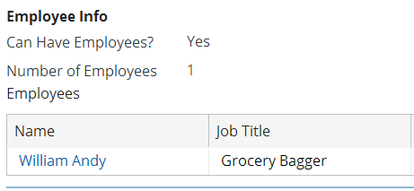

1. On ABContactDetailsCompanyDV, the Company Info card has a list view of employees. Currently, the employee name is not clickable. Modify this widget so that it is clickable, and when clicked it navigates to the company's selected employee. (It should navigate to the Details screen and it should pass that contact's employee to the destination location.)

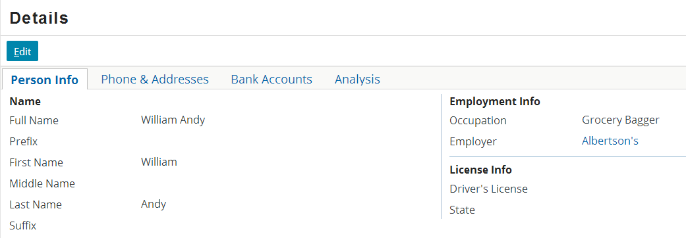

**Note:** If you click on the link for a person that has no employer, the system will produce a stack trace. In the “Server Side Widget Behavior” lab you will modify TrainingApp so that the Employer widget is not clickable if the ABPerson has no employer.

|  |  |
| --- | --- |
|  | Stop and ask your instructor to review your completed lab. |