Lab: View/Edit Popups

In this lab, you will modify TrainingApp so that existing interactions are modified with a popup.

Background

Currently, new interactions can be modified directly in the InteractionsLV list view. Only some of the fields for an interaction are exposed in this list view, however. TrainingApp needs to be modified so that existing interactions are modified using a popup, allowing the user to enter information for other fields without cluttering up the list view.

Tasks

1. Create a popup location named InteractionPopup that contains an inline detail view and displays the details of a passed interaction object. This detail view should contain editable widgets for Interaction Date, Initiated by Contact, Channel Type, Summary, User, and Interaction Reason. For the order of the widgets and the labels, use your best judgment.
2. Modify the Reason cell of the InteractionsLV list view so that clicking the cell opens the corresponding interaction in the popup so that it can be edited.

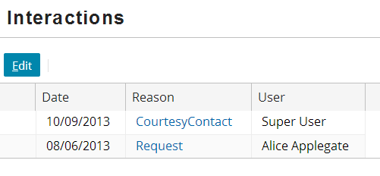

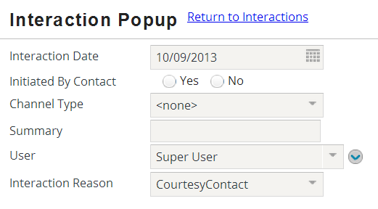

Verification

Test your work by modifying an existing interaction. Change a field that is not displayed in the list view (such as Summary). After you save your changes, display the interaction in the popup again to verify the change.

|  |  |
| --- | --- |
|  | Stop and ask your instructor to review your completed lab. |