Lab: New Popups

Tasks

Currently, new interactions are created directly in the InteractionsLV list view. TrainingApp needs to be modified so that new interactions are created (as well as existing interactions are modified) using a popup.

1. Modify the necessary PCFs in TrainingApp so that users, when viewing interactions on the Interactions page can select the Add button to create new interactions in InteractionPopup.

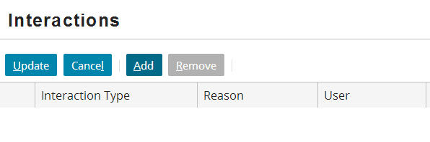

Verification

1. Test your work by creating a new interaction and saving your changes. Make sure you click Update on the Interactions list view so that the list returns to read-only mode. Then, delete an interaction.
2. Now that new interactions can be created in a popup, modify the cells of the InteractionsLV list view so that the cells are no longer editable.

|  |  |
| --- | --- |
|  | Stop and ask your instructor to review your completed lab. |