Lab: Client-side widget behavior

In this lab, you will work with the client reflection feature to effect an immediate change in a dropdown menu.

Requirements

To complete this lab, the only requirement is that your completed the previous lab.

Task

For ABPerson's, the Details screen's Person Info card displays the person's employer. Underneath this widget, add a read-only widget that displays the employer's work phone. This new widget should immediately reflect any change in the Employer widget.

 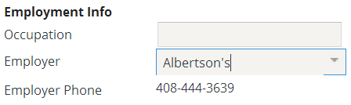

Test Procedure

Test the change by selecting different Employers for a given ABPerson. Verify that the phone number changes with each newly selected Employer. The change should be immediate. You **should not** need to click the Update button to see the change.

|  |  |
| --- | --- |
|  | Stop and ask your instructor to review your completed lab. |