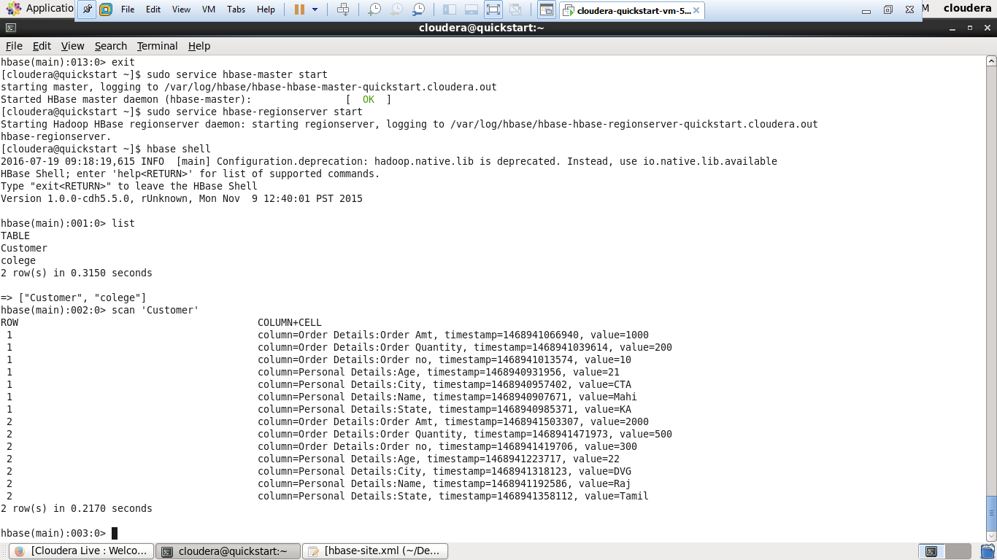

**1. Create the table customer with two column families**

* **Personal details and order details as column families**
* **Create a unique number as row key (ssn/Adhar no.,etc)**
* **Insert at least 10 records to each column**
* **Insert following values for personal details column family**
* **Name, age, city, state**
* **Insert following values for order details column family**
* **Order no., order quantity, and order amount**
* **Use put command to insert the values for each record.**
* **Use get command, to retrieve all the records of single customer.**