1.Loading Data Into HBase Using PIG Scripts

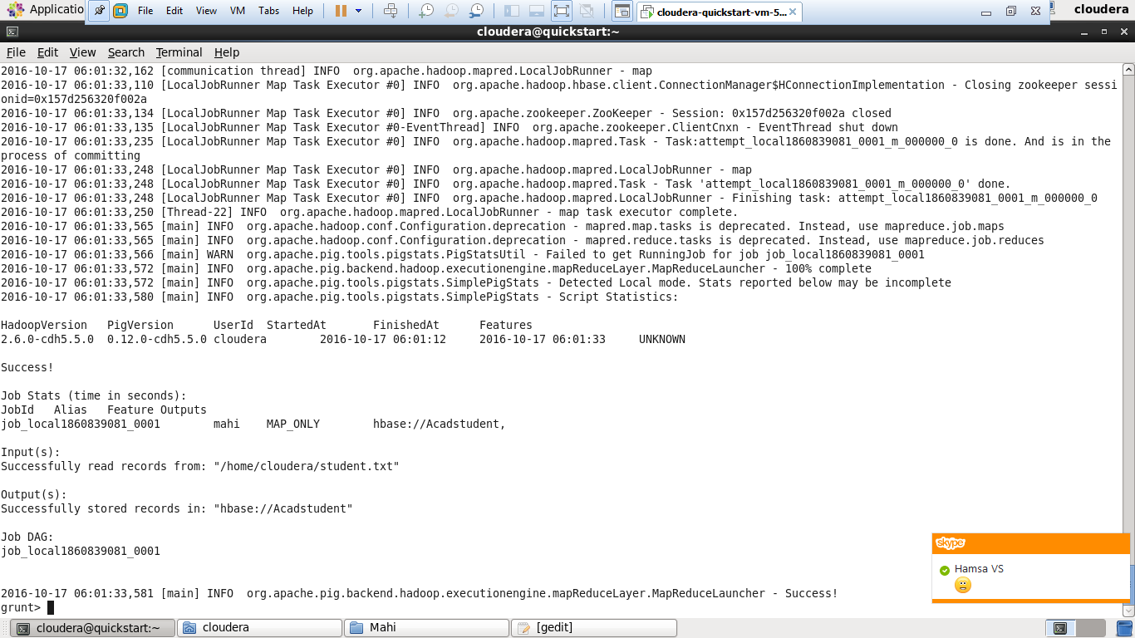

hbase(main):003:0>scan “Acadstudent”

