**Creating Table:**

* Create table Olympic (athlete String, age int, country String, Year String, Closing String, Sport String, ID int, Silver int, Total int) row format delimited fields terminated by ‘\t’ stored as textfile;
* Select AVG(age) from Olympic;

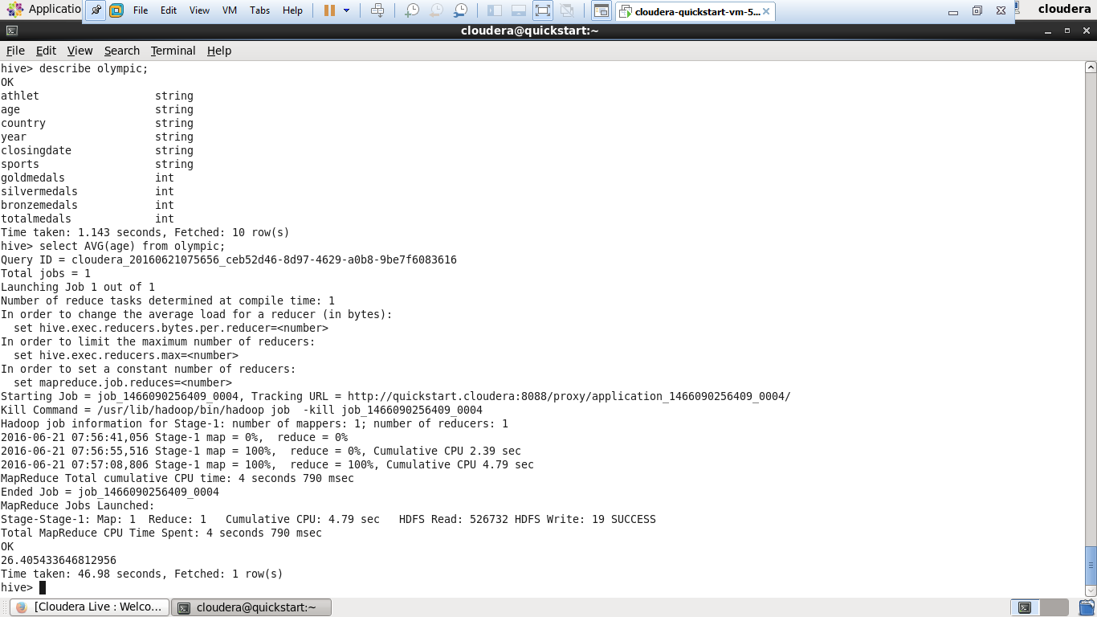

**Creating Index:**

* create INDEX index_olympic on table Olympic(age) as ‘org.apache.hadoop.hive.ql.inde.compact.CompactIndexHandler’ WITH DEFERRED REBUILD;
* alter index Olympic_index on Olympic rebuild;
* show formatted index on Olympic;

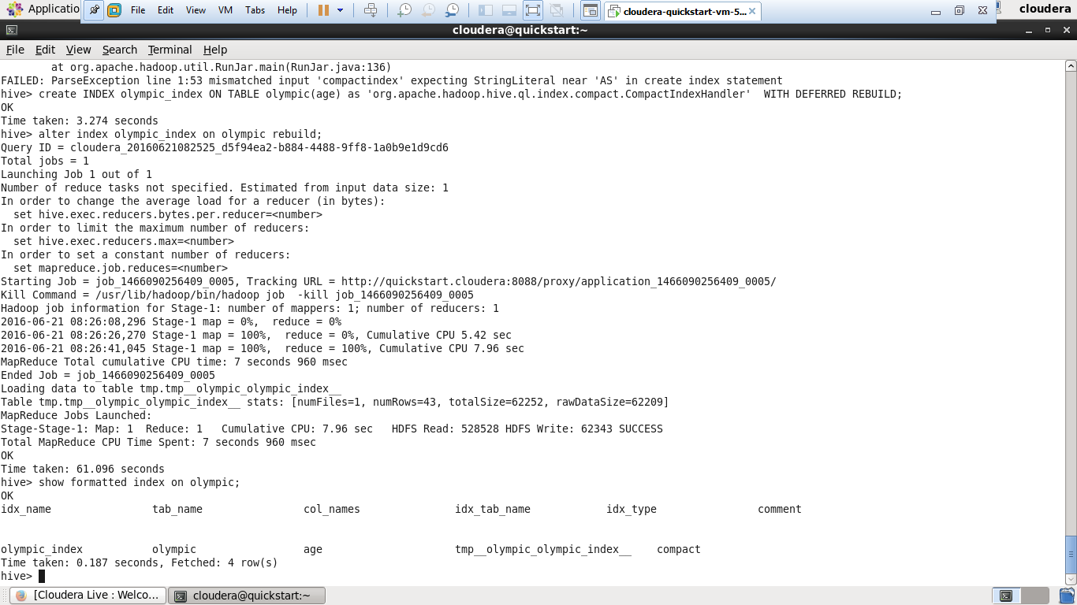

**Creating different index for the same table:**

* create index index_olympic_bitmap on table olympic(age) as ‘bitmap’ with diferred rebuild;
* alter index index_olympic_bitmap on olympic rebuild;
* show formatted index on Olympic;

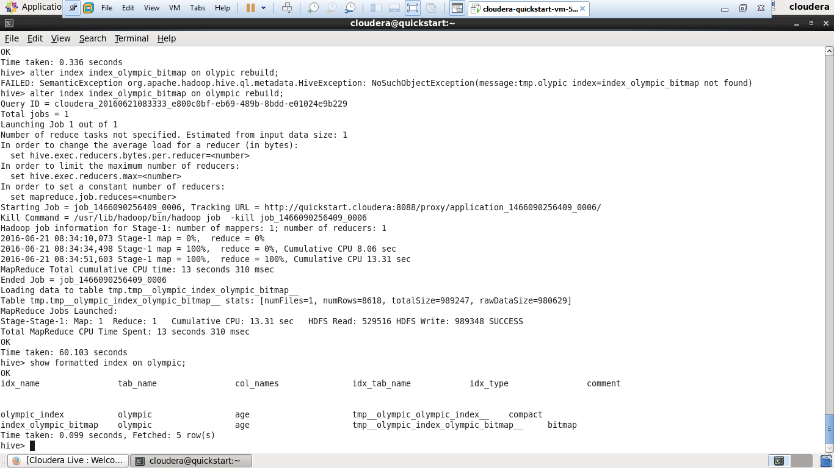

**Dropping index:**

* drop index if exists index_olympic_bitmap on olympic;