1. Write a program to sort array of numbers in asc order.

Input : 44,3,9,81,6,1

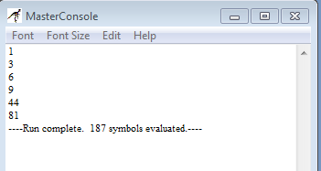

1. Write a program to generating anagrams
2. Write a program to do string search

Input: String 🡪 Arun , Search String 🡪 un

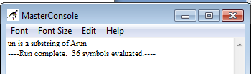

Input String 🡪 Arun, SearchString 🡪 ab

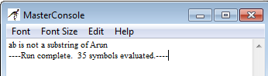

1. Write a program to check whether enter string is a palindrome or not

Input: madam

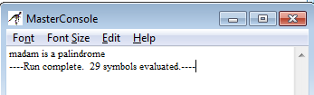

Input : Arun

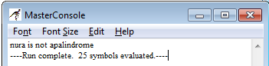

1. Write a program to print the Armstrong number between two numbers.

Input x🡪100 Y🡪500

