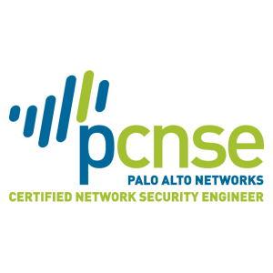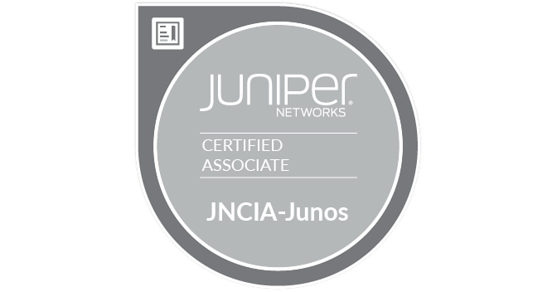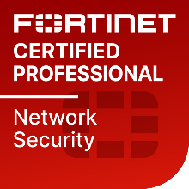
VINOTH KUMAR
Email: vinothkumar16feb@gmail.com
Mobile: +91 9790769056
Linkedin: https://www.linkedin.com/in/vinoth-kumar-97763367

About Me
Strong operations professional with a bachelor’s degree focused on software engineering from The University of Madras, 2010. I want to use my skills and knowledge to deliver value-added results with efficiency and effectiveness by developing state of the art technology as well as further enhance my skills by learning and practicing new technologies.
An enthusiastic technocrat, having 12 years of professional experience in IT function, involved in Installation, Configuration, Administration and Support of Network & Network/application Security. seeking a challenging position in an organization, where I can contribute my skills, experience, and intellect to maximize the organization’s benefits and productivity.
Academic
Bachelor of Science in Software Engineering from Apollo Arts &amp; Science College, Chennai in 2010.
Completed Higher Secondary School (12th) from CSI Corley Higher Secondary School, Chennai.
Senior Secondary School (10th) from St. Mary’s Matriculation Higher Secondary School, Arni.
PROFESSIONAL TRAINING & CERTIFICATION
EC-Council Certified Security Analyst (ECSA)
Palo Alto Networks Certified Network Security Engineer (9.0)
Palo Alto Networks Accredited Configuration Engineer (ACE)
Fortinet Network Security Professional (NSE 4)
Juniper Networks certified Internet Associate (JNCIA)
Pursuing Certified Kubernetes Administrator (CKA)
Pursuing AWS & Google cloud certifications

Technical Competence
Cisco/Juniper routers & switches
Firewalls – Fortinet, ASA, SonicWall, Checkpoint, Palo Alto Firewalls & Panorama, Proxy and IDS/IPS.
Forti SIEM, Forti Analyzer Log Management, Forti Proxy, Forti-Manager & Forti-Authenticator & Fortinet Guard Incident response
Akamai Web Application Firewall, DDOS and layer 7 attack detection and mitigation.
Kubernetes micro services.
AWS, Google & Azure cloud services.
CrowdStrike EDR solution & Palo Alto Cortex EDR Solution.

Professional Abridgement
Strong problem solving & technical skills coupled with confident decision making for enabling effective solutions leading to high customer satisfaction and client relations.
Driven to exceed expectations and willing to work efficiently and effectively.
Extremely self-motivated, independent and dedicated and positively capable of meeting strict deadlines and managing heavy, stressful workloads.

Career Profile

Fortinet Technologies - May 2023 – Till Date

Role: Technical Account Manager

Responsibilities:

Develop a deep understanding about the customer business/technical needs to provide technical information, guidance, and support.
Become a trusted advisor by proactively guide the customers with technical recommendations and best practices.
Run advanced troubleshooting on the full range of Fortinet products, reproduce customer environments with lab equipment, recommend potential new solutions.
Take initiatives and ownership of customer incidents to drive for timely resolutions.
Manage customer communications and expectations until the closure of each case.
Participate in customer conference calls or face to face customer meetings.
Produce service reports to summarize service activity and performance for key stakeholders.
Report Software/Hardware related issues to R&D department and assure follow-up.

Palo Alto Networks - Jan 2019 – May 2023

Role: Senior Staff Escalations Engineer (Prisma SASE (AWS & GCP) Engineering escalations)

This Engineering Escalation role is positioned to intercept and assist or drive technical escalations that come to the executive level in engineering. Escalations of this type are extremely critical and are driven by the account teams in the field. In this role we drive critical escalations, talk with executive levels at customers, deliver, among other things, discussion about the situation, explaining the root cause or progress towards it, providing status internally, and addressing technical questions during customer interactions.

Role: Resident Security Engineer – Professional Services

- Work full-time at the customer site. Reach out to peers and cooperate with managers to establish an overall collaborative working relationship
- Analyse logs and events from the product and provide working solutions
- Build custom security policies and application signatures
- Interact with the Palo Alto Networks TAC to troubleshoot and diagnose support cases
- Mitigate web-based threats in a timely manner
- Maintain the Palo Alto Networks solution and provide guidance on code upgrades, etc.
- Provide on-site expert support, analysis and research into complex problems and processes relating to the deployment of Palo Alto Networks equipment.
- Function as the Palo Alto Networks Subject Matter Expert (SME) and will interact directly with the customer’s personnel.
- Serve as the technical expert on executive-level project teams within the customer providing technical direction, interpretation, and alternatives.
- Contribute to the development of new principles and concepts, work on unusual complex technical problems and provide solutions which are highly innovative and ingenious.
- Provide technical assistance to customers from product trial through implementation
- Provide customer system health checks, performance and capacity reporting for Palo Alto firewall and cloud environments
- Perform installation, configuration, maintenance and troubleshooting of customer managed hardware (Panorama & NGFW) & software
- Perform firewall migration from multiple vendors such as Checkpoint, Juniper, Cisco, Fortinet, Sonicwall to Palo Alto
- Work with customers to develop automation and orchestration workflows for their Palo Alto Networks solution

Akamai Technologies - Nov 2016 – July 2018
Role: Security Operation centre Specialist II

• Primarily focused on consulting customers for their secure cloud deployments, DDoS mitigation, Bot Management and WAF solutions.
• Research on latest new attack vectors (DDoS, zero days in web application security) and provide solutions to Dev teams.
• Assisted clients to migrate their legacy web applications to Cloud environments such as AWS/GCP.
• Log Management, Web gateway security, designing signatures based on L3/L4/L7 attacks.
• Reviewing Penetration Testing Reports conducted by Client's third party.
• Consulting customers for web application hardening and designing solution to patch vulnerabilities
• Follow workflow procedures of operations centers in a large global environment. Perform telemetry analysis to identify new DDoS attacks or platform issues.
• Configuring and Troubleshooting Web Application Firewall (WAF) and leveraging the WAF to detect and mitigate Application Layer attacks and DDOS attacks.
• Troubleshooting OWASP TOP 10 attacks like, XSS, SQL Injection, CSRF, PHP Injection etc.
• Good Understanding of various DDoS attack types (UDP/ICMP Flood, SYN Flood, HTTP Get Flood, TCP Connection Attack, TCP Flag-based Attacks)
• Identifying attack traffic and creating signatures (Based on Metadata and regular expressions) to mitigate the attacks.
• Creating Signatures for detecting attack traffic using SNORT, NETSCALER and Defense PRO.
• Analyze web application security scanner reports and validate false positives and false negatives
• Analyze and suggest workarounds for critical customer issues
• Good knowledge of scrubbing centers to mitigate Application layer and Network
Layer DDOS attacks.
• Good understanding of HTTP protocol: HTTP headers, Caching, Session
management (Cookies), Proxy, and SSL.
• Good Understanding of DNS: Different types of Records, Zone files, DNS Cache
poisoning and Secure DNS.
• Currently Working as an SME for BOT Manager product which identifies BOT traffic and controls the behavior of the BOTS.
• Perform deep level packet analysis with Wire shark and tcpdump
• POST incident analysis using LOGs and creating reports for the same.
• Experience working with Ticketing systems, Change management and Incident management
• Working knowledge of HTTP(S), TCP/IP, GRE, SMTP, DNS, BGP, VPNs,
OSPF and SSL
• Routing / Switch concepts: OSPF, EIGRP, BGP, Policy Based Routing, Static, STP, RSTP and VLANs
• Great team player and ability to work under pressure.
• Good presentation skill, Giving SOC tour with technical explanation to new customer
• Act as an onboarding engineer and do the needful for customer onboarding and make sure customers traverse without any issues.
• Having good hands on with pen test in OSCP lab environment
• Good understanding about exploits and server compromise
• Good hands on with tools like nmap , nikto , dirbuster , and nessus
• Good understanding about Metasploit Framework
• Basic Proficiency with bash scripting
• Good Hands-on with tools like SQLMAP
• Having good understanding about Aircrack tool
• Good knowledge about SIEM tools like Splunk
• Experience in writing a good pen testing report and Good understanding about Pentest.
• Gave AKAMAI internal presentation on IOT and Mirai BOTnet

Palo Alto TAC - August 2015 to October 2016
Role : Senior Network Security Engineer

• Worked on Palo Alto (PA 200, 500, 2000, 3000, 4000, 5000 series firewalls).
• Helped customer migrate their network to cloud AWS/GCP. Configuring log setting for alerts in the cloud.
• Interact with technical engineers to ensure that the requirements are understood and deliver solutions up to the customer satisfaction.
• Assisting customers on live priority issues on the network
• Reproduce, verify and test in LAB firewalls and work towards the solution after thorough understanding of the customer’s requirement and problem observed in the customer’s service provider or enterprise network environment.
• Provide extensive Hardware and Software support for the above-mentioned models.
• Assist customers in their maintenance window with activities like PANOS upgrade, configurations, hardware replacement etc.
• Assist customers with cut-over in their maintenance window.
• Troubleshoot Policy Based Forwarding, Nat, Security policies, Qos, routing protocols, Lacp, Security profiles which includes threat, anti-virus, anti-spyware, wildfire, file-blocking, SSL inbound & outbound decryption, app-override, VPN with ikev1 & 2, Global Protect, captive portal, user-identification with LDAP, SAML, Radius, AD, Panorama, Zones, URL filtering, DHCP, proxy DNS, VLANS, High Availability with Active/Passive & Active/Active.

Juniper TAC - March 2011 to October 2014
Role : Network Engineer

• Worked on Juniper switches (EX2200, EX3200, EX3300, EX4200, EX4500, EX6200 and EX8200)
• Interact with technical engineers to ensure that the requirements are understood and deliver solutions up to the customer satisfaction.
• Assisting customers on live priority issues on the network
• Reproduce, verify and test in LAB routers/switches and work towards the solution after thorough understanding of the customer’s requirement and problem observed in the customer’s service provider or enterprise network environment.
• Provide extensive Hardware and Software support for the entire Ethernet series of Juniper platforms.
• Assist customers in their maintenance window with activities like JUNOS upgrade, configurations, hardware replacement etc.
• Gain access to the customer network (On call) and remotely to help troubleshoot live critical network issues.
• Recreate customers reported issues in the lab, analyze & if required file a bug accordingly and later coordinate with the Engineering team for resolution of it in upcoming Junos releases. Then to test the fix provided by the engineering team in the lab & provide the tested solution to the customer.
• Maintain a healthy relation with customers and ensure high targeted CSAT ratings.

Belkin TAC - Escalation Lead

• Provided L1 & L2 Level Technical Support to Belkin’s Dual-Band AC+ Gigabit Routers N150, N300, N600, N900 & N1200.
• Installation & Configuration of Network printers & Scanner and its basic level of troubleshooting.
• Proficient in handling escalated calls & providing solutions by email and telephone.
• Troubleshoot and reproduce issues in the lab and provide solutions.
• Deliver software upgrade support to resolve issues.
• Work on new upgrade codes in the lab environment and provide product feedback to reduce the number of issues reported by the customers.
• As an Escalation lead, train the L1 engineers on the products.

