**Report Performance and Usuage**

This report is an excellent resource for IT to use to monitor the report server pulse. Using this, you can check your report server at regular intervals to better understand the report usage. If you know what reports are being run and who is running them, you have a much better chance of proactively meeting user needs and mitigating issues before they become problems.

Report Admin should pay attention to long-running queries, peak and idle periods, and overall server capacity and loads. Also, knowing which reports are not being used can help you remove unnecessary reports from the server and to consolidate those that can better meet more users’ need’s with fewer reports.

**ReportExecutionLog:** This is a main report which has drill down to other details and setting up thresholds. User can specify date range in the parameter to get the results for specific period. The report contains three separate report sections that each deliver a different set of statistical information.

1. **Report Executed Per Day:** This is a graphical representation showing execution count each day and their respective rendering time. User can click individual day bar to see all reports which are run in selected day.

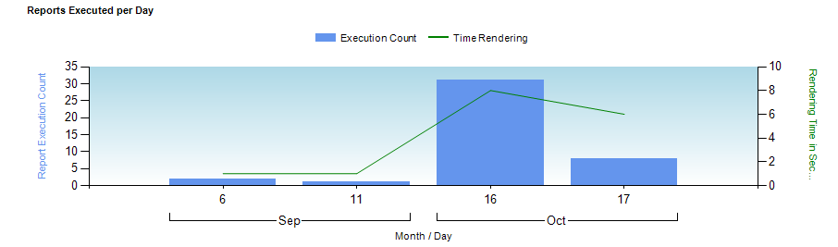

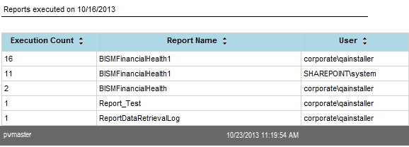

1. **Top 10 - Most Frequently Executed Reports:** This table has execution count at individual report level with their average processing, retrieval and rendering time. Additionally this report also has information about their total byte and row counts. On hover over each time cell it will show Total, Fastest and Slowest times.

User can click on each individual report to see the details of when and who ran the report along with their average processing, retrieval and rendering time.

The default view of this report shows Top 10 most frequently executed reports. User can click “[Browse execution log for all reports](http://oncdkeng04:9000/_layouts/ReportServer/RSViewerPage.aspx?rv:RelativeReportUrl=/AdminReports/ReportExecutionLog.rdl&Source=http%3A%2F%2Foncdkeng04%3A9000%2FAdminReports%2FForms%2FAllItems%2Easpx&DefaultItemOpen=1)” to view details of all reports.

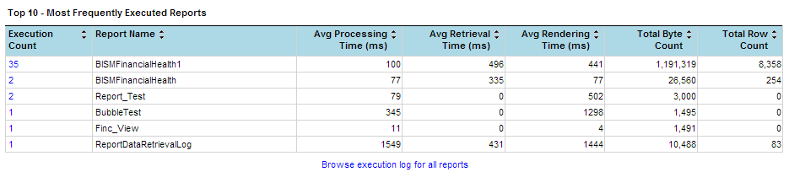

1. **Un-Used Reports:** This table lists all the reports which are not executed in the specified date range. This has a details who created it and path for report. Administrator may use this information to remove all un-used reports by contacting the owner of report.

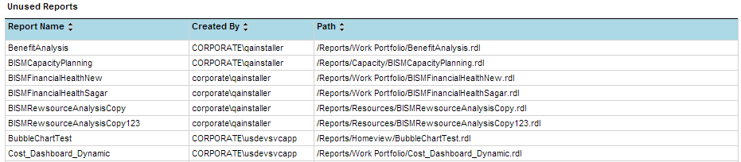

**Setting Threshold:** User can set specific criteria for their admin report by clicking “Set Threshold on Execution Log” link which is present at Top right side on main page.

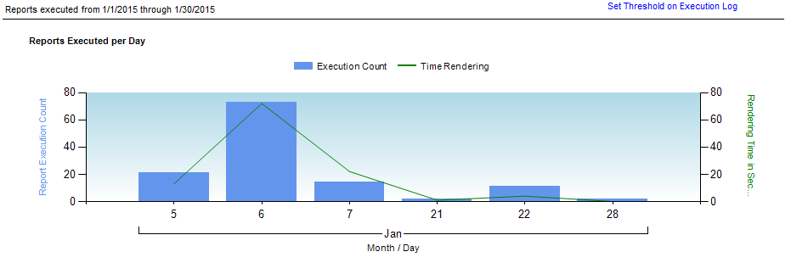

User has flexibility to set threshold at Rendering, Retrieval and processing time. The value should be set in millisecond second.

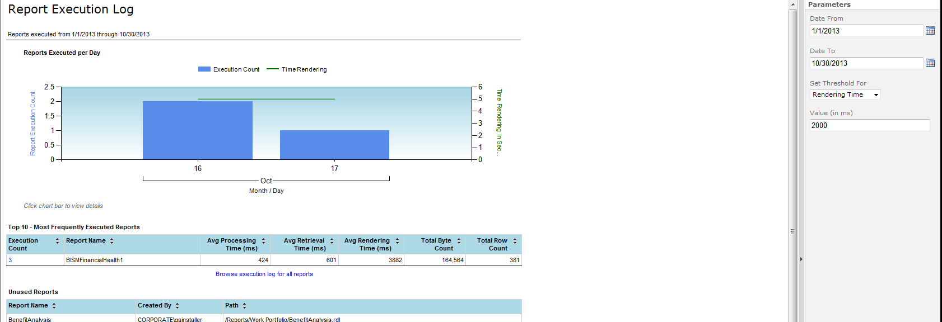

**Below is the list of reports:**

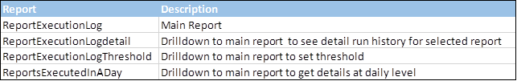

Note: In order to run these reports on sharepoint “[ReportServer_DS](http://oncdkeng08:9500/Data%20Sources/ReportServer_DS.rsds)” datasource must be enabled and pointing to report server database.