BTREE

#include <stdio.h>
#include <stdlib.h>

#define MAX 3
#define MIN 2

struct BTreeNode
{
int val[MAX + 1], count;
struct BTreeNode *link[MAX + 1];
};

struct BTreeNode *root;
struct BTreeNode *createNode(int val, struct BTreeNode *child) {
struct BTreeNode *newNode;
newNode = (struct BTreeNode *)malloc(sizeof(struct BTreeNode));
newNode->val[1] = val;
newNode->count = 1;
newNode->link[0] = root;
newNode->link[1] = child;
return newNode;
}
void insertNode(int val, int pos, struct BTreeNode *node,
struct BTreeNode *child) {
int j = node->count;
while (j > pos) {
node->val[j + 1] = node->val[j];
node->link[j + 1] = node->link[j];
j--;
}
node->val[j + 1] = val;
node->link[j + 1] = child;
node->count++;
}
void splitNode(int val, int *pval, int pos, struct BTreeNode *node,
struct BTreeNode *child, struct BTreeNode **newNode) {
int median, j;

if (pos > MIN)
median = MIN + 1;
else
median = MIN;

*newNode = (struct BTreeNode *)malloc(sizeof(struct BTreeNode));
j = median + 1;
while (j <= MAX) {
(*newNode)->val[j - median] = node->val[j];
(*newNode)->link[j - median] = node->link[j];
j++;
}
node->count = median;
(*newNode)->count = MAX - median;

if (pos <= MIN) {
insertNode(val, pos, node, child);
} else {
insertNode(val, pos - median, *newNode, child);
}
*pval = node->val[node->count];
(*newNode)->link[0] = node->link[node->count];
node->count--;
}
int setValue(int val, int *pval,
struct BTreeNode *node, struct BTreeNode **child) {
int pos;
if (!node) {
*pval = val;
*child = NULL;
return 1;
}

if (val < node->val[1]) {
pos = 0;
} else {
for (pos = node->count;
(val < node->val[pos] && pos > 1); pos--)
;
if (val == node->val[pos]) {
printf("Duplicates are not permitted\n");
return 0;
}
}
if (setValue(val, pval, node->link[pos], child)) {
if (node->count < MAX) {
insertNode(*pval, pos, node, *child);
} else {
splitNode(*pval, pval, pos, node, *child, child);
return 1;
}
}
return 0;
}
void insert(int val) {
int flag, i;
struct BTreeNode *child;

flag = setValue(val, &i, root, &child);
if (flag)
root = createNode(i, child);
}
void search(int val, int *pos, struct BTreeNode *myNode) {
if (!myNode) {
return;
}

if (val < myNode->val[1]) {
*pos = 0;
} else {
for (*pos = myNode->count;
(val < myNode->val[*pos] && *pos > 1); (*pos)--)
;
if (val == myNode->val[*pos]) {
printf("%d is found", val);
return;
}
}
search(val, pos, myNode->link[*pos]);

return;
}

void traversal(struct BTreeNode *myNode) {
int i;
if (myNode) {
for (i = 0; i < myNode->count; i++) {
traversal(myNode->link[i]);
printf("%d ", myNode->val[i + 1]);
}
traversal(myNode->link[i]);
}
}

int main() {
int val, ch;

insert(8);
insert(9);
insert(10);
insert(11);
insert(15);
insert(16);
insert(17);
insert(18);
insert(20);
insert(23);

traversal(root);

printf("\n");
search(11, &ch, root);
}

OUTPUT

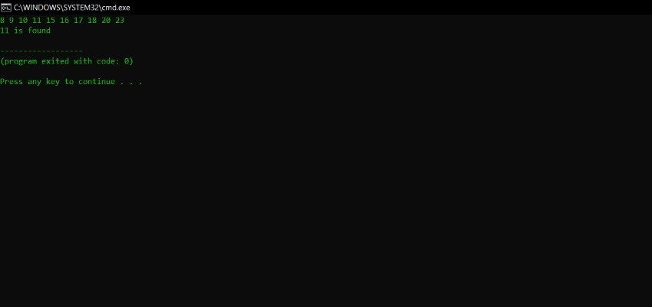

BST

#include<stdio.h>
#include<malloc.h>
#include<stdlib.h>
struct tree{
int info;
struct tree *right;
struct tree *left;
};
struct tree *root=NULL;

void create(){
int n,item;
struct tree *q;
printf("\nEnter the number of nodes to be entered\t");
scanf("%d",&n);
for(int i=0;i<n;i++){
struct tree *p;
p=malloc(sizeof(struct tree));
printf("\nEnter the data ");
scanf("%d",&item);
p->info=item;
p->left=NULL;
p->right=NULL;
if(i==0){
root=p;
}
else{
q=root;
while(1){
if(p->info>q->info){
if(q->right==NULL){
q->right=p;
break;
}
else{
q=q->right;
}
}
else{
if(q->left==NULL){
q->left=p;
break;
}
else{
q=q->left;
}
}
}
}
}
}

void preorder(struct tree *r){
struct tree *t=r;
if(t==NULL)
return;
else{
printf("\t%d",t->info);
preorder(t->left);
preorder(t->right);
}
}

void postorder(struct tree *r){
struct tree *t=r;
if(t==NULL)
return;
else{

postorder(t->left);
postorder(t->right);
printf("\t%d",t->info);
}
}
void inorder(struct tree *r){
struct tree *t=r;
if(t==NULL)
return;
else{

inorder(t->left);
printf("\t%d",t->info);
inorder(t->right);

}
}

struct tree * min(struct tree *r){
struct tree *t=r;
if(t==NULL)
return t;
else{
while(t->left!=NULL){
t=t->left;
}
}
return t;
}

struct tree * max(struct tree *r){
struct tree *t=r;
if(t==NULL)
return t;
else{
while(t->right!=NULL){
t=t->right;
}
}
return t;

}
struct tree * search(struct tree *r,int key){
if(r==NULL){
return 0;
}
else if(key==r->info){
return r;
}
else{
if(key<r->info){
search(r->left,key);
}
else
{
search(r->right,key);
}
}

}

struct tree * inorder_successor(struct tree * t){
if(t->right!=NULL){
struct tree *r=t->right;
while(r->left!=NULL){
r=r->left;
}
return r;
}
else{
struct tree * r=root;
struct tree * s;
while(r->info!=t->info){
if(t->info < r->info){
s=r;
r=r->left;
}
else{
r=r->right;
}
}
return s;
} }

struct tree * delete(struct tree *r,int key){
if(r==NULL){
return r;
}
else if(key<r->info){
printf("\nr to left");
r->left=delete(r->left,key);
printf("\n left set");

}
else if(key>r->info){
printf("\nr to right");
r->right=delete(r->right,key);
printf("\n right set");

}
else{
printf("\nkey matched");
if(r->left==NULL && r->right==NULL){
printf("2 NULL");
free(r);
return NULL;
}
else if(r->left==NULL){
struct tree *temp=r->right;
free(r);
printf("left NULL");
return temp;
}

else if(r->right==NULL){
struct tree *temp=r->left;
free(r);
printf("right NULL");
return temp;
}
struct tree *temp=min(r->right);
printf("found inorder successor");
r->info=temp->info;
r->right=delete(r->right,temp->info);

}
return r;
}

void main(){
int c,k;
struct tree * res;
struct tree * in;
struct tree * ret;
do{
printf("\n1-Insert\n2-preorder\n3-postorder\n4-inorder\n5-Minimum\n6-Maximum\n7-Search\n8-Inorder successor\n9-delete\n0-exit\nEnter choice; ");
scanf("%d",&c);
switch(c){
case 1:create();break;
case 2:preorder(root);break;
case 3:postorder(root);break;
case 4:inorder(root);break;
case 5:ret=min(root);
printf("\nMinimum Node:%d",ret->info);
break;
case 6:ret=max(root);
printf("\nMaximum Node: %d",ret->info);
break;
case 7:printf("\nEnter the data to be searched: ");
scanf("%d",&k);
ret=search(root,k);
if(ret->info==k){
printf("\nNode Found");
}
else{
printf("\nNode Not Found");
}
break;
case 8:printf("\nEnter the node to find its inorder successor: ");
scanf("%d",&k);
ret=search(root,k);
printf("%d",ret->info);
if(ret->info==k){
res=inorder_successor(ret);
printf("\nInorder Successor=%d",res->info);
}
else{
printf("\nNo Such Node to Find the Inorder Successor");
}
break;
case 9:printf("\nEnter the data to be deleted: ");
scanf("%d",&k);
if(k==root->info){
root=NULL;
}
else{
delete(root,k);
}
break;
case 0:exit(0);break;
default:printf("\nInvalid Choice");break;
}
}while(1);

}

OUTPUT
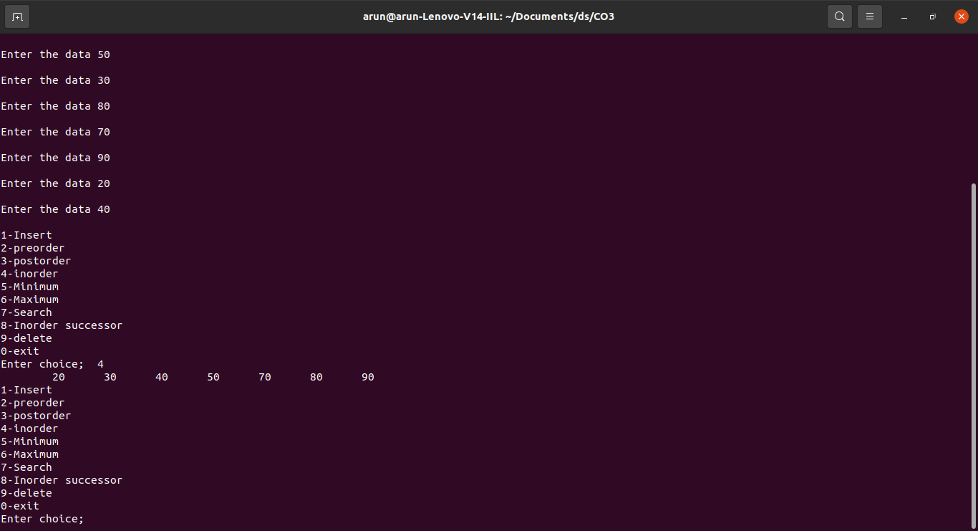

RBT

#include <stdio.h>
#include <stdlib.h>
enum nodeColor {
RED,
BLACK
};
struct rbNode {
int data, color;
struct rbNode *link[2];
};
struct rbNode *root = NULL;
// Create a red-black tree
struct rbNode *createNode(int data) {
struct rbNode *newnode;
newnode = (struct rbNode *)malloc(sizeof(struct rbNode));
newnode->data = data;
newnode->color = RED;
newnode->link[0] = newnode->link[1] = NULL;
return newnode;
}
// Insert an node
void insertion(int data) {
struct rbNode *stack[98], *ptr, *newnode, *xPtr, *yPtr;
int dir[98], ht = 0, index;
ptr = root;
if (!root) {
root = createNode(data);
return;
}

stack[ht] = root;
dir[ht++] = 0;
while (ptr != NULL) {
if (ptr->data == data) {
printf("Duplicates Not Allowed!!\n");
return;
}
index = (data - ptr->data) > 0 ? 1 : 0;
stack[ht] = ptr;
ptr = ptr->link[index];
dir[ht++] = index;
}
stack[ht - 1]->link[index] = newnode = createNode(data);
while ((ht >= 3) && (stack[ht - 1]->color == RED)) {
if (dir[ht - 2] == 0) {
yPtr = stack[ht - 2]->link[1];
if (yPtr != NULL && yPtr->color == RED) {
stack[ht - 2]->color = RED;
stack[ht - 1]->color = yPtr->color = BLACK;
ht = ht - 2;
} else {
if (dir[ht - 1] == 0) {
yPtr = stack[ht - 1];
} else {
xPtr = stack[ht - 1];
yPtr = xPtr->link[1];
xPtr->link[1] = yPtr->link[0];
yPtr->link[0] = xPtr;
stack[ht - 2]->link[0] = yPtr;
}
xPtr = stack[ht - 2];
xPtr->color = RED;
yPtr->color = BLACK;
xPtr->link[0] = yPtr->link[1];
yPtr->link[1] = xPtr;
if (xPtr == root) {
root = yPtr;
} else {
stack[ht - 3]->link[dir[ht - 3]] = yPtr;
}
break;
}
} else {
yPtr = stack[ht - 2]->link[0];
if ((yPtr != NULL) && (yPtr->color == RED)) {
stack[ht - 2]->color = RED;
stack[ht - 1]->color = yPtr->color = BLACK;
ht = ht - 2;
} else {
if (dir[ht - 1] == 1) {
yPtr = stack[ht - 1];
} else {
xPtr = stack[ht - 1];
yPtr = xPtr->link[0];
xPtr->link[0] = yPtr->link[1];
yPtr->link[1] = xPtr;
stack[ht - 2]->link[1] = yPtr;
}
xPtr = stack[ht - 2];
yPtr->color = BLACK;
xPtr->color = RED;
xPtr->link[1] = yPtr->link[0];
yPtr->link[0] = xPtr;
if (xPtr == root) {
root = yPtr;
} else {
stack[ht - 3]->link[dir[ht - 3]] = yPtr;
}
break;
}
}
}
root->color = BLACK;
}
// Delete a node
void deletion(int data) {
struct rbNode *stack[98], *ptr, *xPtr, *yPtr;
struct rbNode *pPtr, *qPtr, *rPtr;
int dir[98], ht = 0, diff, i;
enum nodeColor color;

if (!root) {
printf("Tree not available\n");
return;
}

ptr = root;
while (ptr != NULL) {
if ((data - ptr->data) == 0)
break;
diff = (data - ptr->data) > 0 ? 1 : 0;
stack[ht] = ptr;
dir[ht++] = diff;
ptr = ptr->link[diff];
}

if (ptr->link[1] == NULL) {
if ((ptr == root) && (ptr->link[0] == NULL)) {
free(ptr);
root = NULL;
} else if (ptr == root) {
root = ptr->link[0];
free(ptr);
} else {
stack[ht - 1]->link[dir[ht - 1]] = ptr->link[0];
}
} else {
xPtr = ptr->link[1];
if (xPtr->link[0] == NULL) {
xPtr->link[0] = ptr->link[0];
color = xPtr->color;
xPtr->color = ptr->color;
ptr->color = color;

if (ptr == root) {
root = xPtr;
} else {
stack[ht - 1]->link[dir[ht - 1]] = xPtr;
}

dir[ht] = 1;
stack[ht++] = xPtr;
} else {
i = ht++;
while (1) {
dir[ht] = 0;
stack[ht++] = xPtr;
yPtr = xPtr->link[0];
if (!yPtr->link[0])
break;
xPtr = yPtr;
}

dir[i] = 1;
stack[i] = yPtr;
if (i > 0)
stack[i - 1]->link[dir[i - 1]] = yPtr;

yPtr->link[0] = ptr->link[0];

xPtr->link[0] = yPtr->link[1];
yPtr->link[1] = ptr->link[1];

if (ptr == root) {
root = yPtr;
}

color = yPtr->color;
yPtr->color = ptr->color;
ptr->color = color;
}
}

if (ht < 1)
return;

if (ptr->color == BLACK) {
while (1) {
pPtr = stack[ht - 1]->link[dir[ht - 1]];
if (pPtr && pPtr->color == RED) {
pPtr->color = BLACK;
break;
}

if (ht < 2)
break;

if (dir[ht - 2] == 0) {
rPtr = stack[ht - 1]->link[1];

if (!rPtr)
break;

if (rPtr->color == RED) {
stack[ht - 1]->color = RED;
rPtr->color = BLACK;
stack[ht - 1]->link[1] = rPtr->link[0];
rPtr->link[0] = stack[ht - 1];

if (stack[ht - 1] == root) {
root = rPtr;
} else {
stack[ht - 2]->link[dir[ht - 2]] = rPtr;
}
dir[ht] = 0;
stack[ht] = stack[ht - 1];
stack[ht - 1] = rPtr;
ht++;

rPtr = stack[ht - 1]->link[1];
}

if ((!rPtr->link[0] || rPtr->link[0]->color == BLACK) &&
(!rPtr->link[1] || rPtr->link[1]->color == BLACK)) {
rPtr->color = RED;
} else {
if (!rPtr->link[1] || rPtr->link[1]->color == BLACK) {
qPtr = rPtr->link[0];
rPtr->color = RED;
qPtr->color = BLACK;
rPtr->link[0] = qPtr->link[1];
qPtr->link[1] = rPtr;
rPtr = stack[ht - 1]->link[1] = qPtr;
}
rPtr->color = stack[ht - 1]->color;
stack[ht - 1]->color = BLACK;
rPtr->link[1]->color = BLACK;
stack[ht - 1]->link[1] = rPtr->link[0];
rPtr->link[0] = stack[ht - 1];
if (stack[ht - 1] == root) {
root = rPtr;
} else {
stack[ht - 2]->link[dir[ht - 2]] = rPtr;
}
break;
}
} else {
rPtr = stack[ht - 1]->link[0];
if (!rPtr)
break;

if (rPtr->color == RED) {
stack[ht - 1]->color = RED;
rPtr->color = BLACK;
stack[ht - 1]->link[0] = rPtr->link[1];
rPtr->link[1] = stack[ht - 1];

if (stack[ht - 1] == root) {
root = rPtr;
} else {
stack[ht - 2]->link[dir[ht - 2]] = rPtr;
}
dir[ht] = 1;
stack[ht] = stack[ht - 1];
stack[ht - 1] = rPtr;
ht++;

rPtr = stack[ht - 1]->link[0];
}
if ((!rPtr->link[0] || rPtr->link[0]->color == BLACK) &&
(!rPtr->link[1] || rPtr->link[1]->color == BLACK)) {
rPtr->color = RED;
} else {
if (!rPtr->link[0] || rPtr->link[0]->color == BLACK) {
qPtr = rPtr->link[1];
rPtr->color = RED;
qPtr->color = BLACK;
rPtr->link[1] = qPtr->link[0];
qPtr->link[0] = rPtr;
rPtr = stack[ht - 1]->link[0] = qPtr;
}
rPtr->color = stack[ht - 1]->color;
stack[ht - 1]->color = BLACK;
rPtr->link[0]->color = BLACK;
stack[ht - 1]->link[0] = rPtr->link[1];
rPtr->link[1] = stack[ht - 1];
if (stack[ht - 1] == root) {
root = rPtr;
} else {
stack[ht - 2]->link[dir[ht - 2]] = rPtr;
}
break;
}
}
ht--;
}
}
}
// Print the inorder traversal of the tree
void inorderTraversal(struct rbNode *node) {
if (node) {
inorderTraversal(node->link[0]);
printf("%d ", node->data);
inorderTraversal(node->link[1]);
}
return;
}

int main() {
int ch, data;
while (1) {
printf("1. Insertion\t2. Deletion\n");
printf("3. Traverse\t4. Exit");
printf("\nEnter your choice:");
scanf("%d", &ch);
switch (ch) {
case 1:
printf("Enter the element to insert:");
scanf("%d", &data);
insertion(data);
break;
case 2:
printf("Enter the element to delete:");
scanf("%d", &data);
deletion(data);
break;
case 3:
inorderTraversal(root);
printf("\n");
break;
case 4:
exit(0);
default:
printf("Not available\n");
break;
}
printf("\n");
}
return 0;
}

