Prims Algorithm

#include<stdio.h>
#include<stdbool.h>
#define infinity 1000
//#define v 5

int graph[20][20];
int v;

void mst(bool span[]){

int edge_count=0,total=0,x,y;

span[0]=1;
printf("\nEdge : Weight\n");
while(edge_count<v-1){
int cost=infinity;
for(int i=0;i<v;i++){
if(span[i]){
for(int j=0;j<v;j++){
if(!span[j] && graph[i][j]){
if(graph[i][j] < cost){
cost=graph[i][j];
x=i;
y=j;
}
}
}
}
}
printf("%d - %d : %d\n", x, y, graph[x][y]);
total+=graph[x][y];
span[y]=1;
edge_count++;
}
printf("\nTotal Cost=%d\n",total);
}

void main(){
printf("\nEnter the number of vertices ");
scanf("%d",&v);
printf("\nEnter the Adjacency Matrix \n");
for(int i=0;i<v;i++){
for(int j=0;j<v;j++){
scanf("%d",&graph[i][j]);
}
}

for(int i=0;i<v;i++){
graph[i][i]=0;
}

bool span[v];
for(int i=0;i<v;i++){
span[i]=0;
}

mst(span);

}

OUTPUT

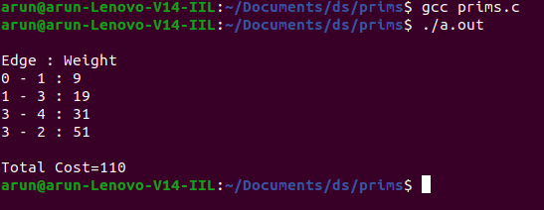

KRUSKALS ALGORITHM

#include<stdio.h>
#include<conio.h>
#include<stdlib.h>
/*int graph[v][v] ={{0,2,3,0},
{2,0,2,1},
{3,2,0,4},
{0,1,4,0}}
*/
int i,j,a,b,u,v,n,ne=1;
int min,cost=0,graph[9][9],parent[9];
int find(int);
int uni(int,int);
void main()
{
printf("\nEnter the no. of vertices:");
scanf("%d",&n);
printf("\nEnter the cost adjacency matrix:\n");
for(i=1;i<=n;i++)
{
for(j=1;j<=n;j++)
{
printf("Enter the edge weight of %d to %d ",i,j);
scanf("%d",&graph[i][j]);
if(graph[i][j]==0)
graph[i][j]=999;
}
}
printf("The edges of Minimum cost Spanning Tree are\n");
while(ne < n)
{
min=999;
for(i=1;i<=n;i++)
{
for(j=1;j<=n;j++)
{
if(graph[i][j] < min)
{
min=graph[i][j];
a=u=i;
b=v=j;
}
}
}
u=find(u);
v=find(v);
if(uni(u,v))
{
printf("edge (%d,%d) =%d\n",a,b,min);
cost +=min;
ne++;
}
graph[a][b]=graph[b][a]=999;
}
printf("\nMinimum cost = %d\n",cost);
}
int find(int i)
{
while(parent[i])
{
i=parent[i];
}
return i;
}
int uni(int i,int j)
{
if(i!=j)
{
parent[j]=i;
return 1;
}
return 0;
}

OUTPUT

TOPOLOGICAL SORT

#include <stdio.h>
void main() {
int n = 0;
printf("enter how many vertex are there - ");
scanf("%d", & n);
int a[n][n], tp[n], f[n], x = 0;

//considering the vertices to be numbers
printf("\nEnter 1 if an edge exits or otherwise\n");
for (int i = 1; i <= n; i++) {
f[i - 1] = 0;
for (int j = 1; j <= n; j++) {
printf("Does an edge exists from %d to %d - ", i, j);
scanf("%d", & a[i - 1][j - 1]);
}
}
while (x < n) {
//finding indegree of all vertices
int in = 0, ind[n];
for (int i = 0; i < n; i++) {
for (int j = 0; j < n; j++) {
if (a[j][i] == 1) {
in ++;
}
}
ind[i] = in ; in = 0;
}
//Actual sorting
int t = 0;
for (t = 0; t < n; t++) {
if (ind[t] == 0 && f[t] == 0) {
f[t] = 1;
printf("%d ", t + 1);
break;
}
}
printf("\n");
//updating matrix with new values
for (int i = 0; i < n; i++) {
if (a[t][i] == 1) {
a[t][i] = 0;
}
}
x++;
}
}

OUTPUT

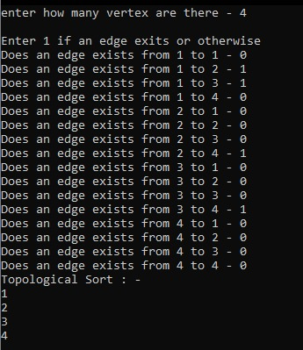

DFS

#include<stdio.h>
int graph[10][10],v,visited[10];
void dfs(int x){
printf("%d\t",x);
visited[x]=1;
for(int j=0;j<v;j++){
if(!visited[j] && graph[x][j]==1){
dfs(j);
}
}
}

void main(){
printf("\nEnter the number of vertices ");
scanf("%d",&v);
printf("\nEnter the adjacency matrix\n");
for(int i=0;i<v;i++){
for(int j=0;j<v;j++){
scanf("%d",&graph[i][j]);
}
}

for(int i=0;i<v;i++){
graph[i][i]=0;
}

for(int i=0;i<v;i++){
visited[i]=0;
}
printf("\nDEPTH FIRST SEARCH\n");
dfs(0);
}

OUTPUT

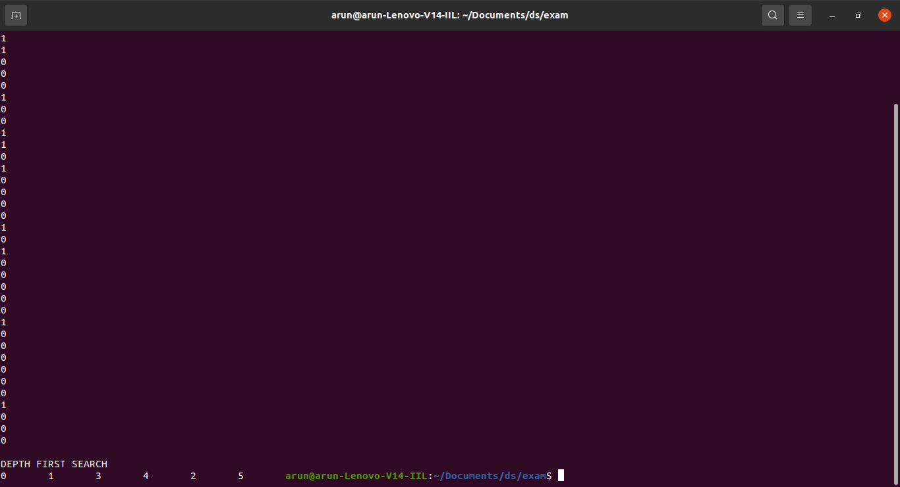

BFS

#include<stdio.h>
int a[20][20],q[20],visited[20],n,i,j,f=0,r=-1;
void bfs(int v);
void main() {
int v; //call the value of starting vertex
printf("\n Enter the number of vertices:");
scanf("%d",&n);
printf("enter the adjecency matrix");
for (i=0;i<n;i++)
{
for (j=0;j<n;j++)
{
scanf("%d",&a[i][j]);
}
}
printf("\n Enter the starting vertex:");
scanf("%d",&v);
for (i=0;i<n;i++)
{
q[i]=0;
visited[i]=0;
}
bfs(v);
printf("\n The node which are reachable are:\n");
for (i=1;i<=n;i++)
{
if(visited[i])
{
printf("%d\t",i);
}
}
}

void bfs(int v)
{
for (i=0;i<n;i++)
{
if(a[v][i] && !visited[i])
q[++r]=i;
}
if(f<=r)
{
visited[q[f]]=1;
bfs(q[f++]);
}
}

OUTPUT

