Loomwork
An open operating system for portable personal agents.

Defines two open specifications — the Agent Container Image (ACI), a signed, portable format that lets agents run identically across IDEs, devices, and runtimes; and the Agent Mesh Protocol (AMP), a peer-to-peer wire protocol for agent-to-agent delegation, capability negotiation, and credit accounting. Together they close the gap left by MCP and turn agents into first-class, composable, ownable units of computing.
Document | Loomwork PRD & Architecture
Version | 0.1 · Draft
Date | 28 September 2026
Status | Open for community review
Scope | ACI spec · AMP wire format · market thesis
License | Apache 2.0 (runtime) · CC-BY 4.0 (spec)

Table of Contents
Table of Contents 1
1. Executive Summary 2
2. Market Thesis 2
2.1 What is trending on GitHub 3
2.2 The seven drivers of traction 3
2.3 The gap nobody has claimed 3
2.4 Why now 4
3. Loomwork Architecture Overview 4
3.1 Layer responsibilities 5
3.2 Design principles 5
3.3 What is not in scope 5
4. ACI — Agent Container Image Specification 5
4.1 Goals and non-goals 6
4.2 File layout 6
4.3 Manifest schema 6
4.4 Persona block 7
4.5 Skills graph 7
4.6 Tool bindings 8
4.7 Sandbox spec 8
4.8 Signing and provenance 9
4.9 Runtime contract 9
4.10 Versioning and compatibility 9
4.11 Conformance requirements 10
5. AMP — Agent Mesh Protocol Wire Format 10
5.1 Design goals 10
5.2 Transport bindings 11
5.3 Message envelope 11
5.4 Capability negotiation handshake 11
5.5 Core RPCs 12
5.5.1 amp/delegate 12
5.5.2 amp/negotiate 13
5.5.3 amp/report 13
5.5.4 amp/credit 13
5.5.5 amp/subscribe and amp/cancel 14
5.6 Task graph and shared state 14
5.7 Credit and accounting 14
5.8 Security model 15
5.9 Error code registry 15
5.10 Version negotiation and backwards compatibility 15
6. Relationship to Existing Protocols 16
7. Roadmap and Risks 16
7.1 Roadmap 17
7.2 Top risks and mitigations 17
7.3 Open questions 17
Appendix A. Glossary 18
Right-click to update field.

1. Executive Summary
The dominant AI agents of 2026 — OpenClaw, OpenHands, GitHub Copilot Mission Control, Bolt.new, Totalum — share a common architectural shape: a capable LLM, a sandbox, a set of tools exposed via the Model Context Protocol (MCP), and an IDE- or chat-bound surface. They are powerful, but they are also sealed. The agent's persona, skills, memory schema, and tool bindings live inside one vendor's runtime. You cannot take an agent you built in Cursor and run it in Claude Code. You cannot let your laptop agent talk to your phone agent. Your memory does not follow you across vendors. And the apps that vibe-coded tools produce ship with no verification gate, which is why serious teams still hand-review every line.
Loomwork is an open-source operating system for portable personal agents that closes these gaps. It is built on two specifications introduced by this document. The Agent Container Image (ACI) is a signed, portable package format for an agent — persona, skill graph, MCP tool bindings, sandbox policy, memory schema, and Sigstore provenance — that runs identically inside any compliant runtime. The Agent Mesh Protocol (AMP) is a peer-to-peer wire protocol, layered on top of MCP, that lets agents delegate, negotiate capabilities, exchange credit, and subscribe to each other's events. Together they turn an agent from a vendor-bound artifact into a first-class, ownable, composable unit of computing — the way Docker turned a server process into a portable artifact, and the way HTTP turned a document into a network resource.
This document specifies ACI and AMP at reference-grade depth, suitable for independent implementation. It opens with a market thesis grounding the design in concrete GitHub trends from the last 90 days, then presents the four-pillar architecture, then dedicates one chapter each to ACI and AMP, including JSON schemas, wire-format examples, sequence diagrams, error-code registries, and conformance requirements expressed in RFC 2119 language. The document closes with a comparison to existing protocols, a 90-day to 24-month roadmap, and an explicit list of open questions. The intended audience is founding engineers who will build the reference runtime and seed the first agents, and investors evaluating whether the timing is right to back an open agent standard.
The ask
Ship ACI v0.1 and AMP v0.1 as open specifications within 90 days, accompanied by a reference Rust runtime, three example agents packaged as ACIs, and a conformance test suite. Apache 2.0 for code, CC-BY 4.0 for the specifications. Working group governed under a neutral foundation (candidate: OpenSSF or Linux Foundation AI & Data).

2. Market Thesis
Every design choice in Loomwork is grounded in observed developer behavior on GitHub over the last 60 to 90 days. This section enumerates what is trending, extracts the underlying drivers of that traction, and identifies the specific gap Loomwork fills.

2.1 What is trending on GitHub
The most striking trend of late 2025 and early 2026 is the velocity of OpenClaw, a Node.js framework that provides OS-level control to AI agents and ships 20+ messaging-platform adapters. Star trackers widely report it went from zero to roughly 390,000 stars in approximately 60 days, surpassing totals that took React 13 years to reach. DigitalOcean noted a 9,000 to 60,000-star jump in a single 72-hour window in late January 2026. Whatever one thinks of the project itself, the velocity is unprecedented and signals that a large latent population of developers was waiting for exactly this category of tool.
Alongside OpenClaw, OpenHands (formerly OpenDevin) has stabilized as the reference open-source autonomous coding agent — a Docker-sandboxed, MIT-licensed platform cited by essentially every 'best of 2026' list. The Model Context Protocol has become the de-facto standard for connecting agents to tools: Anthropic's reference server repository and hundreds of community MCP servers (Context7, GitHub, Playwright, Filesystem, Totalum, Twitter) now anchor the trending feed. Ollama and vLLM continue to grow as the local-first inference substrate, and Bolt.new and Totalum have popularized vibe-coded app generation — natural-language input to deployable Next.js application. Most recently, GitHub itself exposed Copilot Mission Control, an async cloud coding agent that fans out GitHub issues to background agents that open PRs.

2.2 The seven drivers of traction
Reading these projects against their traction, seven recurring drivers emerge. Each driver is independent, and the most successful projects hit several at once.
Driver | What it looks like in practice
1. Open-source and self-hostable | Developers are tired of per-seat SaaS pricing. OpenHands, Ollama, and the MCP ecosystem let you own the runtime.
2. Protocol-driven composability | MCP won because one server works in Claude Code, Cursor, Codex, Copilot, and Windsurf. Write-once, run-in-five-clients is the TCP/IP moment for agents.
3. OS-level reach | OpenClaw's killer feature isn't the LLM — it's that one agent drives Discord, Telegram, WhatsApp, Slack, X, the filesystem, and the browser. Reach beats chat.
4. Async and parallelizable | Copilot Mission Control and OpenHands both let you fan out 10 issues to 10 agents and review PRs later. The mental model shifted from pair-programmer to spawnable junior dev team.
5. Local-first and private | Ollama's continued growth and OpenClaw's 'runs on your machine' framing reflect a real constituency that will not send data to OpenAI.
6. Vibe-coded app generation | Bolt.new + Totalum lowered the floor. The audience expanded from developers to anyone who can describe an app.
7. Viral launch craft | OpenClaw's 9K-to-60K-stars-in-72-hours was driven by a great demo gif, a clean README, and a synchronized Hacker News + Reddit + X drop.

Loomwork is engineered to hit drivers 1 through 5 by design, and to amplify 6 and 7 via the Vibe-to-Verified pipeline and the ACI marketplace respectively. No existing trending project hits all seven.

2.3 The gap nobody has claimed
Look at what is missing from the trending list. MCP standardizes how an agent calls a tool, but the agent itself — its persona, skills, memory schema, prompts, sandbox config, and signing identity — is still locked inside Cursor, Claude Code, Copilot, or Codex. You cannot docker pull an agent. There is no agent-to-agent protocol: MCP is agent-to-tool only, so your research agent cannot formally delegate a subtask to your coding agent. There is no continuous personal memory that follows the user across vendors; every session starts fresh, and your Claude in Cursor does not know what your Copilot in the browser did yesterday. Vibe-coded apps ship broken because there is no open, end-to-end verification gate. And there is no personal agent mesh — your laptop agent, phone agent, and home-server agent do not coordinate without a central cloud.

2.4 Why now
MCP was introduced by Anthropic in late 2024 and reached mainstream adoption through 2025. By mid-2026 it is the lingua franca of agent-to-tool communication. The natural next layer is the agent itself as a portable unit. Whoever defines that layer in 2026 — with an open, well-specced, community-governed format — will set the standard for the next decade of agent tooling, the same way Docker's OCI image format set the standard for cloud-native deployment after Linux containers had been around for years without a common packaging layer. The window is narrow: OpenClaw's viral trajectory shows the demand exists, and a closed-vendor capture of the agent-portability layer is the main competitive risk. The time to ship an open spec is now.

3. Loomwork Architecture Overview
Loomwork is best understood as a five-layer stack. The two layers Loomwork specifies — ACI and AMP — sit in the middle, above the existing MCP and LLM-runtime substrate and below the application and mesh-runtime layers. Each layer is independently replaceable, and every layer above the ACI/AMP core is optional: a single-agent single-device setup uses only ACI + MCP, while a full multi-device team deployment uses all five layers.
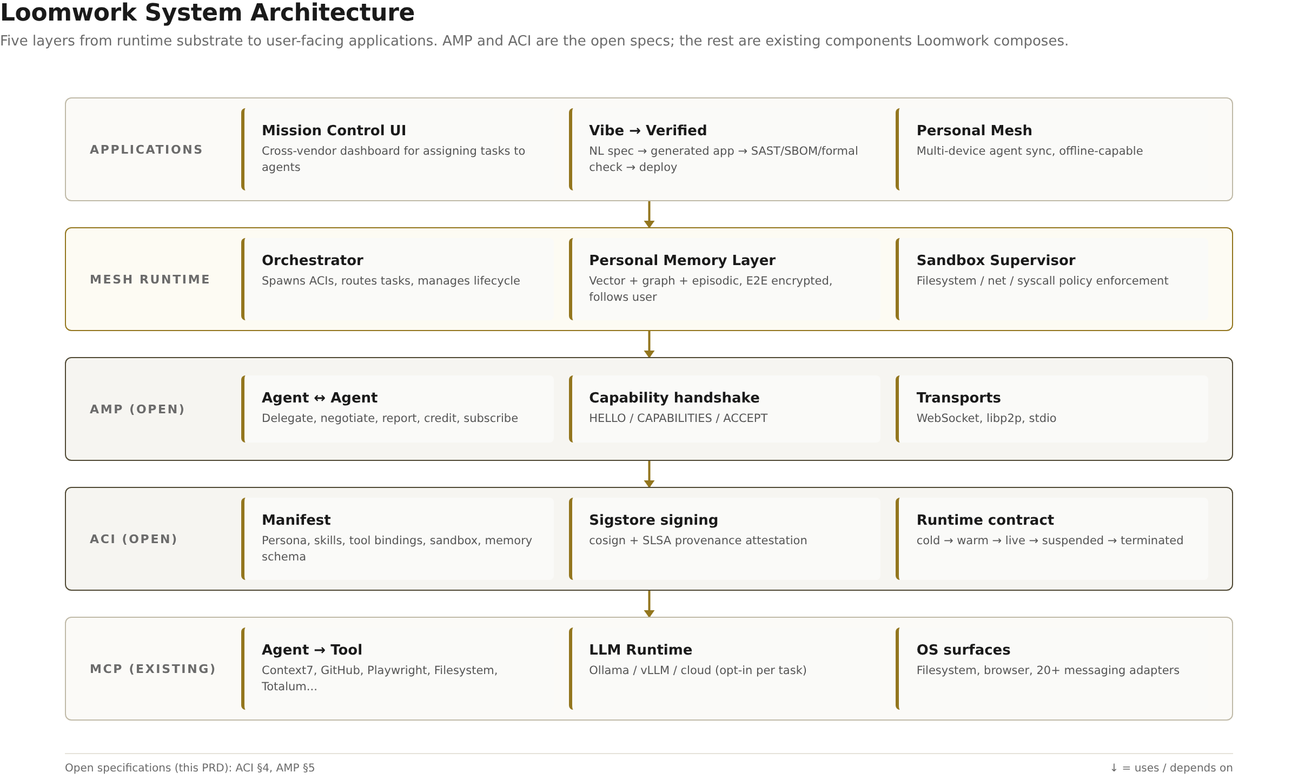
Figure 1. Loomwork five-layer architecture. ACI and AMP are the open specifications; the other layers compose existing components.

3.1 Layer responsibilities
Layer | Owner | Responsibility
Applications | Vendor / user | Mission Control UI, Vibe-to-Verified pipeline, Personal Mesh sync UI. Talks to Mesh Runtime only.
Mesh Runtime | Loomwork runtime | Spawns ACIs, routes AMP traffic, manages lifecycle, enforces sandbox policy, hosts Personal Memory Layer. The orchestrator.
AMP | Loomwork spec (this document) | Peer-to-peer JSON-RPC wire protocol between agents. Delegate, negotiate, report, credit, subscribe.
ACI | Loomwork spec (this document) | Signed, portable agent image: manifest + persona + skills + tool bindings + sandbox + memory schema + provenance.
MCP + LLM runtime + OS | Existing open source | Agent-to-tool protocol (MCP), inference (Ollama / vLLM / cloud), OS surfaces (filesystem, browser, messaging).

3.2 Design principles
Four principles constrain every design decision in this document. First, open by default: every wire format, file format, and protocol described here is licensed to allow independent implementation without permission or royalty. Second, local-first: the reference runtime must work end-to-end on a single laptop with no network dependency; cloud and remote peers are opt-in accelerators, not requirements. Third, composable, not monolithic: an agent is a unit, but it is also a node in a graph; delegation, negotiation, and credit are first-class operations. Fourth, verified before trusted: every artifact an agent produces — code, file, network request, memory write — carries a signed provenance attestation so that downstream consumers can audit who did what, when, with which capability.

3.3 What is not in scope
Loomwork deliberately does not standardize the LLM runtime, the sandbox implementation, or the UI. Those are intentionally left to existing solutions (Ollama, vLLM, Docker, Firecracker, vendor IDEs). Loomwork also does not standardize a marketplace, payment rails, or governance — those are expected to emerge as separate layers above the spec, and the spec is designed to be marketplace-agnostic. Finally, Loomwork does not define a 'safe agent' — it defines the contract under which an agent's safety properties can be verified, but the verification itself is the responsibility of the Vibe-to-Verified pipeline, which is a runtime component, not a spec component.

4. ACI — Agent Container Image Specification
The Agent Container Image (ACI) is a signed, portable package format for an AI agent. An ACI file bundles everything required to reproduce an agent's behavior across compliant runtimes: persona, skill graph, MCP tool bindings, sandbox policy, memory schema, and cryptographic provenance. The design goals are portability (an ACI built for Cursor runs in Claude Code, on a phone, or on a Raspberry Pi), reproducibility (the same ACI + the same inputs produces the same outputs, modulo model nondeterminism), and auditability (every action is traceable to a signed identity).

4.1 Goals and non-goals
ACI's primary goal is to make an agent a portable artifact, analogous to how the OCI Image Format made a server process a portable artifact. An ACI must be self-describing: a runtime that has never seen the ACI before must be able to load it, verify its signature, prepare its sandbox, expose its declared tool bindings, and start it producing output — all without manual configuration. Secondary goals include minimal size (a basic ACI should fit in under 100 KB excluding bundled model weights), strong provenance (Sigstore + SLSA), and version independence (ACIs from v0.1 must remain loadable by v1.0 runtimes, with explicit capability negotiation for newly introduced features).
Explicit non-goals: ACI does not standardize the inference engine, the sandbox implementation, or the prompt template syntax. Prompt templating is delegated to the persona block, which may use any text format the runtime understands (Jinja, Mustache, or plain text with variable interpolation). Sandboxing is specified as policy intent (filesystem paths, network egress rules, syscall allowlist), not as implementation; the runtime is free to use Docker, Firecracker, gVisor, or native Linux seccomp as long as the declared policy is enforced.

4.2 File layout
An ACI is a tar archive (gzip-compressed by default) with the .aci extension. The top-level layout is fixed; runtimes MUST reject archives that omit any required file.
# Top-level layout of an ACI archive
my-agent-v1.2.3.aci
├── manifest.json # Required. Schema in §4.3.
├── persona/
│ ├── system_prompt.md # Required. The agent's identity.
│ └── few_shot.jsonl # Optional. Few-shot exemplars.
├── skills/
│ ├── graph.json # Required. DAG of named capabilities (§4.5).
│ └── src/ # Optional. Skill implementation source.
├── tools/
│ └── bindings.json # Required. MCP server refs + capability URLs (§4.6).
├── memory-schema.json # Required. Shape of agent's persistent memory.
├── sandbox.json # Required. Sandbox policy (§4.7).
├── signatures/
│ ├── manifest.sig # Required. Sigstore cosign signature over manifest.json.
│ ├── manifest.cert # Required. Signing certificate (Fulcio-issued).
│ └── slsa.intoto.json # Required. SLSA Level ≥3 provenance attestation.
└── README.md # Optional. Human-readable description.

4.3 Manifest schema
The manifest is the ACI's root of trust. It is a JSON document with a strict schema; runtimes MUST reject manifests that fail validation. Every other file in the archive is referenced by digest from the manifest, so the signature over the manifest transitively covers the entire ACI.
// manifest.json — JSON Schema (Draft 2020-12)
{
"$schema": "https://json-schema.org/draft/2020-12/schema",
"$id": "https://loomwork.dev/schemas/aci/manifest-v0.1.json",
"title": "ACI Manifest v0.1",
"type": "object",
"required": ["apiVersion", "kind", "metadata", "persona",
"skills", "tools", "memory", "sandbox", "digests"],
"properties": {
"apiVersion": { "const": "aci.loomwork.dev/v0.1" },
"kind": { "const": "Agent" },
"metadata": {
"type": "object",
"required": ["name", "version", "architecture", "os"],
"properties": {
"name": { "type": "string", "pattern": "^[a-z0-9][a-z0-9-]*$" },
"version": { "type": "string", "pattern": "^v?\d+\.\d+\.\d+" },
"architecture": { "enum": ["amd64", "arm64", "wasm"] },
"os": { "enum": ["linux", "darwin", "windows", "any"] },
"description": { "type": "string" },
"license": { "type": "string", "default": "Apache-2.0" },
"homepage": { "type": "string", "format": "uri" }
}
},
"persona": { "$ref": "#/$defs/PersonaRef" },
"skills": { "$ref": "#/$defs/SkillsRef" },
"tools": { "$ref": "#/$defs/ToolsRef" },
"memory": { "$ref": "#/$defs/MemoryRef" },
"sandbox": { "$ref": "#/$defs/SandboxRef" },
"digests": {
"type": "object",
"description": "SHA-256 digest of every other file in the archive.",
"additionalProperties": { "type": "string", "pattern": "^sha256:[0-9a-f]{64}$" }
}
}
}

The digests map is the integrity anchor. Every key is a path relative to the archive root; every value is the SHA-256 of that file's bytes. The signature in signatures/manifest.sig is computed over the canonical JSON serialization of manifest.json (RFC 8785 JCS). A runtime verifies an ACI by recomputing every digest, checking the manifest signature against the supplied certificate, and confirming the certificate chains to a trusted Fulcio root.

4.4 Persona block
The persona block binds the agent's identity, behavioral contract, and model preferences. It is intentionally flexible: the system prompt is plain text, and model preferences are hints, not requirements — the runtime is free to substitute any model that satisfies the declared capability floor.
// persona block (excerpt from manifest.json)
"persona": {
"systemPrompt": "persona/system_prompt.md",
"fewShot": "persona/few_shot.jsonl", // optional
"modelPrefs": {
"minContextWindow": 32768,
"preferred": ["claude-sonnet-4.5", "gpt-5", "llama-3.3-70b"],
"fallback": ["llama-3.1-8b"],
"temperature": 0.2,
"tokenBudget": {
"perTurn": 4096,
"perSession": 131072,
"hardLimit": 1048576
}
},
"capabilities": {
"supportsStreaming": true,
"supportsTools": true,
"supportsVision": false,
"supportsCodeExecution": true
}
}

The tokenBudget field is the runtime's enforcement hook. When hardLimit is reached, the runtime MUST refuse to dispatch the next LLM call and MUST emit an on_budget_exhausted event. This prevents a runaway agent from incurring unbounded cost, which is the single most common operational failure mode in production agent deployments.

4.5 Skills graph
Skills are the agent's named capabilities — a directed acyclic graph (DAG) where each node is a skill with an input contract, an output contract, and an optional implementation reference. A skill without an implementation is a pure prompt-level capability; a skill with an implementation is backed by executable code (Python, JS, or Wasm) that runs in the sandbox. The runtime resolves skill invocations by walking the DAG, checking that the caller's capability token covers the requested skill, and dispatching either to the LLM or to the implementation.
// skills/graph.json — DAG of named capabilities
{
"skills": [
{
"name": "search_web",
"description": "Issue a web search query and return ranked results.",
"inputs": { "query": "string", "maxResults": "int? = 5" },
"outputs": { "results": "array<SearchResult>" },
"requires": [],
"impl": null
},
{
"name": "summarize_page",
"description": "Fetch a URL and return a 3-paragraph summary.",
"inputs": { "url": "string" },
"outputs": { "summary": "string" },
"requires": ["search_web"],
"impl": { "type": "wasm", "entry": "skills/src/summarize.wasm" }
}
]
}

4.6 Tool bindings
Tool bindings are the bridge between the ACI and the MCP ecosystem. Each binding references an MCP server (by URL or by local-socket path), declares which capabilities the agent is allowed to invoke on that server, and binds a capability token scope. The runtime enforces these bindings: an attempt to call an undeclared tool MUST be denied and logged.
// tools/bindings.json
{
"bindings": [
{
"name": "filesystem",
"mcpServer": "stdio:///usr/local/bin/mcp-fs",
"allowedTools": ["read_file", "write_file", "list_dir"],
"scope": { "paths": ["$HOME/agent-workspace/**"] }
},
{
"name": "browser",
"mcpServer": "ws://localhost:8765",
"allowedTools": ["navigate", "click", "extract_text"],
"scope": { "domains": ["*.wikipedia.org", "arxiv.org"] }
}
]
}

4.7 Sandbox spec
The sandbox spec declares the agent's filesystem, network, and syscall rights. The runtime MUST enforce every clause; failure to enforce is a critical conformance violation. The spec is intentionally implementation-agnostic: a runtime may use Docker, Firecracker, gVisor, or native seccomp, provided the declared policy is honored.
Clause | Type | Example | Default if omitted
fs.read | array<path-glob> | ['$HOME/docs/**', '/tmp/agent/**'] | [] (no reads)
fs.write | array<path-glob> | ['/tmp/agent/**'] | [] (no writes)
net.egress | array<host-glob> | ['*.wikipedia.org', 'api.github.com'] | [] (no egress)
net.listen | array<port> | [] | [] (no listening)
syscalls.allow | array<string> | ['read', 'write', 'openat', 'close'] | runtime default
syscalls.deny | array<string> | ['execve', 'fork'] | runtime default
resources.cpu | string (cores) | 2 | 1
resources.memory | string (bytes) | 4GiB | 1GiB
resources.disk | string (bytes) | 10GiB | 1GiB
time.maxWall | string (duration) | 30m | 10m

4.8 Signing and provenance
Every ACI MUST be signed with a Sigstore cosign signature over the canonical-JSON serialization of manifest.json. The signing certificate MUST be issued by a Fulcio certificate authority (the public Sigstore CA is acceptable; private CAs are permitted for internal deployments). The signature and certificate are stored in signatures/manifest.sig and signatures/manifest.cert respectively. An ACI without a valid signature MUST be rejected by the runtime; an ACI with a signature but no SLSA attestation MUST be flagged as unverified-provenance and loaded only if the user explicitly opts in.
The SLSA provenance attestation (signatures/slsa.intoto.json) follows the in-toto statement format and MUST meet at least SLSA Build Level 3. The attestation captures the build environment, the source commit hash, the build steps, and the materials consumed. This is what enables downstream consumers to answer the question 'was this agent built from the source I think it was built from?' — which is the minimum bar for trusting an agent that may run with filesystem and network access.

4.9 Runtime contract
An ACI moves through five lifecycle states. Every transition emits a signed event that subscribers (the mesh runtime, the UI, telemetry) can react to. The state machine is intentionally minimal — five states is enough to express every meaningful operational behavior without over-constraining runtime implementations.
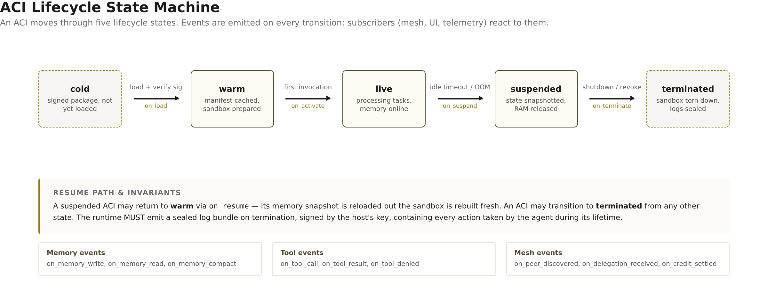
Figure 2. ACI lifecycle state machine. Terminal states (cold, terminated) are dashed. Resume path returns a suspended ACI to warm, not live.

4.10 Versioning and compatibility
ACI follows semantic versioning at the manifest level. The apiVersion field uses Kubernetes-style group-version syntax (e.g. aci.loomwork.dev/v0.1). Within a major version, runtimes MUST accept any minor or patch version. Across major versions, runtime MUST negotiate via the apiVersion field and MUST refuse to load ACIs whose major version exceeds the runtime's supported maximum. A v0.x runtime MAY load v0.y ACIs where y < x by treating unrecognized fields as warnings, not errors. Once the spec reaches v1.0, forward compatibility is guaranteed for two years.

4.11 Conformance requirements
The keywords MUST, MUST NOT, REQUIRED, SHALL, SHALL NOT, SHOULD, SHOULD NOT, RECOMMENDED, MAY, and OPTIONAL in this section are to be interpreted as described in RFC 2119.
# | Requirement | Level
C1 | Runtime MUST verify manifest signature before loading ACI. | MUST
C2 | Runtime MUST verify all file digests against the manifest's digests map. | MUST
C3 | Runtime MUST reject ACI whose manifest fails JSON Schema validation. | MUST
C4 | Runtime MUST enforce every clause of sandbox.json. | MUST
C5 | Runtime MUST emit a signed event on every lifecycle transition. | MUST
C6 | Runtime MUST refuse LLM calls that exceed persona.tokenBudget.hardLimit. | MUST
C7 | Runtime MUST refuse tool calls not declared in tools/bindings.json. | MUST
C8 | Runtime SHOULD cache warm ACIs for at least 5 minutes after last activity. | SHOULD
C9 | Runtime SHOULD persist a sealed log bundle on termination. | SHOULD
C10 | Runtime MAY support ACIs without SLSA attestation if user opts in. | MAY
C11 | Runtime MAY support multiple ACI versions concurrently. | MAY

5. AMP — Agent Mesh Protocol Wire Format
The Agent Mesh Protocol (AMP) is a peer-to-peer wire protocol that lets agents communicate with each other. Where MCP standardizes how an agent calls a tool, AMP standardizes how an agent delegates a task to another agent, negotiates capabilities, reports progress, and exchanges credit for work performed. AMP is layered strictly on top of MCP at the conceptual level — an agent that speaks AMP also speaks MCP — but the two protocols use independent transports and message namespaces. AMP is designed to be asynchronous, capability-bounded, credit-accountable, and transport-agnostic.

5.1 Design goals
AMP's primary design goal is to make agent-to-agent interaction as routable, observable, and accountable as agent-to-tool interaction already is under MCP. Four sub-goals follow. First, the protocol must be peer-to-peer: there is no central broker, and any two compliant runtimes must be able to converse directly. Second, every interaction must be capability-bounded: an agent cannot invoke another agent's skill unless the callee has explicitly granted a capability token for that skill. Third, the protocol must be credit-accountable: every unit of work exchanged between agents is settled by a signed credit receipt, allowing offline reconciliation and preventing freeloading. Fourth, the protocol must be transport-agnostic: the same logical message can be carried over WebSocket, libp2p, or stdio without changing its semantics.

5.2 Transport bindings
AMP defines three transport bindings in v0.1. Implementations MUST support at least one; SHOULD support two; MAY support all three. The choice of transport does not affect message semantics, only the framing.
Transport | Use case | Framing | Discovery
WebSocket | Local network, same-machine agents, IDE↔runtime | JSON-RPC 2.0 over WS frames | Well-known port 7878 + mDNS
libp2p | Cross-device, internet-scale, NAT traversal | JSON-RPC 2.0 inside libp2p streams | DHT + PeerId advertise
stdio | Parent process ↔ child agent (e.g. CLI tool) | Newline-delimited JSON-RPC 2.0 | Spawned with --amp-stdio flag

5.3 Message envelope
AMP messages are JSON-RPC 2.0 objects with three AMP-specific extensions. The amp field carries protocol metadata; the capabilities field lists the capability tokens the sender is presenting; the provenance field traces the request back to its originating ACI. Runtimes MUST reject any message missing these fields when the message is an AMP-namespaced method.
// AMP message envelope — JSON-RPC 2.0 + extensions
{
"jsonrpc": "2.0",
"id": "req_01H8...", // string, ULID
"method": "amp/delegate", // namespaced: amp/*
"params": { /* method-specific */ },
"amp": {
"version": "0.1",
"traceId": "trace_01H8...", // propagates across delegations
"sessionId": "sess_01H8...", // established in HELLO/ACCEPT
"ttl": 30 // seconds; runtime drops after
},
"capabilities": [ // signed capability tokens
{
"id": "cap_01H8...",
"skill": "search_web",
"scope": { /* skill-specific */ },
"issuedBy": "did:key:z6Mk...",
"issuedAt": "2026-09-28T10:00:00Z",
"expiresAt": "2026-09-28T11:00:00Z",
"signature": "z6Mk.../Base64Signature"
}
],
"provenance": {
"aci": "loomwork.dev/example-agent@v1.2.3",
"aciDigest": "sha256:abc123...",
"runtime": "loomwork-rs/0.1.0"
}
}

5.4 Capability negotiation handshake
Before any AMP method can be invoked, two agents MUST complete the capability negotiation handshake. The handshake establishes a session, declares each side's capabilities and constraints, and issues the initial capability tokens. The handshake is three messages: HELLO, CAPABILITIES, ACCEPT.
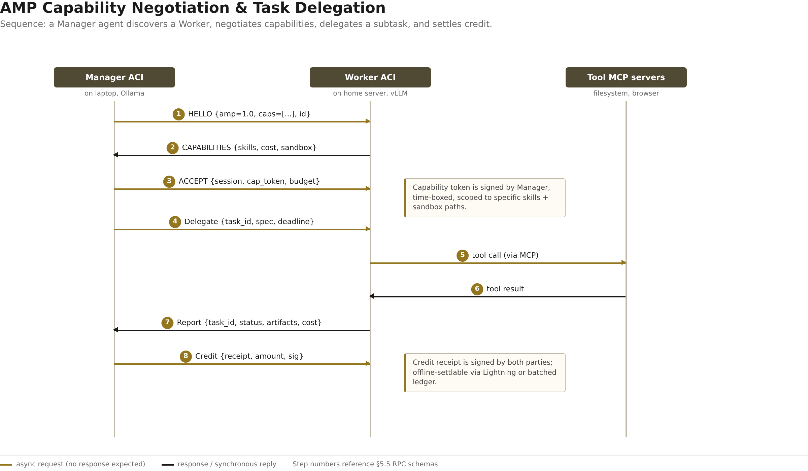
Figure 3. AMP capability negotiation, task delegation, tool call, report, and credit settlement. Step numbers reference §5.5.
// HELLO — initiate session
{
"jsonrpc": "2.0", "id": "req_01H8A...",
"method": "amp/hello",
"params": {
"ampVersion": "0.1",
"agentId": "did:key:z6Mkmanager...",
"offeredSkills": ["delegate", "subscribe", "credit"],
"runtimeInfo": { "name": "loomwork-rs", "version": "0.1.0" }
},
"amp": { "version": "0.1", "traceId": "trace_01H8A...", "ttl": 30 },
"capabilities": [],
"provenance": { "aci": "loomwork.dev/manager@v1.0.0" }
}

// CAPABILITIES — response from peer
{
"jsonrpc": "2.0", "id": "req_01H8A...", // same id = response
"result": {
"sessionId": "sess_01H8B...",
"acceptedSkills": ["delegate", "subscribe"],
"declinedSkills": ["credit"], // peer doesn't settle credit
"offeredSkills": ["research", "summarize"],
"costModel": { "currency": "loompoint", "per1kTokens": 10 },
"sandboxPolicy": { "fs.write": ["/tmp/agent/**"] }
}
}

// ACCEPT — finalize session
{
"jsonrpc": "2.0", "id": "req_01H8C...",
"method": "amp/accept",
"params": {
"sessionId": "sess_01H8B...",
"acceptedSkills": ["research", "summarize"],
"budget": { "maxTokens": 50000, "maxWallSeconds": 300 },
"capabilityToken": { /* signed token for delegated skills */ }
}
}

5.5 Core RPCs
AMP defines six core RPCs in v0.1. Each RPC has a request shape, a response shape, and a defined error set. The schemas below show the params object only; the full envelope (per §5.3) wraps every request and response.

5.5.1 amp/delegate
Delegate a subtask to a peer agent. The peer receives a task spec, a deadline, and a budget; it returns either a task acknowledgment (and later emits amp/report messages) or an immediate refusal.
// Request: amp/delegate params
{
"taskId": "task_01H8D...",
"spec": {
"intent": "research",
"inputs": { "topic": "ACI spec adoption" },
"expectedOutputs": ["summary:string", "citations:array<URL>"],
"format": "markdown"
},
"deadline": "2026-09-28T10:30:00Z",
"budget": { "maxTokens": 8000, "maxToolCalls": 5 }
}
// Response (acknowledgment)
{ "accepted": true, "estimatedCompletion": "2026-09-28T10:15:00Z" }
// Response (refusal)
{ "accepted": false, "reason": "BUDGET_TOO_LOW", "minBudget": { "maxTokens": 12000 } }

5.5.2 amp/negotiate
Negotiate the parameters of a previously-delegated task. Used when the callee realizes the original spec is ambiguous or under-budgeted. Negotiation MUST be idempotent within a (taskId, version) pair.
// Request: amp/negotiate params
{
"taskId": "task_01H8D...",
"version": 2,
"proposedChanges": {
"budget.maxTokens": 12000,
"spec.inputs.depth": "deep"
},
"reason": "Insufficient budget for cited research; 12k tokens needed for arxiv search."
}
// Response
{ "accepted": true, "newBudget": { "maxTokens": 12000 }, "effectiveAt": "2026-09-28T10:05:00Z" }

5.5.3 amp/report
Report progress, partial results, or final results on a delegated task. The callee MAY emit multiple amp/report messages before completing; the final report MUST set status = "complete" or "failed".
// Request: amp/report params
{
"taskId": "task_01H8D...",
"status": "complete",
"artifacts": [
{ "name": "summary.md", "mime": "text/markdown", "digest": "sha256:..." },
{ "name": "citations.json", "mime": "application/json", "digest": "sha256:..." }
],
"usage": { "tokensIn": 4200, "tokensOut": 3100, "toolCalls": 4, "wallSeconds": 87 },
"error": null
}
// Response (ack)
{ "received": true }

5.5.4 amp/credit
Settle credit for work performed. The payer (delegator) issues a signed credit receipt; the payee (delegatee) countersigns. Receipts are offline-settlable: they can be accumulated and redeemed later via Lightning, a batched ledger, or a manual process.
// Request: amp/credit params
{
"receiptId": "rct_01H8E...",
"taskId": "task_01H8D...",
"amount": { "currency": "loompoint", "value": 73 },
"breakdown": { "tokens": 50, "toolCalls": 15, "wallSeconds": 8 },
"payer": "did:key:z6Mkmanager...",
"payee": "did:key:z6Mkworker...",
"issuedAt": "2026-09-28T10:16:00Z",
"payerSig": "z6Mkmanager.../Base64Signature"
}
// Response: payee countersigns
{ "receiptId": "rct_01H8E...", "payeeSig": "z6Mkworker.../Base64Signature" }

5.5.5 amp/subscribe and amp/cancel
Subscribe to a stream of events from a peer (e.g. 'notify me when any agent in the mesh completes a research task') and cancel an outstanding task. Both are lightweight: amp/subscribe returns a subscription ID that future amp/report messages will reference; amp/cancel returns the resources consumed so far and ends the task.

5.6 Task graph and shared state
Every delegated task becomes a node in a shared task graph. The graph is a DAG: tasks may spawn subtasks, but cycles are forbidden and the runtime MUST detect and reject them. Each node carries its status (pending, running, negotiating, complete, failed, cancelled), its budget consumption, and a reference to its parent. The task graph is the source of truth for mesh-wide observability: any agent with read access to the graph can answer 'what is everyone doing right now?' without polling.

5.7 Credit and accounting
AMP uses an off-ledger credit model: agents exchange signed receipts in real time, and settlement happens out-of-band. This avoids the latency of on-ledger confirmation while preserving auditability. Three settlement mechanisms are anticipated in v0.1: (a) Lightning micropayments for internet-scale peer-to-peer settlement, (b) a batched ledger for organizational deployments where a single operator settles periodically, and (c) manual settlement for trusted-mesh deployments where receipts are logged but not redeemed. The protocol itself is settlement-agnostic: the receipt format is identical across all three.

5.8 Security model
AMP security rests on three pillars: mutual authentication, capability tokens, and replay protection. Mutual authentication uses TLS 1.3 with mutual certificates for WebSocket and libp2p's built-in secio for that transport. Capability tokens are signed by the issuer (the agent granting the capability), scoped to a specific skill, time-boxed, and revocable via an amp/revoke message. Replay protection uses a combination of the amp.ttl field (messages expire) and a per-session nonce cache (the runtime rejects duplicate nonces within the TTL window).

5.9 Error code registry
AMP errors use JSON-RPC 2.0's error object with a structured data field. The error code space is partitioned: 1xx for transport, 2xx for capability, 3xx for task, 4xx for credit, 5xx for protocol.
Code | Name | Meaning | Retry?
100 | TRANSPORT_ERROR | Underlying transport failure (WS close, libp2p reset). | Yes, backoff
101 | TTL_EXPIRED | Message arrived after amp.ttl window. | No
200 | CAPABILITY_MISSING | Sender did not present a required capability token. | No
201 | CAPABILITY_EXPIRED | Capability token's expiresAt is in the past. | Yes, after refresh
202 | CAPABILITY_REVOKED | Capability was revoked via amp/revoke. | No
300 | TASK_NOT_FOUND | Referenced taskId does not exist in the callee's graph. | No
301 | TASK_ALREADY_COMPLETE | Callee received a delegate for an already-complete task. | No
302 | BUDGET_EXCEEDED | Task budget has been consumed. | Yes, after negotiate
303 | DEADLINE_EXCEEDED | Task deadline passed before completion. | No
400 | CURRENCY_MISMATCH | Payer and payee use different credit currencies. | No
401 | INVALID_RECEIPT | Credit receipt signature failed verification. | No
402 | INSUFFICIENT_BALANCE | Payer's declared balance is below receipt amount. | No
500 | PROTOCOL_VIOLATION | Message does not conform to AMP envelope schema. | No
501 | VERSION_MISMATCH | amp.version not supported by peer. | No
502 | CYCLE_DETECTED | Delegation would create a cycle in task graph. | No

5.10 Version negotiation and backwards compatibility
AMP version negotiation happens in the HELLO message. The initiator declares the highest version it supports; the responder either accepts that version or proposes a lower one in the CAPABILITIES response. If no common version exists, the responder MUST return a 501 VERSION_MISMATCH error and the session is not established. Within a major version, newer minor versions MUST be backwards-compatible with older ones: a v0.1 runtime MUST accept v0.2 messages by ignoring unrecognized optional fields. Breaking changes require a major version bump and explicit negotiation.

6. Relationship to Existing Protocols
Loomwork does not exist in a vacuum. It is the synthesis of patterns that have emerged across a dozen projects over the last 18 months, and it deliberately reuses existing standards wherever they are sufficient. This section maps Loomwork's components to their closest existing analogues and is explicit about what is borrowed and what is new.
Loomwork component | Closest existing analogue | What is borrowed | What is new
ACI | OCI Image Format (Docker) | Archive layout, manifest+digest pattern, Sigstore signing, SLSA provenance | Persona, skills DAG, MCP tool bindings, sandbox policy, memory schema as first-class fields
AMP | MCP (Anthropic) | JSON-RPC 2.0 framing, capability concept, transport-agnostic design | Agent-to-agent (vs agent-to-tool), credit model, task graph, capability tokens
Memory Layer | Mem0 / Zep | Vector + graph hybrid storage, episodic memory concept | Self-hosted by default, E2E encrypted, provenance on every write, follows user across vendors
Vibe-to-Verified | Bolt.new / Totalum | Natural-language to app generation | Mandatory verification gate (SAST, SBOM, formal spec), signed provenance receipt, deploy refusal on failure
Mesh Runtime | Copilot Mission Control | Async task fan-out, parallel agent dispatch, PR-based review | Cross-vendor (works with any ACI), local-first, no central cloud required

The most important borrowing is from OCI. ACI deliberately mirrors the OCI Image Format's manifest+digests+signature pattern because that pattern has been battle-tested at planet scale and because it gives every developer who has ever built a Docker image an immediate mental model for what an ACI is. The most important innovation is AMP. There is no existing open protocol for agent-to-agent delegation, capability negotiation, and credit accounting — MCP explicitly does not cover this, and the alternatives (A2A Protocol, AutoGen's internal protocol) are either proprietary or framework-locked. AMP is the gap-filler.
Honest limitations
Loomwork is not a silver bullet. It does not solve the model-safety problem (that is the model's job), it does not solve the sandbox-escape problem (that is the sandbox implementation's job), and it does not guarantee that agents from different vendors will cooperate smoothly — it only guarantees that they will be able to negotiate whether they can. The specification's value is in making the negotiation possible, not in predetermining its outcome.

7. Roadmap and Risks
This section outlines the planned rollout in three time horizons and enumerates the top risks with mitigations. The roadmap is intentionally concrete: each milestone has a single deliverable that can be independently verified.

7.1 Roadmap
Horizon | Milestone | Deliverable
90 days | v0.1 spec freeze | ACI v0.1 and AMP v0.1 specifications published under CC-BY 4.0; reference Rust runtime; three example ACIs (research, coding, deploy); conformance test suite.
90 days | First demo | End-to-end demo: a Manager ACI on a laptop delegates a research subtask to a Worker ACI on a Raspberry Pi via AMP; both run Ollama locally.
12 months | v1.0 spec | ACI v1.0 (stable manifest), AMP v1.0 (stable wire format); Memory Layer spec; first 50 community ACIs indexed; marketplace alpha.
12 months | Language bindings | Rust (reference), Python, TypeScript, Go bindings; Swift/Android for mobile mesh.
24 months | Full mesh runtime | Cross-device sync, offline-first conflict resolution, Lightning-based credit settlement; 500+ community ACIs; foundation governance.

7.2 Top risks and mitigations
# | Risk | Likelihood | Impact | Mitigation
R1 | Anthropic (or another major vendor) closes the protocol layer with a proprietary solution before v1.0 | Medium | Existential | Ship v0.1 within 90 days; aggressively recruit early adopters; pursue standardization under OpenSSF / Linux Foundation
R2 | Open-source community fragments into competing standards | Medium | High | Be aggressively neutral on runtime, model, and IDE; explicitly invite competitors to join working group; reject vendor-specific extensions in core spec
R3 | Security hole in agent sandbox leads to a high-profile escape | Medium | High | Mandate SLSA Level 3 for all reference ACIs; ship conformance tests that include negative-path sandbox tests; publish a security disclosure policy with 90-day window
R4 | UX complexity (5 layers, 6 RPCs, multiple transports) deters casual users | High | Medium | Ship a 'batteries-included' default runtime that hides complexity; expose advanced controls only when user opts in
R5 | Cold-start problem: marketplace has no agents, so no users; no users, so no agents | High | High | Ship 3 reference ACIs on day 1; sponsor a community ACI hackathon; reach out to OpenHands/OpenClaw maintainers about repackaging as ACIs

7.3 Open questions
The following questions are explicitly unresolved as of v0.1 and are flagged for community discussion during the 90-day review window.
Q1. Should the ACI manifest support multiple personas in one archive (e.g. an agent that presents different behavior in different contexts), or is one ACI one persona?
Q2. How should AMP handle agents that are offline at delegation time — fire-and-forget queues, or strict refusal?
Q3. What is the right governance model for the spec — single-vendor stewardship, working group under a foundation, or a fully decentralized process?
Q4. Should the Memory Layer be part of the ACI spec, a separate spec, or left to runtime implementations entirely?
Q5. How should AMP handle delegation across trust boundaries (e.g. agent on personal laptop delegates to agent on a public cloud)? Is mutual TLS enough, or is a third-party attestation required?
Q6. Should ACI include a 'kill switch' field that allows the issuer to remotely terminate a running instance of their agent? What are the implications for trust?
Q7. What is the minimum viable subset of AMP that a runtime must implement to call itself 'AMP-compatible'? The current spec requires all six RPCs, which may be too high a bar.
Q8. How does Loomwork relate to emerging standards like A2A Protocol and ACP? Should it merge, compete, or explicitly defer to one of them?

Appendix A. Glossary
Term | Definition
ACI | Agent Container Image. The signed, portable package format for an AI agent defined in §4. An ACI bundles persona, skills, tool bindings, sandbox policy, memory schema, and provenance into a single loadable archive.
AMP | Agent Mesh Protocol. The peer-to-peer wire protocol for agent-to-agent communication defined in §5. AMP is layered on top of MCP at the conceptual level and uses independent transports.
MCP | Model Context Protocol. Anthropic's open protocol for connecting AI agents to tools and data sources, introduced in 2024. MCP standardizes agent-to-tool communication; AMP standardizes agent-to-agent.
OCI | Open Container Initiative. The body that standardizes container formats and runtimes, including the OCI Image Format that ACI's archive layout deliberately mirrors.
SLSA | Supply-chain Levels for Software Artifacts. A framework for hardening software supply chains, expressed as a series of levels. ACI requires SLSA Level 3 or higher for provenance attestations.
Sigstore | An open-source software signing stack using ephemeral keys and a transparency log. ACI uses cosign (part of Sigstore) for manifest signatures and Fulcio (Sigstore's CA) for signing certificates.
libp2p | A modular network stack originally developed for IPFS, providing peer routing, content discovery, and encrypted transport. One of AMP's three transport bindings.
JSON-RPC 2.0 | A stateless, light-weight remote procedure call protocol encoded in JSON. AMP's message envelope is JSON-RPC 2.0 with three AMP-specific extensions.
Capability token | A signed, time-boxed, scope-limited token issued by one agent to another, granting the recipient the right to invoke a specific skill. AMP capability tokens are revocable.
Credit receipt | A signed record of work performed by one agent for another, used for offline settlement. AMP credit receipts are dual-signed (payer and payee) and can be redeemed via Lightning, a batched ledger, or manually.
Agent mesh | A peer-to-peer network of agents that communicate via AMP. A mesh has no central broker; any two compliant runtimes can converse directly.
Vibe-to-Verified | Loomwork's end-to-end pipeline from natural-language spec to deployable, verified application. Includes SAST, SBOM, optional formal-spec checking, and signed provenance attestation. The 'verified' in the name refers to the mandatory verification gate.
Sandbox | The isolated execution environment in which an ACI runs. The sandbox enforces the filesystem, network, and syscall constraints declared in sandbox.json. Implementations may use Docker, Firecracker, gVisor, or native seccomp.
Provenance | A signed attestation linking an artifact (an ACI, an agent action, a memory write) to its source. Provenance is the foundation of Loomwork's auditability guarantee.

