TWO WHEELER TRAFFIC INFRINGEMENT
RECOGNITION USING YOLO V7 AND
AUTOMATED TICKETING

THYAGARAJAN C
Assistant Professor
Computer Science Engineering
Panimalar Engineering College
Chennai, India
thyaguwinner@gmail.com

ARUN KUMAR D
UG Scholar
Computer Science Engineering
Panimalar Engineering College
Chennai, India
arunds130801@gmail.com
ASWIN V
UG Scholar
Computer Science Engineering
Panimalar Engineering College
Chennai, India
aswinv3071@gmail.com

PUGHAZENDI N
Professor
Computer Science Engineering
Panimalar Engineering College
Chennai, India
pughazendi@gmail.com
HARI VIGNESH M
UG Scholar
Computer Science Engineering
lPanimalar Engineering College
Chennai, India
harimurukesan7@gmail.com

Abstract— It is difficult to monitor and control traffic violations in India because to the country's excessive population, growing commuter population, ineffective traffic signal management, and rider mentality. Actual police-based surveillance is obviously insufficient to simultaneously observe such high traffic levels and track down crimes. This has made many infringers difficult to find. More severe catastrophes on the road are caused by the offenders, endangering their personal lives and those of others. In order to automatically recognize two-wheeler infringement on Indian roads including not putting on helmets, and use a cellphone while driving, triples, wheeling, and illegal parking, artificial intelligence (AI) must be used , and automating the ticketing process. By putting the offenses and the number plates that go with them into a database. We suggest utilizing Yolo-V7 with Tesseract for detecting and extracting number plates and Yolo-V7 plus DeepSort for recognizing and tracking infractions. The developed Traffic Infringement Detection And recognition may be used to automate the issuance of vehicle violation tickets. Using the automated Intelligence traffic infringement and ticketing system, the developed system will be particularly helpful in developing a variety of safety-related regulations, supporting in the implementation of strict traffic laws, and fostering the growth of a sustainable urban ecosystem.
Keywords—Traffic Infringement, YOLO V7, Number Plate Recognition, Tesseract, Automatic ticketing.

Introduction
The Indian government is very concerned about traffic monitoring and infringement control because of the excessive crowding, rising commuter numbers, flawed traffic system designs, and general human nature. Today, the majority of India's city traffic control systems are still managed by hand. Both heavy traffic congestion and human error result from this. According to a report by the According to the Ministry of Roads, 37% of fatal traffic accident victims in 2019 were two-wheeler riders.. Furthermore, not wearing a helmet contributed to 44,666 fatalities in road accidents in 2019 . Based on the reports from “World Health Organization (WHO)”, wearing a helmet properly might decrease the threat of serious accidents by 42% and the danger of brain traumas by 69%. Furthermore, according to WHO data, Driving while using a phone increases the risk of an accident by four times compared to not using one. The inevitable results of using a phone while driving include slower reaction times. These statistics cover just two of the numerous two-wheeler traffic infractions that have been documented. According to a 2017 report from the Bureau of Police Research and Development, India's traffic police had a total staffing capacity of just over 72,000 while there are currently over 200 million vehicles on Indian roads .The volume and variety of vehicles are too many for traffic police monitoring to handle alone. Additionally, a lot of current solutions aren't flexible enough to recognise, examine, and track the wide range of vehicle models, licence types, dynamic traffic patterns, and street layouts [2][3][4]. Several cities still rely on outdated traffic management techniques that are ineffectively scaled to meet the number and variety of transit. To address these many issues, contemporary technology must be used to automate enforcement and monitor traffic. enabling more sophisticated traffic control systems.
Current techniques for detecting helmets and licence plates in traffic films have low efficiency and accuracy, rendering them unsuitable for use in the real world. Innovative methods are required in real-time circumstances to attain great accuracy and efficiency. The current approach makes it impossible for the system to distinguish between unclean number plates and corroded number plates, which might result in rule violations and the avoidance of fines. Using a collection of traffic photos, we tested the suggested method, and we outperformed conventional computer vision approaches with high accuracy and recall rates. Our strategy may be utilised to increase traffic safety and enforce rules on the wearing of helmets and vehicle registration. The findings of our investigation show that deep learning is successful.
In this paper, we use YOLO v7 model under the process of Convolutional Neural Network. In this YOLO model, we have the process of collecting data. By the means of collected data, the data sets are being trained and tested in modules. In the YOLO model, the labelling is done like whether the person on the bike or two-wheeler wears the helmet or not. In the labelling model, we give the input in the means of dimensions and array. By this method, the YOLO will be able to learn and process the function.

The ease of use of the technique proposed by this paper are followed:

User-friendly interface: The system ought to have an intuitive user interface that enables users to communicate with it, examine results, and change settings as needed. This can help reduce the learning curve for using the system.

Real-time performance: The system should be designed to achieve real-time performance so that it can process images and provide results quickly. This can help users to make informed decisions in real-world scenarios, such as traffic monitoring and law enforcement.

High accuracy: The system should be designed to achieve high accuracy and robustness under varying conditions so that users can rely on the system to make accurate detections. This can help reduce false positives and false negatives, which can be detrimental to traffic safety and enforcement of regulations.

Automated processing: The system should be designed to automate the processing of images, without requiring manual intervention or adjustment by users. This can help reduce the workload for traffic authorities and improve the efficiency of the system.

Integration with other systems: In order for users to readily access and exchange information, the system must have the ability to interact with the other technologies, such as traffic control systems. The coordination and communication between traffic officials might benefit from this.

The above-mentioned are some of the benefits while using it in real-time. The proposed paper uses the technique of YOLO v7 which provides more accuracy and efficiency.

Related Works

Detection of Infringement

Ross Girshick et al. [5] suggested utilising Fast R-CNN to detect objects. Based on earlier R-CNN and SPPnet models, this was more accurate. A single convolution operation is used to produce a feature map for each picture. The rapid R-CNN technique creates an equilibrium between the reliability and quickness of the R-CNN series approaches. It was still costly to train and had a sluggish top frame rate of up to Five FPS for object recognition.
Xiaoling Wang et al. [6] uses a wavelet transform on such a variable backdrop to suggest an improved background-updating technique, followed by functionality tracking of moving objects.
Awang.S et al. [7] suggested a deep learning-based approach for determining the number of autos that use the layer skipping strategy of CNN. Prior to counting, their system divides the vehicle into numerous categories based on distinctive characteristics.
Maharsh Desai et al. [8] have suggested a method that would identify a two-wheeler driver's run-time helmet and fall detection. In an emergency, our system would alert surrounding hospitals, family members, and law enforcement. As a result, it guarantees the drivers' safety while driving.
Deeksha N et al. [9] suggests a system that keeps track of any riders—individual or group—who are riding sans helmets. The suggested technique starts out by identifying bike riders using the YOLOv3 model, a reliable variation of the YOLO model.
Chien-Yao Wang et al. [10] proposed a novel methodology to real-time object identification as well as a method for matching model scaling. They also discovered that the advancement of object identification methods produces new research topics, and that the variable label assignment distribution and replacement difficulties of the re-parameterized configurations are concerns that occur during the research process. The trainable bag-of-freebies technique is suggested by the authors as a way to increase object detection's accuracy. As a result of the data, we developed the YOLOv7 family of object detecting systems, which yields cutting-edge outcomes.

Detection Of Number Plate
Debby Ratna Daniel et al. [11] proposed an ANPR system, a well-liked expert system that is currently in use in numerous developed nations. It works by collecting license plate photographs from cars in order to locating them and handle traffic difficulties. This framework is very important for vehicle identification and enhancing all capacities, including monitoring, regulating, critical analysis, fine management, and compliance, as well as building relationships with all establishments.
Sangita Kumari et al. [12] established a paradigm for vehicle license plate recognition based on a fictitious brain architecture. This method employs "adaptive thresholding" after transforming the vehicle picture to grayscale. ULEA is used to remove unnecessary lines from a picture after thresholding.
Chirag Patel and colleagues [13] performed several processes in the planned ANPR system, that is hard to be 100% accurate since each step depends on the previous one. ANPR performance depends on illumination, car shadow, registration plate letter sizes, font, and backdrop color. Some systems only operate under certain settings and may be inaccurate under tough situations.
M.S.Sarfraz [14] introduced a unique method for identifying license plate numbers from Surveillance tapes that employs a revamped version of a current framework for monitoring and recognition and enables effective localisation of registration plates in video frames. The authors suggested a unique way to compensating for different camera locations and lighting conditions. The four phases in the license plate identification method include finding contours and related components, picking a rectangle area according to dimension and image resolution, early education for adaptive camera proximity, histogram-based geolocation, gradient processing, and closest mean classifier. When these processes have been completed, the final detection outcome is transmitted to tracking.

N. P. Agrawal et.al. [15] performed Number plate identification uses picture and character segmentation. The high-resolution camera can capture photos and videos, so the output should be clear. This method is made up of four basic phases. The footage from the camera is used as the initial input. After that, the footage is divided into elements, and a single frame or picture is picked from among those frames. The plate's location is then extracted using two features such as angle proportionality and edge texture. The Division is completed on the registration number to fragment and differentiate each numeral from the plate. Finally, the licence plate is detected in order to accurately identify the numerals.

Ray Smith et al.[16] provided a summary of Tesseract OCR, same to HP Research Prototype, was considered. The focus is on unique or unusual components of OCR motors, particularly the flexible encoder, line detection, and components approaches.

Methodology

We’ll go over the suggested end-to-end system for automating ticketing and traffic infringement recognition. The system is made up of four main parts: ticketing, vehicle tracking, number plate recognition, and vehicle detection.

Object detection model: In order to execute violation detection, we first acquire the frames out from the video feed as input. In India, some of the violations that we looked at included not putting on a helmet, using a cell phone while driving, driving in triples, and not parking properly.Each image frame is subjected to object detection using the YOLO-v7 [1] object detector, which can find one or more infringement.

Model for object tracking: To prevent tedious counting and to guarantee that the cars are captured across numerous frames, the identified item is then monitored using the object recognition model.

Licence plate recognition: After the violation has been discovered and monitored, each violating vehicle is clipped by applying the parameters acquired out from clusters supplied by the object prediction system of the automobile detector module. YOLO-V7 detects a vehicle's license plate from cropped automobile images. Using ‘Optical Character Recognition(OCR)’, Tesseract [4] is used to extract numerical information from a numberplate then save them in a database..

Ticketing: Automobile number plates of users who have broken the law are mailed together with the relevant database offences. The database may also be utilised to do statistical research on traffic law infractions.

Object Detecting Module
A well-known object identification method called YOLO (You Only Look Once) V7 may be used to spot traffic infractions in two-wheeler traffic. This is how to create a YOLO v7 module for detecting two-wheeler traffic violations:

Dataset Collection: Collect a dataset of images and videos that contain two-wheelers and traffic violations. You can use public datasets or create your own dataset by capturing images and videos of traffic.

Data Preparation: Preprocess the data by resizing the images, normalizing the pixel values and annotating the objects in the images.

Training: Train a YOLO model on the annotated dataset using a deep learning framework such as TensorFlow or PyTorch. You can use a pre-trained YOLO model and fine-tune it on your dataset or train a model from scratch.

Object Detection: Use the trained YOLO model to detect objects in real-time traffic video streams. The model will output bounding boxes around the objects detected in the video stream.

Traffic Violation Detection: Use the output from the YOLO model to detect traffic violations. For example, you can use computer vision algorithms to detect if a two-wheeler rider is not wearing a helmet, violating traffic signals, or driving in the wrong direction.

Alert System: Implement an alert system that can send notifications to the relevant authorities when a traffic violation is detected.

It is crucial to note that the effectiveness of the YOLO v7 model is reliant on the annotated dataset's quality and quantity, as well as the hyper parameters used during training. As a result, a big and varied dataset is required to effectively train the model.
Object detection is concerned with the identification and localization of objects, in this instance infractions. We utilized YOLOv7 [10] with pre-trained parameters with configuration that can detect and capture 10,000 types of objects. The graph for the YOLO V7 version is shown in the image below.
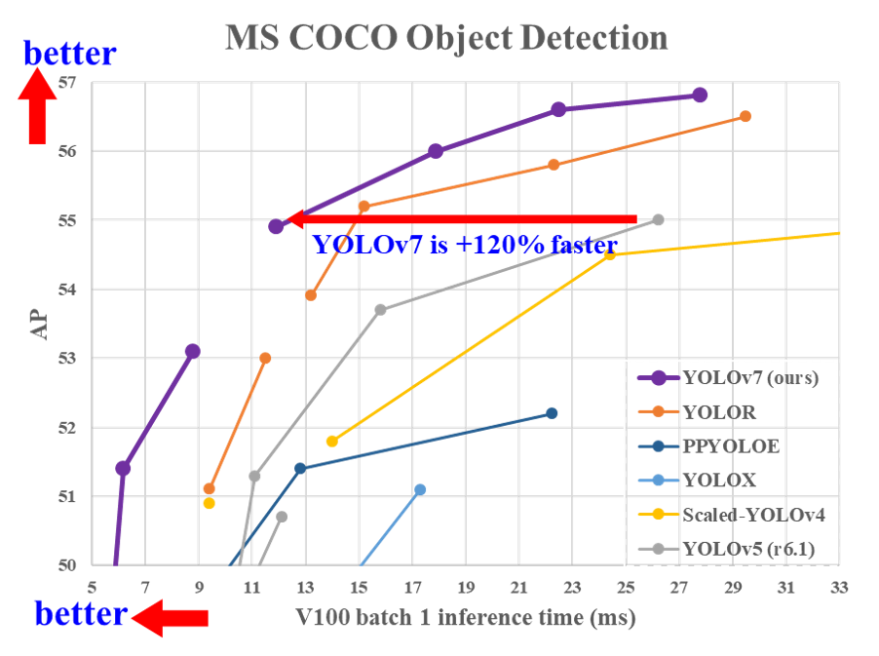
- Yolo V7 Detection Accuracy With Other Models

Model for Object tracking
The process of identifying an item through a number of frames is known as object tracking. To begin, each possible detection and recognition in a frame is given an ID. We attempt to pass an object's ID across to succeeding frames. The ID is lost if the item has moved out of the frame. They begin with a new ID when a new item arises. For us, getting rid of infractions count duplication between frames is crucial. We are utilizing DeepSORT [16], an enhanced version of Kalman filter tracking [17], to track objects. Deep Sort successfully tackles Object Tracking issues such as occlusion, distortion, and so on by using "position-velocity-measured Kalman filter tracking." DeepSORT is divided into three separate stages, which are stated below:
- The first object detections each frame are carried out using Yolo-v7 (Object detector).
- Calculation of the tracks of real - world objects in the video frames using a Kalman filter. This involves the eight elements (box middle (x, y), box magnitude (s), box proportion (a), and the corresponding derivatives represented as movements over period) that constitute up the current state of each segment. The tracking object is deemed out of frame or lost if it is not detected for a threshold of frames in a row. Consequently, a new track starts with each newly discovered box. The Kalman filter further alleviates the issue of unexpected occlusions.
- The Hungarian approach on bipartite graph comparison is then used to associate the projected states from Adaptive thresholding for current identification with custom object tracks inside the reference frame. By adjusting the weights of a matching with distance formulation, this is made reliable.

License Plate recognition
Three crucial phases make up the license plate capture process:

Detection: To locate and identify the license plate and to give coordinates for the frame of the plate in the picture, we use a classification algorithm, in this instance Yolov7. By using image processing, the bounding box is precisely cropped.

Pre-processing: The major objective of pre-processing prior to recognition and segmentation is to increase the accuracy and legibility of the characters on the cropped number plate.

• Greyscale to RGB conversion

• Gaussian blur to reduce noise
• Image binarization to enhance detection quality

• Since it calculates the threshold levels of a more specific area inside the picture as opposed to the image's overall threshold, the adaptive Thresholding approach is used, and it has been shown to provide superior results.

Segmentation and Recognition: Character identification and segmentation are accomplished using tesseracts [4]. The component outline outlines are gathered into Blobs in the first phase of the Integrated Component Analysis merely by layering. Blobs are employed to form characters, and they are checked to see whether they are equal or uniform pitch. The character placement type determines how the characters are divided up into words. Character cells quickly slice fixed pitch text. In proportional writing, words are separated by definite or ambiguous gaps. The process of recognition involves two passes. The first pass contains a word-by-word identification attempt. An adaptive classifier receives the words that were properly recognized as training data. As a result, there is a chance that the adaptive classifier will enhance results for text located farther down the page. To detect small-cap text, the last phase resolves the ambiguous spaces and evaluates alternate x-height hypotheses.

System Architecture
Figure 2 shows the network topology for two-wheeler traffic infraction and number plate identification, which is made up of numerous components, including:
      - Input Data: A camera mounted atop a traffic control system can provide the system with the input data it needs. The camera records pictures or videos of the road and moving vehicles.
      - Pre-processing: Pre-processing is used to improve the picture quality once it has been captured. In doing so, it might be necessary to reduce noise, tweak the luminance and contrast, and fix distortion.
      - Infringement detection: It is used to detect whether the person driving the vehicle wears a helmet. Object detection and facial recognition are two examples of machine-learning methods that can be used for this.
      - Number plate Recognition: Localization of the vehicle's license plate comes after the helmet recognition process is complete. Techniques for picture processing like edge detection and contour analysis can be used for this.
      - Automatic ticketing: After the recognition of traffic infringement the number plate is detected and the screenshot of the number plate is sent to respective mail in database.
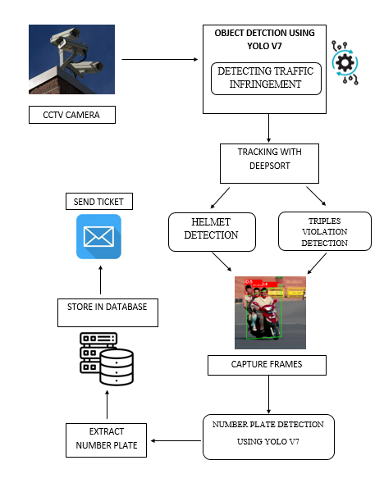
- System Architecture

EXPERIMENTAL SETUP

Information Set
A personalized dataset is created from real-time collected and imagery of offenses obtained from various online sources for the purpose of complaint recognition.With the goal to accommodate many kinds of data, the clips that were selected from the recording portray both moderate and intense traffic scenarios. The captured photos are meticulously marked for various kinds of offenses.
VIOLATION | NO OF  ACTUAL VIOLATION | TRUE POSITIVE | FAKE POSITIVE | ACCURACY
NOT WEARING HELMET | 1048 | 1045 | 15 | 0.988
USAGE OF PHONE WHILE DRIVING | 803 | 789 | 23 | 0.975
TRIPLE RIDING | 166 | 166 | 2 | 0.995
SKIDDING | 46 | 47 | 0 | 1.000
NO PARKING | 23 | 20 | 1 | 0.950
AVERAGE |  |  |  | 0.9816
We have been designated for the following types of offenses to avoid the head protection, using a phone while motoring, transporting two vehicles at once, wheeling, and no parking space.

Analyzing Tasks
We test the framework using the tasks listed below:
1) Identification of deviations for every potential offense on the examination collection.
2) The recognition of license plates across every single frame with discovered offenses obtained from the offense generator.
3) For assessing the entire pipeline's potential and reliability, 8 video streams with both minimal and substantial traffic are utilized.
4) Baseline examination employing sophisticated algorithms.

Table 1

RESULT OF NUMBER PLATE IDENTIFICATION ON TEST INFORMATION SET
 | Number samples | Number plates reliability | Correct Prediction | Success Rate  (%)
Detection | 2068 | 1844 | 1850 | 0.9979
Segmentation | 1888 | 1846 | 1845 | 0.9988
Recognition | 1849 | 1856 | 1860 | 0.9996

TABLE 2

RESULT OF INFRINGEMENT IDENTIFICATION ON TEST INFORMATION SET
We compares the efficiency of various entity sensors and tracking combinations. Finding the most effective functioning entity sensor-tracking combo is the primary goal of this investigation. The designs are assessed on an aggregate of 546 films, each enduring a minute and a half, comprising over 9 hours of footage, for a comparative assessment. All of the sensor's views are portrayed along with the spot created both blue and green grids that count the total amount of automobiles passing through them in either direction, accordingly. Four different standards are used for assessing automobile matters.
(i) total automobile estimates for all motor vehicles, (ii) total automobile counts exclusive to cars,(iii) total automobile counts just for transport vehicles and (iv) total automobile counts for multiple times of a single day (i.e. Day, twilight, and rainfall). The previous 9 hours of footage demonstration data are manually gathered to establish the ground truth for all the vehicles. By comparing the automatic counts derived from various model configurations to the actual value of truth expressed in fraction or per hundredth, the effectiveness is determined. Heat maps of data showing the number of false negatives, fake positives, and True Positives respectively, for all the object trackers used in the study have been displayed in Figure 5 to illustrate how well object analyzers operate. Six distinct webcam views were used for evaluating the creations over the duration of the whole day. The heat map visualizations developed for Center Net are presented in the uppermost left and top right columns, while efficient design and YOLOv7's warmth images are at the bottom left and right columns, respectively. A review of model efficiency under different types of weather. The statistical outcomes suggest that the best effective model configurations were YOLOv7 and Deeply SORT, Detectron2 and Depth SORT, and Center Net and Depth SORT. The reliability of identifying objects models has significant effects on automobile enumeration. However, highlights clear that the models frequently failed to produce the best consequences. The poor video effectiveness, unpredictable camera views caused by the breeze drifting on roadways, and the appearance of snow or condensation on the sensor or optics might be all contributing reasons.
Efficient design pairing with ROUTE and KIOU struggled terribly to measure the total number of vehicles during sunlight, midnight, and rainy times. The main challenge for efficient design was its capability to identify potential. Both the detection system and the tracking device were usually at failure for model configurations that reported count proportions in excess of 100. Object tracking devices developed innumerable box boundaries for the identical car led to an inaccurate excessive count of automobiles. Moreover, certain screens did not occasionally do an excellent job of forecasting vehicle paths and sometimes allocated them as separate entities.
To accurately determine the number of automobiles on the highway, a sensor-tracking approach is applied. The most current detector-tracker model configurations have been enhanced further to accomplish significant enhancements in vehicle tracking outcomes. Since the same automobiles have been recognized repeatedly due to obstacles and reduced exposure, the model was periodically overestimate the overall number of automobiles.

EXPERIMENTAL RESULTS

The YOLO-v7 + Deep SORT approach, which was developed on 29000 Photos (5800 Pictures with data enrichment) consisted of all five infraction classes, was used for infringement recognition and surveillance. The 1210 specimens were used to evaluate the course. It involving both precise and wrong projections for all kinds of infringement.
It should be pointed out that for all classes, the median average accuracy for violations detection is 98.09%. Furthermore, it is clear that no violations related to multiple racing or spinning were disregarded. The predictions usually prove reliable across all classes.
From previous stages, nearby results, such as whether or not the motorcycle rider wears a safety helmet, or observations made at a specific moment in that feature. Whatever has occurred up to this point it cannot be proven that the consistent closures are correlated.
In a comparable manner, reduce fraudulent alerts and combine neighboring results. This involved first spotting the bike and then the person. Just the position of the helmet on the rider was established using YOLO after the recognition of the bike. Separated images with and without headgear appeared in different colored boundary panels.
In compliance with the headwear localization scheme, the bicycle monitor scheme is also operate, and it makes use of estimates operations and simpler duties to calculate the total number of passengers in the car.

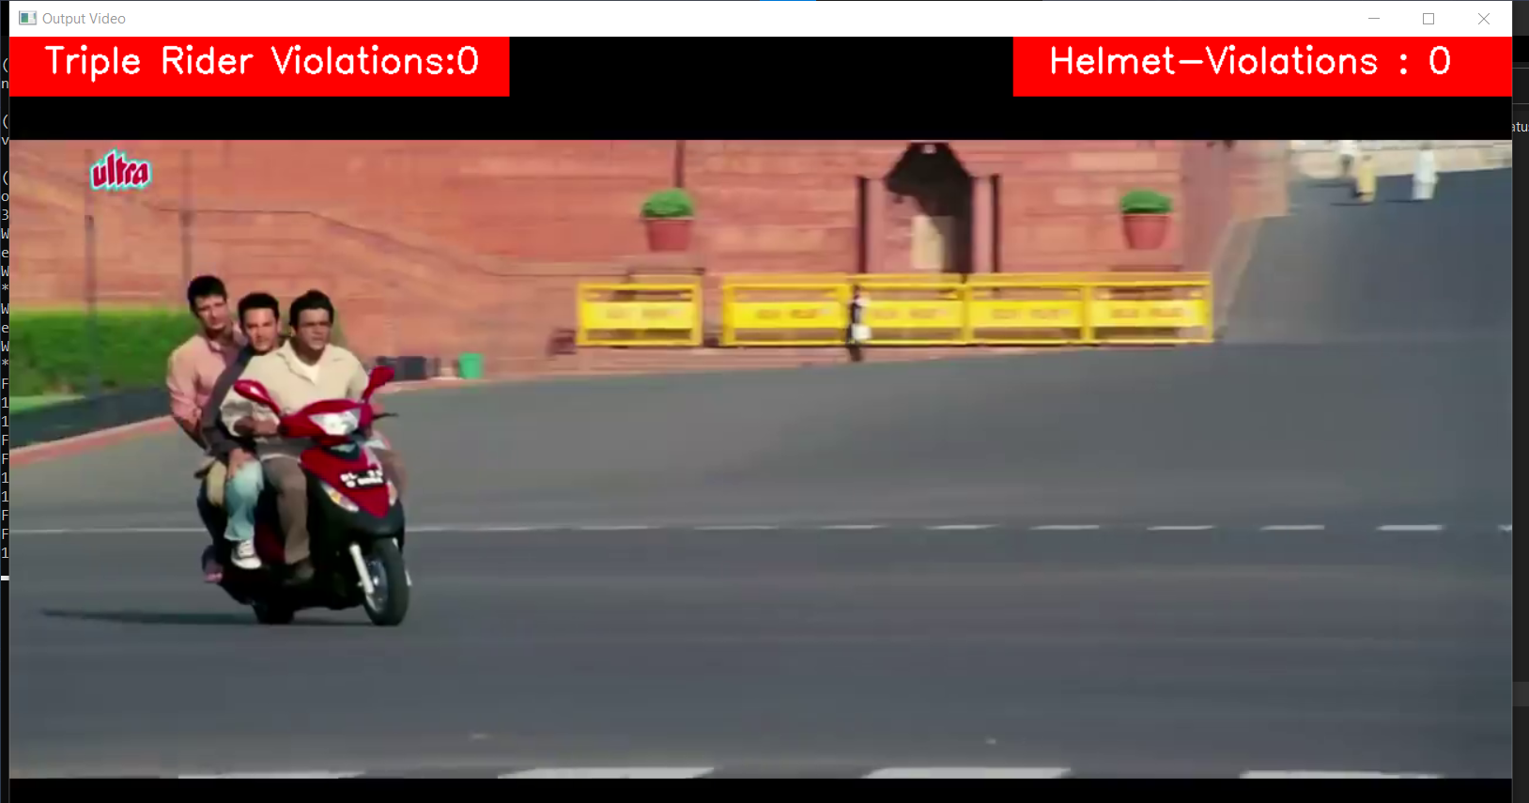

Fig 3 Video input analyzed frame by frame

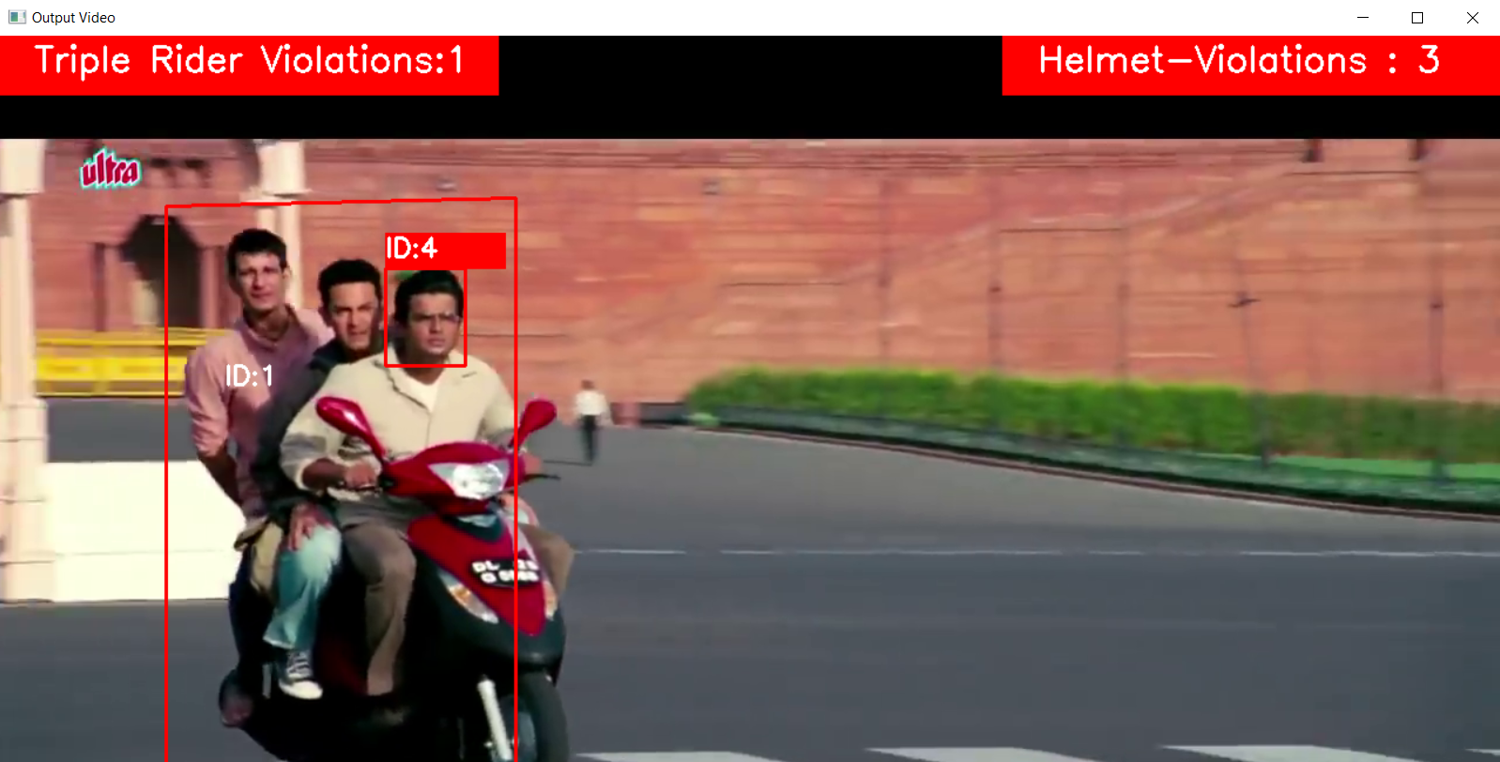

Fig 4. Infringement recognition in output

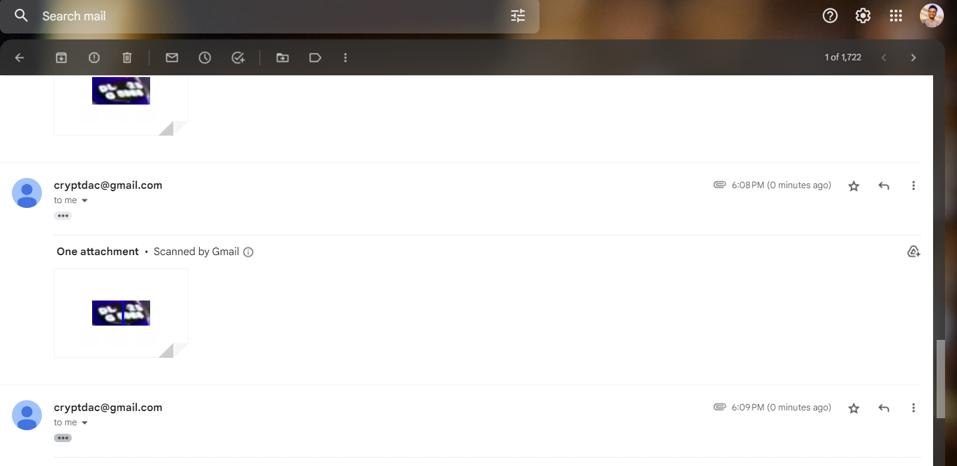
Fig 5. Ticketing alert mail with number plate

As a result, our output receives data in the form of a video as input, the pre-processing is maintained, and the video is turned into frames. As a result, the identification and track of the violation are carried out. In the event that the detection was successful, the license plate will be detected, cropped, processed, and included as an attachments in the ticketing email. The management of road traffic and the issuing of tickets for offences are both going to be significantly impacted by this computerized approach.

Conclusion
In this article, we suggest a comprehensive method for automating the recognition of two-wheeler offenses such that issuing fines involves either none or minimal human intervention. Yolo-v7 + DeepSORT and Yolo-v7 + Tesseract, correspondingly, are suggested for the tracking and detection of violations. Based on test data, this implementation's accuracy for identifying number plates was 99.41%, and its "average mean precision (mAP) for infringement detection" was 98.09%. When tested on eight live feeds simulating real-world occurrences, the system detected 77 out of 93 violations, with no false positives. The system spotted infractions, correctly recorded the accused's license plate, and effectively transferred the data to a database including all pertinent information, allowing automatic invoicing of infractions. As a result, AI-based technologies may be utilized to impose harsh punishments for violating traffic regulations, increasing user awareness and raising the bar for basic road safety. Building a highly trustworthy violation model presents various obstacles. A considerable quantity of tagged data is necessary for training custom models. The process, which comprises the creation, gathering, and labeling of various proprietary data sets, requires a lot of time to perform. The bulk of CCTV video has poor resolution, making the majority of its data unusable, which also causes concerns with picture quality. Unreliable license plates with ornate typefaces, plates in regional languages, and sometimes even no license plates at all are additional problems that have been seen. These are some of the challenges that must be solved in spite of the substantial amounts of processing power required to operate the system successfully. In the near future, the system may be improved by include new kinds of automobiles and recognizing the relevant traffic offenses involving such vehicles. Moreover, systems that can manage numerous camera perspectives and a wider variety of infractions may be developed. It is possible to further train the OCR used to read license plates to recognize plates with odd fonts and patterns. Comparing the accuracy and speed of various models may also be done via trials using more contemporary object detection models.

References

[1] A. Bochkovskiy, C.-Y. Wang, and H.-Y. Mark Liao, “YOLOv4: Optimal speed and accuracy of object detection”, 2020, arXiv:2004.10934.
[2] N. Wojke, A. Bewley, and D. Paulus, “Simple online and realtime racking with a deep association metric,” in Proc. IEEE Int. Conf. Image Process. (ICIP), Sep. 2017, pp. 3645–3649, doi: 10.1109/ICIP.2017.8296962.
[3] A. Bewley, Z. Ge, L. Ott, F. Ramos, and B. Upcroft, “Simple online and realtime tracking,” in Proc. IEEE Int. Conf. Image Process. (ICIP), Sep. 2016, pp. 3464–3468, doi: 10.1109/ICIP.2016.7533003.
[4] R. Smith, “An overview of the Tesseract OCR engine,” in Proc. 9th Int. Conf. Document Anal. Recognit. (ICDAR), Sep. 2007, pp. 629–633, doi: 10.1109/ICDAR.2007.4376991.
[5] Ross Girshick, Jeff Donahue, Trevor Darrell, JitendraMalik(2014), “Rich Feature Hierarchies for Accurate Object Detection and Semantic Segmentation.” The IEEE Conference on Computer Vision and Pattern Recognition (CVPR), pp. 580-587.
[6] Xiaoling Wang “A Video-based Traffic Violation Detection System”, https://www.researchgate.net/publication/271545712, December 2013 DOI: 10.1109/MEC.2013.6885246
[7] S. Awang, and NMAN Azmi, "Vehicle counting system based on vehicle type classification using deep learning method." In IT Convergence and Security 2017, pp. 52-59. Springer, Singapore, 2018.
[8] Maharsh Desai, "Automatic Helmet Detection on Public Roads",in International Journal of Engineering Trends and Technology · May 2016 DOI: 10.14445/22315381/IJETT-V35P241
[9] Deeksha N , "Detection of Bike Riders without Helmet and Triple Riding using YOLO v3 model", International Journal of Scientific Research in Engineering and Management (IJSREM), Volume: 06 Issue: 06 | June - 2022 Impact Factor: 7.185 ISSN: 2582-3930
[10] Chien-Yao Wang, “YOLOv7: Trainable bag-of-freebies sets new state-of-the-art for real-time object detectors.”, https://arxiv.org/abs/2207.02696, 16-07-2022
[11] Debby Ratna Daniel E-Traffic Operational Information System Based on Automatic Number Plate Recognition (ANPR) System as a Tool to Detect Traffic Violation and to Manage the Traffic Fines in Indonesia”, JCAE Symposium 2018 – Journal of Contemporary Accounting and Economics Symposium 2018 on Special Session for Indonesian Study
[12] Sangita Kumari,” A Novel Methodology for Vehicle Number Plate
Recognition using Artificial Neural Network”, Third International Symposium on Computer Vision and the Internet (VisionNet), September 2016
[13] Chirag Patel,” Automatic Number Plate Recognition System (ANPR): A Survey”,
in International Journal of Computer Applications · May 2013
[14] M. S. Sarfraz et al., "Real-Time automatic license plate recognition for CCTV forensic applications," Journal of Real-Time Image Processing- Springer Berlin/Heidelberg, 2011.
[15] Aishwarya Agrawal, N. P. (2017). AUTOMATIC LICENCE PLATE RECOGNITION USING RASPBERRY PI. International Interdisciplinary Conference on Science Technology Engineering Management Pharmacy and Humanities. Singapore.
[16] Xinyu Hou ,” Vehicle Tracking Using Deep SORT with Low Confidence Track Filtering”, 2019 16th IEEE International Conference on Advanced Video and Signal Based Surveillance (AVSS), 25 November 2019,INSPEC Accession Number: 19173920, DOI: 10.1109/AVSS.2019.8909903.
[17] K. Saho, “Kalman Filter for Moving Object Tracking: Performance Analysis and Filter Design,” Kalman Filters - Theory for Advanced Applications, Feb. 2018, doi: 10.5772/intechopen.71731.

[18] R. Shree Charran, Rahul Kumar Dubey. "Two-Wheeler Vehicle Traffic Violations Detection and automated Ticketing for Indian Road Scenario", IEEE Transactions on Intelligent Transportation Systems,2022

