**Travel Management System**

**Team:** Arunsundar Kannan, Ashish Tak, Prajnya Satish

**Title:** Travel Management System

**Project Summary:** A travel management system to enable a traveller to book flight tickets and manage other aspects of his journey such as food, accommodation and commute on the same platform. The customer books for all the services required together. If he so wishes, he could also cancel the booking on the same application.

**Framework:** Spring

**Data Storage:** MySQL Database

**Project Requirements:**

**User Requirements**

|  |  |  |
| --- | --- | --- |
| **ID** | **DESCRIPTION** | **PRIORITY** |
| US01 | As an Airline vendor, I want to add a new flight to the system by providing the details about the particular flight. | Medium |
| US02 | As the system admin, I need to check the details of the newly added route by an airline vendor so that I can decide whether to approve | High |
| US03 | As an Airline vendor, I want to remove any selected route | Medium |
| US04 | As the system admin, I need to decide whether to approve the removal of a route based on passenger and business commitments so that inconvenience to passengers is minimized | High |
| US05 | As a customer, I wish to reserve plane tickets by providing source, destination and dates of travel | High |
| US06 | As a customer, if I prefer to use the accommodation service, I should be able to select from a list of suggested hotels based on my destination | High |
| US07 | As a customer, I should be able to pay for the services I have opted for using my credit/debit card | High |
| US08 | As a customer, I should be able to cancel a reservation by specifying my reservation details | High |
| US09 | As the admin, I need to determine the percentage of refund based on the reason given for cancellation by the customer | High |
| US10 | As a payment gateway operator, I need to process the assigned refund to the customer’s credit/debit card | High |
| US11 | As a customer, I should receive a confirmation message after completing the booking process | Medium |
| US12 | As a customer, I should have an option of reserving a taxi from the destination airport | Medium |

**Business Requirements**

|  |  |
| --- | --- |
| **ID** | **DESCRIPTION** |
| BU01 | Airline provides accommodations for special circumstances in case of senior citizens |
| BU03 | For Airline and Hotel Accomodation vendors, cancellations can only be done 48 hrs prior to departure |

**Functional Requirements**

|  |  |
| --- | --- |
| **ID** | **DESCRIPTION** |
| FR01 | Display confirmation details after booking is complete so that customer has the confirmation number. |
| FR02 | Display message with refund amount after cancellation is complete. |
| FR03 | A unique confirmation number should be generated for each customer. |

**Non-Functional Requirements**

|  |  |
| --- | --- |
| **ID** | **DESCRIPTION** |
| NF01 | The payment gateway should process the transaction in less than 3 seconds, else a timeout would occur on the website |
| NF02 | Confirmation message should contain the confirmation number, Name, flight details and payment information |

**Use Case Diagram:**

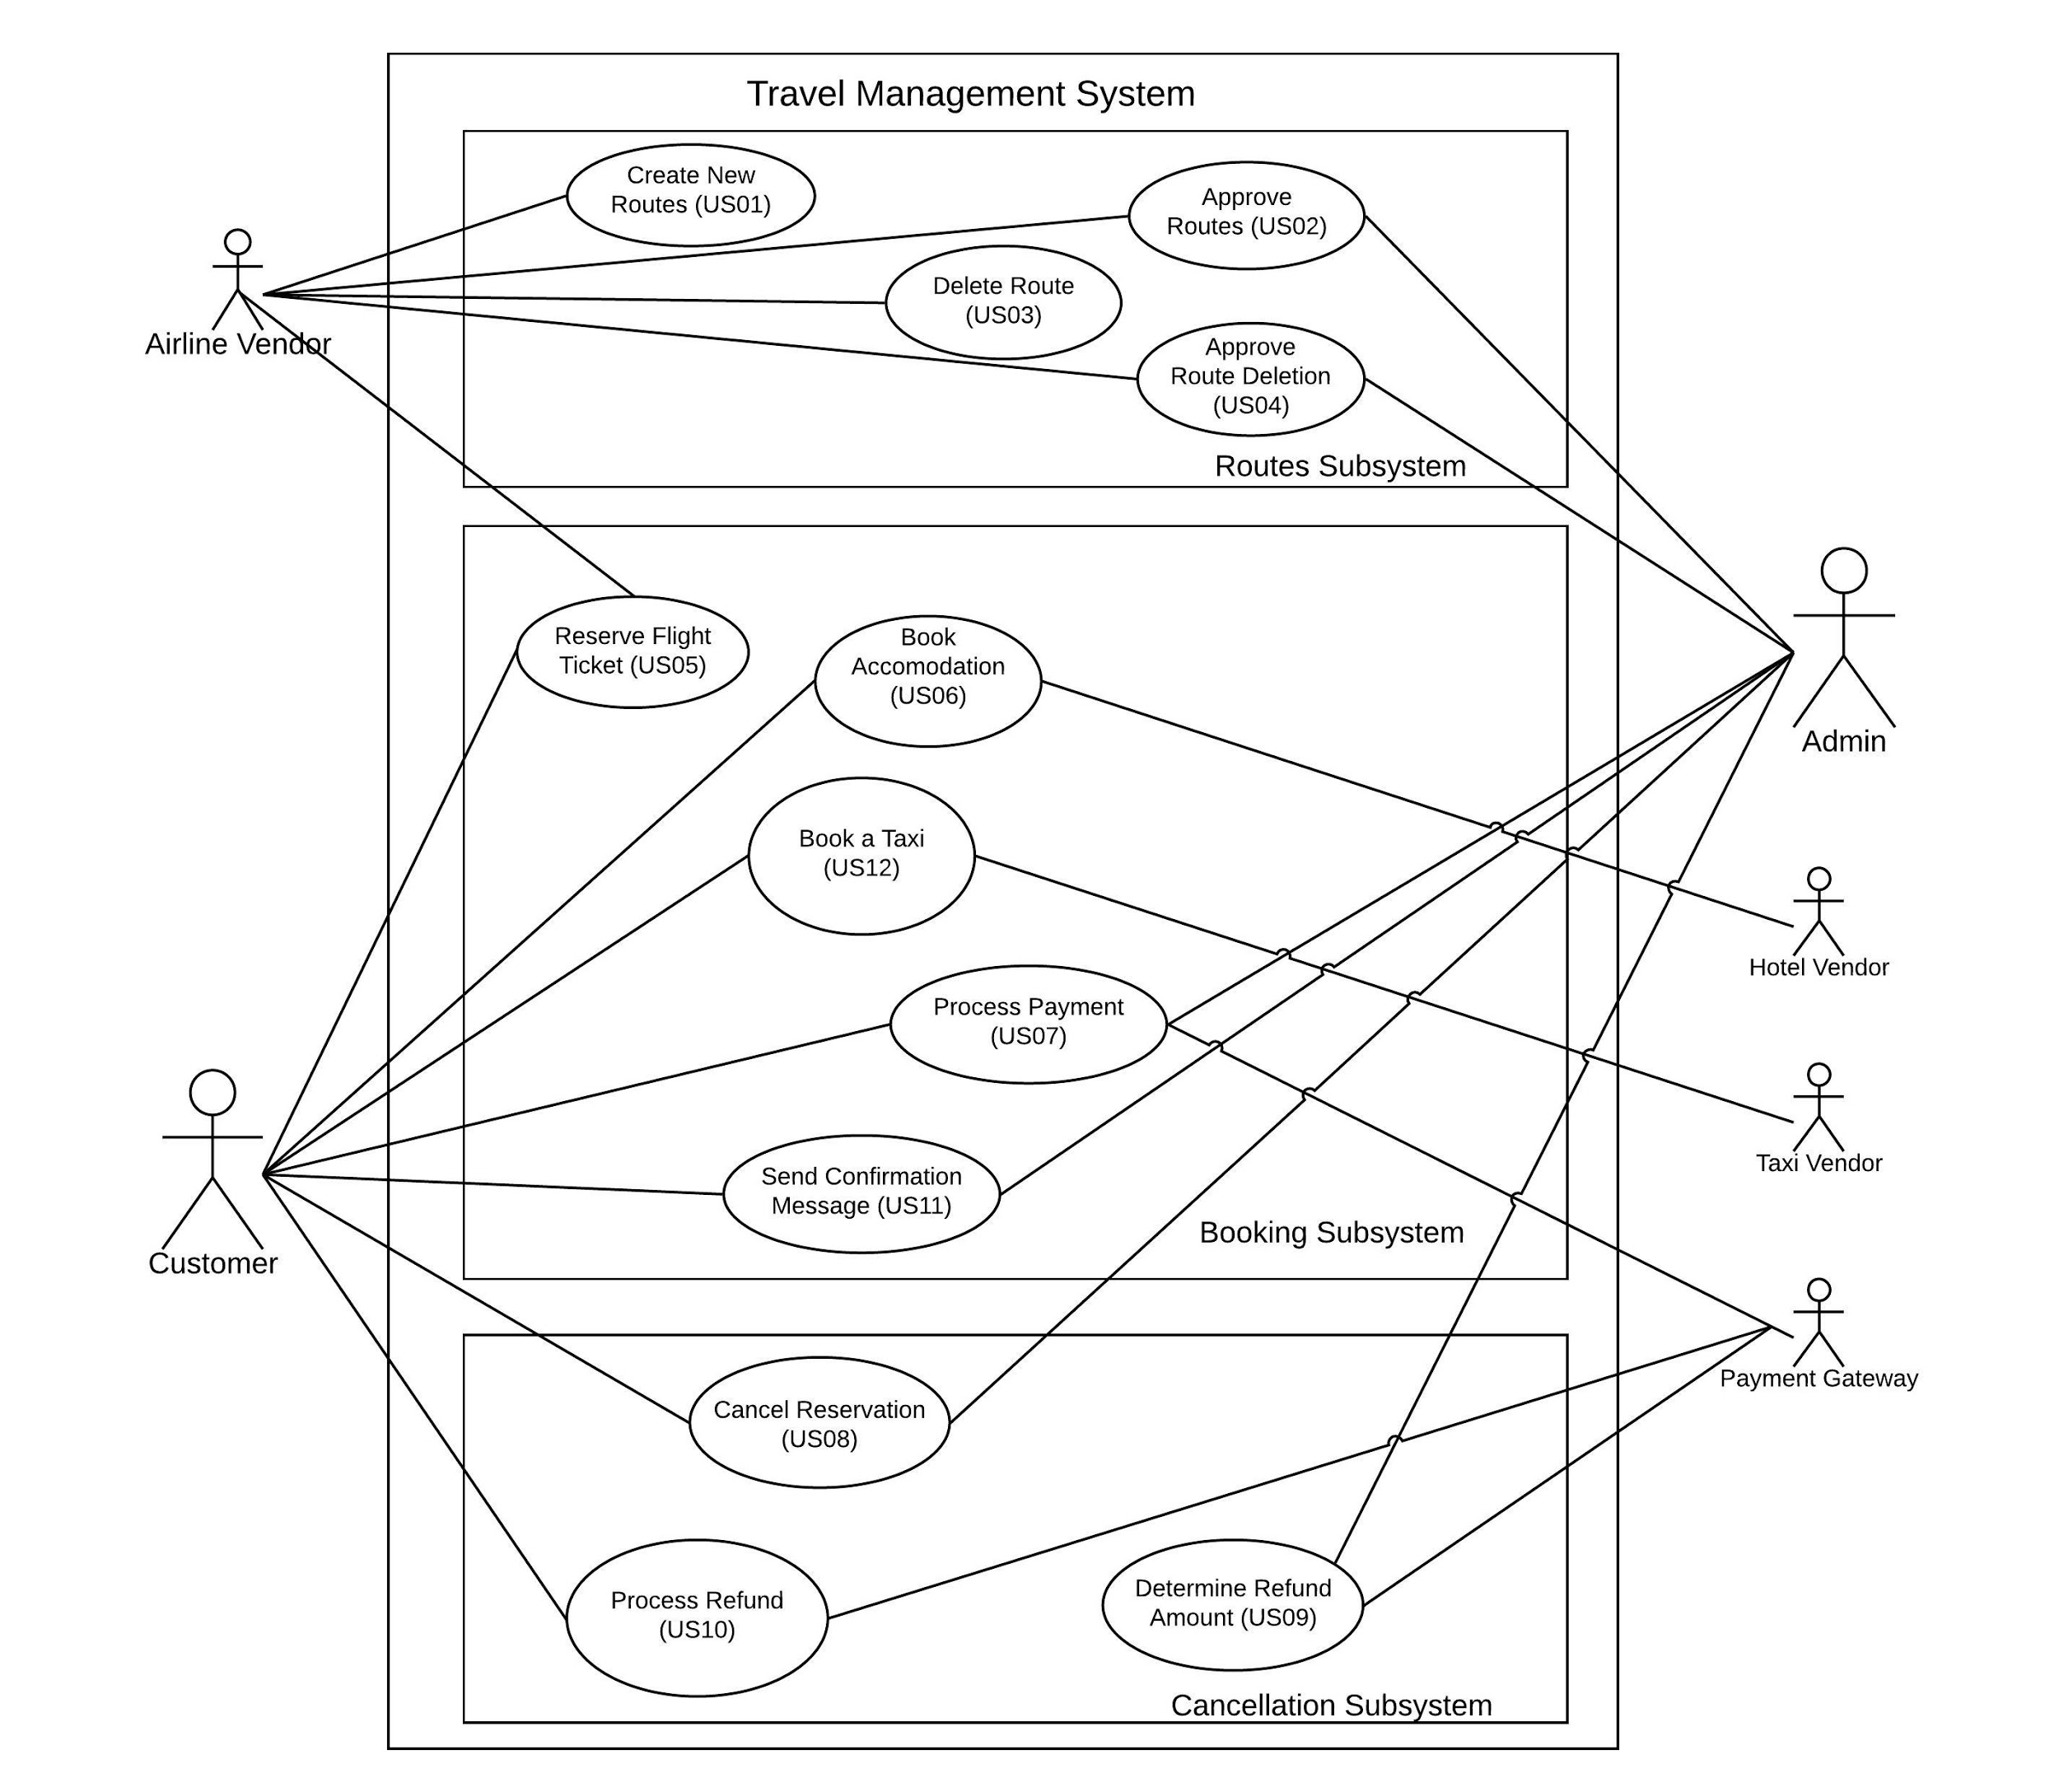

**Sub-Diagrams:**

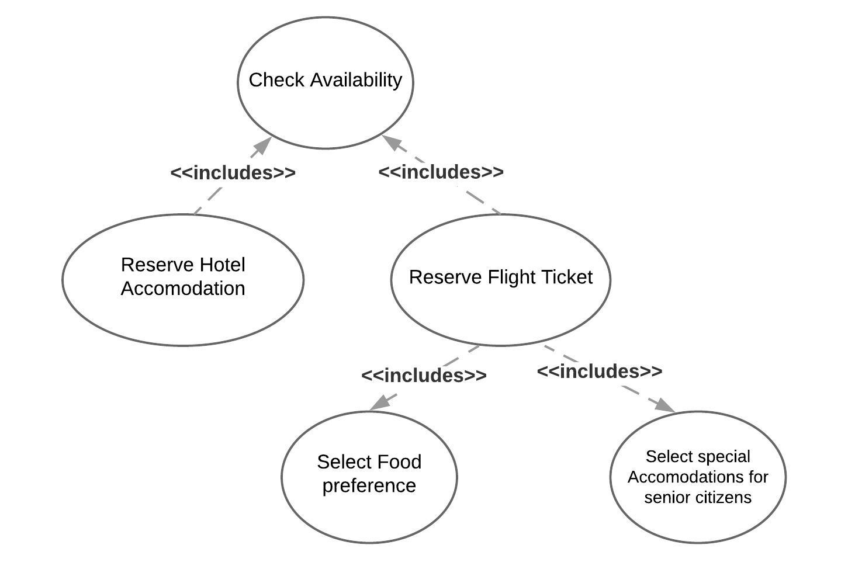

Sub-Diagram 1: US05 (Reserve Flight ticket) and US06 (Reserve Hotel Accommodation)

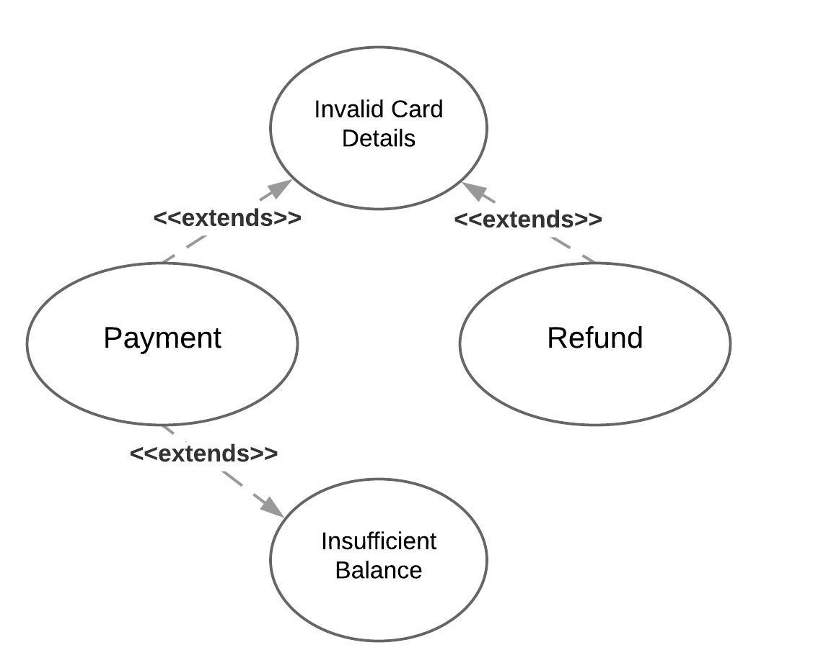

Sub-Diagram 2: US07 (Make Payment) and US10 (Process Refund)

**Use Case Documents:**

|  |  |
| --- | --- |
| Use Case ID: | US05 |
| Use Case Name: | Reserve Flight Ticket |
| Description | Customer reserves flight tickets from list of suggested routes given source, destination and dates of travel |

|  |  |
| --- | --- |
| Actors | Customer |
| Pre-conditions | Customer needs to have valid identification.  Customer has a valid credit/debit card with sufficient balance |
| Post-conditions | Customer gets a confirmation for his flight ticket |
| Frequency of use | Whenever the customer browses through the website to see the options |
| Flow of events | |  |  |  | | --- | --- | --- | |  | Customer | System Response | | 1 | Enter travel details | Display a list of available flights with pricing information | | 2 | Select an option from the list of available flights | Calculate the price for the flight ticket and show food preference options | | 3 | Select food preference and enter personal details | Ask for wheelchair arrangement if the person is a senior citizen | | 4 | Opt for a wheelchair service if required and confirm the flight booking | Display the confirmed flight details and direct the customer to opt for accomodation and/or taxi services | |
| Variations | 1. Fetch travel dates from previous searches 2. Opt for flights with a layover instead of a direct connection |
| Exceptions | 1. No available flights for the selected route |
| Developer Notes |  |

|  |  |
| --- | --- |
| Use Case ID: | US08 |
| Use Case Name: | Cancel a booking |
| Description: | The customer can cancel a reservation made by specifying the confirmation number and a reason for cancellation |

|  |  |
| --- | --- |
| Actors | Customer |
| Pre-conditions | Customer needs to have valid confirmation number and a valid credit/debit card for the refund |
| Post-conditions | The customer is informed that the refund will be processed |
| Frequency of use | Only once per customer if he opts to cancel the complete ticket |
| Flow of events | |  |  |  | | --- | --- | --- | |  | Customer | System Response | | 1 | Enter ticket confirmation number | Display the details of the itenary and asks for services to be cancelled | | 2 | Select the services to be cancelled | Determine whether the cancellation request is valid based on the date of journey and then ask for a cancellation reason | | 3 | Provide cancellation reason and confirm the cancellation | Send the request to admin for refund calculation, and inform the customer that the refund will be processed | |
| Variations | 1. Select from a set of cancellation reasons or type in your own |
| Exceptions | 1. User has an invalid ticket confirmation number 2. Cancellation not possible because time of cancellation is less than 48 hours from departure |
| Developer Notes |  |

**Activity Diagrams:**

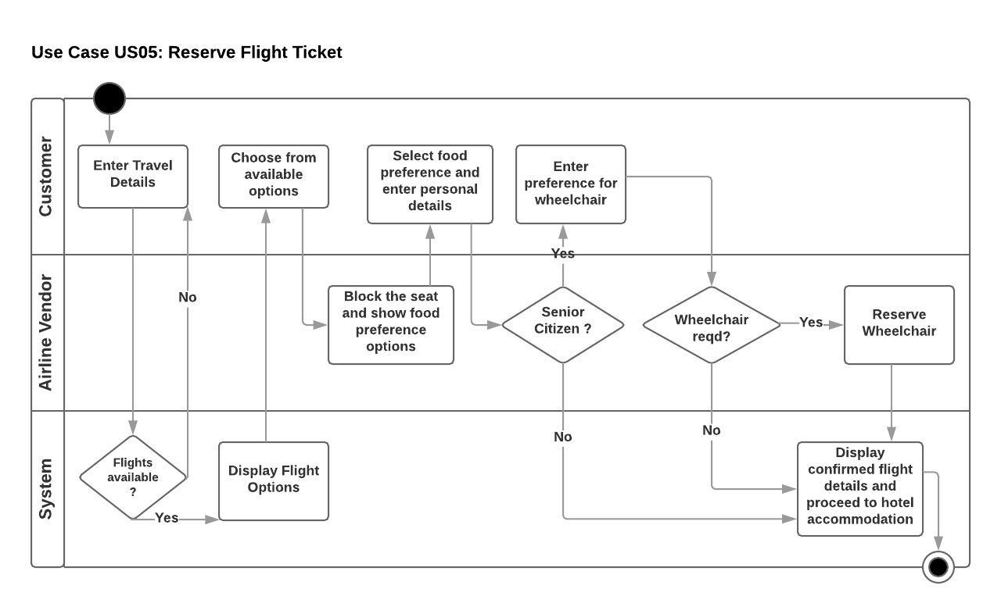

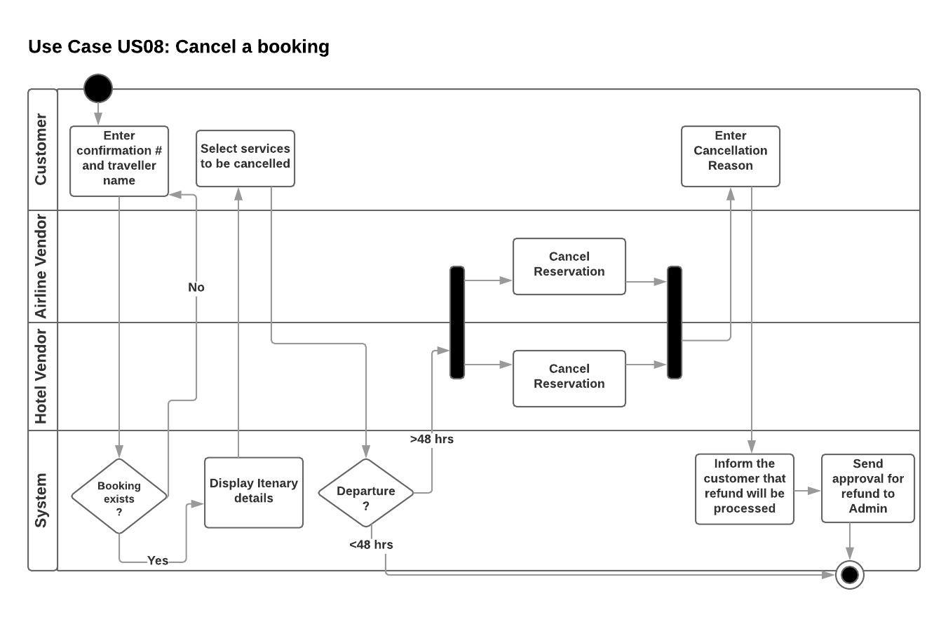

**UI Mockups:**

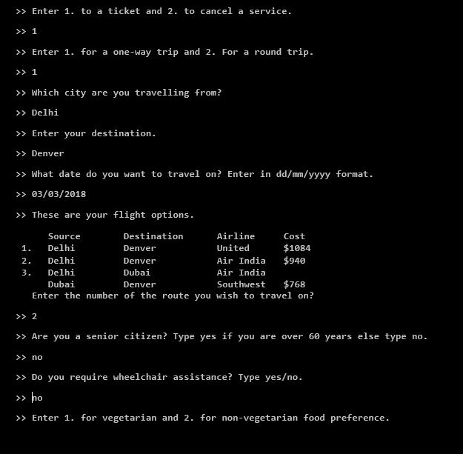

Fig: UI Mockup for Booking

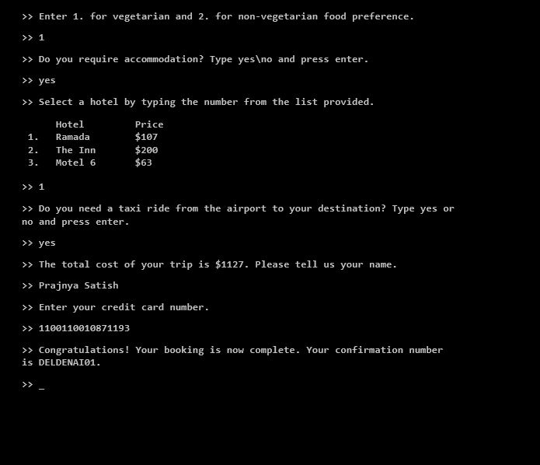

Fig: UI Mockup for Booking (contd.)

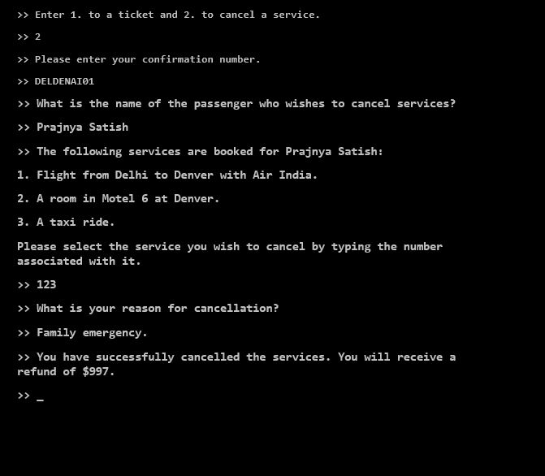

Fig: UI mockup for cancellation

**Sequence Diagrams:**

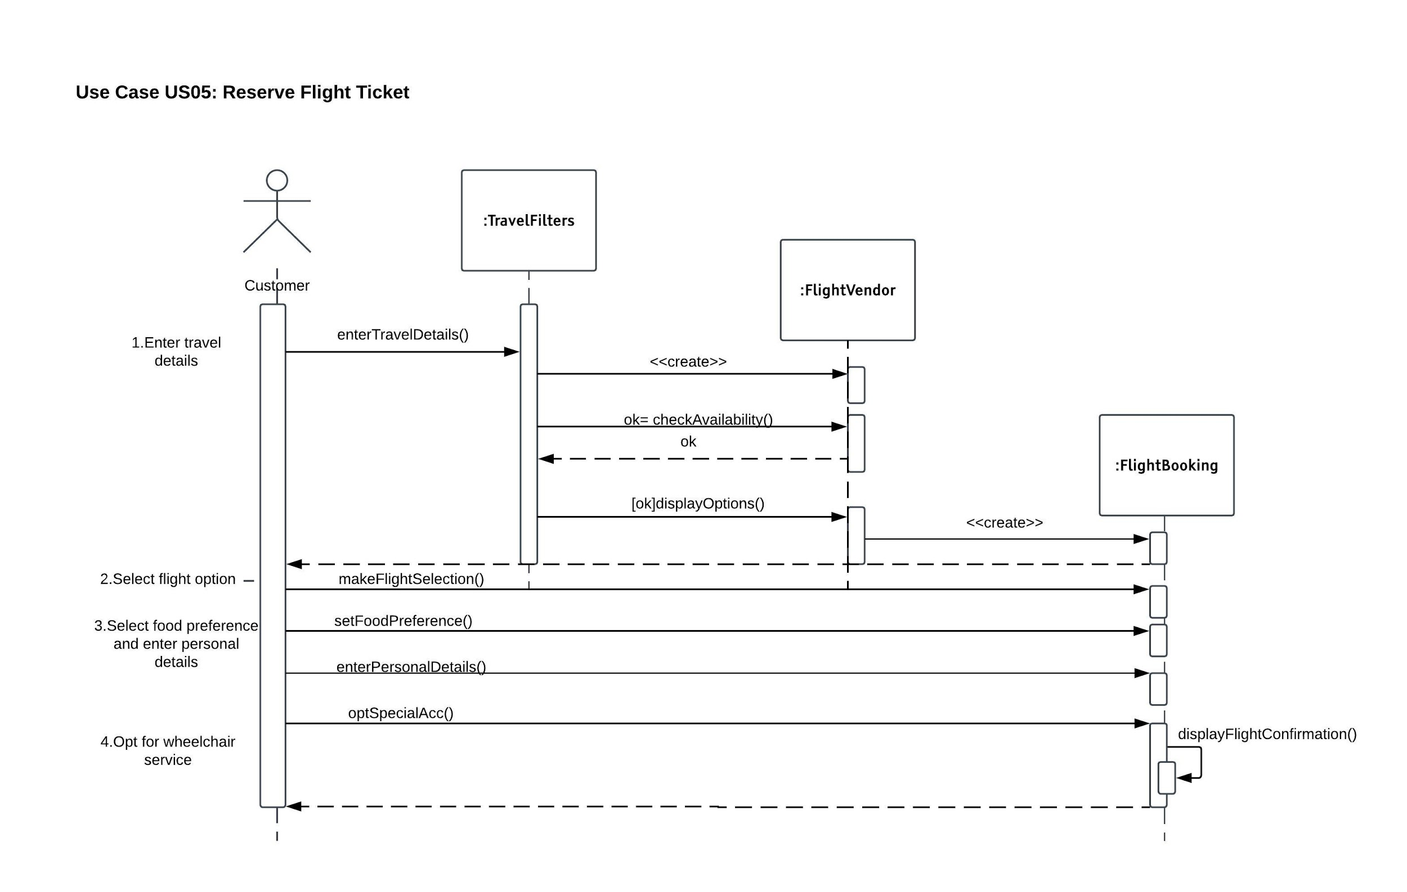

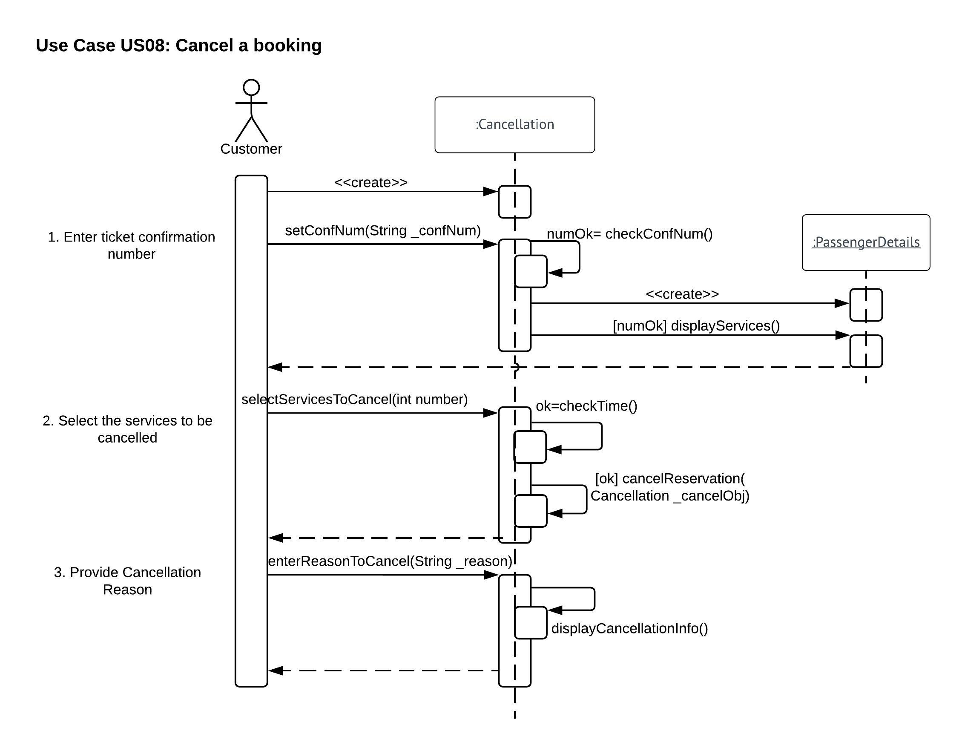

**Class Diagram:**

