**CHAPTER 1**

**INTRODUCTION**

AC induction motors are the most common motors used in industrial motion control systems, as well as in main powered home appliances. Simple and rugged design, low-cost, low maintenance and direct connection to an AC power source are the main advantages of AC induction motors.

The AC induction motor is a rotating electric machine designed to operate from a 3-phase source of alternating voltage. The three phase motor is widely used in industry because of its low maintenance characteristics. The induction motor is made up of the stator, or stationary windings, and the rotor. The stator consists of a series of wire windings of very low resistance permanently attached to the motor frame. As a voltage and a current are applied to the stator winding terminals, a magnetic field is developed in the windings. The rotor is comprised of a number of thin bars, usually aluminum, mounted in a laminated cylinder. The bars are arranged horizontally and almost parallel to the rotor shaft. The rotor and stator are separated by an air gap which allows free rotation of the rotor. The magnetic field generated in the stator induces an EMF in the rotor bars. In turn, a current is produced in the rotor bars and another magnetic field is induced in the rotor with an opposite polarity of that in the stator. The magnetic field, revolving in the stator, will then produce the torque which will “pull” on the field in the rotor and establish rotor rotation.

Generally, induction motors are categorized based on the number of stator windings. They are:

1. Single-phase induction motor
2. Three-phase induction motor

a) Single-phase induction motor

This type of motor has only one stator winding (main winding) and operates with a single-phase power supply. In all single-phase when the motor is connected to a single-phase power supply, the main winding carries an alternating current. This current produces a pulsating magnetic field. Due to induction, the rotor is energized. As the main magnetic field is pulsating, the torque necessary for the motor rotation is not generated. This will cause the rotor to vibrate, but not to rotate. Hence, the single phase induction motor is required to have a starting mechanism that can provide the starting kick for the motor to rotate.

b) Three-phase ac induction motor

Where a polyphase electrical supply is available, the [three-phase](http://en.wikipedia.org/wiki/Three-phase) (or [polyphase](http://en.wikipedia.org/wiki/Polyphase_system)) AC induction motor is commonly used, especially for higher-powered motors. The phase differences between the three phases of the polyphase electrical supply create a rotating electromagnetic field in the motor. Through electromagnetic induction, the rotating magnetic field induces a current in the conductors in the rotor, which in turn sets up a counterbalancing magnetic field that causes the rotor to turn in the direction the field is rotating. The rotor must always rotate slower than the rotating magnetic field produced by the polyphase electrical supply; otherwise, no counterbalancing field will be produced in the rotor.

These motors are self-starting. The power capabilities and efficiency in these motors range from medium to high compared to their single-phase counterparts. Popular applications include grinders, lathes, drill presses, pumps, compressors, conveyors, also printing equipment, frame equipment, electronic cooling and other mechanical duty applications.

They are classified either as SQUIRREL CAGE or WOUND-ROTOR MOTORS.

**1.1 TYPES OF IM**

1.1.1 **Squirrel Cage Motor rotor**

In overall shape, it is a cylinder mounted on a shaft. Internally it contains longitudinal conductive bars (usually made of aluminum or copper) set into grooves and connected at both ends by shorting rings forming a cage-like shape. The name is derived from the similarity between this rings-and-bars winding and a squirrel cage. The solid core of the rotor is built with stacks of electrical steel laminations. The rotor has a smaller number of slots than the stator and must be a non-integral multiple of stator slots so as to prevent magnetic interlocking of rotor and stator teeth at the starting instant. The number of bars on the squirrel cage determines to what extent the induced currents are fed back to the stator coils and hence the current through them.

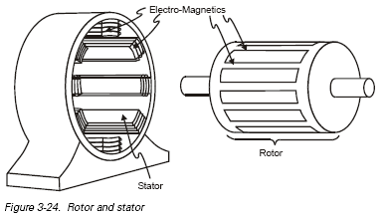

Fig: 1.1.1 Squirrel cage IM

1.1.2 Wound-Rotor Motor

The slip-ring motor or wound-rotor motor is a variation of the squirrel cage induction motor. While the stator is the same as that of the squirrel cage motor, it has a set of

windings on the rotor which are not short-circuited, but are terminated to a set of slip rings. These are helpful in adding external resistors and contactors.

****

Fig 1.1.2: Slip ring IM

The slip necessary to generate the maximum torque (pull-out torque) is directly proportional to the rotor Resistance. In the slip-ring motor, the effective rotor resistance is increased by adding external resistance through the slip rings. Thus, it is possible to get higher slip and hence, the pull-out torque at a lower speed .A particularly high resistance can result in the pull-out torque occurring at almost zero speed, providing a very high pull-out torque at a low starting current. As the motor accelerates, the value of the resistance can be reduced, altering the motor characteristic to suit the load requirement. Once the motor reaches the base speed, external resistors are removed from the rotor. This means that now the motor is working as the standard induction motor. Slip ring IM has high starting torque. This motor type is ideal for very high inertia loads, where it is required to generate the pull-out torque at almost zero speed and accelerate to full speed in the minimum time with minimum current draw.

Although AC induction motors are easier to design than DC motors, the speed and the torque control in various types of AC induction motors require a greater understanding of the design and the characteristics of these motors.

**1.2 SYNCHRONOUS SPEED AND SLIP OF IM**

**1.2.1 Synchronous speed**

The synchronous speed of an AC motor is the rotation rate of the rotating magnetic field created by the stator. It is always an integer fraction of the supply frequency. The synchronous speed *ns* in revolutions per minute (RPM) is given by:

n_s={60\times{f}\over{p}}

where,  *f*  is the frequency of the AC supply current in [Hz](http://en.wikipedia.org/wiki/Hertz) and *p* is the number of magnetic pole pairs per phase.

Generally we speak of two types of speed ranges based on the rated speed of the motor-SUBSYNCHRONOUS SPEED which is below the rated speed and the SUPER SYNCHRONOUS SPEED, above the rated speed.

**1.2.2 Slip**

Slip *s* is the rotation rate of the magnetic field, relative to the rotor, divided by the absolute rotation rate of the stator magnetic field.

s = \frac{n_s-n_r}{n_s}\,

where n_r is the rotor rotation speed in rpm. It is zero at synchronous speed and 1 (100%) when the rotor is stationary. The slip determines the motor's torque. Since the short-circuited rotor windings have small resistance, a small slip induces a large current in the rotor and produces large torque. At full rated load, typical values of slip are 4-6% for small motors and 1.5-2% for large motors, so induction motors have good speed regulation and are considered constant-speed motors.

**1.3 MODES OF OPERATION**

A Motor can operate either in motoring mode or in generating mode. The modes of operation of an IM are classified into four types.

1. SUB SYNCHRONOUS GENERATING
2. SUB SYNCHRONOUS MOTORING
3. SUPER SYNCHRONOUS GENERATING
4. SUPER SYNCHRONOUS MOTORING

Though these 4 modes of operation are possible, IM is mainly driven in Sub- synchronous Motoring and Super Synchronous Generating modes.

Fig 1.3: Different modes of IM operation

**CHAPTER 2**

**GENERALIZED MACHINE THEORY**

Rotating electrical machines work on same basic principles. The various types differ from each other in their winding arrangements and the method of exciting these windings. The attempts to unify the piecemeal treatment of rotating electrical machines have led to generalized machine theory.

In Generalized Machine Theory, any machines can be converted into a two pole, two winding machine. All types of electrical machines have certain common features as follows:

1. An outer stationary member and an inner rotating member.
2. Field windings and field poles, armature windings.
3. An air gap between stator and rotor.
4. A common magnetic flux crosses the air gap from one core to the other.

So a generalized approach is possible for representing different types of electrical machines.

**2.1 TWO POLE REPRESENTATION OF A MACHINE**

The distribution of current and flux under one pair of poles repeats itself under all other pairs of poles, whatever the actual number of pole pairs may be. Hence any machine can be replaced by an equivalent two pole machine and the generalized machine

theory is developed in terms of two pole machines. The number of poles however may be introduced in determining the torque and speed of the machine.

For two pole machine representation,

1. Each winding of the machine is represented by a single coil.
2. The rotating windings are shown inside the circle and stationary armature windings outside the circle.
3. The d-q axis is drawn perpendicular to each other, and the field windings are

shown along d-axis.

1. The positive direction of the current in any coil is towards the coil in the lead nearer to the centre of the diagram. The positive direction of flux is radially outwards along the axis of the coil.
2. The positive direction of rotation of rotor is taken as clockwise.

**2.2 d-q REPRESENTATION OF INDUCTION MOTOR**

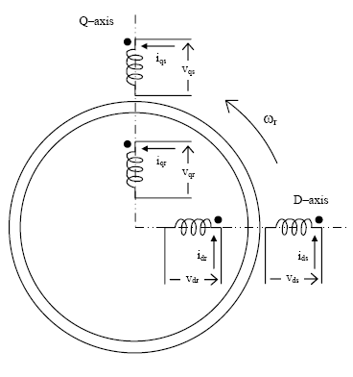

Fig 2.2: d-q model of IM

**CHAPTER 3**

**VSI- FED VECTOR CONTROLLED INDUCTION MOTOR**

As discussed earlier an induction motor can be operated in four different modes. In this project we have used vector control technique for the illustration of these modes using the help of matlab software. Different control strategies can be opted on stator and rotor side of a motor. Here a slip ring im is considered because its rotor side is free for control purpose. The four modes of operation are achieved by rotor side control.

**3.1 CONVENTIONAL METHODS**

The conventional methods used for the control of speed and thereby operating the motor in different modes are static Kramer’s drive, dc link scherbius drive, cycloconverter scherbius drive etc. In static Kramer’s drive the slip frequency power from the rotor is converted to dc voltage which is then converted to line frequency and pumped back to the ac source. As the slip power can flow only in one direction, static Kramer drive offers speed control below synchronous speed only. This disadvantage of Kramer’s drive is overcome in the two configurations – dc link and cycloconverter scherbius drives. They can be operated in sub synchronous as well as super synchronous modes.

**3.2 OPERATING MODES**

**3.2.1 Sub-synchronous motoring**

In this mode, operation is similar to that obtained with a static kramer drive. Slip and torque are both positive, therefore injected voltage must be in phase with rotor current. Power flows into the stator and back out of the rotor circuit.

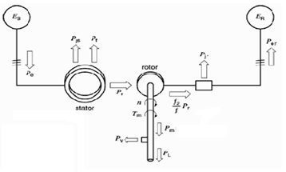

Fig 3.2.1: Sub synchronous motoring

**3.2.2 Sub-synchronous generating**

If generation below synchronous speed is required, torque must be negative whilst slip is positive. Again,

http://www.ece.ualberta.ca/%7Eknight/variable_speed_drives/ssim/images/eqns/ser/scherb_vi.gif

must be negative. Power is being injected into the rotor from the slip rings.

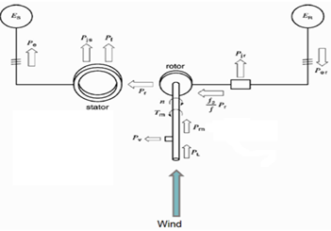

Fig: 3.2.2: Sub-synchronous generating

If an induction motor is driven above synchronous speed, it becomes an induction generator and supplies energy to the power source rather than receiving energy. When a synchronous motor is over-driven, is becomes a generator, but it must still remain at synchronous speed.

**3.2.3 Super-synchronous motoring**

Above synchronous speed, the slip is negative. In order for the torque to be positive,

http://www.ece.ualberta.ca/%7Eknight/variable_speed_drives/ssim/images/eqns/ser/scherb_vi.gif

must be negative. Therefore, voltage and current must be out of phase with each other. Power is being injected into the rotor from the drive circuit connected to the slip rings, in addition to input power flowing into the stator.

**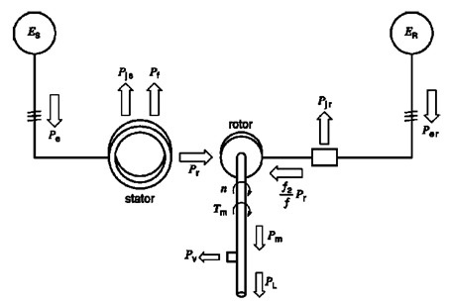**

Fig 3.2.3: Super-synchronous motoring

**3.2.1.4 Super-synchronous generating**

If generating above synchronous speed, slip and torque are both negative, therefore

http://www.ece.ualberta.ca/%7Eknight/variable_speed_drives/ssim/images/eqns/ser/scherb_vi.gif

is positive and injected voltage is in phase with rotor current. In this case, mechanical input power is being supplied from the shaft and both the stator and rotor circuits are

providing output power.

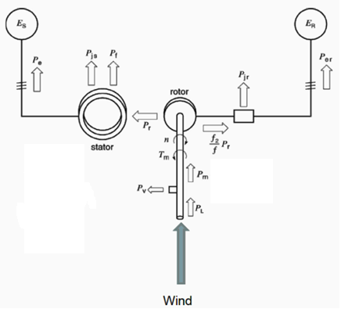

Fig 3.2.4: Super-synchronous generating

Fig 3.2.5: 4 modes of operation

**3.3 BLOCK DIAGRAM OF PROPOSED SCHEME**

c

b

a

Fig 3.3: Block diagram of proposed scheme

The Slip ring IM is connected to a grid .The stator is energized via a,b,c windings. This stator voltage is transformed into d,q of rotor by direct vector transformation. Reverse rotor voltages are pulse width modulated and fed to a VSI. The 3-level output of VS I is actually slip frequency times the stator voltage, which is given to the rotor. A simplified block diagram of the above process is shown in fig:3.3

**CHAPTER 4**

**PULSE-WIDTH MODULATED VSI**

**4.1 PULSE-WIDTH MODULATION (PWM)**

Pulse-width modulation (PWM), as it applies to motor control, is a way of delivering energy through a succession of pulses rather than a continuously varying (analog) signal. By increasing or decreasing pulse width, the controller regulates energy flow to the motor shaft. The motor’s own inductance acts like a filter, storing energy during the “on” cycle while releasing it at a rate corresponding to the input or reference signal. In other words, energy flows into the load not so much the switching frequency, but at the reference frequency. The duty cycle of the output waveform needs to be modulated by a certain rule and as a result both the output voltage and output frequency of the inverter can be regulated. The term duty cycle describes the proportion of 'on' time to the regular interval or 'period' of time; a low duty cycle corresponds to low power, because the power is off for most of the time.

The index of modulation is:

m =

Where,

is the frequency of the carrying wave.

is the frequency of the reference.

The control factor in voltage is:

*r* =

Where,

is the Amplitude of the reference.

is the Amplitude of the carrying wave

**4.1.1 Advantage of PWM**

The main advantage of PWM is that power loss in the switching devices is very low. When a switch is off there is practically no current, and when it is on, there is almost no voltage drop across the switch. Power loss, being the product of voltage and current, is thus in both cases close to zero. Load efficiency is almost always a critical factor in renewable energy systems. An additional advantage of pulse width modulation is that the pulses are at the full supply voltage and will produce more torque in a motor by being able to overcome the internal motor resistances more easily. A resistive speed control will present a reduced voltage to the load, which can cause stalling in motor applications. Finally, in a PWM circuit, common small potentiometers may be used to control a wide variety of loads, whereas large and expensive high power variable resistors are needed for resistive controllers. With PWM, lower order harmonics can be eliminated or minimized along with its output voltage control. As higher order harmonics can be filtered easily, the filtering requirements are minimized.

**4.1.2 Industrial applications of PWM**

PWM A.C. drive is very popular in industry. By controlling the speed of the induction motor, production can be varied as needed. The industries that use PWM drive are:

* Telecommunications: In telecommunications, the widths of the pulses correspond to specific data values encoded at one end and decoded at the other. Pulses of various lengths (the information itself) will be sent at regular intervals (the carrier frequency of the modulation).
* Power delivery: PWM can be used to control the amount of power delivered to a load without incurring the losses that would result from linear power delivery by resistive means.
* Variable-speed fan controllers for computers usually use PWM, as it is far more

efficient when compared to a [potentiometer](http://en.wikipedia.org/wiki/Potentiometer) or [rheostat](http://en.wikipedia.org/wiki/Rheostat).

* Light dimmers for home use a specific type of PWM control. Home-use light dimmers typically include electronic circuitry which suppresses current flow during defined portions of each cycle of the AC line voltage. Adjusting the brightness of light emitted by a light source is then merely a matter of setting at what voltage (or phase) in the AC half cycle the dimmer begins to provide electrical current to the light source. In this case the PWM duty cycle is the ratio of the conduction time to the duration of the half AC cycle defined by the frequency of the AC line voltage.
* In electric cookers, continuously-variable power is applied to the heating elements such as the hob or the grill using a device known as a Simmerstat. This consists of a

thermal oscillator running at approximately two cycles per minute and the mechanism varies the duty cycle according to the knob setting. The thermal time constant of the heating elements is several minutes, so that the temperature fluctuations

* Voltage regulation: PWM is also used in efficient [voltage regulators](http://en.wikipedia.org/wiki/Voltage_regulator). By switching voltage to the load with the appropriate duty cycle, the output will approximate a voltage at the desired level. The switching noise is usually filtered with an [inductor](http://en.wikipedia.org/wiki/Inductor) and a [capacitor](http://en.wikipedia.org/wiki/Capacitor).
* Audio effects and amplification: PWM is sometimes used in sound (music) synthesis, in particular [subtractive synthesis](http://en.wikipedia.org/wiki/Subtractive_synthesis), as it gives a sound effect similar to chorus or slightly detuned oscillators played together. The ratio between the high and low level is typically modulated with a low frequency oscillator. In addition, varying the duty cycle of a pulse waveform in a subtractive-synthesis instrument creates useful timbral variations.
* A new class of audio amplifiers based on the PWM principle is becoming popular. Called "[Class-D amplifiers](http://en.wikipedia.org/wiki/Switching_amplifier)", these amplifiers produce a PWM equivalent of the analog input signal which is fed to the [loudspeaker](http://en.wikipedia.org/wiki/Loudspeaker) via a suitable filter network to block the carrier and recover the original audio.
* Historically, a crude form of PWM has been used to play back [PCM](http://en.wikipedia.org/wiki/PCM) digital sound on the [PC speaker](http://en.wikipedia.org/wiki/PC_speaker).
* In more recent times, the [Direct Stream Digital](http://en.wikipedia.org/wiki/Direct_Stream_Digital) sound encoding method was introduced, which uses a generalized form of pulse-width modulation called [pulse density modulation](http://en.wikipedia.org/wiki/Pulse_density_modulation), at a high enough sampling rate (typically in the order of MHz) to cover the

whole [acoustic](http://en.wikipedia.org/wiki/Acoustics) frequencies range with sufficient fidelity. This method is used in the [SACD](http://en.wikipedia.org/wiki/Super_Audio_CD) format.

**4.1.3 Different types of pwm control**

* Single pulse width modulation
* Multiple pulse width modulation
* Sinusoidal pulse width modulation

**4.1.3.1 Sinusoidal pulse width modulation**

Among all PWM schemes, SPWM is one of the most popular and simple methods utilized in power inverter and motor control fields. Its main features can be summarized as sine-triangle wave comparison. A sine wave (modulated wave) is compared with a triangle wave (carrier wave) and when the instantaneous value of the triangle wave is less than that of the sine wave, the PWM output signal is in high level .Otherwise it is turned into the low level . The level switching edge is produced at every moment the sine wave intersects the triangle wave. Thus the different crossing positions result in variable duty cycle of the output waveform.

**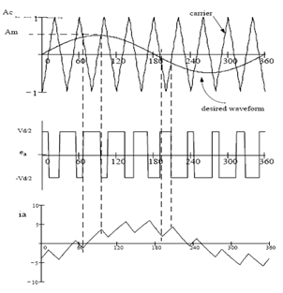**

Fig 4.1.3.1: Sinusoidal pulse width modulation

**4.1.3.2 SPWM for Three Phase VSI**

This is an extension of the one introduced for single-phase VSIs. In this case and in order to produce 120⁰ out-of-phase load voltages, three modulating signals that are 120⁰ out of phase

are used. FIG shows the ideal waveforms of three-phase VSI SPWM. In order to use a single carrier signal and preserve the features of the PWM technique, the normalized carrier frequency ***mf*** should be an odd multiple of 3. Thus, all phase voltages (***vaN*** , ***vbN*** , and ***vcN*** ) are identical but 120⁰ out of phase without even harmonics; moreover, harmonics at frequencies a multiple of 3 are identical in amplitude and phase in all phases.

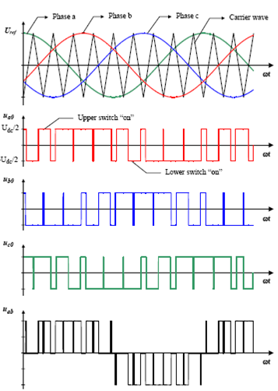

Fig 4.1.3.2: SPWM for three phase VSI

**4.2 VOLTAGE SOURCE INVERTER**

The main objective of static power converters is to produce an ac output waveform from a dc power supply. These are the types of waveforms required in adjustable speed drives (ASDs), uninterruptible power supplies (UPS), static variable compensators, active filters, flexible ac transmission systems (FACTS), and voltage compensators, which are only a few applications. For sinusoidal ac outputs, the magnitude, frequency, and phase should be controllable.

According to the type of ac output waveform, these topologies can be considered as voltage source inverters (VSIs), where the independently controlled ac output is a voltage waveform. These structures are the most widely used because they naturally behave as

voltage sources as required by many industrial applications, such as adjustable speed drives , which are the most popular application of inverters. Similarly, these topologies can be found as current source inverters (CSIs), where the independently controlled ac output is a current waveform. These structures are still widely used in medium-voltage industrial applications, where high-quality voltage waveforms are required. Static power converters, specifically inverters, are constructed from power switches and the ac output waveforms are therefore made up of discrete values. This leads to the generation of waveforms that feature fast transitions rather than smooth ones. For instance, the ac output voltage produced by the VSI of a standard ASD is a three-level waveform.

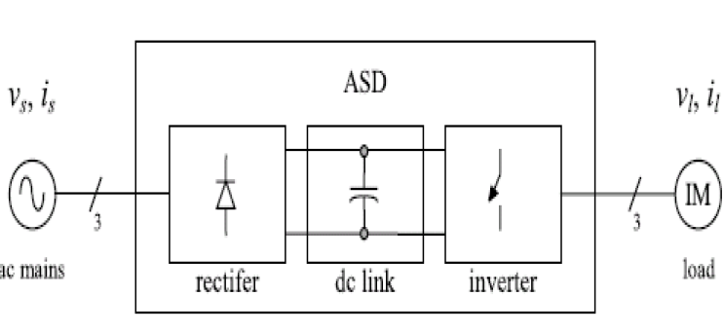

Fig 4.2.1: block diagram of VSI

Although this waveform is not sinusoidal as expected its fundamental component behaves as such. This behavior should be ensured by a modulating technique that controls the amount of time and the sequence used to switch the power valves on and off. The

modulating techniques most used are the carrier-based technique (e.g., sinusoidal pulse width modulation, SPWM), the space-vector (SV) technique, and the selective-harmonic-elimination (SHE) technique.

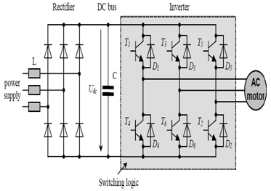

Fig 4.2.2: VSI

Some features of VSI:

a) Operates easily at no load.

b) Normally used where multi-machine capability is required.

c) Open loop volt/hertz is common.

d) Less interactive with load

e) Requires regenerative converter on line side.

f) Superior efficiency, overall cost and transient response than CSI.

g) Less rugged and reliable

h) Good dynamic response as compared to CSI

Output voltage from an inverter can also be adjusted by exercising a control within the inverter itself. The most efficient method of doing this is by pulse-width modulation control used within an inverter.

**CHAPTER 5**

**VECTOR CONTROL**

The induction motor, which is the most widely used motor type in the industry, has been favored because of its good self-starting capability, simple and rugged structure, low cost and reliability, etc. Along with variable frequency AC inverters, induction motors are used in many adjustable speed applications which do not require fast dynamic response. Induction motor speed control methods are varied in number of which vector or field oriented control is the most widely accepted method. The concept of vector control has opened up a new possibility that induction motors can be controlled to achieve dynamic performance as good as that of DC or brushless DC motors.

**5.1 WHY VECTOR CONTROL?**

The main advantage of vector control is to achieve good performance when speed and torque conditions change. Speed control possible within the range of +/- 30%

In order to understand and analyze vector control, the dynamic model of the induction motor is necessary. It has been found that the dynamic model equations developed on a rotating reference frame is easier to describe the characteristics of induction motors.

The DC like performance can be achieved to the AC machine, if the machine control is considered in synchronously rotating d-q reference frame .In d-q model, the sinusoidal variables appears as DC quantities in steady state, or the three current vectors and voltage vectors are transformed into equivalent current and voltage vectors in d-q frame which are at .The control is performed as in DC machine.

Inverter

Vector control

3to

Fig 5.1.1: Block diagram of vector controlled VSI

The voltage references are first transformed to the stationary coordinate system (usually through rotor d-q coordinates) and then fed into a modulator that using one of the many [Pulse Width Modulation (PWM)](http://en.wikipedia.org/wiki/Pulse-width_modulation) algorithms defines the required pulse widths of the stator phase voltages and controls the transistors (usually [IGBTs](http://en.wikipedia.org/wiki/IGBT)) of the inverter according to these.

Advantages of reference frame transformation

* The number of voltage equations is reduced
* The time-varying voltage equations become time-invariant ones

**5.2 REFERENCE FRAME TRANSFORMATIONS**

Based on fig 5.2 the stator abc reference frame and rotor abc reference frame are transformed into their corresponding d-q reference frame.

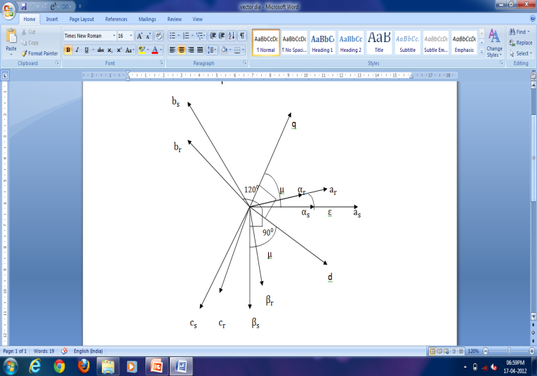

Fig 5.2: Phasor diagram

**5.2.1 Stator side equations**

abc αβ

= + cos120° + cos240°

=

= - cos30° + cos30°

=

αβ dq

= +

=

= -

= -

= -

= -

**5.2.2 Rotor side equations**

abc αβ

= + cos120° + cos240°

= + cos240°

= + cos30° +

=cos30

αβ dq

= sin (μ-ε) + cos (μ-ε)

=sin (μ-ε) + cos (μ-ε)

= cos (μ-ε) - sin (μ-ε)

= cos (μ-ε) -

Now for the purpose feeding into PWM, the rotor side is reverse transformed into abc reference frame using the relation:

For an Induction machine,

s =

Also,

**5.2.3 Reverse rotor transform**

dq 𝛂𝛃

=

=

𝛂𝛃 abc

=

= -

= -

**5.3 Machine modeling**

= + + -

= = dt

= + + +

= = dt

= + +

= = dt

= + + +

= = dt

= + J

=

=

=

According to the equations given above (5.2.1,5.2.2,5.2.3,5.3) the SRIM is modelled in matlab.

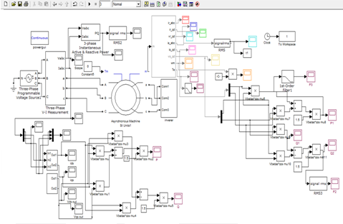

Fig 5.2: Motoring operation

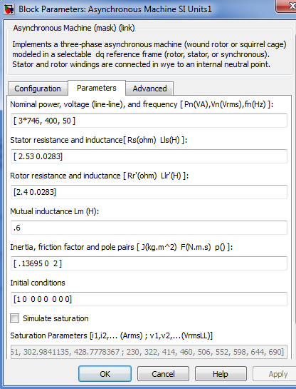

Fig 5.3: IM parameters

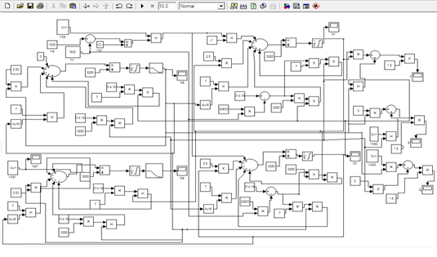

Fig 5.4: Generating operation

**CHAPTER 6**

**OVERVIEW OF THE PROJECT**

The whole project is divided into two parts:

6.1 Hardware Implementation

6.1.1 Determining the equivalent circuit parameters by conducting No Load and

Blocked rotor test

6.1.2 Load test

6.2 Simulation in Matlab software

6.2.1 Load test of three phase slip ring IM

6.2.2 Load dynamics

6.2.3 VSI fed IM drive

**6.1 HARDWARE IMPLEMENTATION**

**6.1.1 No load and blocked rotor test**

Aim

To conduct no load and blocked rotor test on a three phase slip ring induction motor and determine the circuit parameters.

Instruments required

|  |  |  |  |
| --- | --- | --- | --- |
| Sl. No | Instruments | Specifications | Quantity |
| 1 | Ammeter | 0-10A | 1 |
| 0-5A | 1 |
| 2 | Voltmeter | 0-600V | 1 |
| 0-150V | 1 |
| 3 | Wattmeter | 600V, 10A,lpf | 2 |
| 150v, 10A, upf | 2 |
| 4 | Tachometer | Digital | 1 |
| 5 | Autotransformer | 3, 415V, 15A | 1 |

Machine details

Rated voltage = 415V

Power = 5 HP

Rated Current = 6A

Rated Speed = 1450 rpm

Supply - 3

Procedure

*NO LOAD TEST*

1. Connections are done as per the circuit diagram.
2. Keep the autotransformer at minimum position, switch on the supply.
3. Adjust the autotransformer voltage to the rated value.
4. Note down the no load voltage, no load current and the wattmeter

readings.

*BLOCKED ROTOR TEST*

1. Connections are made as per the circuit diagram.
2. Keep the autotransformer at minimum position , switch on the supply.
3. Keeping the rotor blocked, slowly increase the applied voltage using the

AT until the stator current reaches the full load value.

1. Take the ammeter, voltmeter and wattmeter readings and it is tabulated.

Circuit diagram

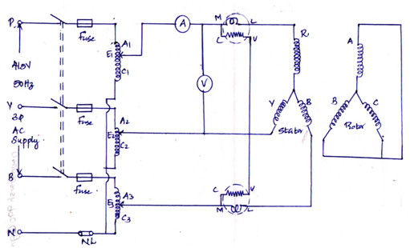

Fig 6.1.1: No load test

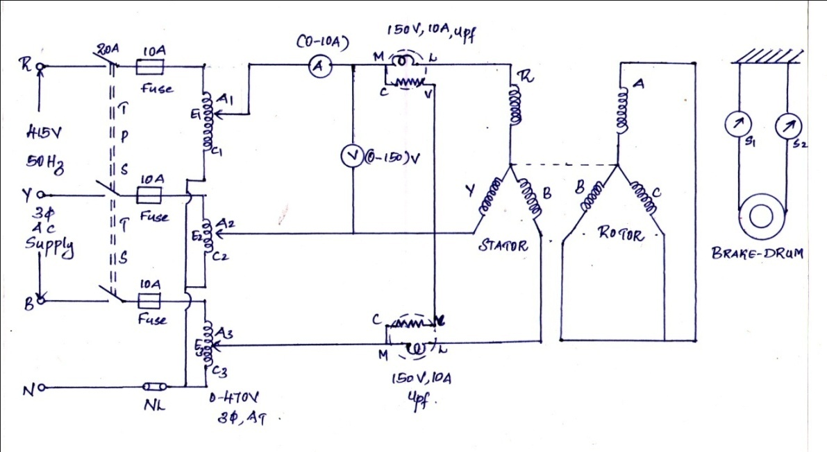

Fig 6.1.2: Blocked rotor test

Observations

*NO LOAD TEST*

|  |  |  |  |  |
| --- | --- | --- | --- | --- |
|  |  |  |  | W =- |
| 372 | 1 | 107 | 220 | 113 |

*BLOCKED ROTOR TEST*

|  |  |  |  |  |
| --- | --- | --- | --- | --- |
|  |  |  |  | W =- |
| 192 | 6 | 920 | 140 | 780 |

Calculations

*a) NO LOAD TEST*

= 1A

= 372V

= = =214.77V

3 Power = 113W

1 Power = = 37.67W

cos = cos √3 ( )

= cos(30.902) =0.858

= 30.902

=

= 1\*0.858

= 0.858A

=

= 1\*sin (30.902)

= 0.513A

= = = 433.566Ω

= = = 725.146Ω

b)

= = 6A

= = = 110.85V

Power = = = 260W

= = = = 18.475Ω

= = = = 7.22Ω

*= = = 17Ω*

Stator winding resistance measured using dc supply

|  |  |  |
| --- | --- | --- |
| Voltage(v) | Current(A) | Resistance(Ω) |
| 2.2 | 0.5 | 4.4 |
| 4.2 | 1 | 4.2 |
| 5.2 | 1.25 | 4.6 |
| 6.3 | 1.5 | 4.2 |
| 8.3 | 2 | 4.15 |

= 4.22Ω

= = = 2.11Ω

Actual stator resistance, = 1.2\* = 1.2\*2.11 = 2.53Ω

Rotor resistance referred to stator = - = 7.22-2.53 = 4.692Ω

= = = = 8.5Ω

**6.1.2 Load test**

Aim

To conduct load test on given slip ring IM.

Instruments required

|  |  |  |  |
| --- | --- | --- | --- |
| Sl. No | Instruments | Specifications | Quantity |
| 1 | Ammeter | 0-10A | 1 |
| 2 | Voltmeter | 0-150V | 1 |
| 3 | Wattmeter | 600V, 10A,lpf | 2 |
| 4 | Tachometer | Digital | 1 |
| 5 | Autotransformer | 3, 415V, 15A | 1 |

Procedure

1. Connections are made as per the circuit diagram.
2. Keep the autotransformer at minimum position , switch on the supply.
3. Keeping the rotor blocked, slowly increase the applied voltage using the

AT until the stator current reaches the full load value.

4. Take the ammeter, voltmeter and wattmeter readings and it is tabulated

Circuit diagram



Fig 6.2: load test on IM

Observations

|  |  |  |  |  |
| --- | --- | --- | --- | --- |
| V  (v) | I  (A) | N  (rpm) | T  (Nm) | P  (Kw) |
| 412 | 1 | 1442 | 0.981 | 148.13 |
| 412 | 1.5 | 1412 | 4.51 | 666.84 |
| 412 | 2 | 1410 | 6.37 | 940.5 |
| 412 | 2.5 | 1401 | 8.19 | 1204.09 |
| 412 | 3 | 1376 | 9.51 | 1370.29 |

This load test results are compared with the load dynamics of modeled machine which gives similar results.

**6.2 SIMULATION IN MATLAB SOFTWARE**

**6.2.1 Load test on slip ring IM**

**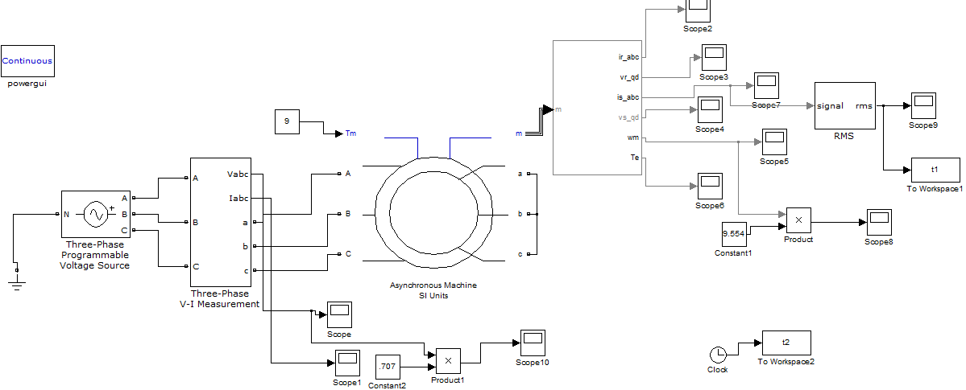**

Fig 6.2.1(a): load test on IM

**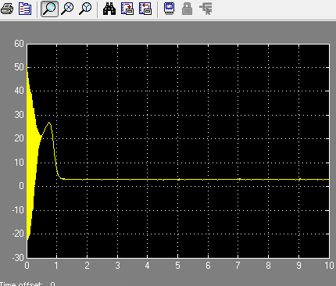**

Fig 6.2.1(b): waveform for torque

**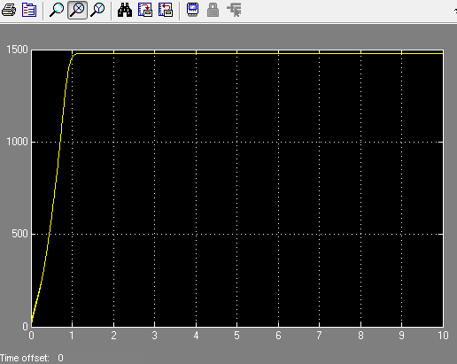**

Fig 6.2.1(c): waveform for speed

**6.2.2 LOAD DYNAMICS**

**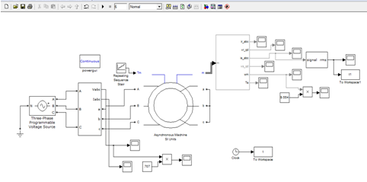**

Fig 6.2.2(a) Load dynamics of IM

**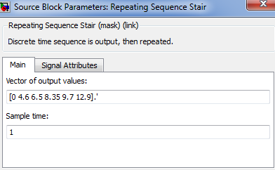**

Fig 6.2.2(b): Torque

**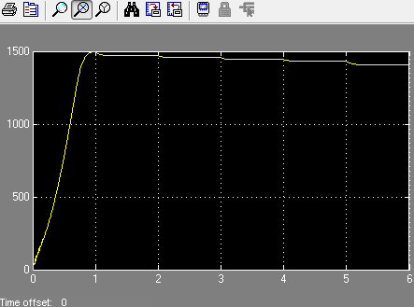**

Fig 6.2.2(c). Speed

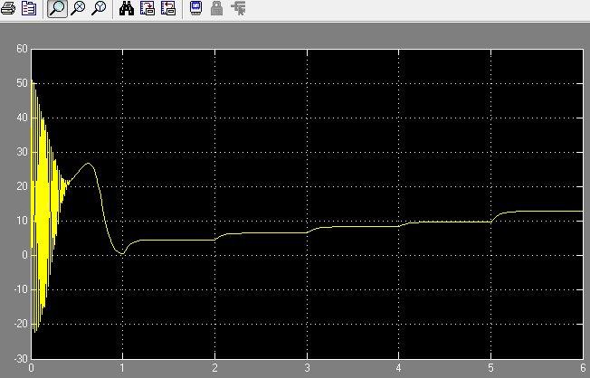

Fig 6.2.2(d) :torque

**6.2.3 VSI fed IM drive**

**6.2.3 (A) Pulse width modulated IM drive**

**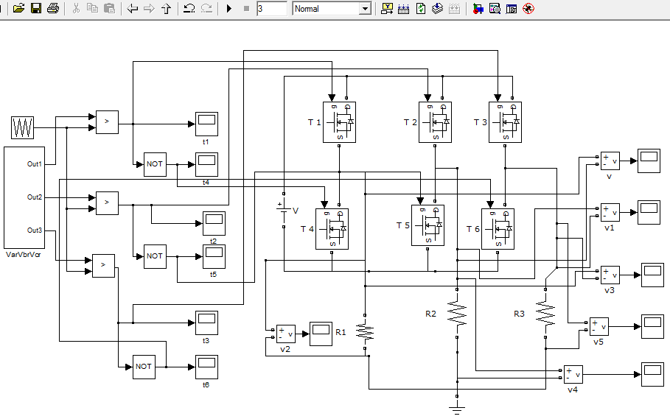**

Fig 6.2.3(a) Pulse width modulated IM drive

The following figure shows a pulse width modulated VSI. Its output –line to phase (fig 6.2.3(a 1) is a three level output. It’s advantageous because harmonic content of the output I reduced considerably.fig shows the line to line voltage.

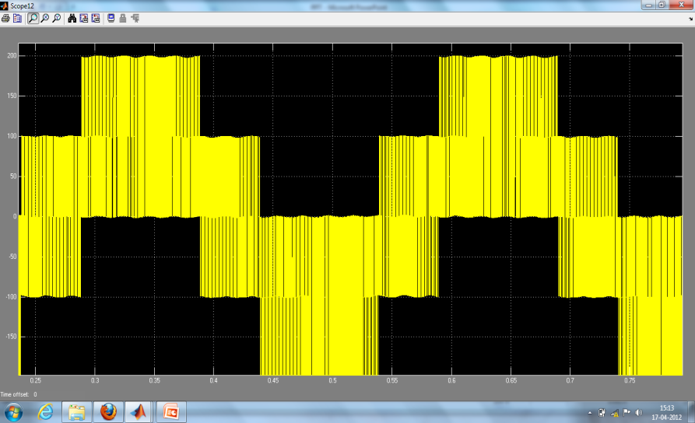

Fig 6.2.3(a1) line-phase voltage waveform

**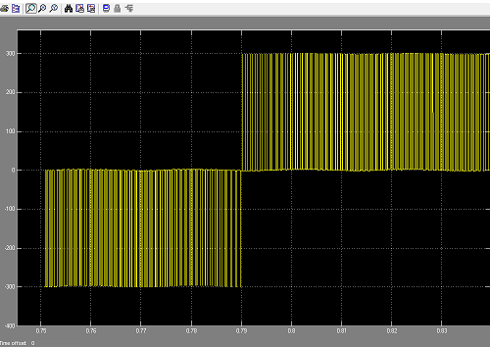**

Fig 6.2.3(a2) line-line voltage waveform

**6.2.3(B) Rotor circuitry**

The reverse transformed rotor is shown in fig6.2.3 (b) and the output is shown in fig 6.2.3(b1)

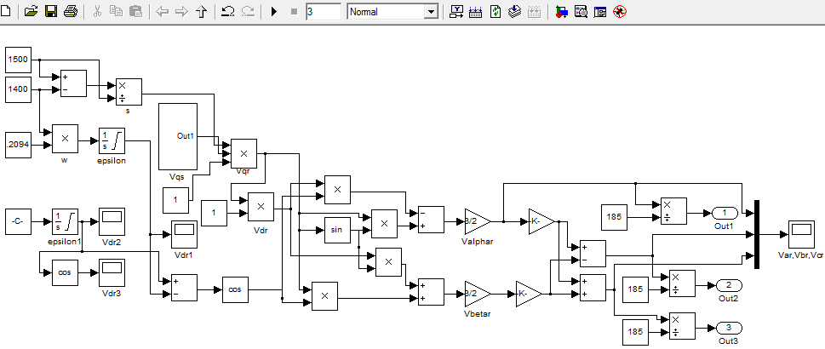

Fig 6.2.3(b): reverse rotor transform

**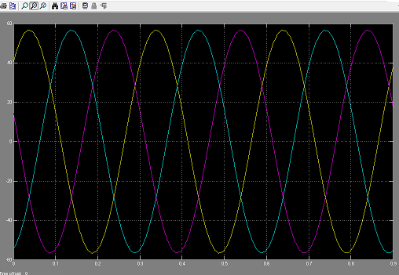**

Fig 6.2.3(b1) voltage waveforms of Var,Vbr, Vcr

**6.2.3 (C) MODES OF OPERATION**

The whole circuit model is given in fig(5.2)and fig (5.3).Based on the same, the following outputs are obtained

**6.2.3.(c 1) Super synchronous motoring**

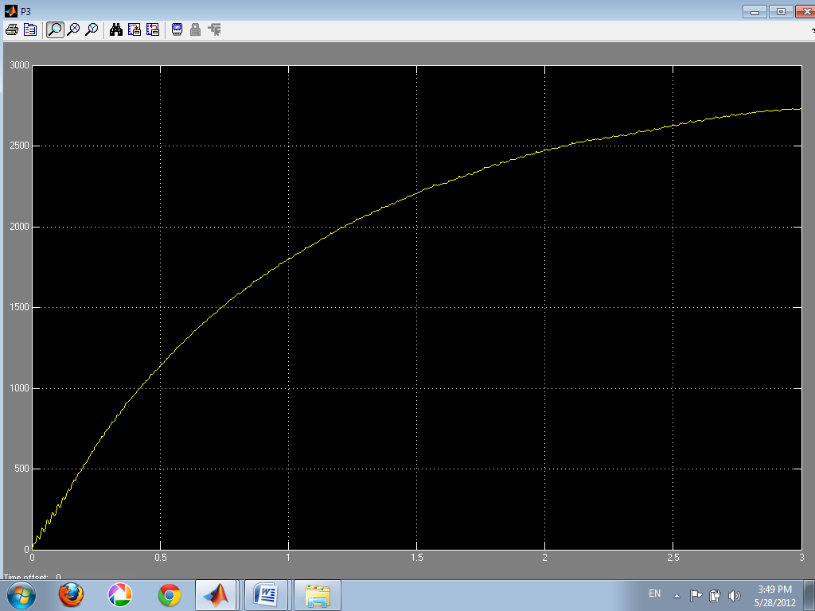

Fig 6.2.3(C 1): Waveform for Active Power

**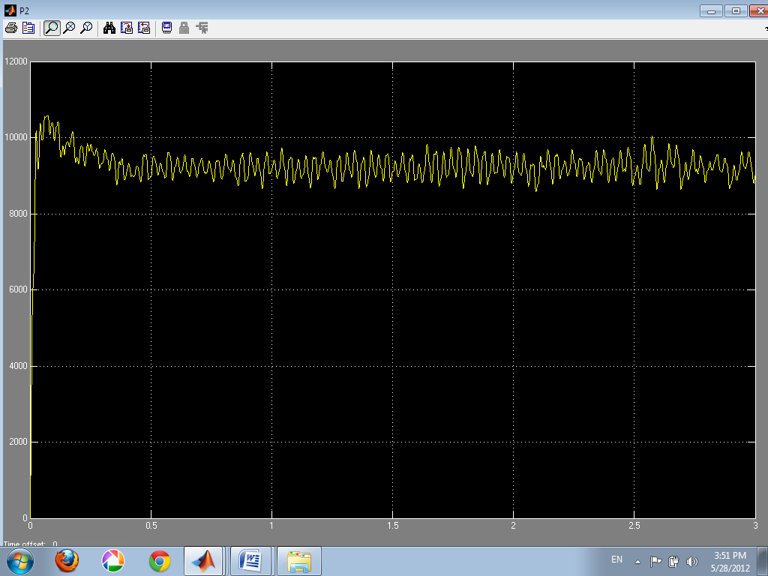**

Fig 6.2.3 (c2): Waveform for Reactive Power

**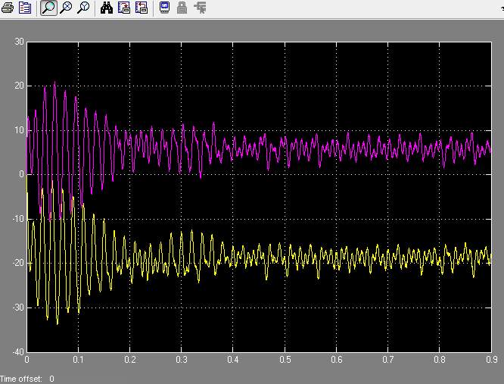**

Fig 6.2.3(c3): Waveform for isqd

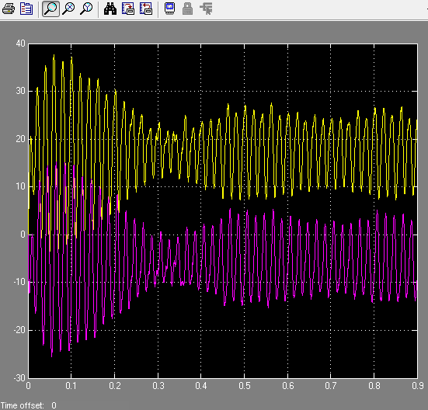

Fig 6.2.3(c4): waveform for irqd

**6.2.3(C 2) Sub synchronous motoring**

**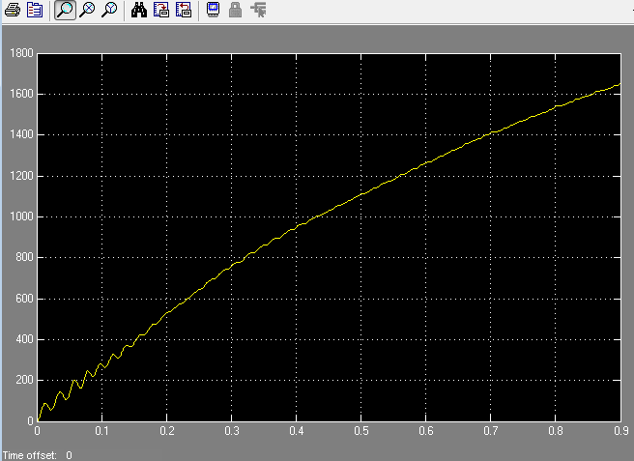**

Fig 6.2.3(c5): Waveform for Active Power

**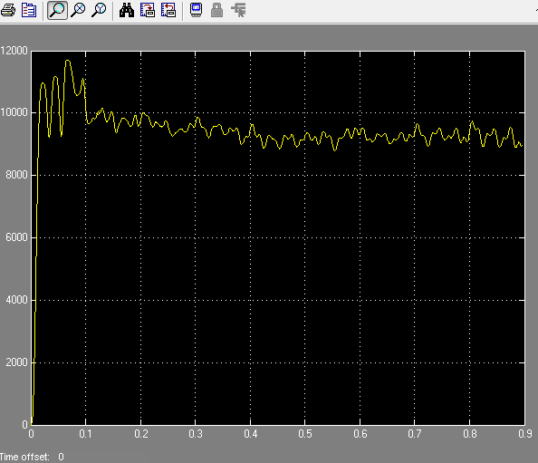**

Fig 6.2.3(c6): Waveform for Reactive Power

**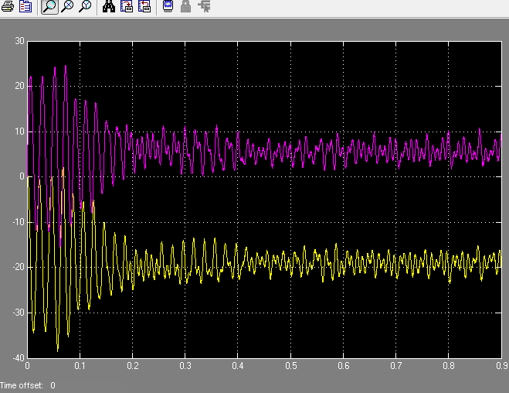**

Fig 6.2.3(c7): Waveform for isqd

**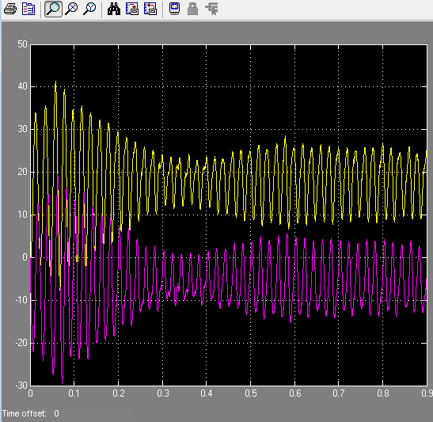**

Fig 6.2.3(c8): Waveform for irqd

**6.2.3(C3) Super synchronous generation**

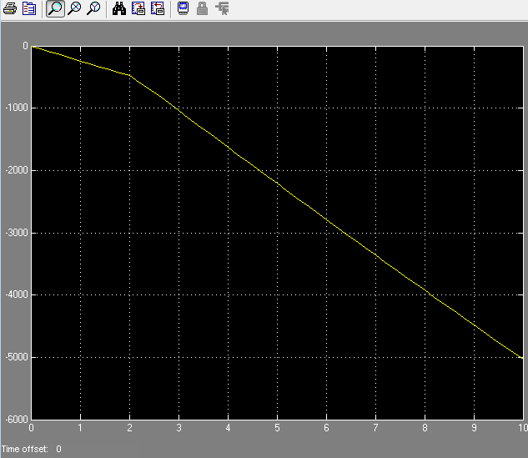

Fig 6.2.3(c9): Waveform for Active Power

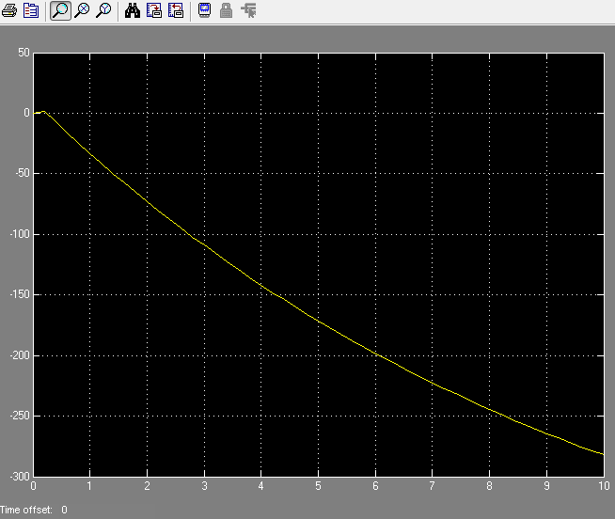

Fig 6.2.3(c10): Waveform for Reactive Power

**6.2.3(C4) Sub synchronous generation**

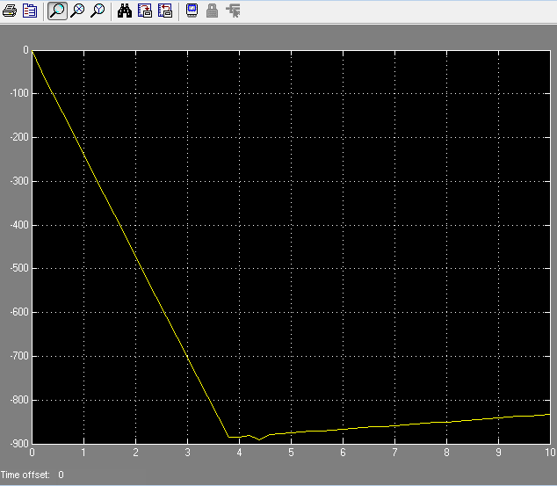

Fig 6.2.3(c11): Waveform for Active Power

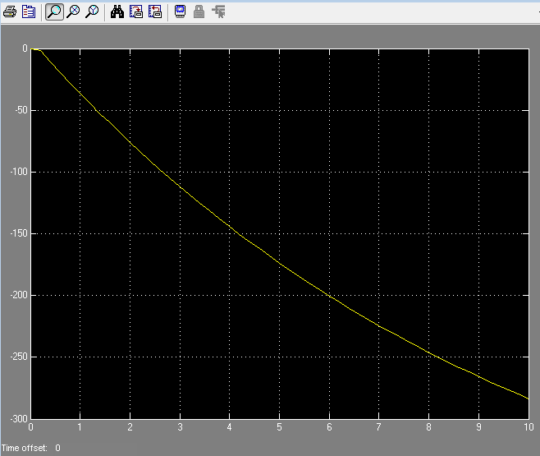

Fig 6.2.3(c12):Waveform for Reactive Power

**ADVANTAGES AND FUTURE SCOPE**

The main advantage of the proposed scheme is that the speed control is possible within

+/- 30%. This is not possible in any other conventional schemes. Also the same IM is operated

as a motor and as a generator. Modified form of SRIM – DFIG, is used for energy generation

purpose.

APPLICATIONS

* Large-capacity pumps and fan drives
* Variable-speed wind energy systems
* Shipboard VSCF (variable-speed/constant frequency) systems
* Variable speed hydro-pumps/generators
* Utility system flywheel energy storage systems

**CONCLUSION**

IM can be driven in four different modes according to the requirements

* speed control possible within the range of +/- 30%

REFERENCE