1. Flow charts

**FlowCharts** : Diagram to represent solutions of problems

Example: Tea making, Sum of two numbers etc.

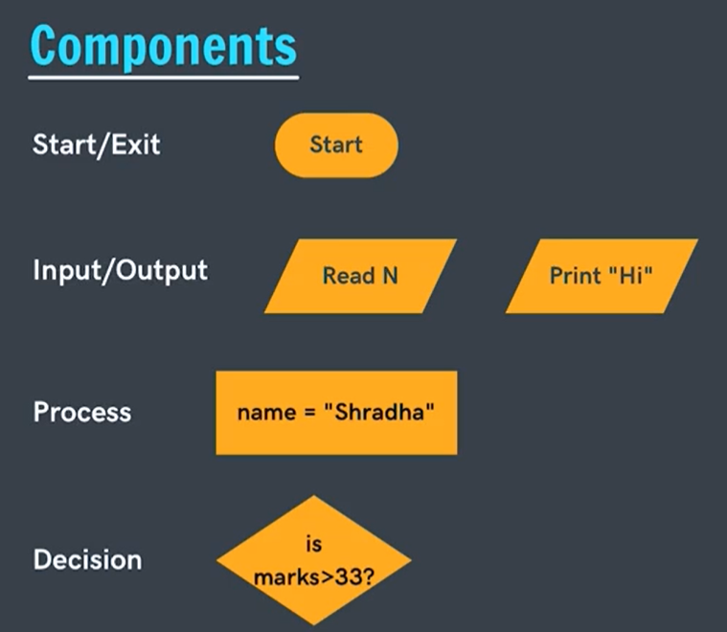

Name=”Shradha”// value “Shardha” Assign to name

***Sum of two numbers:***

