**TWO WAY ACTIVE CROSSOVER FILTER**

**Group Members:**

Gopireddy Arunteja Reddy-B180679EC

Gedela Akhil -B180609EC

G.Santhosh Babu -B180326EC

Govind -B180544EC

Email: [aruntejagopireddy18@gmail.com](mailto:aruntejagopireddy18@gmail.com)

**Objective:**

To design and simulate a Two way active crossover filter using operational amplifier circuits.

**Block diagram:**

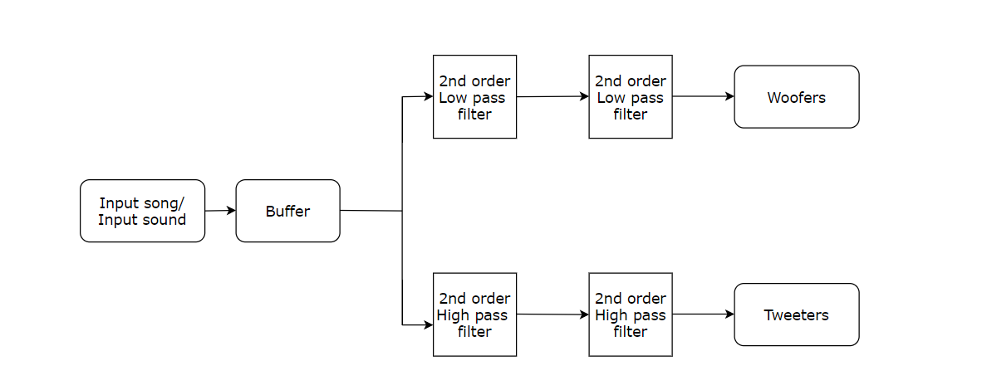

**Theory:**

The idea behind the project is to divide the frequency components of a input song/sound in order to give it to different speakers The input sound/song is given to a buffer and the output of the buffer is given to the second order low pass and high pass filters.The output of these are given to another second order low pass and high filters respectively.The output of the second order low pass filter is given to a speaker called Woofer and the second order high pass filter to a speaker called Tweeter,used in normal speakers.

A woofer is a technical term for loudspeaker driver designed to produce low frequency sounds. The name is from the English word for a dog's bark, "woof" in contrast to the name used for speakers designed to reproduce high-frequency sounds, tweeter. A tweeter the treble speaker a special type of loudspeaker (usually dome or horn-type) that is designed to produce high audio frequencies, typically from around 2,000 Hz to 20,000 Hz . Some tweeters can deliver high frequencies up to 100 kHz. The name is derived from the high pitched sounds made by some birds.