BDA LAB 5

1) Start all the Hadoop daemons.
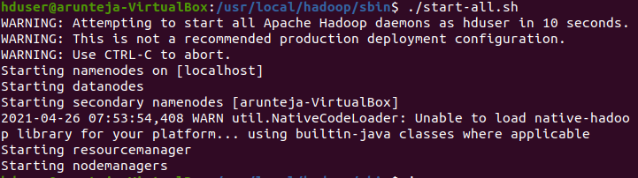
2) Verify running daemons
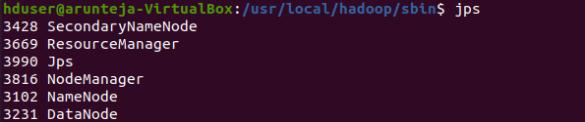
3) Create a input directory and a word_sample.txt
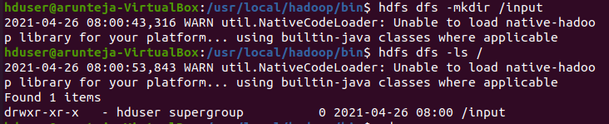
4)

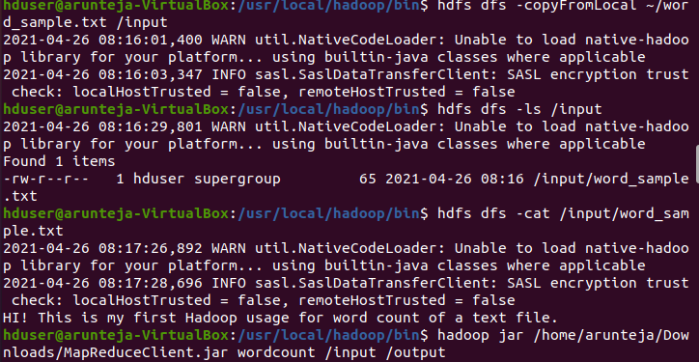
5)Put the file in input of hadoop and use MapReduce to execute word count problem.

6) Output of the word count

