ARUN THAKUR
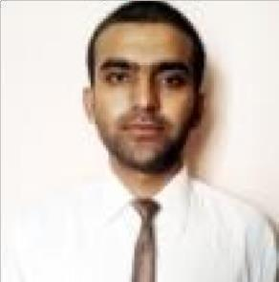

7,Preet nagar ,F G C Road

Amritsar, Punjab, India

Email Id- arunworld36@gmail.com Phone No. - 9971641412

OBJECTIVE

Seeking employment that allows me to grow professionally, while being able to utilize my skills for the betterment of the organization.

EDUCATIONAL BACKGROUND

BACHELOR DEGREE

Bachelor of Technology in Electronics & Communication Engineering (2011-2015): 58.3%

HIGHER SECONDARY

Spring Dale Senior School, Amritsar (2011), CBSE: 79%

HIGH SCHOOL

Lovedale Senior School, Amritsar (2009), CBSE: 64 %

WORK EXPERIENCE

Organization: APSOM LIMITED

Designation : Service Trainee

Duration : Sept- Dec’15
 
- Ensuring proper working of the 3D and 2D printers.

- Troubleshooting the problems with proper equipment.

- Handling hardware and software conflicts.

- Installation of softwares

Organization: HJ INFRA INDUSTRIES

Designation : Quality Engineer

Duration : Sept’16- Oct'17
- Maintaning the quality of the fan shaft that are produced in the factory

SUMMER TRAINING

Radar Rohini Project (June-Aug 2014)

ABSTRACT:

To control the position of such radar antennas that is being deployed in the modern warfare. The positioning system for radar is intended to drive the antenna, comprising the electronics for the antenna along with the antenna, in the azimuth axis as per the command from either a local control panel or from the radar computer. The drive employs a brushless motor which controlled from a digital signal processor based controller. The positioning system slews the antenna 360 degree continuously. This is primarily used for the purpose of locating aircrafts.

Role: Checked the feedback system by giving possible numbers of input and outputs.

Project Center: BHARTI ELECTRONIC LIMITED (BEL), NEW DELHI, INDIA

PROJECTS UNDERTAKEN

Intelligent Break oil Leakage Detection and Early Warning System: (Jan-June, 2015)

ABSTRACT:

“INTELLIGENT BREAK OIL LEAKAGE DETECTION AND EARLY WARNING SYSTEM’’

The system monitors break leakage and efficiently detects any further leakage. This is primarily used to inform the user of any leakage at an early stage so that further damage can be minimized.

Role: To ensure safety by thoroughly checking the breaking system.

SKILLS

Programming Languages: Python, DJango, HTML and CSS, proficiency in Microsoft and PowerPoint

Areas of interest: Networking, Database Management, Software testing

Personal Strengths:
- Analytical thinking and Decision Making

- Managing people and time efficiently

- Team Bonding and Building, Leadership capabilities

Interests: Travelling, Reading, Sports

Languages known: English, Hindi, German, Punjabi

