

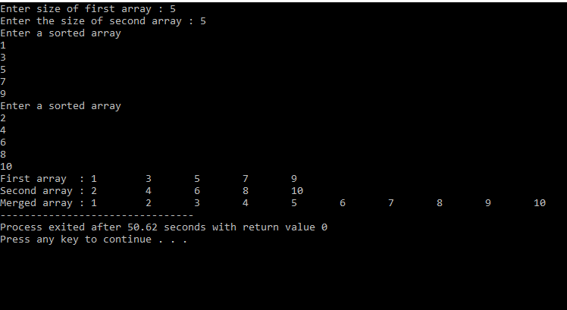
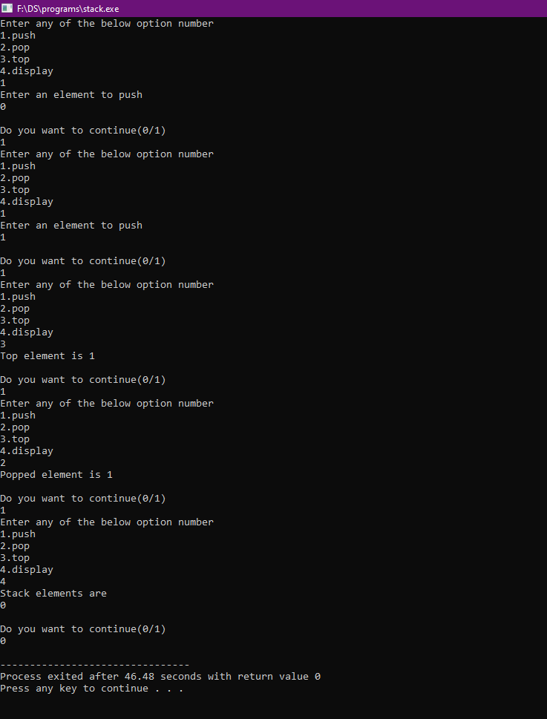
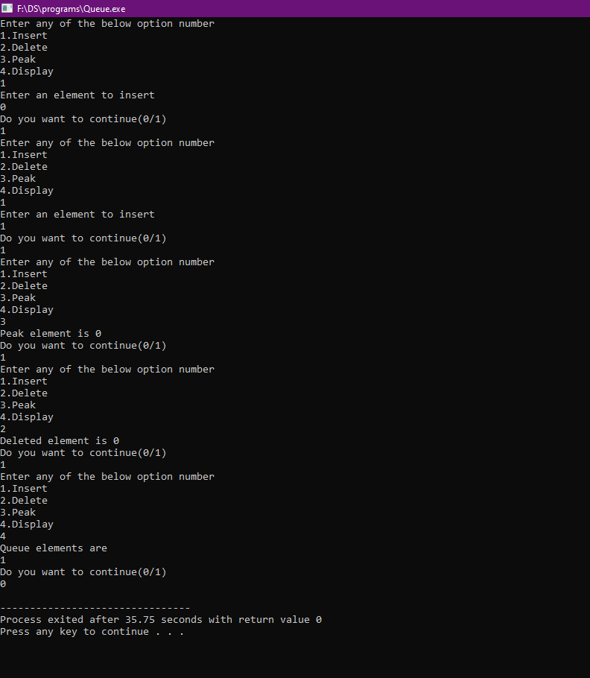
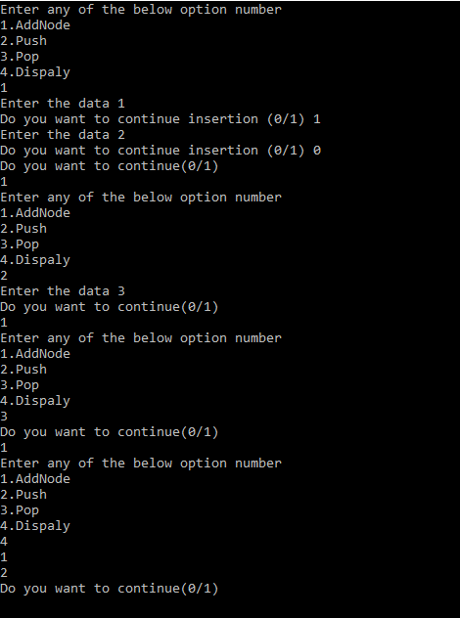
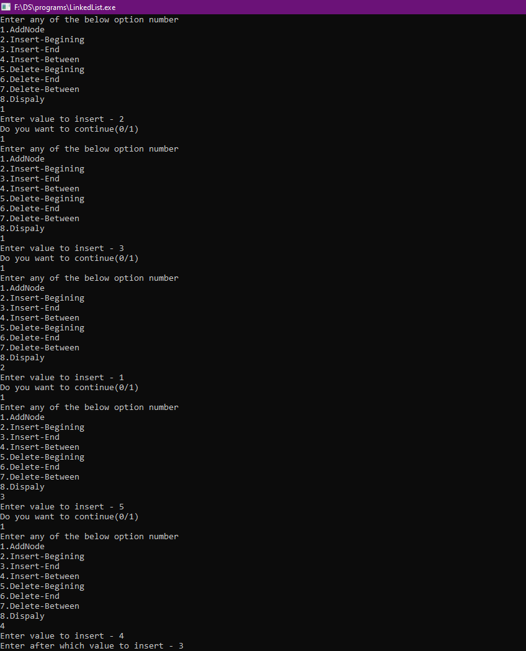
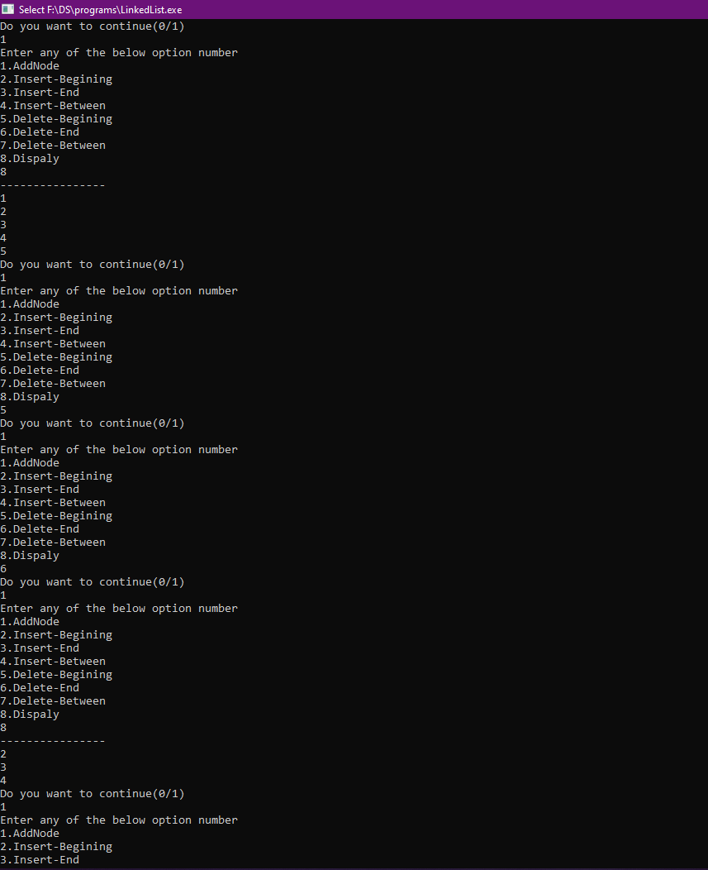
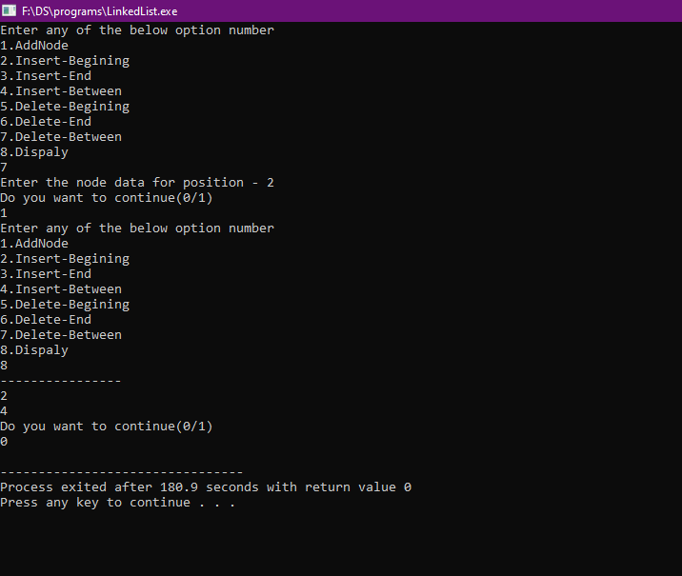
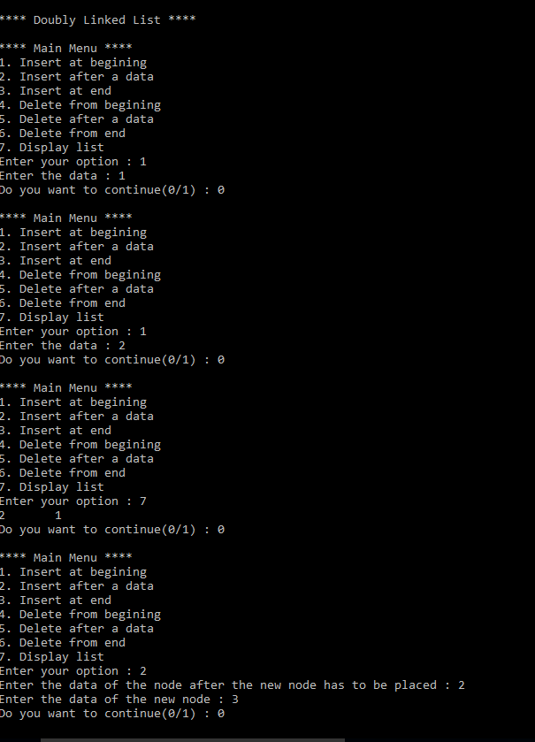
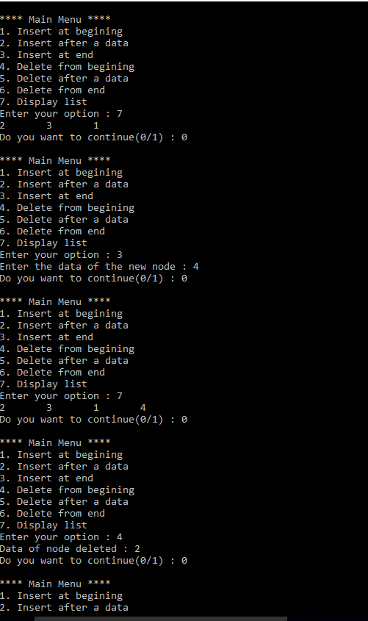
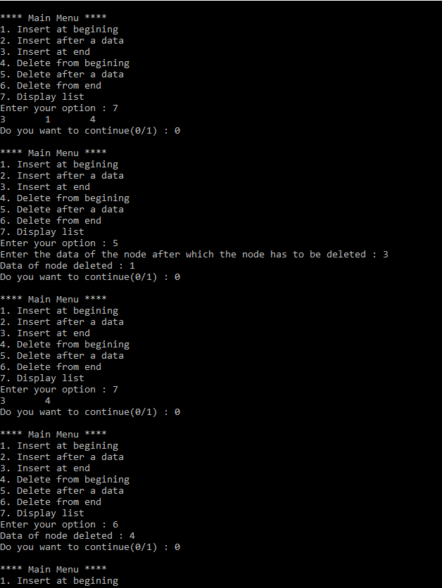
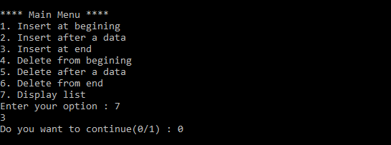
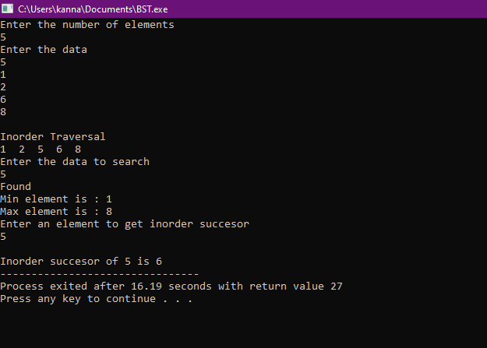
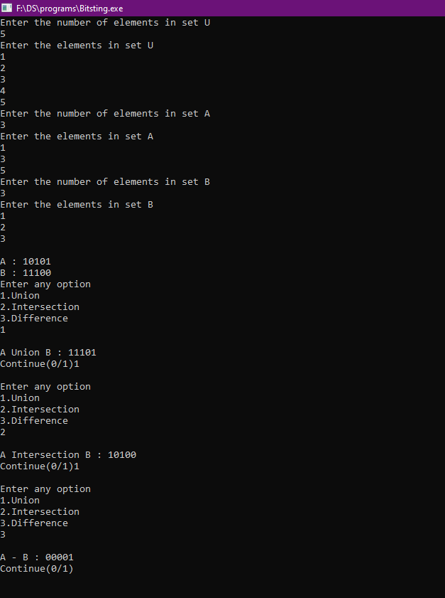
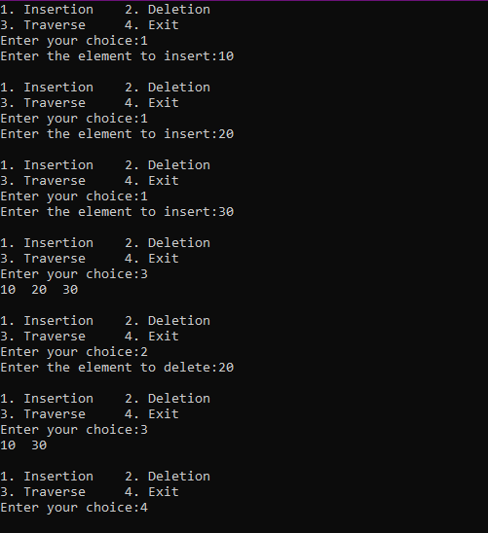
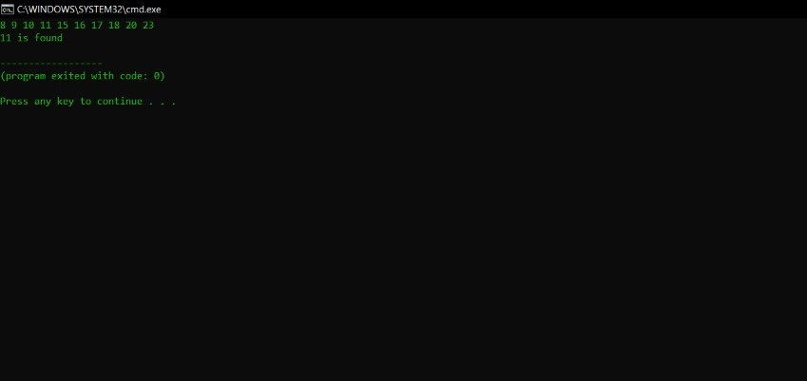
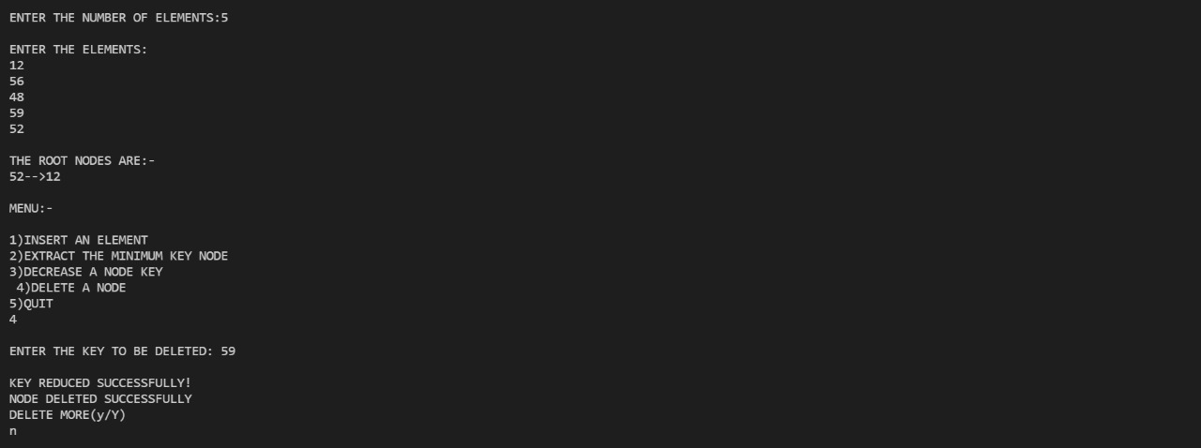
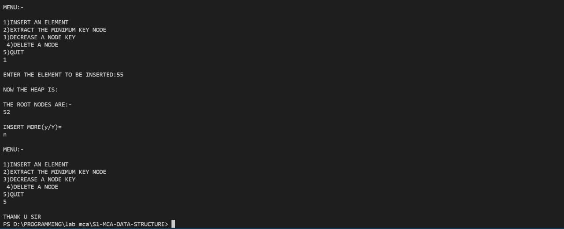
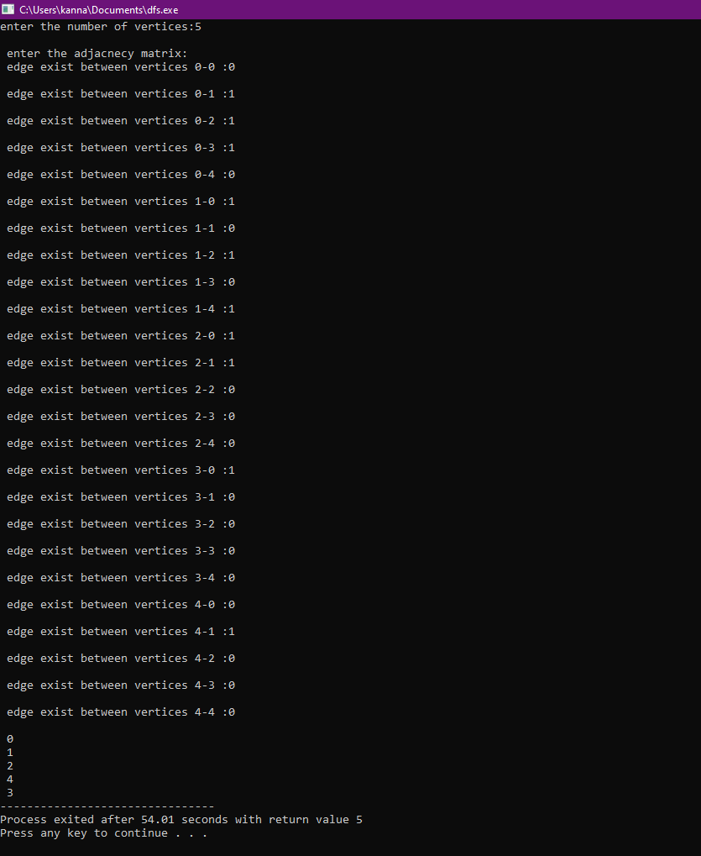
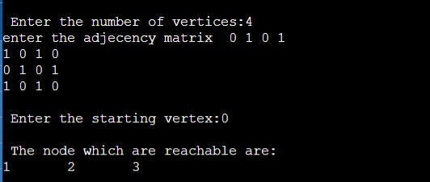
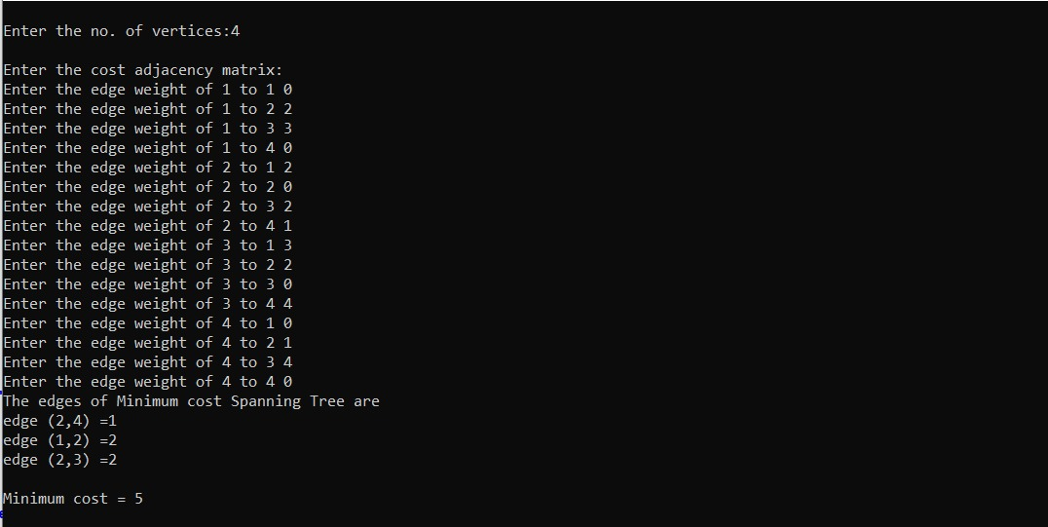
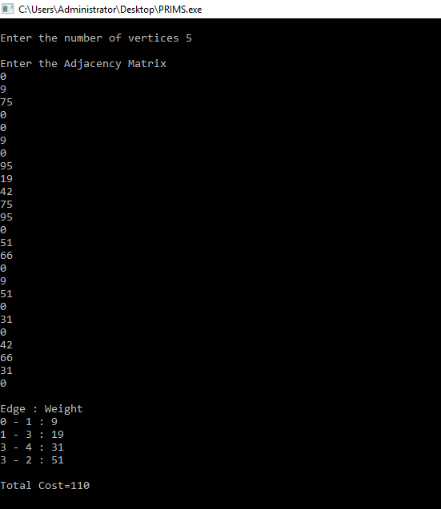
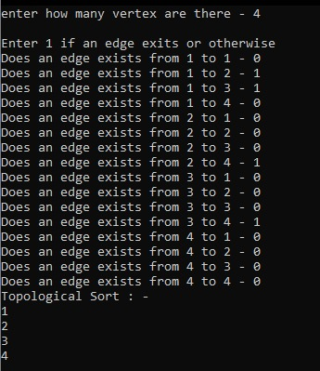
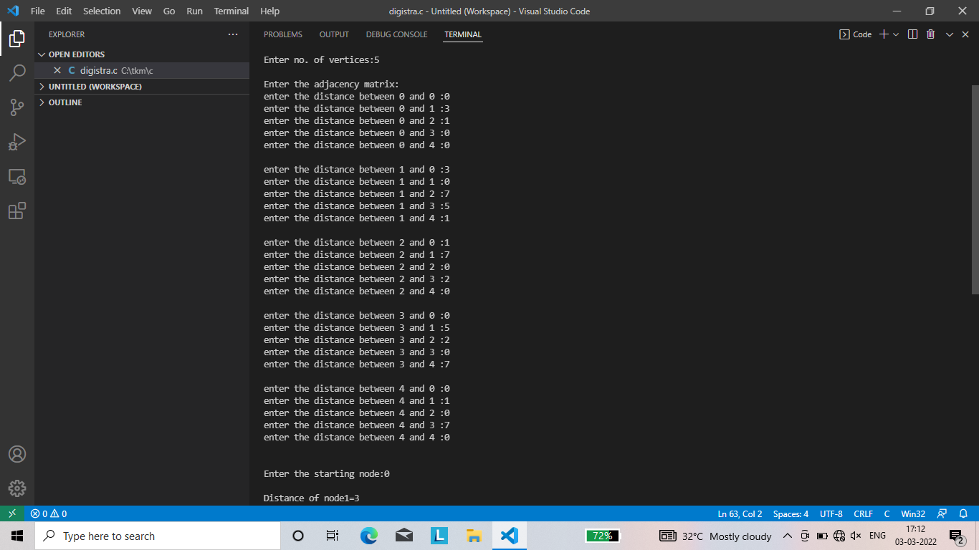
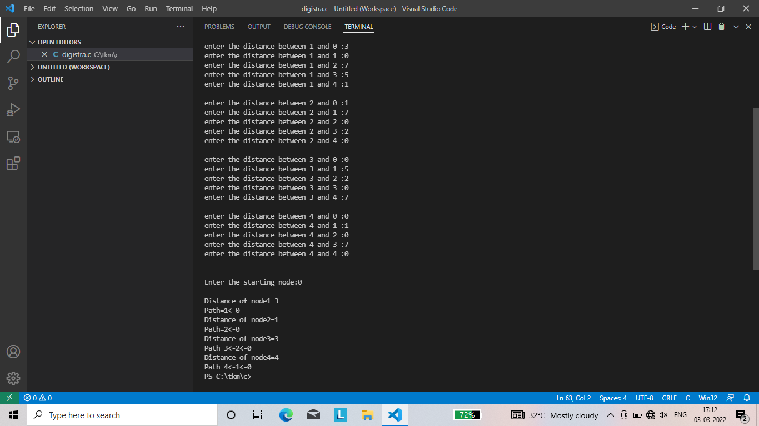
DEPARTMENT OF COMPUTER APPLICATION
TKM COLLEGE OF ENGINEERING
KOLLAM – 691005

20MCA135 – DATA STRUCTURES LAB
PRACTICAL RECORD BOOK
First Semester MCA
2021-2022
okda bye daaaa

Submitted by:
NAME : ARUN UDAY
REG NO : TKM21MCA-2011
DEPARTMENT OF COMPUTER APPLICATION TKM COLLEGE OF ENGINEERING
KOLLAM – 691005

Certificate

This is a bonafide record of the work done by ARUN UDAY (TKM21MCA-2011) in the First Semester in Data Structures Lab Course(20MCA135) towards the partial fulfillment of the degree of Master of Computer Applications during the academic year 2021-2022

Staff Member in-charge Examiner

……………………….. ……………………….

INDEX
Program No : | Programs
 | CO1
1 | 1.1 | Write a C program to Merge two sorted arrays
2 | 1.2 | Write a C program to implement Stack Operations
3 | 1.3 | Write a C program to implement Queue Operations
4 | 1.4 | Write a C program to implement Linked stack
5 | 1.5 | Write a C program to implement Singly Linked List Operations
6 | 1.6 | Write a C program to implement Doubly Linked List Operations.
7 | 1.7 | Write a C program to implement Binary Search Tree.
 | CO2
8 | 2.1 | Write a C program to implement BitString Operations.
 | CO3
9 | 3.1 | Write a C program to implement Red Black Tree Operations.
10 | 3.2 | Write a C program to implement B-Tree Operations.
 | C04
11 | 4.1 | Write a C program to implement Binomial Heap.
 | CO5
12 | 5.1 | Write a C program to implement Depth first Search.
13 | 5.2 | Write a C program to implement Breadth first Search.
14 | 5.3 | Write a C program to implement Kruskal’s algorithm.
15 | 5.4 | Write a C program to implement Prim’s Algorithm
16 | 5.5 | Write a C program to implement Topological Sort
17 | 5.6 | Write a C program to implement Dijkstra’s Algorithm

PROGRAM NO : 1

AIM : Write a C program to Merge two sorted array.

CODE :

#include<stdio.h>
int main()
{
int i,j,m,n,k;
int arr1[10],arr2[10],res[10];
printf("Enter size of first array : ");
scanf("%d",&m);
printf("Enter the size of second array : ");
scanf("%d",&n);
printf("Enter a sorted array\n");
for(i=0;i<m;i++)
{
scanf("%d",&arr1[i]);
}
printf("Enter a sorted array\n");
for(i=0;i<n;i++)
{
scanf("%d",&arr2[i]);
}
printf("First array : ");
for(i=0;i<m;i++)
{
printf("%d\t",arr1[i]);
}
printf("\n");
printf("Second array : ");
for(i=0;i<n;i++)
{
printf("%d\t",arr2[i]);
}
i=0;
j=0;
k=0;
printf("\n");
while((i<m)&&(j<n))
{
if(arr1[i]<arr2[j])
{
res[k]=arr1[i];
i++;k++;
}
else
{
res[k]=arr2[j];
j++;k++;
}
}
while(i<m)
{
res[k]=arr1[i++];
}
while(j<n)
{
res[k]=arr2[j++];
}
printf("Merged array : ");
for(i=0;i<m+n;i++)
{
printf("%d\t",res[i]);
}
return 0;
}

OUTPUT :

RESULT : The program was executed successfully and output obtained

PROGRAM NO : 2

AIM : Write a C program to implement Stack Operations .

CODE :

#include<stdio.h>
#define n 5
int s[n],top=-1;
void push();
void pop();
void Top();
void display();
void main() {
int o,c=1;
while(c==1) {
printf("Enter any of the below option number\n1.push\n2.pop\n3.top\n4.display\n");
scanf("%d",&o);
switch(o) {
case 1 : push();
break;
case 2 : pop();
break;
case 3 : Top();
break;
case 4 : display();
break;
}
printf("Do you want to continue(0/1)\n");
scanf("%d",&c);
}
}
void push() {
int x;
printf("Enter an element to push\n");
scanf("%d",&x);
if(top==n-1) {
printf("\nOverflow\n");
} else {
top++;
s[top]=x;
}
}

void pop() {
if(top==-1) {
printf("\nUnderflow\n");
} else {
printf("Popped element is %d",s[top]);
top--;
}
}
void Top() {
if(top==-1) {
printf("\nUnderflow\n");
} else {
printf("Top element is %d",s[top]);
}
}
void display() {
if(top==-1) {
printf("\nUnderflow\n");
} else {
printf("Stack elements are\n");
for (int i=top; i>=0; i--) {
printf("%d\n",s[i]);
}
}
}

OUTPUT :

RESULT : The program was executed successfully and output obtained

PROGRAM NO : 3

AIM : Write a C program to implement Queue Operations

CODE :

#include<stdio.h>
#define n 5
int q[n],front=-1,rear=-1;
void insert();
void delete();
void peak();
void display();
void main() {
int o,c=1;
while(c==1) {
printf("Enter any of the below option number\n1.Insert\n2.Delete\n3.Peak\n4.Display\n");
scanf("%d",&o);
switch(o) {
case 1 : insert();
break;
case 2 : delete();
break;
case 3 : peak();
break;
case 4 : display();
break;
default : printf("Invalid entry");
}
printf("Do you want to continue(0/1)\n");
scanf("%d",&c);
}
}

void insert() {
int x;
printf("Enter an element to insert\n");
scanf("%d",&x);
if(rear==n-1) {
printf("\nOverflow\n");
//return;
} else if(front==-1 && rear==-1) {
front=rear=0;
} else {
rear++;
}
q[rear]=x;
}
void delete() {
if(front==-1 || front>rear) {
printf("\nUnderflow\n");
} else {
printf("Deleted element is %d",q[front]);
front++;
if(front>rear) {
front=rear=-1;
}
}
}
void peak() {
if(front==-1 || front>rear) {
printf("\nUnderflow\n");
} else {
printf("Peak element is %d",q[front]);
}
}
void display() {
if(front==-1 || front>rear) {
printf("\nUnderflow\n");
} else {
printf("Queue elements are\n");
for (int i=front;i<=rear;i++) {
printf("%d\n",q[i]);
}
}}

OUTPUT :

RESULT : The program was executed successfully and output obtained

PROGRAM NO : 4

AIM : Write a C program to implement Linked Stack.

CODE :

#include<stdio.h>
#include<stdlib.h>
struct node
{
int data;
struct node *next;
};
struct node *head,*newnode,*temp,*prev;
void push()
{ printf("Enter the data ");
scanf("%d",&newnode->data);
newnode->next=head;
head=newnode; }
void pop()
{head=head->next; }
void display()
{
temp=head;
int count=0;
while(temp!=0)
{ printf("%d\n",temp->data);
count++;
temp=temp->next; }}
void addnode()
{
int o=1,c=0;
head=0;
while(o==1)
{
newnode=(struct node *)malloc(sizeof(struct node));
printf("Enter the data ");
scanf("%d",&newnode->data);
newnode->next=0;
if(head==0)
{head=temp=newnode; }
else
{ temp->next=newnode;
temp=newnode; }
printf("Do you want to continue insertion (0/1) ");
scanf("%d",&o); }}
void main()
{
int c=1,o,i,m;
while(c==1)
{
printf("Enter any of the below option number\n1.AddNode\n2.Push\n3.Pop\n4.Dispaly\n");
scanf("%d",&o);
newnode=(struct node *)malloc(sizeof(struct node));
switch(o)
{ case 1 : addnode();
break;
case 2 : push();
break;
case 3 : pop();
break;
case 4 : display();
break; }
printf("Do you want to continue(0/1)\n");
scanf("%d",&c); }}

OUTPUT :

RESULT : The program was executed successfully and output obtained

PROGRAM NO : 5

AIM : Write a C program to implement Singly Linked List Operations

CODE :

#include<stdio.h>
#include<stdlib.h>
struct node {
int data;
struct node *next;};
struct node *head,*newnode,*temp,*prev;
void InsertBeg() {
int m;
printf("Enter value to insert");
scanf("%d",&m);
newnode=(struct node *)malloc(sizeof(struct node));
newnode->data=m;
newnode->next=head;
head=newnode;
}
void InsertBetween() {
int m,x;
printf("Enter value to insert");
scanf("%d",&m);
printf("Enter after which value to insert");
scanf("%d",&x);
newnode=(struct node *)malloc(sizeof(struct node));
newnode->data=m;
temp=head;
while(temp->next!=0) {
if(temp->data==x) {
break;}
temp=temp->next;}
newnode->next=temp->next;
temp->next=newnode;}
void InsertEnd() {
int m;
printf("Enter value to insert");
scanf("%d",&m);
newnode=(struct node *)malloc(sizeof(struct node));
newnode->data=m;
while(temp->next!=0) {
temp=temp->next;}
temp->next=newnode;
newnode->next=0;}
void DeleteBeg() { head=head->next;}
void DeleteBetween() {
int x;
printf("Enter the node data for position");
scanf("%d",&x);
temp=head;
while(temp->data!=x) {
temp=temp->next;}
temp->next=temp->next->next;}
void DeleteEnd() {
temp=head;
while(temp->next!=0) {
prev=temp;
temp=temp->next;}
prev->next=NULL;}
void display() {
temp=head;
while(temp!=0) {
printf("%d\n",temp->data);
temp=temp->next;}}
void addnode() {
int o=1,c=0,m;
printf("Enter value to insert");
scanf("%d",&m);
newnode=(struct node *)malloc(sizeof(struct node));
newnode->data=m;
newnode->next=0;
if(head==0) {
head=temp=newnode;
} else {
temp->next=newnode;
temp=newnode;}}
void main() {
int c=1,o,i,m;
head=0;
while(c==1) {
printf("Enter any of the below option number\n1.AddNode\n2.Insert-Begining\n3.Insert-End\n4.Insert-Between\n5.Delete-Begining\n6.Delete-End\n7.Delete-Between\n8.Dispaly\n");
scanf("%d",&o);
switch(o) {
case 1 : addnode();break;
case 2 : InsertBeg();break;
case 3 : InsertBetween();break;
case 4 : InsertEnd();break;
case 5 : DeleteEnd();break;
case 6 : DeleteEnd();break;
case 7 : DeleteEnd();break;
case 8 : display();break;
}
printf("Do you want to continue(0/1)\n");
scanf("%d",&c);
}
}

OUTPUT :

RESULT : The program was executed successfully and output obtained

PROGRAM NO : 6

AIM : Write a C program to implement Doubly Linked List Operations .

CODE :

#include<stdio.h>
#include<stdlib.h>
struct node {
struct node *prev;
int data;
struct node *next;};
struct node *head,*newnode,*temp,*ptr;
void Beg() {
newnode->prev = head;
head=newnode;
newnode->next = head->prev;}
void Between() {
int x;
temp=head;
printf("Enter the node data for position");
scanf("%d",&x);
while(temp->data!=x) {
temp=temp->next;}
newnode->next=temp->next;
temp->next=newnode;
temp->next->prev=newnode;}
void End() {
temp=head;
while(temp->next!=NULL) {
temp=temp->next;}
temp->next=newnode;
newnode->prev=temp;}
void DelBeg() {head=head->next;}
void DelBetween() {
int x;
temp=head;
printf("Enter the node data for position");
scanf("%d",&x);
while(temp->data!=x) {
temp=temp->next;}
printf("asa");
ptr=temp;
temp->next->next->prev=ptr;
temp->next=ptr->next->next;}
void DelEnd() {
temp=head;
while(temp->next!=NULL) {
temp=temp->next;}
temp->next=newnode;
newnode->prev=temp;}
void display() {
temp=head;
int count=0;
while(temp!=0) {
printf("%d\n",temp->data);
count++;
temp=temp->next;}}
void addnode() {
int o=1,c=0;
head=0;
while(o==1) {
if(head==0) {
head=temp=newnode;
} else {
temp->next=newnode;
newnode->prev=temp;
temp=newnode;}
printf("Do you want to continue insertion (0/1) ");
scanf("%d",&o);}}
void CreateNode() {
newnode=(struct node *)malloc(sizeof(struct node));
printf("Enter the data ");
scanf("%d",&newnode->data);
newnode->next=NULL;
newnode->prev=NULL;}
void main() {
int c=1,o,i,m;
while(c==1) {
printf("Enter any of the below option number\n1.AddNode\n2.Insert-Begining\n3.Insert-End\n4.Insert-Between\n5.Delete-Begining\n6.Delete-End\n7.Delete-Between\n8.Dispaly\n");
scanf("%d",&o);
newnode=(struct node *)malloc(sizeof(struct node));
switch(o) {
case 1 : CreateNode();
addnode();
break;
case 2 : CreateNode();
Beg(m);
break;
case 3 : CreateNode();
End(m); break;
case 4 : CreateNode();
Between();break;
case 5 : DelBeg();break;
case 6 : DelEnd();break;
case 7 : DelBetween();break;
case 8 : display();break;
}
printf("Do you want to continue(0/1)\n");
scanf("%d",&c);
}
}

OUTPUT :

RESULT : The program was executed successfully and output obtained

PROGRAM NO : 7

AIM : Write a C program to implement Binary Search Tree .

CODE :
#include <stdio.h>
#include <stdlib.h>
struct node {
int data;
struct node *left, *right;};
void inorder(struct node *r) {
if(r!=NULL) {
inorder(r->left);
printf("%d ",r->data);
inorder(r->right);}}
void min(struct node *r) {
struct node *pre;
while(pre!= NULL && r->left!=NULL) {
pre=r;
r=r->left;
}
printf("\nMin element is : %d",r->data);}
void max(struct node *r) {
struct node *pre;
while(pre!=NULL && r->right!=NULL) {
pre=r;
r=r->right;}
printf("\nMax element is : %d",r->data);}
void insuc(struct node *r,int x) {
struct node *temp=r,*l;
struct node *n;
while(temp->right!=NULL || temp->left!=NULL) {
if(x==temp->data) {
n=temp;
break;
} else if(x> temp->data) {
temp=temp->right;
} else {
l=temp;
temp=temp->left;}}
if(temp->right!=NULL) {
temp=temp->right;
while(temp->left!=NULL) {
temp=temp->left; }
printf("\nInorder succesor of %d is %d",x,temp->data);
} else {
printf("\nInorder succesor of %d is %d",x,l->data);}}
void search(struct node *r,int x) {
int f=0;
struct node *pre=r;
while(pre->right!=NULL || pre->left!=NULL) {
if(x==r->data) {
pre=r;
f=1;
break;
} else if(x> r->data) {
pre=r;
r=r->right;
} else {
pre=r;
r=r->left;}}
if(f==1) {
printf("Found");
} else {
printf("Not Found");
}}
void main() {
int n, i, item,x;
struct node *new, *temp, *root;
printf("Enter the number of elements\n");
scanf("%d", &n);
for (int i = 0; i < n; i++) {
new = (struct node *) malloc(sizeof(struct node));
new->right = NULL;
new->left = NULL;
printf("Enter the data \n");
scanf("%d", &item);
new->data = item;
if (i == 0) {root = new;
} else {
temp = root;
while (1) {
if (item > temp->data) {
if (temp->right != NULL) {
temp = temp->right;
} else {
temp->right = new;
break; }
} else {
if (temp->left != NULL) {
temp = temp->left;
} else {
temp->left = new;
break; }}}
}}
inorder(root);
printf("\nEnter the data to search \n");
scanf("%d",&x);
search(root,x);
min(root);
max(root);
int v=0;
printf("Enter an element to get inorder succesor\n");
scanf("%d",&v);
insuc(root,v);}

OUTPUT:

RESULT : The program was executed successfully and output obtained

PROGRAM NO : 8

AIM : Write a C program to implement BitString Operations .

CODE :

#include<stdio.h>
int x,y,z,a[10],b[10],b1[10],b2[10],b2c[10],u[10],d=0,o=1;
void Union() {
printf("\nA Union B : ");
for (int i=0;i<10;i++) {
printf("%d",b1[i] | b2[i]);
}
}
void Intersection() {
printf("\nA Intersection B : ");
for (int i=0;i<10;i++) {
printf("%d",b1[i] * b2[i]);
}
}
void Diff() {
for (int i=0;i<10;i++) {
if(b2[i]==0) {
b2c[i]=1;
} else {
b2c[i]=0;
}
}
printf("\nA - B : ");
for (int i=0;i<10;i++) {
printf("%d",b1[i] * b2c[i]);
}
}
void main() {
printf("Enter the number of elements in set U\n");
scanf("%d",&x);
printf("Enter the elements in set U\n");
for (int i=0;i<x;i++) {
scanf("%d",&u[i]);
}
printf("Enter the number of elements in set A\n");
scanf("%d",&y);
printf("Enter the elements in set A\n");
for (int i=0;i<y;i++) {
scanf("%d",&a[i]);
}
printf("Enter the number of elements in set B\n");
scanf("%d",&z);
printf("Enter the elements in set B\n");
for (int i=0;i<z;i++) {
scanf("%d",&b[i]);
}
for (int i=0;i<x;i++) {
for (int j=0;j<y;j++) {
if(a[j]==u[i]) {
b1[i]=1;
break;
} else {
b1[i]=0;
}
}
}
for (int i=0;i<x;i++) {
for (int j=0;j<z;j++) {
if(b[j]==u[i]) {
b2[i]=1;
break;
} else {
b2[i]=0;
}
}
}
printf("\nA : ");
for (int i=0;i<10;i++) {
printf("%d",b1[i]);
}
printf("\nB : ");
for (int i=0;i<10;i++) {
printf("%d",b2[i]);
}
while(o==1) {
printf("\nEnter any option \n1.Union\n2.Intersection\n3.Difference\n");
scanf("%d",&d);
switch(d) {
case 1 : Union();
printf("\n");
break;
case 2 : Intersection();
printf("\n");
break;
case 3 : Diff();
printf("\n");
break;
}
printf("Continue(0/1)");
scanf("%d",&o);
}
}

OUTPUT :
RESULT : The program was executed successfully and output obtained

PROGRAM NO : 9

AIM : Write a C program to implement Red Black Tree Operations .

CODE :
#include <stdio.h>
#include <stdlib.h>
enum nodeColor {
RED,
BLACK
};
struct rbNode {
int data, color;
struct rbNode *link[2];
}
;
struct rbNode *root = NULL;
// Create a red-black tree
struct rbNode *createNode(int data) {
struct rbNode *newnode;
newnode = (struct rbNode *)malloc(sizeof(struct rbNode));
newnode->data = data;
newnode->color = RED;
newnode->link[0] = newnode->link[1] = NULL;
return newnode;
}
// Insert an node
void insertion(int data) {
struct rbNode *stack[98], *ptr, *newnode, *xPtr, *yPtr;
int dir[98], ht = 0, index;
ptr = root;
if (!root) {
root = createNode(data);
return;
}
stack[ht] = root;
dir[ht++] = 0;
while (ptr != NULL) {
if (ptr->data == data) {
printf("Duplicates Not Allowed!!\n");
return;
}
index = (data - ptr->data) > 0 ? 1 : 0;
stack[ht] = ptr;
ptr = ptr->link[index];
dir[ht++] = index;
}
stack[ht - 1]->link[index] = newnode = createNode(data);
while ((ht >= 3) && (stack[ht - 1]->color == RED)) {
if (dir[ht - 2] == 0) {
yPtr = stack[ht - 2]->link[1];
if (yPtr != NULL && yPtr->color == RED) {
stack[ht - 2]->color = RED;
stack[ht - 1]->color = yPtr->color = BLACK;
ht = ht - 2;
} else {
if (dir[ht - 1] == 0) {
yPtr = stack[ht - 1];
} else {
xPtr = stack[ht - 1];
yPtr = xPtr->link[1];
xPtr->link[1] = yPtr->link[0];
yPtr->link[0] = xPtr;
stack[ht - 2]->link[0] = yPtr;
}
xPtr = stack[ht - 2];
xPtr->color = RED;
yPtr->color = BLACK;
xPtr->link[0] = yPtr->link[1];
yPtr->link[1] = xPtr;
if (xPtr == root) {
root = yPtr;
} else {
stack[ht - 3]->link[dir[ht - 3]] = yPtr;
}
break;
}
} else {
yPtr = stack[ht - 2]->link[0];
if ((yPtr != NULL) && (yPtr->color == RED)) {
stack[ht - 2]->color = RED;
stack[ht - 1]->color = yPtr->color = BLACK;
ht = ht - 2;
} else {
if (dir[ht - 1] == 1) {
yPtr = stack[ht - 1];
} else {
xPtr = stack[ht - 1];
yPtr = xPtr->link[0];
xPtr->link[0] = yPtr->link[1];
yPtr->link[1] = xPtr;
stack[ht - 2]->link[1] = yPtr;
}
xPtr = stack[ht - 2];
yPtr->color = BLACK;
xPtr->color = RED;
xPtr->link[1] = yPtr->link[0];
yPtr->link[0] = xPtr;
if (xPtr == root) {
root = yPtr;
} else {
stack[ht - 3]->link[dir[ht - 3]] = yPtr;
}
break;
}
}
}
root->color = BLACK;
}
// Delete a node
void deletion(int data) {
struct rbNode *stack[98], *ptr, *xPtr, *yPtr;
struct rbNode *pPtr, *qPtr, *rPtr;
int dir[98], ht = 0, diff, i;
enum nodeColor color;
if (!root) {
printf("Tree not available\n");
return;
}
ptr = root;
while (ptr != NULL) {
if ((data - ptr->data) == 0)
break;
diff = (data - ptr->data) > 0 ? 1 : 0;
stack[ht] = ptr;
dir[ht++] = diff;
ptr = ptr->link[diff];
}
if (ptr->link[1] == NULL) {
if ((ptr == root) && (ptr->link[0] == NULL)) {
free(ptr);
root = NULL;
} else if (ptr == root) {
root = ptr->link[0];
free(ptr);
} else {
stack[ht - 1]->link[dir[ht - 1]] = ptr->link[0];
}
} else {
xPtr = ptr->link[1];
if (xPtr->link[0] == NULL) {
xPtr->link[0] = ptr->link[0];
color = xPtr->color;
xPtr->color = ptr->color;
ptr->color = color;
if (ptr == root) {
root = xPtr;
} else {
stack[ht - 1]->link[dir[ht - 1]] = xPtr;
}
dir[ht] = 1;
stack[ht++] = xPtr;
} else {
i = ht++;
while (1) {
dir[ht] = 0;
stack[ht++] = xPtr;
yPtr = xPtr->link[0];
if (!yPtr->link[0])
break;
xPtr = yPtr;
}
dir[i] = 1;
stack[i] = yPtr;
if (i > 0)
stack[i - 1]->link[dir[i - 1]] = yPtr;
yPtr->link[0] = ptr->link[0];
xPtr->link[0] = yPtr->link[1];
yPtr->link[1] = ptr->link[1];
if (ptr == root) {
root = yPtr;
}
color = yPtr->color;
yPtr->color = ptr->color;
ptr->color = color;
}
}
if (ht < 1)
return;
if (ptr->color == BLACK) {
while (1) {
pPtr = stack[ht - 1]->link[dir[ht - 1]];
if (pPtr && pPtr->color == RED) {
pPtr->color = BLACK;
break;
}
if (ht < 2)
break;
if (dir[ht - 2] == 0) {
rPtr = stack[ht - 1]->link[1];
if (!rPtr)
break;
if (rPtr->color == RED) {
stack[ht - 1]->color = RED;
rPtr->color = BLACK;
stack[ht - 1]->link[1] = rPtr->link[0];
rPtr->link[0] = stack[ht - 1];
if (stack[ht - 1] == root) {
root = rPtr;
} else {
stack[ht - 2]->link[dir[ht - 2]] = rPtr;
}
dir[ht] = 0;
stack[ht] = stack[ht - 1];
stack[ht - 1] = rPtr;
ht++;
rPtr = stack[ht - 1]->link[1];
}
if ((!rPtr->link[0] || rPtr->link[0]->color == BLACK) &&
(!rPtr->link[1] || rPtr->link[1]->color == BLACK)) {
rPtr->color = RED;
} else {
if (!rPtr->link[1] || rPtr->link[1]->color == BLACK) {
qPtr = rPtr->link[0];
rPtr->color = RED;
qPtr->color = BLACK;
rPtr->link[0] = qPtr->link[1];
qPtr->link[1] = rPtr;
rPtr = stack[ht - 1]->link[1] = qPtr;
}
rPtr->color = stack[ht - 1]->color;
stack[ht - 1]->color = BLACK;
rPtr->link[1]->color = BLACK;
stack[ht - 1]->link[1] = rPtr->link[0];
rPtr->link[0] = stack[ht - 1];
if (stack[ht - 1] == root) {
root = rPtr;
} else {
stack[ht - 2]->link[dir[ht - 2]] = rPtr;
}
break;
}
} else {
rPtr = stack[ht - 1]->link[0];
if (!rPtr)
break;
if (rPtr->color == RED) {
stack[ht - 1]->color = RED;
rPtr->color = BLACK;
stack[ht - 1]->link[0] = rPtr->link[1];
rPtr->link[1] = stack[ht - 1];
if (stack[ht - 1] == root) {
root = rPtr;
} else {
stack[ht - 2]->link[dir[ht - 2]] = rPtr;
}
dir[ht] = 1;
stack[ht] = stack[ht - 1];
stack[ht - 1] = rPtr;
ht++;
rPtr = stack[ht - 1]->link[0];
}
if ((!rPtr->link[0] || rPtr->link[0]->color == BLACK) &&
(!rPtr->link[1] || rPtr->link[1]->color == BLACK)) {
rPtr->color = RED;
} else {
if (!rPtr->link[0] || rPtr->link[0]->color == BLACK) {
qPtr = rPtr->link[1];
rPtr->color = RED;
qPtr->color = BLACK;
rPtr->link[1] = qPtr->link[0];
qPtr->link[0] = rPtr;
rPtr = stack[ht - 1]->link[0] = qPtr;
}
rPtr->color = stack[ht - 1]->color;
stack[ht - 1]->color = BLACK;
rPtr->link[0]->color = BLACK;
stack[ht - 1]->link[0] = rPtr->link[1];
rPtr->link[1] = stack[ht - 1];
if (stack[ht - 1] == root) {
root = rPtr;
} else {
stack[ht - 2]->link[dir[ht - 2]] = rPtr;
}
break;
}
}
ht--;
}
}
}
// Print the inorder traversal of the tree
void inorderTraversal(struct rbNode *node) {
if (node) {
inorderTraversal(node->link[0]);
printf("%d ", node->data);
inorderTraversal(node->link[1]);
}
return;
}
int main() {
int ch, data;
while (1) {
printf("1. Insertion\t2. Deletion\n");
printf("3. Traverse\t4. Exit");
printf("\nEnter your choice:");
scanf("%d", &ch);
switch (ch) {
case 1:
printf("Enter the element to insert:");
scanf("%d", &data);
insertion(data);
break;
case 2:
printf("Enter the element to delete:");
scanf("%d", &data);
deletion(data);
break;
case 3:
inorderTraversal(root);
printf("\n");
break;
case 4:
exit(0);
default:
printf("Not available\n");
break;
}
printf("\n");
} return 0;}
OUTPUT :

RESULT : The program was executed successfully and output obtained

PROGRAM NO : 10

AIM : Write a C program to implement B-Tree Operations .

CODE :

#include <stdio.h>
#include <stdlib.h>
#define MAX 3
#define MIN 2
struct BTreeNode {
int val[MAX + 1], count;
struct BTreeNode *link[MAX + 1];
}
;
struct BTreeNode *root;
struct BTreeNode *createNode(int val, struct BTreeNode *child) {
struct BTreeNode *newNode;
newNode = (struct BTreeNode *)malloc(sizeof(struct BTreeNode));
newNode->val[1] = val;
newNode->count = 1;
newNode->link[0] = root;
newNode->link[1] = child;
return newNode;
}
void insertNode(int val, int pos, struct BTreeNode *node,
struct BTreeNode *child) {
int j = node->count;
while (j > pos) {
node->val[j + 1] = node->val[j];
node->link[j + 1] = node->link[j];
j--;
}
node->val[j + 1] = val;
node->link[j + 1] = child;
node->count++;
}
void splitNode(int val, int *pval, int pos, struct BTreeNode *node,
struct BTreeNode *child, struct BTreeNode **newNode) {
int median, j;
if (pos > MIN)
median = MIN + 1; else
median = MIN;
*newNode = (struct BTreeNode *)malloc(sizeof(struct BTreeNode));
j = median + 1;
while (j <= MAX) {
(*newNode)->val[j - median] = node->val[j];
(*newNode)->link[j - median] = node->link[j];
j++;
}
node->count = median;
(*newNode)->count = MAX - median;
if (pos <= MIN) {
insertNode(val, pos, node, child);
} else {
insertNode(val, pos - median, *newNode, child);
}
*pval = node->val[node->count];
(*newNode)->link[0] = node->link[node->count];
node->count--;
}
int setValue(int val, int *pval,
struct BTreeNode *node, struct BTreeNode **child) {
int pos;
if (!node) {
*pval = val;
*child = NULL;
return 1;
}
if (val < node->val[1]) {
pos = 0;
} else {
for (pos = node->count;
(val < node->val[pos] && pos > 1); pos--)
;
if (val == node->val[pos]) {
printf("Duplicates are not permitted\n");
return 0;
}
}
if (setValue(val, pval, node->link[pos], child)) {
if (node->count < MAX) {
insertNode(*pval, pos, node, *child);
} else {
splitNode(*pval, pval, pos, node, *child, child);
return 1;
}
}
return 0;
}
void insert(int val) {
int flag, i;
struct BTreeNode *child;
flag = setValue(val, &i, root, &child);
if (flag)
root = createNode(i, child);
}
void search(int val, int *pos, struct BTreeNode *myNode) {
if (!myNode) {
return;
}
if (val < myNode->val[1]) {
*pos = 0;
} else {
for (*pos = myNode->count;
(val < myNode->val[*pos] && *pos > 1); (*pos)--)
;
if (val == myNode->val[*pos]) {
printf("%d is found", val);
return;
}
}
search(val, pos, myNode->link[*pos]);
return;
}
void traversal(struct BTreeNode *myNode) {
int i;
if (myNode) {
for (i = 0; i < myNode->count; i++) {
traversal(myNode->link[i]);
printf("%d ", myNode->val[i + 1]);
}
traversal(myNode->link[i]);
}
}
int main() {
int val, ch;
insert(8);
insert(9);
insert(10);
insert(11);
insert(15);
insert(16);
insert(17);
insert(18);
insert(20);
insert(23);
traversal(root);
printf("\n");
search(11, &ch, root);
}

OUTPUT :

RESULT : The program was executed successfully and output obtained

PROGRAM NO : 11

AIM : Write a C program to implement Binomial Heap.

CODE :

#include<stdio.h>
#include<stdlib.h>
struct node {
int n;
int degree;
struct node* parent;
struct node* child;
struct node* sibling;
};
/* struct node* MAKE_bin_HEAP(); */
int bin_LINK(struct node*, struct node*);
struct node* CREATE_NODE(int);
struct node* bin_HEAP_UNION(struct node*, struct node*);
struct node* bin_HEAP_INSERT(struct node*, struct node*);
struct node* bin_HEAP_MERGE(struct node*, struct node*);
struct node* bin_HEAP_EXTRACT_MIN(struct node*);
int REVERT_LIST(struct node*);
int DISPLAY(struct node*);
struct node* FIND_NODE(struct node*, int);
int bin_HEAP_DECREASE_KEY(struct node*, int, int);
int bin_HEAP_DELETE(struct node*, int);
int count = 1;
struct node * H = NULL;
struct node *Hr = NULL;
int bin_LINK(struct node* y, struct node* z) {
y->parent = z;
y->sibling = z->child;
z->child = y;
z->degree = z->degree + 1;
}
struct node* CREATE_NODE(int k) {
struct node* p;
//new node;
p = (struct node*) malloc(sizeof(struct node));
p->n = k;
return p;
}
struct node* bin_HEAP_UNION(struct node* H1, struct node* H2) {
struct node* prev_x;
struct node* next_x;
struct node* x;
struct node* H = NULL;
H = bin_HEAP_MERGE(H1, H2);
if (H == NULL)
return H;
prev_x = NULL;
x = H;
next_x = x->sibling;
while (next_x != NULL) {
if ((x->degree != next_x->degree) || ((next_x->sibling != NULL)
&& (next_x->sibling)->degree == x->degree)) {
prev_x = x;
x = next_x;
} else {
if (x->n <= next_x->n) {
x->sibling = next_x->sibling;
bin_LINK(next_x, x);
} else {
if (prev_x == NULL)
H = next_x; else
prev_x->sibling = next_x;
bin_LINK(x, next_x);
x = next_x;
}
}
next_x = x->sibling;
}
return H;
}
struct node* bin_HEAP_INSERT(struct node* H, struct node* x) {
struct node* H1 = NULL;
x->parent = NULL;
x->child = NULL;
x->sibling = NULL;
x->degree = 0;
H1 = x;
H = bin_HEAP_UNION(H, H1);
return H;
}
struct node* bin_HEAP_MERGE(struct node* H1, struct node* H2) {
struct node* H = NULL;
struct node* y;
struct node* z;
struct node* a;
struct node* b;
y = H1;
z = H2;
if (y != NULL) {
if (z != NULL && y->degree <= z->degree)
H = y; else if (z != NULL && y->degree > z->degree)
/* need some modifications here Don look on it!!! */
H = z; else
H = y;
} else
H = z;
while (y != NULL && z != NULL) {
if (y->degree < z->degree) {
y = y->sibling;
} else if (y->degree == z->degree) {
a = y->sibling;
y->sibling = z;
y = a;
} else {
b = z->sibling;
z->sibling = y;
z = b;
}
}
return H;
}
int DISPLAY(struct node* H) {
//work on display
struct node* p;
if (H == NULL) {
printf("\nHEAP EMPTY");
return 0;
}
printf("\nTHE ROOT NODES ARE:-\n");
p = H;
while (p != NULL) {
printf("%d", p->n);
if (p->sibling != NULL)
printf("-->");
p = p->sibling;
}
printf("\n");
}
struct node* bin_HEAP_EXTRACT_MIN(struct node* H1) {
int min;
struct node* t = NULL;
struct node* x = H1;
struct node *Hr;
struct node* p;
Hr = NULL;
if (x == NULL) {
printf("\nNOTHING TO EXTRACT");
return x;
}
// int min=x->n;
p = x;
while (p->sibling != NULL) {
if ((p->sibling)->n < min) {
min = (p->sibling)->n;
t = p;
x = p->sibling;
}
p = p->sibling;
}
if (t == NULL && x->sibling == NULL)
H1 = NULL; else if (t == NULL)
H1 = x->sibling; else if (t->sibling == NULL)
t = NULL; else
t->sibling = x->sibling;
if (x->child != NULL) {
REVERT_LIST(x->child);
(x->child)->sibling = NULL;
}
H = bin_HEAP_UNION(H1, Hr);
return x;
}
int REVERT_LIST(struct node* y) {
if (y->sibling != NULL) {
REVERT_LIST(y->sibling);
(y->sibling)->sibling = y;
} else {
Hr = y;
}
}
struct node* FIND_NODE(struct node* H, int k) {
struct node* x = H;
struct node* p = NULL;
if (x->n == k) {
p = x;
return p;
}
if (x->child != NULL && p == NULL) {
p = FIND_NODE(x->child, k);
}
if (x->sibling != NULL && p == NULL) {
p = FIND_NODE(x->sibling, k);
}
return p;
}
int bin_HEAP_DECREASE_KEY(struct node* H, int i, int k) {
int temp;
struct node* p;
struct node* y;
struct node* z;
p = FIND_NODE(H, i);
if (p == NULL) {
printf("\nINVALID CHOICE OF KEY TO BE REDUCED");
return 0;
}
if (k > p->n) {
printf("\nSORY!THE NEW KEY IS GREATER THAN CURRENT ONE");
return 0;
}
p->n = k;
y = p;
z = p->parent;
while (z != NULL && y->n < z->n) {
temp = y->n;
y->n = z->n;
z->n = temp;
y = z;
z = z->parent;
}
printf("\nKEY REDUCED SUCCESSFULLY!");
}
int bin_HEAP_DELETE(struct node* H, int k) {
struct node* np;
if (H == NULL) {
printf("\nHEAP EMPTY");
return 0;
}
bin_HEAP_DECREASE_KEY(H, k, -1000);
np = bin_HEAP_EXTRACT_MIN(H);
if (np != NULL)
printf("\nNODE DELETED SUCCESSFULLY");
}
int main() {
int i, n, m, l;
struct node* p;
struct node* np;
char ch;
printf("\nENTER THE NUMBER OF ELEMENTS:");
scanf("%d", &n);
printf("\nENTER THE ELEMENTS:\n");
for (i = 1; i <= n; i++) {
scanf("%d", &m);
np = CREATE_NODE(m);
H = bin_HEAP_INSERT(H, np);
}
DISPLAY(H);
do {
printf("\nMENU:-\n");
printf(
"\n1)INSERT AN ELEMENT\n2)EXTRACT THE MINIMUM KEY NODE\n3)DECREASE A NODE KEY\n 4)DELETE A NODE\n5)QUIT\n");
scanf("%d", &l);
switch (l) {
case 1:
do {
printf("\nENTER THE ELEMENT TO BE INSERTED:");
scanf("%d", &m);
p = CREATE_NODE(m);
H = bin_HEAP_INSERT(H, p);
printf("\nNOW THE HEAP IS:\n");
DISPLAY(H);
printf("\nINSERT MORE(y/Y)= \n");
fflush(stdin);
scanf("%c", &ch);
}
while (ch == 'Y' || ch == 'y');
break;
case 2:
do {
printf("\nEXTRACTING THE MINIMUM KEY NODE");
p = bin_HEAP_EXTRACT_MIN(H);
if (p != NULL)
printf("\nTHE EXTRACTED NODE IS %d", p->n);
printf("\nNOW THE HEAP IS:\n");
DISPLAY(H);
printf("\nEXTRACT MORE(y/Y)\n");
fflush(stdin);
scanf("%c", &ch);
}
while (ch == 'Y' || ch == 'y');
break;
case 3:
do {
printf("\nENTER THE KEY OF THE NODE TO BE DECREASED:");
scanf("%d", &m);
printf("\nENTER THE NEW KEY : ");
scanf("%d", &l);
bin_HEAP_DECREASE_KEY(H, m, l);
printf("\nNOW THE HEAP IS:\n");
DISPLAY(H);
printf("\nDECREASE MORE(y/Y)\n");
fflush(stdin);
scanf("%c", &ch);
}
while (ch == 'Y' || ch == 'y');
break;
case 4:
do {
printf("\nENTER THE KEY TO BE DELETED: ");
scanf("%d", &m);
bin_HEAP_DELETE(H, m);
printf("\nDELETE MORE(y/Y)\n");
fflush(stdin);
scanf("%c", &ch);
}
while (ch == 'y' || ch == 'Y');
break;
case 5:
printf("\nTHANK U SIR\n");
break;
default:
printf("\nINVALID ENTRY...TRY AGAIN....\n");}}
while (l != 5);
}

OUTPUT:

RESULT: The program was executed successfully and output obtained

PROGRAM NO : 12

AIM : Write a C program to implement Depth first Search.

CODE :

#include<stdio.h>
void dfs(int);
int g[10][10],visited[10], n;
void main()
{
int i, j;
printf ("enter the number of vertices:");
scanf ("%d", &n);
printf ("\n enter the adjacnecy matrix:");
for(i = 0; i < n; ++i)
{for(j = 0; j < n; ++j)
{printf("\n edge exist between vertices %d-%d :", i, j);
scanf("%d", &g[i][j]);}}
for(i = 0; i < n; ++i)
{visited[i] = 0; }
dfs(0);}
void dfs(int i)
{
int j;
printf ("\n %d", i);
visited[i] = 1;
for (j = 0; j < n; j++)
{
if(!visited[j] && g[i][j] == 1)
{ dfs(j); } } }

OUTPUT :

RESULT : The program was executed successfully and output obtained

PROGRAM NO : 13

AIM : Write a C program to implement Breadth first Search.

CODE :

#include<stdio.h>
int a[20][20],q[20],visited[20],n,i,j,f=0,r=-1;
void bfs(int v);
void main() {
int v;
printf("\n Enter the number of vertices:");
scanf("%d",&n);
printf("enter the adjecency matrix");
for (i=0;i<n;i++) {
for (j=0;j<n;j++) {
scanf("%d",&a[i][j]);}}
printf("\n Enter the starting vertex:");
scanf("%d",&v);
for (i=0;i<n;i++) {
q[i]=0;
visited[i]=0; }
bfs(v);
printf("\n The node which are reachable are:\n");
for (i=1;i<=n;i++) {
if(visited[i]) {
printf("%d\t",i);}}}
void bfs(int v) {
for (i=0;i<n;i++) {
if(a[v][i] && !visited[i])
q[++r]=i;}
if(f<=r) {
visited[q[f]]=1;
bfs(q[f++]);}}

OUTPUT :

RESULT: The program was executed successfully and output obtained

PROGRAM NO : 14

AIM : Write a C program to implement Kruskal’s algorithm .

CODE :

#include<stdio.h>
#include<conio.h>
#include<stdlib.h>
int i,j,a,b,u,v,n,ne=1;
int min,cost=0,graph[9][9],parent[9];
int find(int);
int uni(int,int);
void main() {
printf("\nEnter the no. of vertices:");
scanf("%d",&n);
printf("\nEnter the cost adjacency matrix:\n");
for (i=1;i<=n;i++) {
for (j=1;j<=n;j++) {
printf("Enter the edge weight of %d to %d ",i,j);
scanf("%d",&graph[i][j]);
if(graph[i][j]==0)
graph[i][j]=999;
}
}
printf("The edges of Minimum cost Spanning Tree are\n");
while(ne < n) {
min=999;
for (i=1;i<=n;i++) {
for (j=1;j<=n;j++) {
if(graph[i][j] < min) {
min=graph[i][j];
a=u=i;
b=v=j;
}
}
}
u=find(u);
v=find(v);
if(uni(u,v)) {
printf("edge (%d,%d) =%d\n",a,b,min);
cost +=min;
ne++;
}
graph[a][b]=graph[b][a]=999;
}
printf("\nMinimum cost = %d\n",cost);
}
int find(int i) {
while(parent[i]) {
i=parent[i];
}
return i;
}
int uni(int i,int j) {
if(i!=j) {
parent[j]=i;
return 1;
}
return 0;
}

OUTPUT :

RESULT : The program was executed successfully and output obtained

PROGRAM NO : 15

AIM : Write a C program to implement Prim’s Algorithm

CODE :

#include<stdio.h>
#include<stdbool.h>
#define infinity 1000
//#define v 5
int graph[20][20];
int v;
/*int graph[v][v] = {
{0, 9, 75, 0, 0},
{9, 0, 95, 19, 42},
{75, 95, 0, 51, 66},
{0, 19, 51, 0, 31},
{0, 42, 66, 31, 0}};
*/
/*void display(){
for(int i=0;i<v;i++){
for(int j=0;j<v;j++){
printf("%d",graph[i][j]);
}
}
}*/
void mst(bool span[]) {
int edge_count=0,total=0,x,y;
span[0]=1;
printf("\nEdge : Weight\n");
while(edge_count<v-1) {
int cost=infinity;
for (int i=0;i<v;i++) {
if(span[i]) {
for (int j=0;j<v;j++) {
if(!span[j] && graph[i][j]) {
if(graph[i][j] < cost) {
cost=graph[i][j];
x=i;
y=j; }}}}
printf("%d - %d : %d\n", x, y, graph[x][y]);
total+=graph[x][y];
span[y]=1;
edge_count++;
printf("\nTotal Cost=%d\n",total); }
void main() {
printf("\nEnter the number of vertices ");
scanf("%d",&v);
printf("\nEnter the Adjacency Matrix \n");
for (int i=0;i<v;i++) {
for (int j=0;j<v;j++) {
scanf("%d",&graph[i][j])} }
for (int i=0;i<v;i++) {
graph[i][i]=0;
}
bool span[v];
for (int i=0;i<v;i++) {
span[i]=0;
}
mst(span);
}

OUTPUT :

RESULT : The program was executed successfully and output obtained

PROGRAM NO : 16

AIM : Write a C program to implement Topological Sort

CODE :

#include <stdio.h>
void main() {
int n = 0;
printf("enter how many vertex are there - ");
scanf("%d", & n);
int a[n][n], tp[n], f[n], x = 0;
//considering the vertices to be numbers
printf("\nEnter 1 if an edge exits or otherwise\n");
for (int i = 1; i <= n; i++) {
f[i - 1] = 0;
for (int j = 1; j <= n; j++) {
printf("Does an edge exists from %d to %d - ", i, j);
scanf("%d", & a[i - 1][j - 1]);}}
printf("Topological Sort : - \n");
while (x < n) {
//finding indegree of all vertices
int in = 0, ind[n];
for (int i = 0; i < n; i++) {
for (int j = 0; j < n; j++) {
if (a[j][i] == 1) {
in ++;}
}
ind[i] = in ;
in = 0; }
//Actual sorting
int t = 0;
for (t = 0; t < n; t++) {
if (ind[t] == 0 && f[t] == 0) {
f[t] = 1;
printf("%d ", t + 1);
break;
}
}
printf("\n");
//updating matrix with new values
for (int i = 0; i < n; i++) {
if (a[t][i] == 1) {
a[t][i] = 0;
}
}
x++;
}
}

OUTPUT :

RESULT : The program was executed successfully and output obtained

PROGRAM NO : 17

AIM : Write a C program to implement Dijkstra’s Algorithm
CODE :

#include<stdio.h>
#include<conio.h>
#define INFINITY 9999
void dijkstra(int G[10][10], int n, int start);
int main() {
int G[10][10], i, j, n, u;
printf("Enter no. of vertices:");
scanf("%d", & n);
printf("\nEnter the adjacency matrix:\n");
for (i = 0; i < n; i++) {
for (j = 0; j < n; j++) {
printf("enter the distance between %d and %d :", i, j);
scanf("%d", & G[i][j]);
}
printf("\n");
}
printf("\nEnter the starting node:");
scanf("%d", & u);
dijkstra(G, n, u);
return 0;
}
void dijkstra(int G[10][10], int n, int start) {
int cost[10][10], distance[10], pred[10];
int visited[10], count, min, nextnode, i, j;

for (i = 0; i < n; i++) {
for (j = 0; j < n; j++) {
if (G[i][j] == 0) {
cost[i][j] = INFINITY;
} else {
cost[i][j] = G[i][j]; }}}
for (i = 0; i < n; i++) {
distance[i] = cost[start][i];
pred[i] = start;
visited[i] = 0;
}
distance[start] = 0;
visited[start] = 1;
count = 1;
while (count < n) {
min = INFINITY;
for (i = 0; i < n; i++) {
if (distance[i] < min && !visited[i]) {
min = distance[i];
nextnode = i; }}
visited[nextnode] = 1;
for (i = 0; i < n; i++) {
if (!visited[i]) {
if (min + cost[nextnode][i] < distance[i]) {
distance[i] = min + cost[nextnode][i];
pred[i] = nextnode;
}
count++;}}}
for (i = 0; i < n; i++) {
if (i != start) {
printf("\nDistance of node%d=%d", i, distance[i]);
printf("\nPath=%d", i);
j = i;
do {
j = pred[j];
printf("<-%d", j);
} while (j != start);
}
}
}

OUTPUT :

RESULT : The program was executed successfully and output obtained

