Fix: openSUSE Not Booting/Detecting from VirtIO Ubuntu24 Chainloader.
Table of Contents
Fix: openSUSE Not Booting/Detecting from VirtIO Ubuntu24 Chainloader. 1
Issue Summary 2
Environment 2
Root Cause 2
Solution Overview 2
Step-by-Step Solution 3
Step 1: Boot into Ubuntu 3
Step 2: Mount openSUSE root subvolume 3
Step 3: Bind required system directories 4
Step 4: Chroot into openSUSE 4
Step 5: Install openSUSE GRUB into Ubuntu disk 4
Step 6: Generate GRUB configuration 4
Step 7: Update Ubuntu GRUB 4
Step 8: Reboot system 4
Technical Explanation 5
Disk Layout Example 6
References 6

Issue Summary
When Ubuntu and openSUSE are installed on separate VirtIO disks in OpenStack or KVM:
- Ubuntu boots correctly from primary disk (/dev/vda chainloader)
- openSUSE is installed on secondary disk (/dev/vdc)
- Ubuntu detects openSUSE using GRUB or manual chainloader
- Selecting openSUSE from GRUB menu results in:
  - Blank screen, OR
  - No boot action, OR
  - Chainloader failure

Environment
- Platform: OpenStack / KVM / VirtIO
- Boot Mode: BIOS (i386-pc)
- OS Layout:
  - Ubuntu → /dev/vda
  - openSUSE → /dev/vdc
- openSUSE filesystem: BTRFS with snapshot subvolumes
- GRUB version: GRUB2

Root Cause
openSUSE installs GRUB in its own disk boot partition:
/dev/vdc1 (BIOS boot partition)
Ubuntu GRUB cannot reliably chainload openSUSE GRUB in VirtIO environments due to:
- VirtIO disk geometry limitations
- BTRFS snapshot subvolume layout
- core.img embedded in BIOS boot partition
- os-prober limitations with BTRFS snapshots
Result: openSUSE fails to boot when selected.

Solution Overview
Install openSUSE GRUB into the primary Ubuntu disk (/dev/vda) so a single GRUB controls both OS installations.
This is the recommended enterprise solution.

Step-by-Step Solution

Step 1: Boot into Ubuntu
Login as root or use sudo.

Step 2: Mount openSUSE root subvolume
List BTRFS subvolumes:

sudo mount -o subvolid=5 /dev/vdc2 /mnt
sudo btrfs subvolume list /mnt

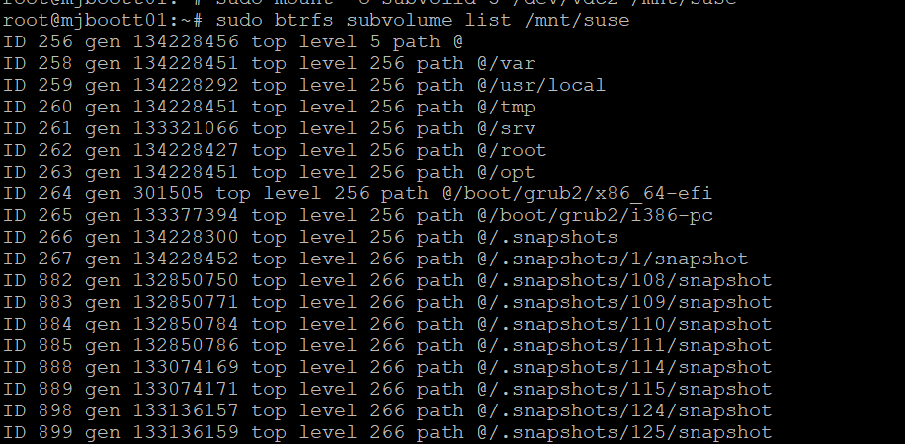

Identify snapshot root, typically:

@/.snapshots/1/snapshot

Mount correct root:
sudo umount /mnt
sudo mount -o subvol=@/.snapshots/1/snapshot /dev/vdc2 /mnt/suse

Verify:

ls /mnt/suse/bin/bash
Expected output:
/mnt/suse/bin/bash

Step 3: Bind required system directories

sudo mkdir -p /mnt/suse/dev
sudo mkdir -p /mnt/suse/proc
sudo mkdir -p /mnt/suse/sys

sudo mount --bind /dev /mnt/suse/dev
sudo mount --bind /proc /mnt/suse/proc
sudo mount --bind /sys /mnt/suse/sys

Step 4: Chroot into openSUSE
sudo chroot /mnt/suse

Step 5: Install openSUSE GRUB into Ubuntu disk
grub2-install /dev/vda
Expected output:
Installation finished. No error reported.

Step 6: Generate GRUB configuration
grub2-mkconfig -o /boot/grub2/grub.cfg
Exit chroot:
exit

Step 7: Update Ubuntu GRUB
sudo update-grub

Step 8: Reboot system
sudo reboot

Verification
GRUB menu should now display:

Ubuntu
Advanced options for Ubuntu
openSUSE Leap

Selecting openSUSE should boot successfully.

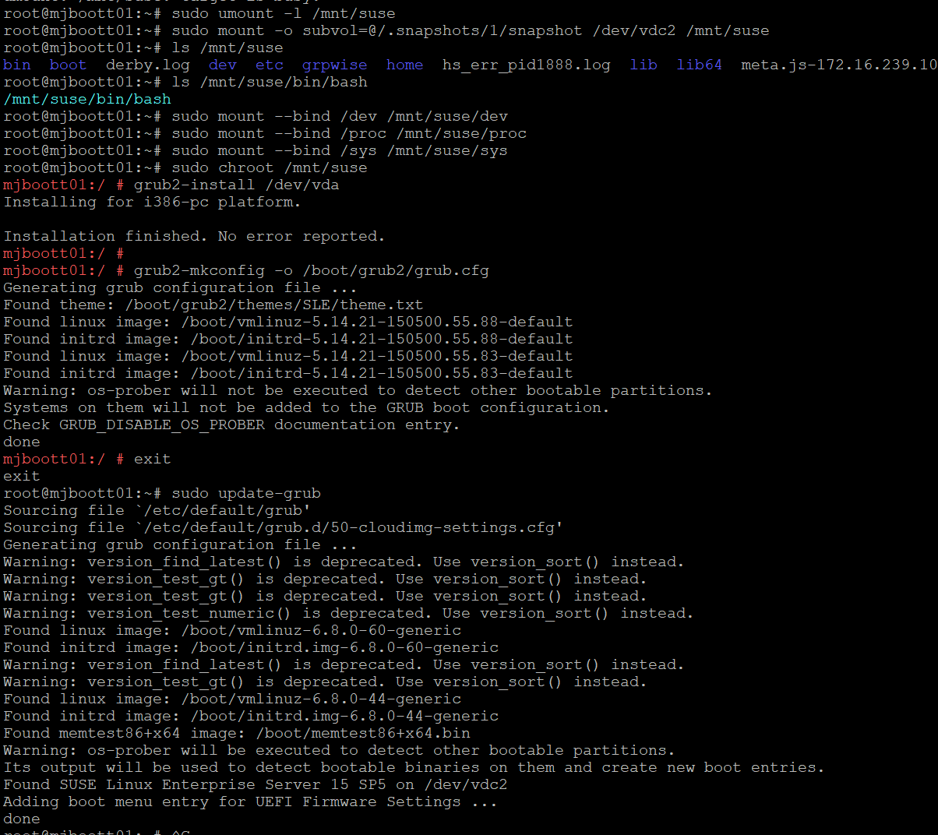

Technical Explanation
Before fix:

Ubuntu GRUB → chainload → openSUSE GRUB in /dev/vdc → fails (VirtIO limitation)
After fix:
Primary disk MBR (/dev/vda)
↓
openSUSE GRUB installed
↓
Loads openSUSE kernel directly

Disk Layout Example
/dev/vda Ubuntu + GRUB (Primary boot disk)
/dev/vdc
├─ /dev/vdc1 BIOS boot partition
├─ /dev/vdc2 BTRFS root
├─ /dev/vdc3 BTRFS data
└─ /dev/vdc4 Swap

References
- GNU GRUB Official Manual
https://www.gnu.org/software/grub/manual/grub/grub.html
- openSUSE Official Boot Loader Documentation
https://doc.opensuse.org/documentation/leap/reference/html/book-reference/cha-boot.html
- openSUSE GRUB2 Configuration Guide
https://en.opensuse.org/SDB:GRUB2
- openSUSE Booting from Rescue System
https://en.opensuse.org/SDB:Booting_into_a_Rescue_System

