Robot Inspection - Field Network Setup Guide
Spot (GXP) + Beryl AX robot LAN + Trimble X7 - Jetson Orin Nano, fully wireless operator laptop

1. Overview
The system spans two computers, each owning a device only it can talk to. The Jetson (a Spot payload) runs ROS/autonomy and owns Spot, the Oak-D, and navX. The Windows laptop runs Trimble Perspective, the only software that can drive the X7, over the X7's own Wi-Fi. The two computers must message each other, so they share one network - the Beryl robot LAN. Everything is split across three subnets that must never overlap:
Subnet | Range | Carries | Link
Spot payload (GXP) | 192.168.50.x | Jetson <-> Spot SDK (pose, motion) | Wired Ethernet
Beryl robot LAN | 10.0.0.0/24 | Jetson <-> laptop (SSH :22, HTTP :8765) | Wi-Fi
Trimble X7 | its own AP | laptop <-> X7 (Perspective) | Wi-Fi

Note: only the Jetson runs ROS, so ROS_DOMAIN_ID matters only there. The laptop is not a ROS node - it talks to the Jetson over plain SSH and HTTP.

2. Topology diagram
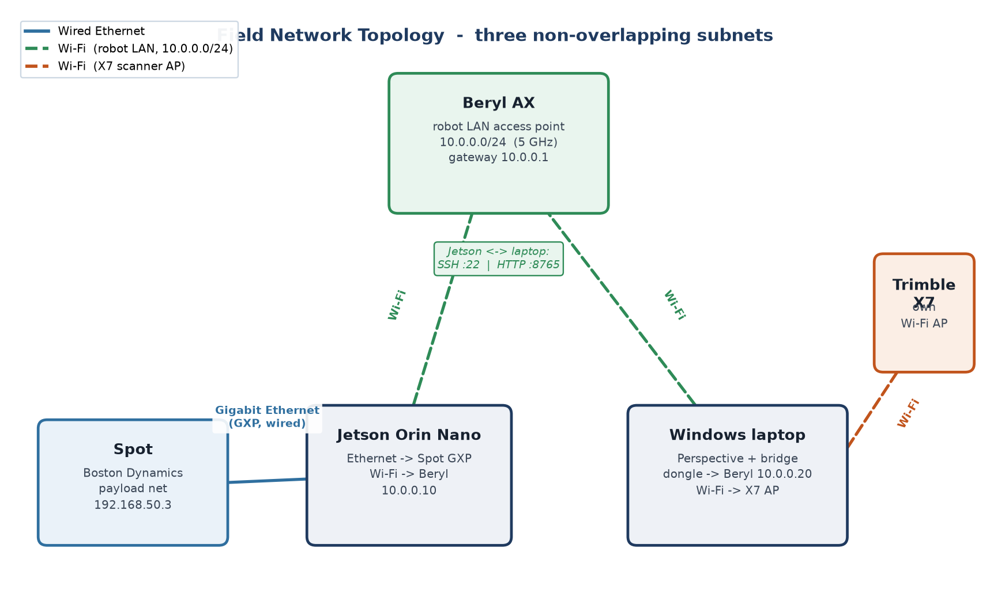
The Beryl is a hub the Jetson and laptop both join by Wi-Fi. Jetson<->Spot is a separate wired link that never touches the Beryl.

3. Hardware checklist
Item | Purpose | Notes / recommendation
Beryl AX (GL-MT3000) | Hosts the robot LAN (Wi-Fi AP) | Already owned
USB Wi-Fi adapter (laptop) | 2nd radio: laptop -> Beryl while built-in Wi-Fi stays on X7 | Netgear A6210 (MT7612U). Dual-band, external antenna, plug-and-play on Windows
Jetson Wi-Fi (M.2 E-key) | Jetson -> Beryl (single Ethernet is used by Spot) | Intel AX210 M.2 2230 if the slot is empty; or a USB Wi-Fi dongle / USB-Ethernet adapter

4. Beryl AX configuration
Admin UI at http://192.168.8.1 (factory default). Configure it as a standalone router/AP - no internet uplink is needed for the mission.
- Mode: Router (default). Leave WAN unplugged - this is an offline field LAN.
- LAN subnet: set to 10.0.0.0/24, gateway 10.0.0.1. Keeping it off the 192.168.x ranges avoids clashing with the X7 AP and Spot payload net.
- Wi-Fi: create an SSID (e.g. 'spot-field'), WPA2/WPA3, strong password. Prefer the 5 GHz band for the robot LAN, away from the X7's Wi-Fi.
- DHCP static leases (so field.env IPs never drift): Jetson -> 10.0.0.10, laptop USB-dongle MAC -> 10.0.0.20.
- Turn client isolation OFF - the Jetson and laptop must reach each other.

5. Jetson (Orin Nano)
The single Gigabit Ethernet port goes to Spot's GXP. The Beryl link comes off the Jetson's Wi-Fi.
- Wire the Jetson's Ethernet port to Spot's GXP / payload port. Spot is reachable on the payload net (default 192.168.50.3 - confirm yours).
- Check for Wi-Fi: run 'nmcli device status' and look for a 'wifi' device (wlan0).
- If wlan0 exists: join the Beryl SSID; set a static/reserved 10.0.0.10.
- If there is no wlan0: install an Intel AX210 card in the M.2 E-key slot (connect both antennas), or plug in a USB Wi-Fi dongle, or a USB-to-Ethernet adapter into a Beryl LAN port.
- Confirm both links: 'ping 192.168.50.3' (Spot) and 'ping 10.0.0.20' (laptop).

field.env values on the Jetson (config/field.env):
SPOT_IP=192.168.50.3
TRIMBLE_WINDOWS_URL=http://10.0.0.20:8765
ROS_DOMAIN_ID=42

6. Windows laptop (two wireless NICs)
Completely wireless: built-in Wi-Fi stays on the X7; the USB dongle carries the robot LAN. Two radios = two networks at once, on different subnets.
- Built-in Wi-Fi: join the X7's own AP exactly as Perspective uses it today (no router hop, so no discovery issues).
- USB dongle: join the Beryl SSID; it should receive 10.0.0.20.
- Windows routes by subnet automatically. On an offline LAN neither interface needs to be the default gateway; if traffic misroutes, set the interface metrics so each subnet exits its own adapter.
- Open the firewall so the Jetson can poll the bridge:
New-NetFirewallRule -DisplayName "Trimble Bridge" -Direction Inbound -LocalPort 8765 -Protocol TCP -Action Allow
- In the bridge app Settings: jetson_host = 10.0.0.10, listen_port = 8765, windows_advertise_host = 10.0.0.20.

7. How the laptop and Jetson talk
- Laptop -> Jetson (SSH :22): 'Start Mission' SSHes in to build and launch the stack; 'Stop' SSHes a shutdown and scp's the digital twin back.
- Jetson -> laptop (HTTP :8765): the trimble_windows_bridge node POSTs scan requests / status and GETs /status every ~2 s. Pressing 'Next scan location' on the laptop bumps a counter the Jetson sees on its next poll, which releases the robot to the next vantage.

8. Verification (bench test before the field)
On the Jetson:
ping 10.0.0.20 && curl http://10.0.0.20:8765/status
ping 192.168.50.3
./scripts/field_preflight.sh mission
On the laptop:
ssh <user>@10.0.0.10 "echo ok"
Then a motion-safe end-to-end dry run (proposes goals, does not move Spot):
ROBOT_GOAL_BRIDGE=false ./scripts/run_field.sh mission
Confirm the bridge app shows scan requests and that pressing 'Next scan location' advances /mission/state.

9. Troubleshooting
Symptom | Likely cause | Fix
Jetson can't curl :8765 | Windows firewall / wrong dongle IP | Add the firewall rule; confirm dongle = 10.0.0.20
Laptop SSH hangs | No key / Jetson not on LAN | Set up an SSH key; confirm Jetson = 10.0.0.10 on the Beryl
Perspective loses the X7 | Laptop's built-in Wi-Fi left the X7 AP | Keep built-in Wi-Fi on the X7; robot LAN stays on the dongle
Routing conflicts / no traffic | Overlapping subnets | Keep X7 AP, Beryl (10.0.0.x), Spot (192.168.50.x) all distinct
Jetson has no wlan0 | M.2 E-key slot empty | Install Intel AX210, or use a USB Wi-Fi / USB-Ethernet adapter

