This documentation is prepared for validating GridPACK Dynamic Simulation with classical models. During the validation, three power systems are used to represent small, medium, and large system, 300-bus, 3,000-bus, and 14,000-bus. For each system, a small disturbance case and a near unstable boundary case are selected to have a strong validation.

The GridPACK simulation results are comparing against PowerWorld commercial tool in this document. All the test results have shown a great match between GridPACK and PowerWorld.

**300-Bus Test System**

Dynamic simulations for a 300-bus system were implemented by Gridpack and Powerworld and the simulation results were compared as follows:

1. **Near unstable boundary case**: 300-bus system, 3-phase fault with impedance 0.00001 p.u. at bus 7130 (near generator 10061), from 1 second to 1.28 seconds (the critical clearing time is around 1.31 seconds). And the speed of the generator 10061 is compared as follows:
2. **Small disturbance case**: 300-bus system, 3-phase fault with impedance 0.00001 p.u. at bus 234 (near generator 10039), from 1 second to 1.05 seconds. And the speed of the generator 10039 is compared as follows:

**3000-Bus Test System**

Dynamic simulations for a 3000-bus system were implemented by Gridpack and Powerworld and the simulation results were compared as follows:

1. **Near unstable boundary case**: 3000-bus system, 3-phase fault with impedance 0.00001 p.u. at bus 188 (near generator 190), from 1 second to 1.433 seconds (the critical clearing time is around 1.438 seconds). And the speed of the generator 190 is compared as follows:
2. **Small disturbance case**: 3000-bus system, 3-phase fault with impedance 0.00001 p.u. at bus 2534 (near generator 190), from 1 second to 1.05 seconds. And the speed of the generator 190 is compared as follows:

**14000-Bus Test System**

Dynamic simulations for a 14000-bus system were implemented by Gridpack and Powerworld and the simulation results were compared as follows:

1. **Near unstable boundary case**: 14000-bus system, 3-phase fault with impedance 0.00001 p.u. at bus 962 (near generator 7233), from 1 second to 1.35 seconds. And the speed of the generator 7233 is compared as follows:

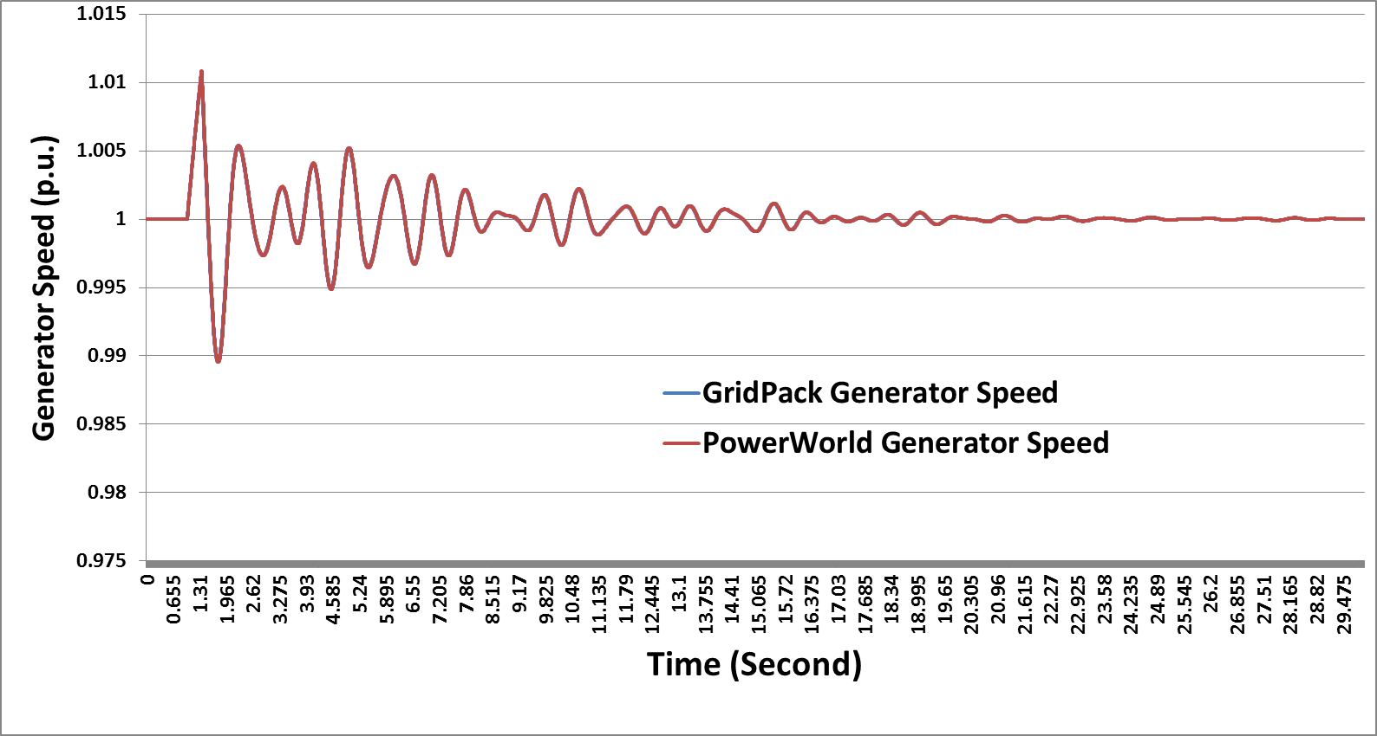

1. **Small disturbance case**: 14000-bus system, 3-phase fault with impedance 0.00001 p.u. at bus 962 (near generator 7233), from 1.0 second to 1.05 seconds. And the speed of the generator 7233 is compared as follows:

