Digital India is a campaign launched by the government of India on 1st of July in 2015 at Indira Gandhi Indoor Stadium. It is to facilitate Indian citizens with electronic government’s services in order to reduce paperwork, improve work efficiency and save time. This project has been approved by the prime minister of India, Narendra Modi and is expected to be completed by 2019. It is headed and planned by the ministry of communications and information technology.

This plan will really ensure the growth and development in India especially in the rural areas by connecting rural regions and remote villages with high-speed internet services. It will benefit villagers a lot who travel long distance and waste time and money in doing paper works for various reasons. In the very starting of the project launch, there was a plan by the state government to make available high speed internet connection in almost 250,000 villages and other residential areas of the country.

Focus of Digital India programme has been to,

* Ensure the broadband highways.
* Ensure the universal access to mobile phones.
* Facilitate people with high speed internet.
* Bring e-Governance by reforming government through digitization.
* Bring e-Kranti through electronic delivery of services.
* Make available online information for all.
* Ensure more IT jobs.

**Focus Areas**

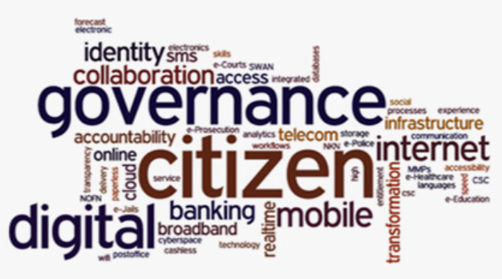

Many apps have been launched to take forward Digital India initiative such as

|  |  |  |
| --- | --- | --- |
| E-PANCHAYAT | DIGILOCKER | eHospital |
| COE-IOT  (Center of Excellence for Internet of Things) | BHIM  (Bharat Interface for Money) | eBASTA |
|  |  |  |

**Vision**

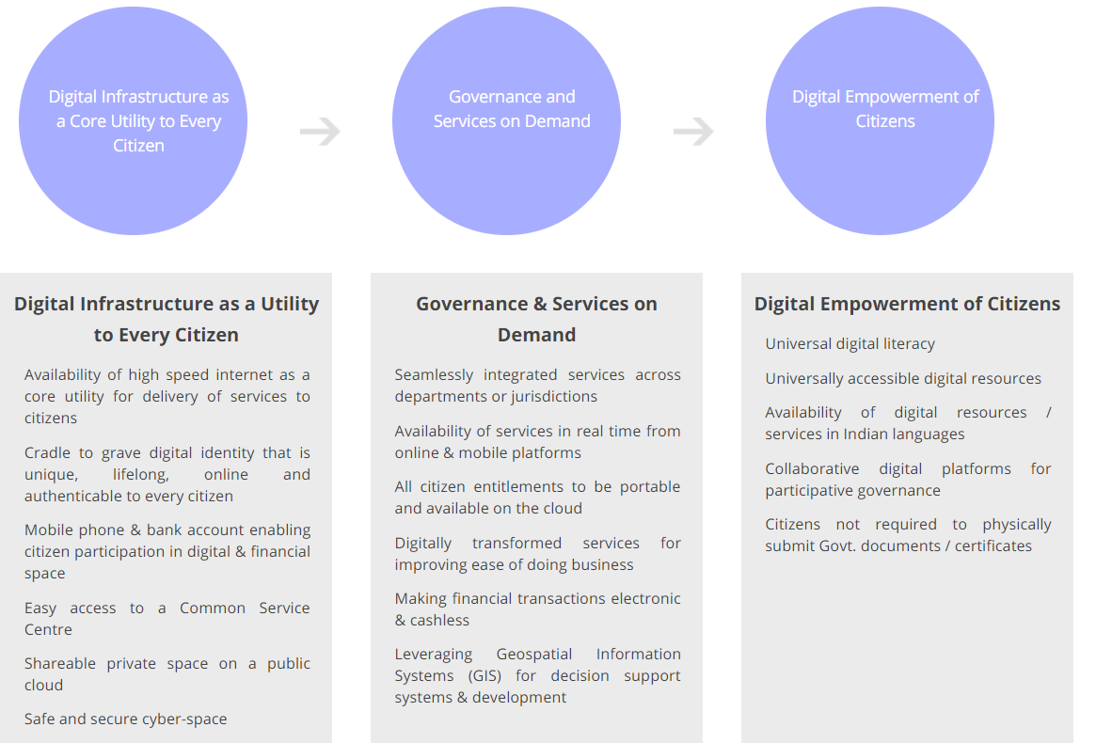

**Benefits**

In the digital India there would be easy digitization of data which will help in making things much more efficient and fast in the future. It will reduce paper work, save man power and save time as well. This project will take a speed by tying the knot between government and private sectors. Huge number of villages interconnected with high speed network will really undergo a huge change from backward regions to complete digitally equipped areas. All the cities, towns and villages in India will get more tech savvy.