DATA SCIENCE PROJECT REPORT
KUMARAGURU COLLEGE OF TECHNOLOGY
ARTIFICIAL INTELLIGENCE AND DATA SCIENCE – A10
PROJECT REPORT
CREDIT CARD FRAUD DETECTION
USING DATA SCIENCE AND EXPLORATORY DATA ANALYSIS
Course: 24ADI204 – Data Science and Visualization
Submitted by
Abishake P — 25BAD002
Arunvignesh R S — 25BAD012
Nishanth M — 25BAD069
Academic Year 2026

ABSTRACT
Credit card fraud is difficult to detect because fraudulent transactions are rare and can look similar to genuine purchases. In this project, the team used exploratory data analysis (EDA) and data visualisation to study how fraudulent and legitimate transactions differ in an analysis-ready sample of 20,492 transactions.
The sample contains 492 fraudulent and 20,000 legitimate transactions, so fraud represents 2.40% of the sample. The dataset has 31 numeric columns: Time, V1–V28, Amount and Class. There are no missing values and 22 exact duplicate rows.
The analysis showed that V14, V12, V17 and V10 have the strongest association with the fraud label. Transaction Amount alone is a weak indicator, with a correlation of 0.025. Interestingly, the fraudulent class has a lower median amount but a higher mean because a small number of large transactions pull the average upward. A derived Hour variable also showed differences in fraud rate across the two-day time window.
The project demonstrates how EDA can reveal patterns that are easy to miss when only averages or accuracy are considered. The study stops before machine learning, but it provides a useful foundation for future classification and fraud-monitoring work.
Keywords: Credit card fraud, EDA, data visualisation, class imbalance, Python, Pandas, Matplotlib, Seaborn.

TABLE OF CONTENTS
1. Introduction
2. Problem Statement
3. Objectives
4. Dataset Description
5. Tools and Technologies Used
6. Methodology
7. Four-Week Project Progress
8. Exploratory Data Analysis
9. Data Preprocessing
10. Data Visualisation
11. Selected Analysis Code
12. Fraud vs Legitimate Transaction Analysis
13. Key Insights
14. Relevance to Machine Learning
15. Individual Project Contributions
16. Challenges Faced
17. Results and Findings
18. Limitations
19. Future Scope
20. Conclusion
21. References

1. INTRODUCTION

1.1 Credit Card Fraud
Credit card fraud happens when a transaction is made without the legitimate cardholder’s permission. Online and card-not-present payments make this problem harder because stolen card details can be used without physically possessing the card.

1.2 Why Detection is Difficult
• Fraud is a minority class. In the analysis-ready sample, only 2.40% of transactions are fraudulent.
• Fraudulent spending can look normal, so a simple amount-based rule is not enough.
• The two classes overlap in several features, which means no single variable separates them perfectly.
• Missing a fraudulent transaction and incorrectly flagging a genuine one have different consequences.
• The V1–V28 features are anonymised, so their business meaning cannot be explained directly.

2. PROBLEM STATEMENT
The project focuses on the following question: what patterns in the available transaction data are associated with fraudulent activity? The study therefore examines the dataset systematically, measure the class imbalance, compare the two classes, study relationships between variables and use visualisations to communicate the important patterns.
The project is intentionally an analysis project rather than a prediction project. Its purpose is to understand the data and prepare a sound base for a future fraud-detection model.

3. OBJECTIVES
• Understand the size, structure and columns of the dataset.
• Check data quality, including missing values and duplicates.
• Measure the imbalance between fraudulent and legitimate transactions.
• Use descriptive statistics to understand the variables.
• Study relationships between features and the Class label.
• Compare transaction amount, time and feature distributions across the two classes.
• Create clear charts that support the numerical findings.
• Identify useful observations for future machine learning work.
• Understand why accuracy alone is not suitable for an imbalanced fraud problem.
• Document the complete analysis in a reproducible form.

4.1 Dataset Overview
Attribute | Value
Rows analysed | 20,492
Columns | 31
Fraudulent records | 492
Legitimate records | 20,000
Fraud percentage | 2.4009%
Class ratio | 40.65 : 1
Missing values | 0
Exact duplicates | 22
Data types | 30 float64, 1 int64
Time range | 0–172,768 seconds (~48 hours)
The source follows the commonly used credit card fraud dataset structure associated with the Machine Learning Group of the Université Libre de Bruxelles. For this project, all 492 fraud records were retained and 20,000 legitimate records were randomly selected to create a smaller analysis-ready file. Therefore, the cross-class percentages in this report describe the sample, not the full original dataset.

4. DATASET DESCRIPTION

4.2 Columns
Column group | Meaning
Time | Seconds elapsed from the first transaction in the dataset.
V1–V28 | Anonymized numerical features produced from transformed transaction information.
Amount | Transaction value.
Class | Target label: 0 = legitimate, 1 = fraudulent.

4.3 Important Sampling Note
The analysis-ready file is not the complete source dataset. The fraud class was kept in full, while the legitimate class was reduced to 20,000 records. This makes the sample easier to work with and increases the visibility of the minority class during EDA.
This sampling choice is important when interpreting results. The 2.40% fraud rate is specific to the analysis-ready sample. Correlations and other statistics calculated across both classes also depend on this sampling ratio.

4.4 Data Types and Quality
All 31 columns are numeric. No categorical encoding was needed and no missing-value treatment was required. The duplicate check found 22 exact duplicate rows. Since 19 of them belong to the fraud class, removing them immediately would reduce the available fraud examples. We therefore retained them for the descriptive study and documented the issue for future modelling.
Because V1–V28 are anonymised, the report focuses on statistical behaviour rather than trying to assign real-world meanings to individual variables.

5. TOOLS AND TECHNOLOGIES USED
Tool / Library | How it was used
Python | Main programming language for the analysis.
Pandas | CSV loading, inspection, filtering, grouping and statistics.
NumPy | Numerical operations and transformations.
Matplotlib | Main plotting library for charts and figures.
Seaborn | Correlation heatmap and density-based visualisations.
Jupyter Notebook / Google Colab | Interactive environment for running and checking the analysis.
Microsoft Word | Preparation of the final report.
Microsoft PowerPoint | Preparation of the project presentation.
The project deliberately uses a simple and widely used Python data-science stack. No machine learning library was needed for the EDA reported here.

5.1 Why These Tools?
Pandas made it easy to move between raw transaction records and summary tables. Matplotlib and Seaborn helped us turn the numerical results into charts that were easier to interpret. Jupyter/Colab was useful because each stage could be run and checked separately, which also matched the four-week project schedule.

6. METHODOLOGY
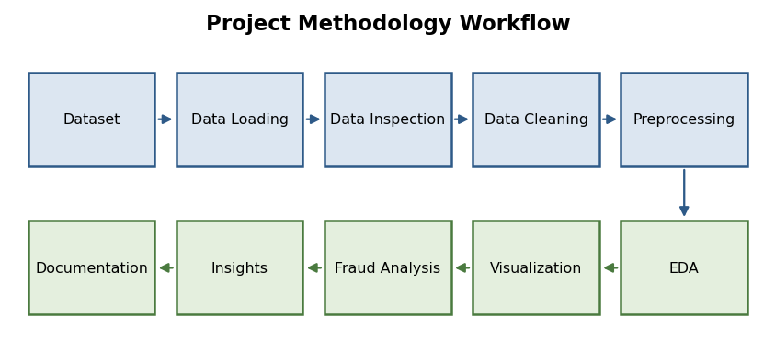
Figure 1: Project methodology workflow used for the study.
The workflow moves from the dataset to loading, inspection, cleaning, preprocessing, EDA, visualisation, fraud comparison, insight extraction and final documentation.

6.1 Main Steps
• Load the analysis-ready CSV file into a Pandas DataFrame.
• Check shape, column names and data types.
• Check missing values and exact duplicate rows.
• Review descriptive statistics and class counts.
• Compare the two classes using amount, time and anonymised features.
• Create an Hour variable from the relative Time value for daily-cycle analysis.
• Use charts to understand skewness, class differences and correlations.
• Summarise the observations and identify directions for future modelling.
The preprocessing was kept deliberately light. No rows were imputed, no features were removed and no resampling was applied during this EDA stage.

7. FOUR-WEEK PROJECT PROGRESS
Week | Member | Main work
Week 1 | Arunvignesh R S (25BAD012) | Problem understanding, dataset identification and environment setup.
Week 2 | Nishanth M (25BAD069) | Data loading, inspection, cleaning and initial EDA.
Week 3 | Abishake P (25BAD002) | Detailed EDA, visualisation and fraud comparison.
Week 4 | Arunvignesh R S (25BAD012) | Consolidation, verification, report and presentation preparation.

7.1 Week 1
The first week focused on understanding the fraud-detection problem and preparing the working environment. The team identified a labelled dataset and prepared the smaller analysis-ready sample so that the analysis could be performed comfortably.

7.2 Week 2
The second week established the basic profile of the data. The team confirmed the shape, data types, missing-value status, duplicate count and class distribution. This week made the class imbalance clear and helped define the questions for the detailed analysis.

7.3 Week 3
Week 3 was the main analysis stage. The class distribution, transaction amount, correlations, leading feature distributions, time patterns and outliers were studied. The figures in this report were produced from these analyses.

7.4 Week 4
The final week focused on checking the results, bringing the sections together and preparing the presentation and final report. Important numerical results were rechecked before final documentation.

7. PROJECT WORK AND TEAM FLOW

7.5 How the Weeks Connected
The work was planned as a sequence rather than four separate mini-projects. Week 1 produced the dataset and working environment. Week 2 established a reliable data profile. Week 3 used that profile to investigate the main questions. Week 4 then checked the findings and converted them into the final deliverables.

7.6 Individual Work in Brief
Member | Contribution
Arunvignesh R S | Dataset preparation, initial inspection, data-quality checks and early EDA.
Abishake P | Detailed EDA, visualisation, fraud-vs-legitimate comparison and report preparation.
Nishanth M | Final review, consolidation, verification and project presentation.
The team used the same analysis-ready dataset throughout the project. This helped keep the figures, tables and written findings consistent.

7.7 Outcome
By the end of the four weeks, the team had a complete EDA workflow, a set of 11 analytical figures, supporting tables and a clear list of findings and limitations. The project also established the next step: supervised machine learning using an evaluation strategy designed for class imbalance.

8. EXPLORATORY DATA ANALYSIS

8.1 Dataset Shape and Types
The dataset contains 20,492 transactions and 31 columns. Thirty columns are stored as floating-point values and Class is stored as an integer. Since all columns are numeric, there was no need for categorical encoding.

8.2 Missing Values
The missing-value check returned zero missing values across all 31 columns. This meant that no imputation was required and the analysis could move directly to descriptive statistics and visualisation.

8.3 Duplicate Records
There are 22 exact duplicate rows. Nineteen are in the fraud class and three are in the legitimate class. For this descriptive project they were retained, but they should be reviewed before any train-test split in a future modelling stage.

8.4 Class Distribution
The class distribution is the most important starting point because it changes how every later result should be interpreted. The sample contains 20,000 legitimate transactions and 492 fraudulent transactions.
Class | Meaning | Count | Percentage
0 | Legitimate | 20,000 | 97.5991%
1 | Fraudulent | 492 | 2.4009%
— | Total | 20,492 | 100%
8.5 Class Distribution
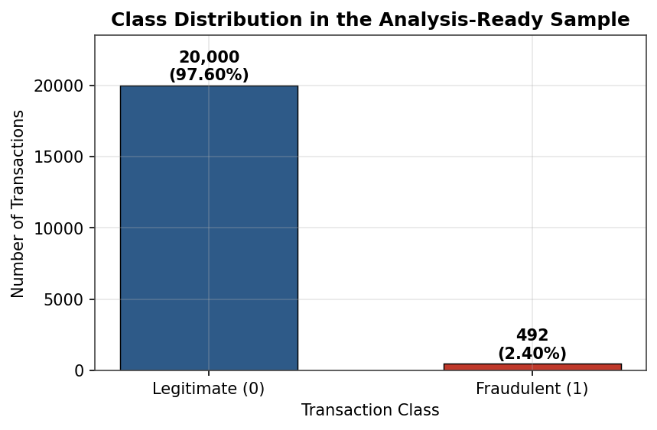
Figure 2: Class distribution in the analysis-ready sample.
The bar chart makes the imbalance easy to see. The legitimate class is much larger than the fraudulent class. There are about 40.65 legitimate transactions for every fraudulent transaction in this sample.
This imbalance is not just a visual detail. A model that predicts every transaction as legitimate would appear to have high accuracy while completely missing fraud. For this reason, later modelling should focus on metrics such as precision, recall and F1-score rather than accuracy alone.
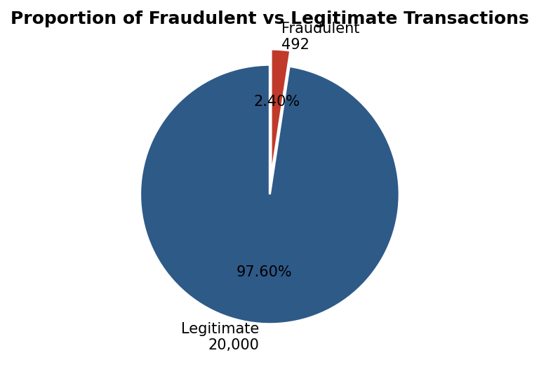
Figure 3: Proportion of fraudulent and legitimate transactions.
10.1 Transaction Amount Distribution
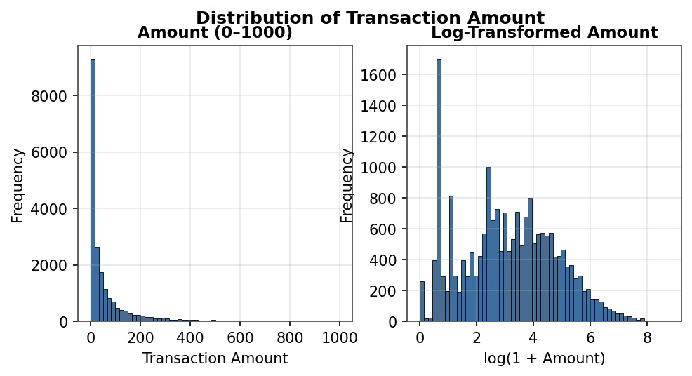
Figure 4: Distribution of transaction amount on linear and log-transformed scales.
Transaction Amount is strongly right-skewed. Most transactions are relatively small, while a small number of transactions have much larger values. The overall skewness is 8.10 and the excess kurtosis is 114.73.
The linear histogram compresses most observations near the lower end, so the log-transformed view is much easier to read. This is a good example of why visualisation matters: the raw values are correct, but the choice of scale changes how clearly the distribution can be understood.
The amount ranges from 0.00 to 6,511.00, with a sample median of 21.50.
10.2 Transaction Amount by Class
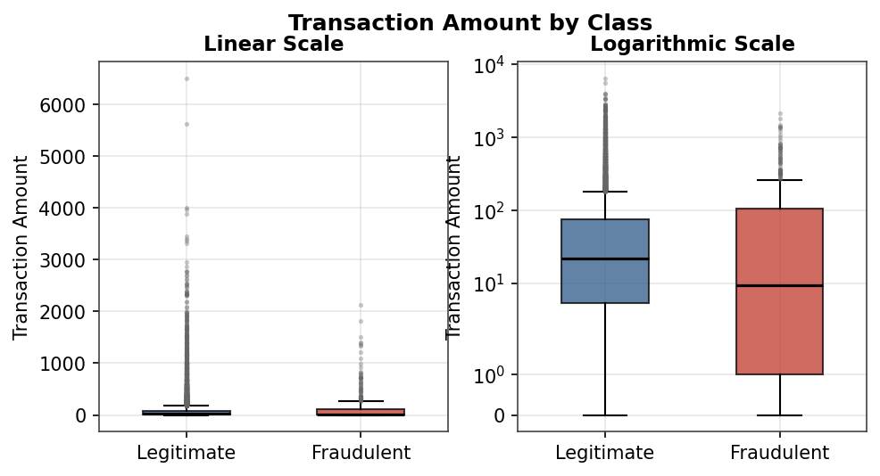
Figure 5: Transaction amount by class using linear and symmetric-logarithmic scales.
Statistic | Legitimate | Fraudulent
Mean amount | 86.34 | 122.21
Median amount | 21.80 | 9.25
Lower quartile | 5.37 | 1.00
Observation | Typical value is higher | Typical value is lower; long upper tail
At first, the higher fraud mean might suggest that fraudulent transactions are generally larger. The median shows the opposite: the typical fraudulent transaction is smaller. A small number of high-value fraudulent transactions pulls the mean upward.
This is an important finding for the project. Transaction amount by itself is not a reliable fraud indicator, and a simple rule such as “flag every high-value transaction” would miss many fraudulent transactions.

10.3 Transaction Activity by Hour
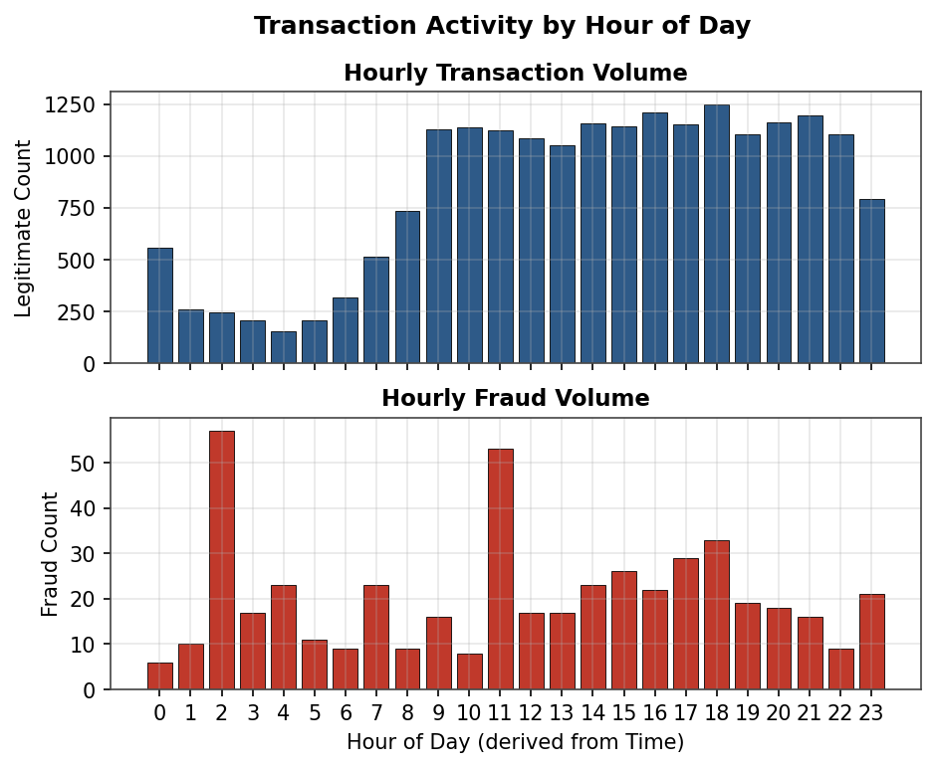
Figure 6: Hourly transaction activity and hourly fraud volume.
The Time column is a relative number of seconds from the first transaction, not a calendar timestamp. To make the two-day period easier to compare, an Hour value was derived by mapping the elapsed time onto a 24-hour daily cycle.
The upper panel shows that transaction volume is much higher during some hours than others. The lower panel isolates the fraudulent transactions so that their pattern is not hidden by the much larger legitimate class.
The derived time variable is therefore more useful for visual exploration than the raw Time value, although it should not be interpreted as an actual clock time.

10.4 Fraud Rate by Hour
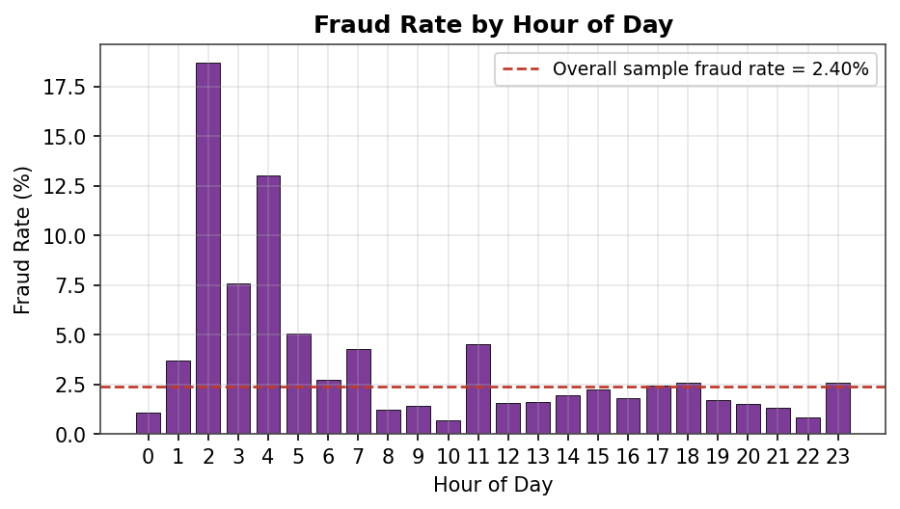
Figure 7: Fraud rate by hour of the derived daily cycle.
The fraud rate varies considerably across the derived hourly groups. It reaches 18.69% in the 02:00 group and falls to 0.70% in the 10:00 group. Overall, the sample fraud rate is 2.40%.
About 25.20% of fraudulent transactions fall between 00:00 and 05:59, compared with 8.17% of legitimate transactions. However, the total number of transactions in these early-hour groups is relatively small.
Because Time is only a relative offset, the safest conclusion is that fraud rates differ across the derived daily cycle. We should not claim that actual real-world midnight or 2 a.m. behaviour has been proven by this dataset.
10.5 Correlation Structure
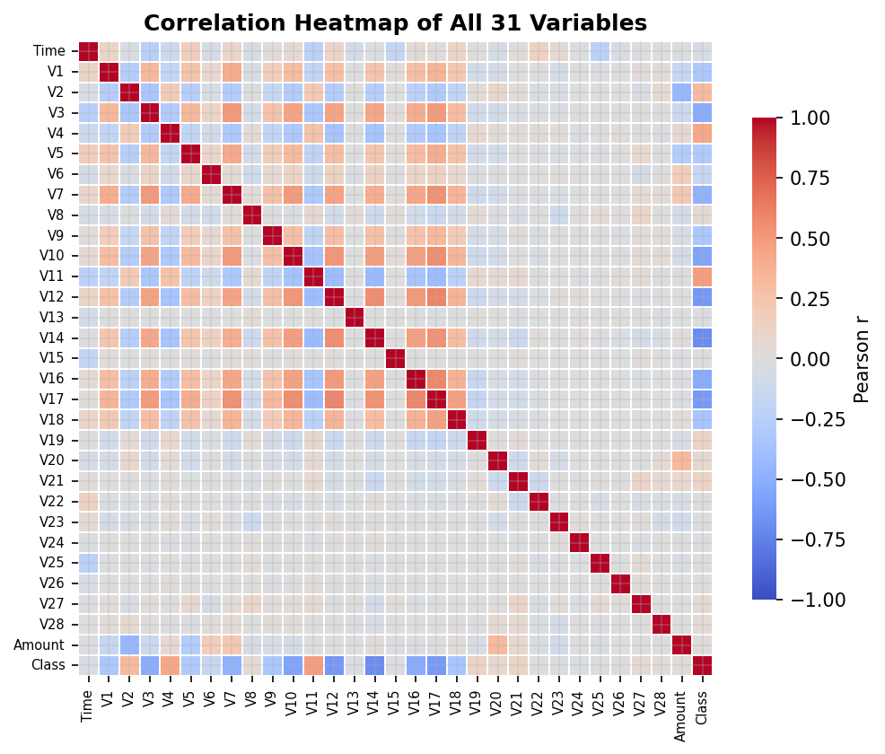
Figure 8: Correlation heatmap for the 31 variables.
The correlation heatmap gives a quick view of relationships among the variables. The V1–V28 block is based on transformed features, so most of these variables show relatively weak pairwise relationships with one another.
The Class row is especially useful because it allows us to identify which features have the strongest linear association with the fraud label. This does not prove causation, but it provides a useful direction for further analysis and future model development.
10.6 Features Most Associated with Fraud
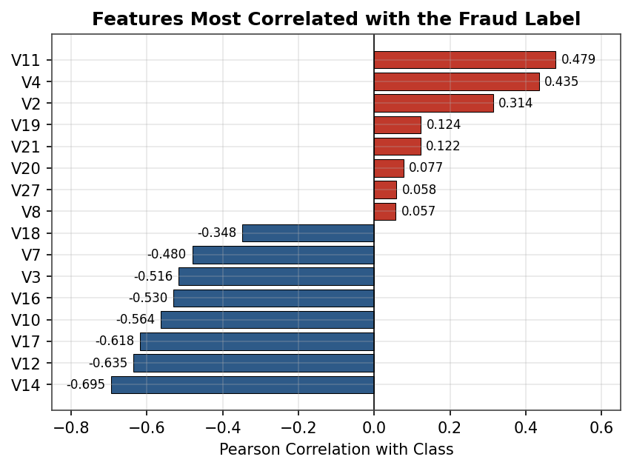
Figure 9: Features with the strongest Pearson correlation with the Class label.
Feature | Correlation with Class
V14 | −0.695
V12 | −0.635
V17 | −0.618
V10 | −0.564
V16 | −0.530
V3 | −0.516
V11 | +0.479
V4 | +0.435
V14 has the strongest correlation in the sample, followed by V12, V17 and V10. Amount has a correlation of only 0.025 with Class, while raw Time has −0.046.
These values should be treated as indicators of association, not as proof that a feature independently causes or determines fraud. Because the features are anonymised, we can discuss their statistical behaviour but cannot give them a business interpretation.
10.7 Class-Conditional Feature Distribution
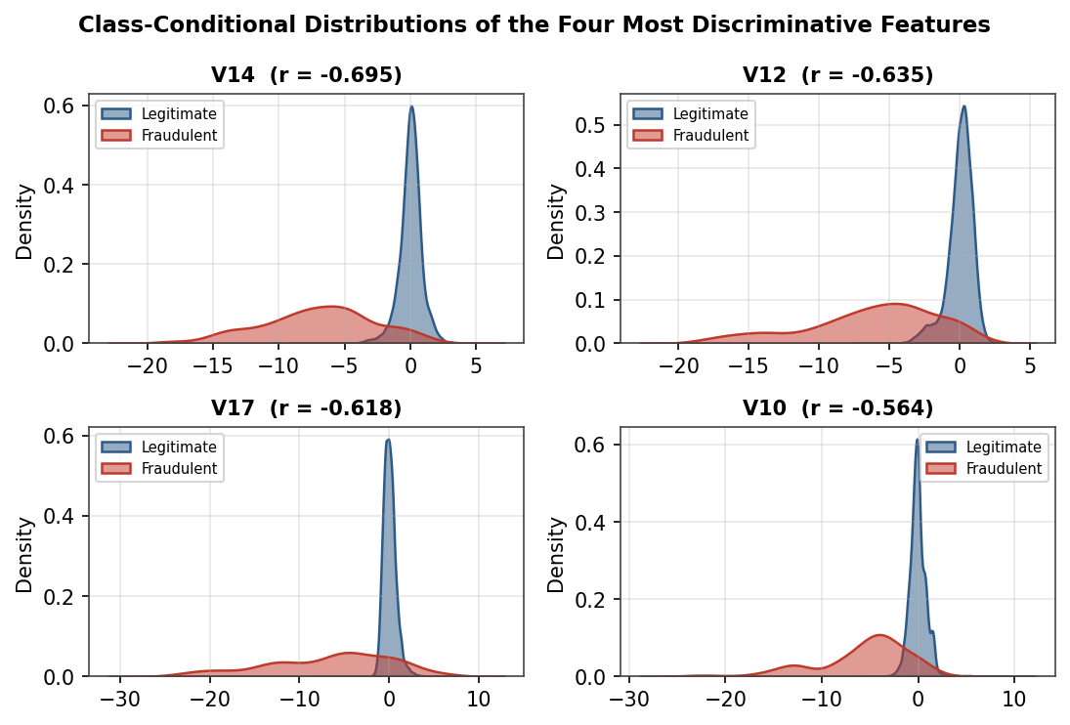
Figure 10: Class-conditional distributions of V14, V12, V17 and V10.
The density plots support the correlation results. For the strongest features, the legitimate transactions are concentrated close to zero, while the fraud distributions are shifted towards negative values. The two classes still overlap, so none of these variables gives a perfect separation.
For example, V14 has a legitimate mean of about 0.008 and a fraudulent mean of about −6.972. The difference in location is much larger than the difference seen in many weaker features.
This visual comparison is useful because correlation gives a single number, while the density plots show the shape and overlap of the two distributions.

10.8 Amount and Time Together
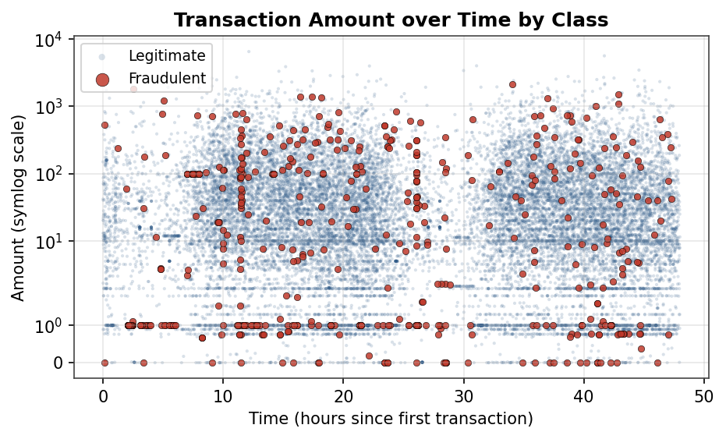
Figure 11: Transaction amount over time by class.
The scatter plot combines two directly interpretable variables: transaction amount and the elapsed time in hours. A symmetric-logarithmic amount scale is used because the amounts are heavily skewed.
Fraudulent points appear throughout the time window rather than being limited to one small interval. The plot also reinforces the heavy-tail behaviour of transaction amounts. It is useful for seeing the overall structure, but it does not by itself identify a clean fraud boundary.
9. DATA PREPROCESSING

9.1 Missing Values
No missing values were found, so no imputation was performed.

9.2 Data Types
All columns were already numeric. No encoding step was needed.

9.3 Duplicate Records
Twenty-two exact duplicates were found. They were retained for this descriptive analysis because 19 belong to the fraud class. For future machine learning, duplicates should be reviewed and removed before splitting the data so that identical records do not appear in both training and test sets.

9.4 Scaling
No scaling was required for the visual analysis itself. If models such as logistic regression or distance-based methods are used later, scaling decisions should be made as part of the modelling pipeline.

9.5 Transformations
A logarithmic transformation of Amount was used only to improve visualisation. An Hour variable was derived from Time to study daily-cycle patterns.

9.6 What Was Not Done
No resampling, feature deletion or machine learning model training was performed. Keeping the preprocessing simple helps the report remain faithful to the actual EDA work.
12. FRAUD VS LEGITIMATE TRANSACTION ANALYSIS
Dimension | Legitimate | Fraudulent | Main observation
Frequency | 20,000 | 492 | Strong class imbalance
Mean Amount | 86.34 | 122.21 | Fraud mean is higher
Median Amount | 21.80 | 9.25 | Fraud median is lower
Amount correlation | — | — | Amount–Class r = 0.025
Strong feature | Near 0 for many | Shifted in several features | V14 is strongest at −0.695
Derived time | 8.17% in 00–05:59 | 25.20% in 00–05:59 | Fraud share is higher in this period

12.1 Overall Comparison
The clearest difference between the classes is their frequency. The next strongest pattern comes from the anonymised feature space, especially V14, V12, V17 and V10. Transaction amount shows a more complicated pattern: fraudulent transactions have a lower median but a higher mean.
The time analysis also suggests that the proportion of fraud is not constant across the derived daily cycle. Together, these findings show why fraud analysis needs several variables and several views of the data rather than one simple rule.
13. KEY INSIGHTS
• Fraud represents only 2.40% of the analysis-ready sample.
• V14, V12, V17 and V10 show the strongest negative association with the fraud label.
• V11 and V4 are the strongest positive correlates among the features shown.
• Amount is a weak linear discriminator, with r = 0.025.
• The fraudulent class has a lower median amount but a higher mean because of a long upper tail.
• The amount distribution is highly right-skewed, so median and plots are more informative than mean alone.
• The derived Hour variable reveals large differences in fraud rate across the daily cycle.
• Early derived-hour groups contain a larger share of fraud than their share of legitimate transactions.
• Twenty-two exact duplicate rows were found, including 19 fraud rows.
• The anonymised features allow statistical comparison but do not support direct business interpretation.
• EDA shows useful associations but does not prove causation or provide a fraud prediction model.
• The analysis provides a practical starting point for future supervised machine learning.
These insights are specific to the analysis-ready sample and should be interpreted together with the sampling and time-window limitations described later.
11. SELECTED ANALYSIS CODE
The original project used Python with Pandas, NumPy, Matplotlib and Seaborn. To keep this report readable, only representative code is included here; the full notebook remains the better place for execution details.

Load and inspect the dataset
import pandas as pd
df = pd.read_csv("creditcard_analysis_ready.csv")
print(df.shape)
print(df.dtypes)

Check data quality
print(df.isnull().sum().sum())
print(df.duplicated().sum())

Class distribution
print(df["Class"].value_counts())
print(df["Class"].value_counts(normalize=True) * 100)

Correlation with fraud label
corr = df.corr(numeric_only=True)["Class"].sort_values()
print(corr)

Create the derived hour variable
df["Hour"] = ((df["Time"] // 3600) % 24).astype(int)
hour_rate = df.groupby("Hour")["Class"].mean() * 100
print(hour_rate)
The important point is not the number of lines of code. It is that each step produces a checkable result that can be traced back to the dataset.

14. RELEVANCE TO MACHINE LEARNING

14.1 Why Accuracy Can Mislead
In this sample, 20,000 of 20,492 transactions are legitimate. A trivial classifier that predicts “legitimate” for every transaction would achieve 97.5991% accuracy but would detect none of the 492 fraud cases.
For a future model, precision, recall, F1-score, the confusion matrix and the area under the precision-recall curve should be considered. These measures provide a clearer picture of how well a model handles the minority class.

14.2 Foundation Created by the EDA
• The strongest candidate features have been identified.
• The class imbalance has been measured and documented.
• The Hour feature provides a possible engineered input.
• Missing-value handling is not currently required.
• Duplicate records have been identified and can be addressed before model splitting.
• Visualisations provide a baseline for checking whether future model results make sense.
No machine learning model was trained in this project. Therefore, this report makes no claim about fraud-detection accuracy, precision or recall from a predictive system.
15. INDIVIDUAL PROJECT CONTRIBUTIONS
Member | Register No. | Main contribution
Abishake P | 25BAD002 | Detailed EDA, visualisation, fraud comparison and report preparation.
Arunvignesh R S | 25BAD012 | Problem understanding, dataset preparation, inspection and initial EDA.
Nishanth M | 25BAD069 | Final consolidation, verification and project presentation.

15.1 Team Integration
The project depended on each member’s work. The initial dataset and environment made the early analysis possible; the Week 2 checks established the basic facts; the Week 3 analysis produced the main findings; and the final week brought the results together and checked them.
Using the same dataset and rechecking important numerical values helped keep the final report and presentation consistent.

16. CHALLENGES FACED
• Dataset size: repeated interactive analysis can become slow, so an analysis-ready sample was used.
• Class imbalance: fraud is much smaller than legitimate activity, making some standard charts hard to read.
• Skewed amounts: the linear histogram hides the shape of the data, so a log view was added.
• Anonymised variables: the strongest features cannot be translated into specific business meanings.
• Duplicate records: most duplicates belong to the minority class, so removing them without discussion could discard useful examples.
• Time interpretation: Time is a relative offset, so the derived hour cannot be treated as a real clock timestamp.
• Summary statistics: the mean and median tell different stories for transaction amount, showing why one statistic is not enough.

16.2 General Fraud-Detection Challenges
Fraud patterns can change over time, genuine and fraudulent transactions can overlap, and the cost of false positives is different from the cost of missed fraud. Real systems also depend on reliable labels and sensitive transaction information. These issues mean that a successful fraud-detection system needs continuous evaluation rather than a one-time model.
17. RESULTS AND FINDINGS
Measure | Result
Transactions analysed | 20,492
Fraudulent transactions | 492
Fraud proportion | 2.4009%
Legitimate transactions | 20,000
Imbalance ratio | 40.65 : 1
Missing values | 0
Exact duplicate rows | 22
Strongest feature correlation | V14 = −0.695
Amount–Class correlation | 0.025
Highest derived hourly fraud rate | 18.69%
Lowest derived hourly fraud rate | 0.70%

17.1 Findings in Relation to the Objectives
The project met its main objectives by profiling the dataset, checking data quality, quantifying class imbalance, analysing the variables, creating visualisations and comparing fraudulent with legitimate transactions. The strongest feature associations, the amount distribution and the derived time pattern were all identified and supported with figures.
The main outcome is a clearer understanding of the structure of the fraud problem in this dataset. The analysis also shows exactly what needs attention before a predictive model is attempted.
18. LIMITATIONS
• The analysis uses a sample containing 20,000 legitimate records and all 492 fraud records, not the full source dataset.
• Cross-class percentages and correlations are therefore sample-specific.
• V1–V28 are anonymised and cannot be given direct business meanings.
• Time is a relative offset over about 48 hours, so long-term and seasonal patterns cannot be studied.
• There are no cardholder, merchant or geographic identifiers, so transaction sequences cannot be examined.
• EDA identifies associations, not causes.
• Pearson correlation measures linear association and may miss non-linear relationships.
• No machine learning model was trained, so predictive performance cannot be reported.
• Duplicate records were retained for descriptive analysis and should be reviewed before modelling.
These limitations do not invalidate the EDA. Instead, they define the level of confidence and the type of conclusions that can reasonably be drawn from the project.
19. FUTURE SCOPE
• Repeat the analysis on the complete dataset to confirm whether the patterns remain at the original class ratio.
• Build a simple supervised baseline such as logistic regression, followed by tree-based models.
• Use stratified train-test splitting and report precision, recall, F1-score, confusion matrix and precision-recall curves.
• Compare class-weighting, undersampling, oversampling and SMOTE.
• Explore ensemble methods such as gradient boosting for tabular data.
• Test anomaly-detection approaches such as Isolation Forest.
• Add useful features such as log amount, night-cycle indicators and selected interactions.
• Use explainable AI methods such as SHAP when interpreting future model predictions.
• Consider real-time scoring, monitoring and periodic retraining for a production system.
The next practical step is therefore not simply to train a model, but to build a modelling pipeline that respects the imbalance, checks for data leakage and evaluates the minority class properly.

20. CONCLUSION
This project used exploratory data analysis and visualisation to study fraudulent and legitimate credit card transactions. The analysis-ready sample contained 20,492 records, including 492 fraud transactions and 20,000 legitimate transactions.
The study showed that the dataset is highly imbalanced, complete with respect to missing values, and contains 22 exact duplicate rows. Among the anonymised variables, V14, V12, V17 and V10 showed the strongest association with the fraud label. Transaction Amount was much less informative on its own. The difference between the mean and median amount also showed why visualisation and multiple summary statistics are important.
The derived Hthe analysis found clear differences in fraud rate across the two-day daily cycle, although the relative Time variable cannot be treated as a real-world clock. Overall, the project provided a practical understanding of how EDA can uncover patterns before machine learning is attempted.
The final outcome is not a fraud prediction system. It is a structured, evidence-based analysis that identifies useful features, data-quality considerations and modelling challenges. This provides a clear foundation for the next stage of the project.
21. REFERENCES
1. Machine Learning Group, Université Libre de Bruxelles. Credit Card Fraud Detection dataset, Kaggle.
2. Python Software Foundation. Python Documentation.
3. The Pandas Development Team. pandas User Guide and API Reference.
4. Harris, C. R., Millman, K. J., van der Walt, S. J., et al. “Array programming with NumPy.” Nature, 2020.
5. Hunter, J. D. “Matplotlib: A 2D Graphics Environment.” Computing in Science & Engineering, 2007.
6. Waskom, M. L. “seaborn: statistical data visualization.” Journal of Open Source Software, 2021.
7. Project Jupyter. Jupyter Notebook Documentation.
8. Google Research. Google Colaboratory.
9. Tukey, J. W. Exploratory Data Analysis. Addison-Wesley, 1977.
10. McKinney, W. Python for Data Analysis. 3rd ed., O’Reilly Media, 2022.
11. Dal Pozzolo, A., Caelen, O., Johnson, R. A., and Bontempi, G. “Calibrating Probability with Undersampling for Unbalanced Classification.” 2015.
12. Chawla, N. V., Bowyer, K. W., Hall, L. O., and Kegelmeyer, W. P. “SMOTE: Synthetic Minority Over-sampling Technique.” JAIR, 2002.
13. Saito, T. and Rehmsmeier, M. “The Precision-Recall Plot Is More Informative than the ROC Plot When Evaluating Binary Classifiers on Imbalanced Datasets.” PLOS ONE, 2015.
14. Jolliffe, I. T. Principal Component Analysis. 2nd ed., Springer, 2002.
All numerical findings and figures in this reduced report are based on the analysis-ready dataset used in the original project report.
APPENDIX – QUICK PROJECT SUMMARY
Item | Summary
Project title | Credit Card Fraud Detection Using Data Science and Exploratory Data Analysis
Course | 24ADI204 – Data Science and Visualization
Dataset size | 20,492 rows × 31 columns
Fraud records | 492
Legitimate records | 20,000
Main tools | Python, Pandas, NumPy, Matplotlib, Seaborn, Jupyter/Colab
Main methods | EDA, descriptive statistics, correlation analysis, visualisation, derived Hour analysis
Figures | 11
Machine learning | Not performed; listed as future scope
Main finding | Fraud is strongly imbalanced and several anonymised features show much stronger association with Class than Amount.
End of Report

